Riga, June 17, 2015 | No. 190
To the Ministry of Education and Science of the Republic of Latvia
APPLICATION
FOR ACCREDITATION OF THE FIELD OF STUDY

Name of the higher education institution |  | European Distance University
Name of the field of study |  | Management, Administration and Real Estate Management
Names and codes of the programmes of study  Duration and scope of the programmes of study |  | Business Administration (42345)
 |  | Personnel Management (42345)
Duration and scope of the programmes of study |  | Full-time studies: 4 years  Part-time studies: 4 years and 2 months  160 credits (240 ECTS)
Address of place of implementation of the programmes of study, mode and form of study |  | Kr.Valdemāra iela 26, Riga, LV-1010  Full-time intramural studies  Part-time intramural studies  Part-time extramural studies (Distance education)
Requirements set out to start the acquisition of the programme of study corresponding to the field of study |  | Secondary education
Degree, professional qualification or degree and professional qualification to be obtained under the programme of study |  | Professional Bachelor's degree in Management Science and Business Manager qualification
 |  | Professional Bachelor's degree in Management Science and Personnel Manager qualification
The person duly authorised to handle accreditation issues |  | Rector Normunds Gūtmanis
European Distance Education Rector |  |  | N.Gūtmanis



APPROVED
at the EDU Senate meeting
on 15 June 2015
Decision No.1

European Distance University

Field of Study
„Management, Administration and Real Estate Management”
Self-Assessment Report

Riga, 2015
CONTENT

1. Description of the Field of Study 5
1.1. Strategy for development of the field of study, common goals and their relationship with the overall strategy of the university 5
1.2. Prospective evaluation of the field of study and programmes of study from the viewpoint of the interests of the Republic of Latvia 6
1.3. Development plan for the field of study 7
1.4. Conformity of the field of study and programmes of study to labour market needs: results of the assessment of the labour and education market in regard to availability of jobs for the graduates of the programmes of study and results of employers’ survey 9
1.5. Analysis of the strengths, weaknesses, opportunities and threats of the field of study 11
1.6. Description of the internal quality assurance system of the field of study 12
1.7. Resources available for the field of study (including financial resources) and material and technical facilities 13
1.8. Opportunities for cooperation in Latvia and abroad in regard to the field of study concerned 17
1.9. List of the programmes of study, broken down by credits, form of study, acquired degree, degree and professional qualification or professional qualification. Compliance of the programmes of study with the strategy of the Republic of Latvia or the strategy of the university or college 18
1.10. List of the academic staff members involved in the implementation of the field of study, broken down by qualifications and obligations, including the programme of study or part thereof to be implemented by each member of the academic staff 18
1.11. Research work of the academic staff members involved in the implementation of the field of study and its influence on studies, involvement of students in research projects, as well as participation in international projects and projects financed by the Latvian Council of Science and other institutions during the reporting period 21
1.12. List of key scientific publications and educational material designed by the academic staff members involved in the implementation of the field of study during the reporting period 21
1.13. List of bodies (such as academic departments, groups of professors, laboratories and institutes) involved in the implementation of the field of study, broken down by their tasks in the implementation of the field of study and specific programmes of study 22
1.14. Description of the supporting staff members required for the implementation of the field of study, broken down by their tasks in the implementation of the field of study and specific programmes of study 24
1.15. Information on External Relations 26
1.15.1. Cooperation with employers and professional organisations 26
1.15.2. Cooperation with Latvian and foreign universities and colleges which implement similar fields of study and similar programmes of study 27
1.15.3. Students who have studied in exchange programmes abroad, broken down by exchange programmes and countries 28
1.15.4. Number of foreign students in the field of study in total and broken down by programmes of study, duration of study and countries 28

2. Description of the Programme of Study Business Administration 29
2.1. Objectives and tasks for implementation of the programme of study 29
2.2. Expected study results of the programme of study 29
2.3. Plan of the programme of study (list of courses and study modules and course credits, broken down by required courses, optional courses and elective courses of the programme of study, indicating the course credits and implementation plan) 32
2.4. Description of the courses and modules of study (if any) 36
2.5. Organisation of the programme of study 36
2.6. Admission requirements for the programme of study 38
2.7. Practical implementation of the programme of study (methods and modes of study used; use of distance education methods) 38
2.8. Assessment system (education criteria and assessment methods for achievement and evaluation of the study results, test forms and procedures) 39
2.9. Costs of the programme of study 41
2.10. Compliance of the programme of study with the state standards of academic education or the professional standard and professional higher education state standards and other regulations in regard to higher education 42
2.11. Comparison with one programme of study of the same level and similar field of study in Latvia (if a similar programme of study is implemented in Latvia) and at least two programmes of study at universities or colleges recognised by the European Union countries 43
2.12. Information on students 46
2.12.1. Number of students 46
2.12.2. Number of students enrolled in the first year of study 47
2.12.3. Number of graduates (if any) 47
2.13. Surveys of students and analysis of surveys 47
2.14. Surveys of graduates and analysis of surveys 48
2.15. Participation of students in the improvement of the study process 48

3. Description of the Programme of Study Personnel Management 49
3.1. Objectives and tasks for implementation of the programme of study 49
3.2. Expected study results of the programme of study 49
3.3. Plan of the programme of study (list of courses and study modules and course credits, broken down by required courses, optional courses and elective courses of the programme of study, indicating the course credits and implementation plan) 50
3.4. Description of the courses and modules of study (if any) 54
3.5. Organisation of the programme of study 54
3.6. Admission requirements for the programme of study 56
3.7. Practical implementation of the programme of study (methods and modes of study used; use of distance education methods) 56
3.8. Assessment system (education criteria and assessment methods for achievement and evaluation of the study results, test forms and procedures) 57
3.9. Costs of the programme of study 59
3.10. Compliance of the programme of study with the state standards of academic education or the professional standard and professional higher education state standards and other regulations in regard to higher education 60
3.11. Comparison with one programme of study of the same level and similar field of study in Latvia (if a similar programme of study is implemented in Latvia) and at least two programmes of study at universities or colleges recognised by the European Union countries 65
3.12. Information on students 67
3.12.1. Number of students 67
3.12.2. Number of students enrolled in the first year of study 68
3.12.3. Number of graduates (if any) 68
3.13. Surveys of students and analysis of surveys 68
3.14. Surveys of graduates and analysis of surveys 68
3.15. Participation of students in the improvement of the study process 68

4. Summary of the Development Plans for the Field of Study 69
4.1. Prospective evaluation of the field of study and programmes of study having regard to the tasks of the Republic of Latvia in implementation of the common strategies of the European Union 69
4.1.1. Compliance of the programme of study with laws and regulations and recommendations for establishment of the European Higher Education Area 69
4.2. Information provided by employers and professional organisations regarding the prospects for the employment of graduates over at least the next six years 70

5. Annexes to the Self-Assessment Report of the Field of Study 71

Description of the Field of Study

Strategy for development of the field of study, common goals and their relationship with the overall strategy of the university
European Distance University Ltd. (hereinafter the University College) is registered in the Educational Institutions Register of the Republic of Latvia on 13.10.2010, Certificate No. 3343802833, the previous title was Higher School EIHSEBA (European International High School of Economics and Business Administration) until 21.06.2013.
The following programmes of study are included in the field of study “Management, Administration and Real Estate Management” (hereinafter referred to as the field of study)
- Business Administration (42345)
- Personnel Management (42345)
On 18th December 2013 the field of study was accredited, fixing the accreditation term until 17th December 2015 and conferring the right to implement the study program „Business Administration” that is appropriate to this field of study, Accreditation Sheet No. 273 of this study
The study programme “Personnel Management” was licensed on 24 September 2014, occupation code: 2423 03 (licence No. 04065-7, see Annex 2), with the right of implementing the programme till the final date of accreditation of the field of studies “Management, Administration and Real Estate Management”, i.e. 17 December 2015.
The study field development strategy is an integral part of the University College development strategy and its goals, objectives, lines of action and attainable results are defined in order to ensure the University College mission and the achievement of strategic goals.
The University College mission is to implement higher education study programs, by providing higher education that is qualitative, relevant to the labor market, open and internationally competitive in a modern multimedia environment.
The strategic goals of the study field are as follows:
- To achieve the learning outcomes that meet the requirements of the European Qualifications Framework (EQF ) knowledge, skills and competence, which are defined in the Latvian education classification;
- Training of the qualified specialists for the labour market;
- The sustainable development of the study field by improving the program content and organization of studies in accordance with the labor market and technology development;
- To increase the number of students, to attract foreign students
- To provide opportunities for full-scale acquisition of the study program through distance learning;
- To upgrade qualifications of the academic staff and promote research activities;
- To create and develop external relations;
- To improve logistical support and methodological support.
The planned measures of the University College strategy, which promote study and research process development, resource management development, internal quality culture development, personnel cooperation with the Latvian and foreign academic communities, create the preconditions for improving competitiveness with the fields of study of similar typeimplemented by other higher education institutions.
The qualitative implementation of the study field programs is ensured by the Quality Management System, which was developed by the University College (see Item 1.6 in detail). On 6th February 2013 the Certificate of the Bureau Veritas Certification was issued, which certifies that the quality management system has been audited and found to be appropriate to the LVS EN ISO 9001:2009 requirements.

Prospective evaluation of the field of study and programmes of study from the viewpoint of the interests of the Republic of Latvia
The objectives and tasks of the field of study and the corresponding programme of study have been identified according to the priorities set out in the Sustainable Development Strategy of Latvia until 2030 (Latvia 2030):
- Long-term investments in human capital: Elimination of socio-economic inequalities, availability of the necessary resources, especially high-quality education, as an essential prerequisite for human life and job opportunities.
- Change of paradigm in education: Qualitative and available lifelong education, improved general level of technological competence, by integrating distance learning elements in the study process.
- Innovative and eco-efficient economy: Environment supporting entrepreneurship, support for the creation and commercialisation of new ideas, knowledge transfer and participation of entrepreneurs in research.
- Innovative government and public participation: Developed ability of inhabitants of Latvia to participate in public processes in order to strengthen the necessary knowledge and skills acquired in the context of education acquired.
One of the directions of action set out in the guidelines of the National Development Plan of Latvia for 2014-2020 is “Developed research, innovation and higher education”, linking the national economy growth with provision of access to higher education, science and private sector cooperation, as well as transfer of research and innovation to business. To ensure the opportunity for people to work, get a decent job and contribute to the development of the country, the direction of action Development of Competences provides for a need for different competences in the labour market of Latvia (a combination of knowledge, skills and attitudes), which are to be improved throughout a lifetime, because it is impossible to predict future needs with certainty. The expected knowledge and skills include language skills, knowledge and command of information and communication technologies, communication and cooperation skills, entrepreneurial ability, civic consciousness, creativity, as well as the ability to think critically, plan finances, assess risks and identify solutions to such risks.
The Ministry of Economy " Informative Report on the Medium and Long-Term Forecasts on the Labour Market " of 08.15.2014 provides for an increasingly rapid rise in demand for highly skilled professionals, to a large extent determined by the increase in demand for labour in the service sector.
The content of the field of study corresponds to the requirements and guidelines set out in laws and regulations to attain the strategic goals for the development of Latvia. Implementation of the programmes of study corresponding to the field of study and sustainable development require academic staff, as well as appropriate infrastructure in order to offer the programmes to a numerous audience.

Development plan for the field of study
Fulfilment of the tasks planned within the field of study is monitored and assessed at the meetings of the academic staff and administration using the results of the surveys of students, graduates and employers and recommendations of the academic staff, assessing the results of tests and examinations, as well as the submitted study papers and final papers.
Development plan for the field of study:
Event | Period of implementation | Responsible persons
- Process of study
- To update the programmes of the courses of study according to the standard of education, labour market changes and the latest technology | until the start of the academic year | Methodology committees, academic staff
- To organise regular surveys of employers and graduates regarding the correspondence of the content of the programme to the labour market requirements | once per semester | Director of the programme of study, academic staff
- To improve the opportunities for computerised studies, to develop e-learning mode | throughout the academic year | Director of the programme of study, academic staff
- To promote development of skills of the academic staff, to attract new specialists | throughout the academic year | Director of the programme of study, academic staff
- To involve guest lecturers in the process of study who would share their practical experience | at least once per semester | Director of the programme of study, academic staff
- To organise lectures by foreign guest lecturers | at least once per semester | Director of the programme of study, academic staff
- To implement at least one international cooperation project | throughout the academic year | Rector,  Erasmus coordinator
- To ensure international mobility of the students and academic staff | for at least one semester | Rector,  Erasmus coordinator
- To build cooperation with employers and employers’ organisations | throughout the academic year | Director of the programme of study, academic staff
- Scientific work
- To motivate and support the participation of the academic staff in Latvian and international scientific conferences | throughout the academic year | Director of the programme of study,  Erasmus coordinator
- To organise a regular scientific research conference | every second year in Semester 2 | Rector,  Director of the programme of study
- To organise a regular scientific research conference of the students | every year in Semester 2 | Director of the programme of study, academic staff
- To motivate the students to get involved in grants and scientific research projects (including those at the international level) | throughout the academic year | Academic staff
- To expand scientific research cooperation with Latvian and foreign universities | throughout the academic year | Director of the programme of study, academic staff
- Material and technical facilities
- To constantly improve material and technical facilities by purchasing up-to-date hardware on a yearly basis | throughout the academic year | Rector,  Director of the programme of study
- To set up a third computer room with 30 work stations and internet connection | throughout the academic year | Rector,  Director of the programme of study
- To install multimedia projectors in all instruction rooms | throughout the academic year | Rector,  Director of the programme of study
- To provide Wi-Fi access in all premises | throughout the academic year | Rector,  Director of the programme of study
- Improvement of internal quality management
- To improve the quality policy developed by the University College | throughout the academic year | Director of the programme of study, academic staff
- To update the development plan for the field of study based on the tasks fulfilled and external regulatory requirements | at the end the academic year | Director of the programme of study, academic staff

Conformity of the field of study and programmes of study to labour market needs: results of the assessment of the labour and education market in regard to availability of jobs for the graduates of the programmes of study and results of employers’ survey
In accordance with the forecasts of the European Centre for the Development of Vocational Training (Cedefop), the overall EU demand for labour force in the coming years will grow very slowly. It is expected that from 2013 to 2020, the number of employees will increase by approximately 0.35% per year, amounting to 2% growth, while the number of employees in Latvia during this period will grow by 4.4%, which represents a significant increase in jobs.
Viens no absolventu iespējas iekļauties darba tirgū rādītājiem ir studiju virziena piederība pie Latvijas darba tirgus pieprasītajām nozarēm. Ekonomikas ministrijas 2014.gada “Informatīvais ziņojums par darba tirgus vidēja un ilgtermiņa prognozēm” paredz darbaspēka pieprasījumu pēc darbiniekiem ar augstāko izglītību, kas norāda uz darba tirgus kvalitatīvu attīstību, kam par iemeslu ir nozaru tehnoloģiskā attīstība un uzņēmumu starptautiskā konkurence. Kopsavilkumā atzīmēts, ka dažās jomās pašlaik ir darbaspēka pārpalikums, taču demogrāfijas izaicinājumi tuvāko gadu laikā var saasināt darbaspēka nepietiekamības problēmu, kas nākotnē var radīt jaunas darba tirgus disproporcijas un kļūt par vienu no galvenajiem šķēršļiem Latvijas izaugsmei.
One of the indicators of the availability of jobs is the supply of vacancies published on the internet. During the preparation of this accreditation report, monitoring of job ads published on Latvijas Vēstnesis portal (http://www.lvportals.lv/amatu-konkursi.php), CV and job ads portal of the State Employment Agency (https://cvvp.nva.gov.lv/vakances) and job ads website CV-Online (http://www.cv.lv/darba-sludinajumi) was conducted during one month and demonstrated the relevance of the qualification obtained within the field of study for the labour market demand.
Novērtējot izglītības piedāvājumu studiju virzienā, tika analizēts līdzīgu programmu piedāvājums citās augstākās izglītības iestādēs, datu atlasei izmantota Nacionālās izglītības datu bāzē apkopotā informācija par izglītības iespējām Latvijā un IZM informācija par akreditēto studiju virzienu 2. līmeņa profesionālā augstākā bakalaura izglītības programmām, kurās iegūstamā kvalifikācija ir “Uzņēmuma vadītājs” un “Personāla vadītājs” vai tām pietuvinātās.
The professional bachelor’s study programme with the qualification of the “Manager of Enterprises and Institutions” is implemented by the following state universities and higher education institutions: Riga Technical University “Entrepreneurship and Management”; the University of Latvia “Financial Sector Management”; Latvia University of Agriculture “Entrepreneurship and Business Management”; BA School of Business and Finance “Business Administration”; Rezekne Higher Education Institution “Entrepreneurship”; Riga Teacher Training and Educational Management Academy “Entrepreneurship and Business Management”; Liepaja University “Management of Institutions and Enterprises”; Vidzeme University College “Business Administration”, as well as by the following non-university type higher education institutions founded by legal entities: the LLC “Riga International School of Economics and Business Administration” “Business Studies”; the University College of Economics and Culture “Cultural Management”; the LLC “School of Business Administration Turiba” “Business Administration”; the International Higher School of Practical Psychology “Business Administration”.
The professional study programme with the qualification of the “Manager of Enterprises and Institutions” is implemented by the Baltic International Academy, the study programme Entrepreneurship, and Riga Aeronautical Institute Organisation of International Transportation.
The professional bachelor’s study programme with the qualification of the “Personnel Manager” or “Human Resource Management” is implemented by Riga Technical University, the study programme Human Resource Management, Riga Teacher Training and Educational Management Academy Personnel Management.
The University College cooperates with employers, organizing debates, surveys and analyzing the feedback to find out their wishes in relation to the preparation of qualified employees. Analyzing the feedback and assessments from the students’ practice sites, it can be concluded that employers assess the students' theoretical training, acquired skills and competencies as good and excellent. The heads of several companies and institutions, in which the students have done practical training, want to collaborate with the University College systematically, that allows to predict the recruitment prospects of graduates.
Social partners and employers are involved in the events organized by the University College - in scientific research conferences, assessment of study programs, jointly organized seminars and other activities, thus providing feedback. During the employers’ focus group discussion the employers laid emphasis that students have a lot of theoretical knowledge, but in practice the initiative and the desire to go into the subject and to transfer the acquired knowledge to practice disappear, as a result it is planned that the University College course content will include the necessary knowledge, skills and competences, raising awareness about the sector.
The University College students - potential graduates also help to create a link between the University College and employers.

Analysis of the strengths, weaknesses, opportunities and threats of the field of study
Study direction and its realization strengths and weaknesses, opportunities and threats analysis is the basis for field of study development plan establishment, this is University College administration, Program director and academic staff joint task.
Strengths | Opportunities
The programmes within the field of study are modern and are designed according to the professional standards and the Cabinet’s Regulations regarding the State Standard for the Second Level Higher Professional Education.  The acquired education is relevant and applicable in practice.  The students can combine their studies with work.  Research skills are developed during the process of study.  There is cooperation with employers regarding the provision of work placement.  The programmes within the field of study are implemented by skilled and professional academic staff members with vast practical and teaching experience.  Quality training and methodological material is used for implementation of the programmes within the field of study; academic staff members revise and update their lectures and practical work materials.  The students have access to a broad information base.  Library funds are supplemented with the latest publications on a regular basis. | Specialists in the field are in demand in the labour market.  The employers' interest in professional staff preparation.  The sector employs specialists, who are happy to participate in the study process or exchange experience on selected topics.  The Latvian citizens and non-citizens, who are living and working abroad, wish to study in their native language.  The CIS residents are interested in getting higher education diplomas that are recognized in the EU.
Weaknesses | Threats
Different age structure of students in the same group, insufficient background knowledge of students in certain courses.  The mobility of students is not ensured.  The number of elected faculty members holding a doctoral is not large.  There are no guest lecturers from foreign universities.  The academic staff members are not provided with the internship opportunity in related programmes abroad..  Lack of the University College’s recognition. | Economic situation in Latvia.  There are a relatively large number of educational institutions which offer similar education in Latvia.  Political instability of higher education.  Decreasing number of students due to poor demographic situation in the country and outflow of population to foreign countries.  Increasing competition in higher education.

Description of the internal quality assurance system of the field of study
One of the strategic goals of the University College is the provision of an efficient organisational administration and maintenance of the quality management system, which is vital for the future growth of any company operating in any field.
The quality management system developed by the University College has been found to be in accordance with the requirements of ISO 9001:2008.
Taking into account the requirements of Standards and Guidelines for Quality Assurance in the European Higher Education Area (ESG) developed by the European Association for Quality Assurance in Higher Education (ENQA), accepted at the Bergen Conference of European Ministers Responsible for Higher Education on 20 May 2005 and approved in London on 19 May 2007, the development of the education quality management system of EDU incorporates the interest of students and employers in a quality higher education and its compliance with the requirements of the labour market, with the aim of enhancing quality improvement in higher education by promoting freedom of information and interaction of the parties concerned, as well as ensuring regular assessment of quality.
The quality management system was developed and certified as compliant with the international standards LV EN ISO 9001:2008 and 9001:2009 in February 2013.The following steps have been taken to ensure the establishment of the quality management system of the University College:
- policies and procedures for quality assurance in higher education have been developed;
- mechanisms for creation, approval, implementation and regular periodic testing of own programmes of study have been designed;
- criteria for assessing students’ achievement have been designed, incorporated into the course descriptions and made known to students;
- internal policies and mechanisms for personnel qualifications and work quality assurance have been developed;
- an Intranet database containing information on the students’ progress, tuition fees and other key indicators of the University College’s activities and ensuring access to a variety of documents governing the operation of the University College and specific study programmes has been provided.
Internal quality is ensured at the level of the field of study by:
- student performance assessment and analysis (each semester after the defense of term papers and practice reports);
- determining student satisfaction (questionnaires) and analysis (course assessment questionnaires);
- teacher performance assessment (analysis of hospitation questionnaires and documents);
- employee performance assessment (performance analysis);
- the study program's internal quality audits;
- the study program's annual self-assessment;
- practice assessment (supervisor reviews and employer questionnaires);
- graduates' knowledge and skills assessment (employer questionnaires);
- thesis quality assessment (sector professionals’ reviews, who work in the state examination board, assessment of accreditation experts);
- the program’s external quality audits (reports of the accrediting commission experts).
The system of the internal self-assessment and quality improvement is functioning on a continuous basis during the academic year. Debates on the strengths and weaknesses, changes and developments in the programme of study and the University College at the Senate of the University College are planned at the end of the academic year.

Resources available for the field of study (including financial resources) and material and technical facilities
Funding of the University College is composed of:
- Student tuition fees, including study loans (160,000 EUR on average per year)
- Paid services (10,800 EUR on average per year);
- Founder’s financial contribution;
- Donations and charity.
In accordance with the decision of the Board, each year EUR 7,000 is set aside to replenish the library stock of University College, while EUR 71,000 per year is allocated towards the development of research activity.
To ensure the process of studies, the University College includes 41 instruction rooms equipped with projectors and computers, including two computer rooms (with a total of 83 work stations for students) the total area of the building at Kr. Valdemāra iela 26 is 3,312.3 sq.m.
University College premises
Description of premises | Description of agreement
Permanent premises of the University College:  Kr.Valdemāra iela 26, Riga  Total area: 3,312.30 sq.m.  administrative premises – 301 sq.m.  instruction rooms – 1,363.9 sq.m.  computer rooms – 182.5 sq.m.  recreational space – 211.6 sq.m.  library – 67 sq.m. | On 29 June 2012, a real estate agreement with the state joint-stock company Valsts nekustamie īpašumi was signed for a period of 10 years.

The material and technical facilities of the University College provide the necessary preconditions for the implementation of the study process. Lectures and tutorials take place in comfortable modern rooms where latest technology is used to conduct the classes and communication with students.
Changes in the material and technical facilities of the University College from 2011 to 2014
Name | Number (pcs.) |  | Change, %
Name | 2011 | 2014 | Change, %
Printers | 4 | 11 | + 275%
Monitors | 70 | 158 | + 225%
Computers | 73 | 164 | + 223%
TVs | 1 | 4 | + 400%
Projectors | 3 | 13 | + 433%
Cash register | 1 | 1 | 0%
Queuing system | 0 | 1 | + 100%
Pass entry system | 0 | 1 | + 100%
Premises* | 1,280 sq.m. | 3,312.3 sq.m. | + 258%

On 19 March 2014, the united library of the University College and College became a member of the Academic Libraries Association of Latvia (Annex 2), which allows the students to use the services of the 24 libraries which are members of the Association (http://www.lataba.lv), such as the library of BA School of Business and Finance, the library of Turība University, the library of Stockholm School of Economics in Riga, the library of the University of Latvia and other libraries within the Association.
The e-library of the University of Latvia provides links to free-access multi-sectoral and sectoral encyclopaedias, dictionaries and full-text reference databases: http://www.biblioteka.lu.lv/e-resursi/brivpieejas-e-resursi/uzzinu-db/.
The University College promotes the students’ research work, offering access to electronic libraries. For example, the students have an opportunity to use the services of the following electronic libraries: Научная электронная библиотека - http://elibrary.ru/, electronic library catalogue of Chalmers University (Sweden) - http://www.lib.chalmers.se, electronic library of the University of Toronto (Canada) - http://query.library.utoronto.ca/, as well as the full-text databases of EBSCO national package - Academic Search Complete, MasterFILE Premier, Health Source:Nursing/Academic Edition+Consumer Edition, Newspaper Source, Regional Business News, ERIC, GreenFILE, European Views of the Americas: 1493 to 1750, LISTA, MEDLINE, The Teacher Reference Center TRC.
Moreover, the students have access to the following databases in the premises of the library of the University College and the computer rooms:
- http://news.lv/ – access to Latvian periodicals (such as Dienas Bizness, Jurista Vārds, Komersanta Vēstnesis, Latvijas Vēstnesis, Likuma Vārdā and others) with an opportunity to read the current news and the archived articles.
- http://letonika.lv/ – extensive information on Latvian culture, its professionals and events. Access to encyclopaedias, dictionaries and literature.
- The Economist online version offers articles from 1997. News on politics, economics, business, finance, science, technology and culture.
- books.google.com – GOOGLE offers an opportunity to search for and read the full texts and fragments of books. There is an opportunity to read online and download fiction, special literature (on politics, public relations, tourism, etc.), reference material, scientific publications, textbooks, educational and other literature in English.
- http://www.gutenberg.org – full-text e-books.
- Directory of Open Access Journals (DOAJ.org) – full-text scientific and research journals on various topics in English, French, Spanish, Italian and other languages. Currently, the database includes 2,310 journals, some of them are searchable as articles: http://doaj.org/
- Findarticles.com (English) – free- and pay-articles from various periodicals on various topics: http://www.search.com/search
- Electronic Journals Library (English, German) – a journal database in different languages and in different sectors. Full texts are available for some of the journals: http://rzblx1.uni-regensburg.de/ezeit/index.phtml?bibid=AAAAA&colors=7&lang=en
- Bibliomania (English) – offers to read, study and explore through thousands of e-books http://www.bibliomania.com/
- http://www.opendoar.org/index.html – compiles academic free-access resource repositories and provides search through all repositories at the same time
- OpenAIRE is a single European scientific repository network that provides a single search option and offers more than 8,613,743 free-access scientific articles, including full-text dissertations, abstracts and conference proceedings in English, Spanish, Portuguese, German, Russian and other languages.
- http://www.encyclopedia.com/ – offers a compilation of more than 100 online encyclopaedias and dictionaries.
- http://bookfi.org/ – Russia’s largest electronic library offers free-access e-books in various industries.
The University College supplements its library on a regular basis. Every year, EUR 7,000 is allocated to replenish the library resources.
No. | Sector | Number of book titles | Total number of copies
No. | Sector | Number of book titles | Latvian | English | Russian
1 | Languages | 75 | 25 | 30 | 20
2 | Economics, management science | 608 | 1028 | 312 | 453
3 | Computers | 73 | 83 | 47 | 25
The students may freely use the Internet, including Wi-Fi, to obtain information from national and international information networks. E-learning is carried out through the interactive multimedia learning environment designed for the University College, where the students are provided with a personalised access to learning materials.
The agreement signed with Microsoft IT Academy provides for the opportunity to install Microsoft software packages necessary for the learning process.
The following packages have been installed in the computer rooms:
- Microsoft Dynamics CRM
- WinQSB
- SPSS
- Microsoft Office 2007, 2010
- Microsoft Windows 7, 8
- C1
- Microsoft Windows Server 2008, 2012
- CMS Moodle.
The Board of the University College provides all necessary infrastructure for educational services and research activities of the academic staff. Members of the academic staff hand in the lists of the necessary research literature to the Rector. There are material funds (a budget) available for continuous expansion of the library resources, and the decision on the use of these funds is made by the Rector. There is also a budget for low-value inventory and office supplies needed to maintain daily operations of the University College, and the purchase of such goods is organised by the Information Centre.

Opportunities for cooperation in Latvia and abroad in regard to the field of study concerned
The University College cooperates with Latvian and foreign universities, employers and organisations relevant for the sectors of the programmes of study.
In case, if the University College is unable to provide students training according to the licensed or accredited professional study program and one of the implemented programs is closed, the University College has concluded a cooperation agreement with LLC „Biznesa augstskola Turība” ("School of Business Administration Turība") regarding opportunities for students to continue studies (see Annex 4).
4 agreements have been concluded with four universities of St. Petersburg and 2 agreements with universities in Prague, the Czech Republic (see Annex 5) on cooperation in scope of scientific research work, exchange of students and academic staff, organization of joint seminars, as well as participation in conferences of the second higher education institutions.
In order to provide student practice placements in the field of study, some contracts have been concluded with several companies in Latvia, the Russian Federation, etc. countries, their copies are found in Annex 6.

List of the programmes of study, broken down by credits, form of study, acquired degree, degree and professional qualification or professional qualification. Compliance of the programmes of study with the strategy of the Republic of Latvia or the strategy of the university or college
In the field of study „Management, Administration and Real Estate Managemen” the University College implements the professional bachelor’s degree programs Business Administration (code 42345) and Personnel Management (code 42345), volume of 160 credit points (hereinafter - CP). The full-time studies program is intended to be mastered within 4 years - part-time studies - 4 years and 2 months. The program graduates have professional bachelor's degree in Management science and the qualification of “Business Manager” or “Personnel Manager” according to the program, see Annex 7 for the sample of the received Diploma and Diploma Supplement.
The study program is developed in accordance with the provisions of the Cabinet of Ministers Regulations Nr.512 of 26th August 2014 "Regulations regarding the State Standard for the Second Level Higher Professional Education" and in line with the with the provisions of the Cabinet of Ministers Regulations Nr.461 of 10th May 2010 “Regulations Regarding the Classification of Occupations, Basic Tasks Corresponding to the Occupation, Basic Qualification Requirements and Procedures for the Use and Updating of the Classification of Occupations” requirements.
The study field program’s compliance with the strategies of the Republic of Latvia and the University College has been evaluated in this Report, Items 1.1 and 1.2.

List of the academic staff members involved in the implementation of the field of study, broken down by qualifications and obligations, including the programme of study or part thereof to be implemented by each member of the academic staff
The following academic staff members are involved in the implementation of the field of study Management, Administration and Real Estate Managemen (see CV Annex 8):
Academic staff | Courses of study | Study program * | Dr. | Mg. | Elected
Guest Lecturer , Mg.phil. Marija Antāne | World Market Conjucture and Tourism Management | U |  | 1 | 1
Leading Researcher, Dr.iur. Aleksandrs Baikovs | Commercial Law | U, PV | 1 |  | 1
Assistant Professor, Dr.habil.oec. Nikolajs Baranovskis | Finance and Credit | U, PV | 1 |  | 1
Assistant Professor, Dr.habil.oec. Nikolajs Baranovskis | Environmental, Labour and Civil Protection | U, PV | 1 |  | 1
Assistant Professor, Dr.oec. Irēna Baraškina | Personnel Marketing | PV | 1 |  | 1
Lecturer, Mg.paed. Ieva Berkmane | Sales Management | U |  | 1 | 1
Lecturer, Mg.paed. Ieva Berkmane | Commodity Science | U |  | 1 | 1
Lecturer, Mg.paed. Ieva Berkmane | Sociology | PV |  | 1 | 1
Lecturer, Mg.paed. Ieva Berkmane | Basics of Sociology | U |  | 1 | 1
Lecturer, Mg.paed. Ieva Berkmane | Marketing | U, PV |  | 1 | 1
Guest Lecturer,  Mg.iur. Ināra Brante | Labour Law | U, PV |  | 1
Guest Lecturer,  Mg.iur. Ināra Brante | Social Rights | PV |  | 1
Guest Lecturer, Mg. in Project Management Ieva Celmiņa | Quality Management | U, PV |  | 1
Guest Lecturer, Mg. in Personnels Management  Gudrīte Daukste | Taxes and Fees | U, PV |  | 1
Assistant Professor, Dr.sc.comp.Andrejs Ermuiža | Computer Science | PV | 1 |  | 1
Assistant Professor, Dr.sc.comp.Andrejs Ermuiža | Computer Science and Records Management | U | 1 |  | 1
Lecturer, Mg.paed., Mg.oec. Irēna Germane | Internal Communication | PV |  | 1 | 1
Lecturer, Mg.paed., Mg.oec. Irēna Germane | Internet Marketing | U, PV |  | 1 | 1
Lecturer, Mg.paed., Mg.oec. Irēna Germane | Entrepreneurship | U, PV |  | 1 | 1
Lecturer, Mg.paed., Mg.oec. Irēna Germane | Management Sciences | U, PV |  | 1 | 1
Guest Assistant Professor, Dr.oec. Gunta Grīnberga-Zālīte | Globalisation | U, PV | 1
Guest Assistant Professor, Dr.oec. Gunta Grīnberga-Zālīte | Internet Technologies and their use in Commercial Activities | U | 1
Guest Assistant Professor, Dr.oec. Gunta Grīnberga-Zālīte | Corporate Social Responsibility and Social Dialogue | U, PV | 1
Guest Assistant Professor, Dr.oec. Gunta Grīnberga-Zālīte | International Marketing | U, PV | 1
Assistant Professor, Dr.sc.ing. Normunds Gūtmanis | E-commerce | U | 1 |  | 1
Assistant Professor, Dr.sc.ing. Normunds Gūtmanis | Innovation and Risk Management | U, PV | 1 |  | 1
Guest Assistant Professor, Dr.habil. philol. Juris Andrejs Kastiņš | Business Foreign Language II | U, PV | 1
Researcher, Dr. in Management Science, Inta Kulberga | Banking | U, PV | 1 |  | 1
Researcher, Dr. in Management Science, Inta Kulberga | Business Communication | U, PV | 1 |  | 1
Researcher, Dr. in Management Science, Inta Kulberga | Production and Service Management | U, PV | 1 |  | 1
Researcher, Dr. in Management Science, Inta Kulberga | Strategic Management | U, PV | 1 |  | 1
Assistant Professor, Dr.math. Evija Liepa | Research methods | U | 1 |  | 1
Assistant Professor, Dr.math. Evija Liepa | Research Methods and Labour Market Research | PV | 1 |  | 1
Assistant Professor, Dr.math. Evija Liepa | General economic and company statistics | U, PV | 1 |  | 1
Assistant Professor, Dr.math. Evija Liepa | Mathematics for Economists | U, PV | 1 |  | 1
Guest Assistant Professor, Dr.math. Vineta Minkēviča | Inventory Management | U | 1
Guest Assistant Professor, Dr.math. Vineta Minkēviča | Supply Chain Management | U | 1
Guest Assistant Professor, Dr.math. Vineta Minkēviča | Logistics | PV | 1
Guest Lecturer, Mg. in Public Administration  Agris Olmanis | Project Personnel Management | PV |  | 1
Guest Lecturer, Mg. in Public Administration  Agris Olmanis | Project Management | U, PV |  | 1
Researcher , Mg. in Public Administration  Ināra Parādniece | Personnel Strategic Planning and Recruitment | PV |  | 1 | 1
Researcher , Mg. in Public Administration  Ināra Parādniece | Personnel Management | U, PV |  | 1 | 1
Researcher , Mg. in Public Administration  Ināra Parādniece | Personnel Management System and Specific Functions in the Sectoral Context | U, PV |  | 1 | 1
Researcher , Mg. in Public Administration  Ināra Parādniece | Politology | U |  | 1 | 1
Researcher, Dr.psych. Alla Plaude | Conflictology | PV | 1 |  | 1
Researcher, Dr.psych. Alla Plaude | Personality Psychology | PV | 1 |  | 1
Researcher, Dr.psych. Alla Plaude | Rhetoric | U, PV | 1 |  | 1
Researcher, Dr.psych. Alla Plaude | Management Psychology | U | 1 |  | 1
Researcher, Dr.psych. Alla Plaude | Management Psychology and Team Building | PV | 1 |  | 1
Researcher, Mg.oec. Svetlana Polovko | Insurance | U, PV |  | 1 | 1
Researcher, Mg.oec. Svetlana Polovko | World Economics | U, PV |  | 1 | 1
Guest Lecturer, Mg. in Finances Inga Pumpure | Financial Management in Business | U, PV |  | 1
Guest Lecturer, Mg. in Finances Inga Pumpure | Management Accountancy | U, PV |  | 1
Guest Lecturer, Mg. in Finances Inga Pumpure | Accountancy | U, PV |  | 1
Assistant Professor, Dr.philol. Sandra Ratniece | Cultural History | U, PV | 1 |  | 1
Assistant Professor, Dr.philol. Sandra Ratniece | Official Business Language and Record Keeping | PV | 1 |  | 1
Guest Lecturer, Mg.psych. Lilita Reķe | Business Communication, Presentation and Ethics | U, PV |  | 1
Guest Lecturer, Mg.psych. Lilita Reķe | Professional ethics and etiquette | U |  | 1
Guest Lecturer, Mg.psych. Lilita Reķe | Communication Psychology | U |  | 1
Guest Lecturer, Mg.psych. Lilita Reķe | Intercultural Communication | U, PV |  | 1
Assistant Professor, Dr.paed. Nils Sautiņš | Pedagogy | U, PV | 1 |  | 1
Assistant Professor, Dr.paed. Nils Sautiņš | Personnel Record Keeping | PV | 1 |  | 1
Guest Lecturer, Mg. in Management Science Konstantīns Savenkovs | Investments | U |  | 1
 | Macroeconomics | U, PV |  | 1
 | Microeconomics | U, PV |  | 1
Lecturer, Mg. in Management Science Jeļena Stepanova | Business Foreign Language I | U, PV |  | 1 | 1
Lecturer, Mg.paed. Sanita Vāne | Web site designing | U |  | 1 | 1
Lecturer, Mg.paed. Sanita Vāne | Management Information Systems | U, PV |  | 1 | 1
Guest Assistant Professor, Dr.psych. Mārtiņš Veide | Marketing Research | U, PV | 1
Guest Assistant Professor, Dr.psych. Mārtiņš Veide | Advertising Psychology | U, PV | 1
Guest Assistant Professor, Dr.psych. Mārtiņš Veide | Advertising and Public Relations Management | U, PV | 1
 | Total: |  | 13 | 14 | 17
* U – Business Administration, PV – Personnel Management

Research work of the academic staff members involved in the implementation of the field of study and its influence on studies, involvement of students in research projects, as well as participation in international projects and projects financed by the Latvian Council of Science and other institutions during the reporting period
According to the development strategy of the University College and development plan of the programme of study, the academic staff members must conduct scientific research, providing updates for the field of study based on the novelties of the sector relevant for the course taught. When guiding the students in the study, research, course and qualification papers, the academic staff also involves the students in research activities.
The academic staff of the University College participates in Latvian and international scientific conferences and uses the obtained information and experience to update the study subjects. Summarised information on the scientific and organisational activities of the academic staff in the field of study see in Annex 12.

List of key scientific publications and educational material designed by the academic staff members involved in the implementation of the field of study during the reporting period
List of key scientific publications designed by the academic staff members involved in the implementation of the field of study are presented in Annex 12.

List of bodies (such as academic departments, groups of professors, laboratories and institutes) involved in the implementation of the field of study, broken down by their tasks in the implementation of the field of study and specific programmes of study
The University College does not form faculties, academic departments, groups of professors, institutes and other bodies which would provide for the distribution of the academic staff members involved in the programmes of study.
To improve the programmes of study, EDU has established programme councils, which consist of employers, academic staff members and students. This facilitates the students’ integration into the labour market and ensures the flexibility of the programmes of study and their responsiveness to labour market requirements. The program is governed by the ETA Study Programme Council Regulations, approved in the ETA Senate on October 7, 2013 by the decision No.14.
The council of the programme Business Administration is composed of:
Chairman of the Council: Lecturer, Mg.oec. Svetlana Polovko
Members of the Council:
Study Vice Rector, Dr.paed. Nils Sautiņš
Assistant Professor, Dr.math. Evija Liepa
Lecturer, Mg. in Management Science Konstantīns Savenkovs
Mg. in Management Science Tālis Tjarve, LTD "Priedes IT" Director
Mg. oec. Jānis Aļlis, Joint Stock Company "Latvian Plywood" farm "Zābaki" Director
2 student representatives: Gunārs Pelšs, Diāna Viršila.
To ensure the quality of the programme of study, there is ongoing work in the academic methodology committees in regard to the specifics of the courses of study, which is aimed at improving the course content and requirements, as well as teaching materials. The commission is governed by the ETA Regulations of the methodical commission, approved in the ETA Senate on October 7, 2013 by the decision No.15.
Apart from the academic staff members, the implementation of the field of study involves bodies such as Academic Office, Information Centre, IT Department, Accounts Department and Library. The responsibilities and obligations of each body are set out in the internal regulatory documents of the University College.
Academic Office
Drafting and registration of administrative orders and saving them on the server:
regarding enrolment,
regarding exclusion,
regarding the change of programme, department or group and repeated studies,
regarding the recognition of courses completed in other universities and colleges,
regarding transfers,
regarding the change of surname,
regarding granting, extending and discontinuing of academic leave.
Working with personal files:
Preparation of the students’ personal files.
Preparation and control of academic records.
Working with the database:
Preparation and checking of records for tests planned in the curriculum of the programme of study.
Preparation and checking of students’ diplomas and diploma supplements within the programme of study.
Entering of the numbers of the issued diplomas and administrative orders.
Entering of grades.
Issuance of assignment letters.
Correcting/changing of the information entered incorrectly (surnames, phone numbers, addresses).
Working with students:
Preparation of academic transcripts.
Registration and archiving of defended test papers.
Consulting on the study process (by phone and in person).
Communication with academic staff
Harmonisation of topics for library-research papers, term papers, qualification papers
Information Centre
The Information Centre examines the applications submitted by the students within 2 weeks of the registration of the application.
Replies to electronic letters received in the University College mailbox are provided within 3 working days, by sending a reply to the e-mail address specified in the letter received.
Provides replies to the students and other interested parties according to the established procedures.
IT Department
Ensures the operation of the informative data system of the University College that provides the students with the following opportunities:
access to lectures, progress tutorials, test schedules,
access to documents regulating the study process at the University College,
access to academic progress shown in the academic records,
working in the e-distance learning environment,
registering a research topic,
submitting applications, suggestions, complaints, etc. electronically,
access to information on the current events in the study process.
Ensures a continuous operation of the computer system.
Controls that data security measures are observed.
Accounts Department
Conducts cost estimates for the programmes of study.
Plans cash flows in order to ensure the continuity of the study process.
Provides the students with the opportunity to receive a student loan.
Performs accurate accounting of tuition fees.
Library
Provides the students with access to literature in Latvian, English and Russian, according to the contents of the programme of study.
Updates and issues to the University College students the information regarding accessible electronic encyclopaedias, databases, and other information resources.

Description of the supporting staff members required for the implementation of the field of study, broken down by their tasks in the implementation of the field of study and specific programmes of study
The Law on Higher Education stipulates that the highest governing and decision-making body of a higher educational institution in the strategic, financial and economic matters is its founder, but the highest representation and governing body and decision-making body in academic and scientific issues - the Constituent Assembly of a higher school.
The University College structure has been established accordingly:
Accounts Dept.
Information Centre
Academic Office
Library
IT Dept.
Vice-Rector for Studies
Vice-Rector for Research and Development
Methodology Committees
Founder
Constituent Assembly
Senate
Rector
The Information Centre ensures communication with students (see Table: Provision of replies to applications by the Information Centre), matriculates students, The Academic Office provides curriculum implementation, the Accounts Department provides information about fulfillment of the students’ contract financial obligations with the University College, these services are managed by the Vice- Rector for Studies. The Vice- Rector for Studies also prepares and concludes employment contracts with the academic staff involved in the study process as well as oversees the study process.
Provision of replies to applications by the Information Centre
No. | Type of application | Type of reply provision
1. | Request for academic transcript | The academic transcript is prepared and can be picked up at the Information Centre. The academic transcript is issued within 3 working days.
2. | Repeated enrolment | The potential student should consult the staff of the Information Centre (hereinafter referred to as the IC) or the Vice-Rector for Studies. A new agreement is signed in case of a positive answer.
3. | Issuance of a free permit- assignment letter | A free permit- assignment letter is prepared in case of a positive answer. It can be picked up at the Academic Office.
4. | Change of the advisor for any research paper | The student should consult the Vice-Rector for Studies.
5. | Change of the topic of any research paper | The student should consult Vice-Rector for Studies.
6. | Change of data (address, passport data, given name, surname) | Data in the EDU database are changed.
7. | Change of group, without changing of the study time (mode) and the study year | Information can be obtained from the Vice-Rector for Studies
8. | Revision of the decision of the previous application | A letter is sent to the student’s residential address specified in the study agreement.
9. | Termination of an agreement | A letter is sent to the student’s residential address specified in the study agreement.
10. | Tuition fee payment deadline extension | A written reply should be received at the Information Centre within 3 working days.
11. | Tuition fee payment procedure change | The student should consult the staff of the IC. A new payment schedule is approved in case of a positive answer.
12. | Payment of the tuition fee in arrears | A letter is sent to the student’s residential address specified in the study agreement.
13. | Reimbursement of the tuition fee paid in excess or its transfer to the next stage of study | The student should submit an application to the IC.
14. | Change of the programme of study | The student should consult the staff of the IC. A new agreement is signed in case of a positive answer.
15. | Resumption of studies after interruption of studies | The student should consult the Vice-Rector for Studies. Amendments to the agreements are made and an administrative order is prepared.
16. | Extension of the interruption of study | The student should consult the Vice-Rector for Studies. An administrative order is prepared.
17. | Change of the mode, type, year and language of study | The student should consult the Vice-Rector for Studies. Amendments to the agreements are made and an administrative order is prepared.
18. | Request for an academic leave | The student should consult the Vice-Rector for Studies. An administrative order is prepared.
19. | Initiation of study at later stages of study, when changing the programme of study | The student should consult the staff of the IC. In case of a positive answer:  1. A comparison record based on the academic transcript is prepared.  2. An administrative order is issued and a new agreement is signed.
20. | Initiation of study at later stages of study, when getting transferred from another university | The potential student should consult the staff of the IC. In case of a positive answer:  1. A comparison record based on the academic transcript is prepared.  2. An administrative order is issued and a new agreement is signed.
21. | Final examination appeal | The student should consult the Vice-Rector for Studies. In case of a positive answer, an administrative order is prepared, based on which the student is included in the joint record for the final tests.

Information on External Relations

Cooperation with employers and professional organisations
The University maintains cooperation with various institutions, including higher education institutions, employers, professional organisations, etc. Cooperation is carried out both over a long period of time on the basis of agreements signed, and without agreements in the form of special events, for example:
01.04.2015. | Corporation "Microsoft" senior consultant and RTU leading researcher, Werner von Siemens honorary award winner, Anton Mislevičs’s lecture "9 Key Skills of the Modern World" (English).
19.12.2014. | Guest lecture Developments in Distance Education by Antonio Medina Rivilla, Director of Didactics and School Management Department of the National University of Distance Education (UNED, Spain) was held.
10.11.2014. | 4finance AS organised Toms Jurjevs's guest lecture START UP: To Get from an Idea to a Successful Export Product, which was attended by the students, academic staff and other persons interested.
2014 In May | there took place an experience exchange trip to Pskov branch of the Russian International Academy of Tourism, which led to a cooperation agreement on mutual cooperation in mobility of students and teachers.
The University College intends to continue to organise lectures by Latvian and foreign scientists and practitioners for the academic staff and students, providing opportunities to get acquainted with the latest research findings in various branches of science and current events in Latvia and in other parts of the world as regards the topics covered within the fields of study implemented by the University College.
Employers have welcomed the developed study programs and will be happy to offer practice placements for students (agreements with employers on providing internships are presented in Annex 6):
One of the forms of cooperation is the involvement of employers in the study process, most commonly, as practice managers. In recent years, employers have been happy to agree to supervise the term papers, organize guest lectures and seminars, two representatives of employers have been elected in the council of the study program.

Cooperation with Latvian and foreign universities and colleges which implement similar fields of study and similar programmes of study
The University College has signed cooperation agreements with the following Latvian and foreign higher schools (see Annex 4, Annex 5):
- School of Business Administration Turība
- Prague Business School (Vysoka škola obchodni v Praze), Prague, the Czech Republic
- Baltic Academy of Tourism and Business, St. Petersburg, the Russian Federation
- Russian State Hydrometeorological University, Saint Petersburg, the Russian Federation
- Saint-Petersburg Institute of Hospitality, St. Petersburg, the Russian Federation
- Northwest National Tourism Academy, St. Petersburg, the Russian Federation
- Prague Higher School TBS, Prague, the Czech Republic
- Czech University Institute, Prague, the Czech Republic
Contracts contain agreements on the academic staff and students cooperation in scope of the study and research work, organization of scientific conferences as well as support for the student self-government cooperation. Students are given the opportunity to study certain courses at other universities, while the academic staff - give lectures and run seminars in co-operating higher education institutions (see Annex 5).
The academic staff that is attracted from other universities contributes to inter-university co-operation.
The University College students can learn the subjects of free - choice courses in a different university. "Study Regulations" (Protocol No.1-1.1./05-13) that is adopted by the ETA Senate on 13th July, 2013 regulates the credit point comparison and accreditation. In turn, students of other higher education institutions, as well as any other interested person, can attend a selected lesson of the University College. To get a certificate of the acquired study courses, students must pass the required tests and pay a certain fee according to the price list.
The University College web site information about the university and its programs is available in Latvian and Russian. This approach also allows attract Russian-speaking students who want to get education of European level.

Students who have studied in exchange programmes abroad, broken down by exchange programmes and countries
The students of the program of the field of study have not participated in student exchange programs so far, however, the attraction of foreign students takes place through in the distance learning studies. Distance education studies take place in the Latvian and Russian languages, that makes possible to attract students from the EU countries, which do not offer higher education in the Russian language, but in which this education is in demand, such as Lithuania and Estonia as well as outside the EU – students from the former USSR republics.
The University College preparatory work has been carried out and the application for participation in the competition for the Erasmus University Charter.

Number of foreign students in the field of study in total and broken down by programmes of study, duration of study and countries
Total number of foreign students is 30. The students represent Azerbaijan, Belarus, Kazakhstan, Russia, Turkmenistan, Ukraine and Uzbekistan. All the students are acquiring the part-time study programme “Business Administration” (code 42812) which is 4 years and 2 months long.
Distribution of students by the countries:
Country | Number of Students
Azerbaijan | 2
Belarus | 3
Kazakhstan | 2
Russia | 17
Turkmenistan | 1
Ukraine | 4
Uzbekistan | 1
Total | 30

Description of the Programme of Study Business Administration

Objectives and tasks for implementation of the programme of study
The University College study program “Business Administration” (code 42345) professional bachelor's degree in management science and qualification of the business manager was licensed on 20.10.2011., License No. 04065-4.
The study program of the year 2013 was fully assessed within the framework of the project of the European Social Fund, according to the Ministry of Education Accreditation Commission decision of 18.12.2013 it was included in the field of study „Management, Administration and Real Estate Managemen” by the accreditation deadline until 17.12.2015, Accreditation Certificate No. 273, issued on 30.05.2014.
The strategic goal of the study program is to provide students the opportunity to gain knowledge, skills and competences that are necessary for competitive professional bachelor’s education of the second level and for qualification of business manager. Conformity of the study program learning outcomes with the European Qualifications Framework (EQF) descriptions contributes to achieving the goals.
Objectives:
- to encourage students' analytical skills, develop professional skills to raise a concern and to solve the related problems;
- to encourage the future business managers’ ability to apply theoretical knowledge in practice by establishing companies and managing organizations or their structural units and other employees, creating a product or service production, or realizing the commercial activities in different economic areas;
- to develop students' skills to carry out scientific research work;
- to maintain students' interest in the novelties in the business management sector;
- to develop the study process so that students can develop their intelligence, promote their spiritual perfection, contribute to the use of their intellectual abilities in practical activities;
- to stimulate students' communication, the ability to manage and work in a team, defend a personal opinion.

Expected study results of the programme of study
Professional competences necessary for the performance of professional activities:
- The ability to use theoretical and practical knowledge and skills for the company and its structural units effective management.
- The ability to develop the company's business strategy, mission and goals for the best interests of the state, owners and society.
- The ability to plan and predict the effective operation of the company in accordance with the specified objectives, the economic environment and the labour market situation.
- The ability to organize the reasonable operation of the company in accordance with the specified objectives, the economic environment and the labour market situation.
- The ability to manage national and international - multicultural team members.
- The ability to work individually and in groups, using own knowledge and leadership skills, the ability to take responsibility for personal performance.
- The ability to represent the company in transactions with other companies, organizations, institutions, including municipalities and public institutions.
- The ability to collaborate with other companies, owners and other groups of interested persons in order to achieve the company's goals.
- The ability to communicate in the state language and at least two foreign languages.
- The ability to carry out research with the scientific value in the field of management science.
The ability to use information technology to carry out own activities.
- The ability to ensure compliance to the requirements of labour protection and fire safety laws and regulations in the company.
- The ability to ensure compliance to the requirements of employment relations norms in the company.
- The ability to ensure compliance to the requirements of environmental protection laws and regulations in the company.

Skills necessary for the performance of basic professional tasks:
- To understand the current economic development regularities and principles.
- To understand the company's business activities interrelationship.
- To analyze the processes, taking place in the economic environment, and make decisions according to changing circumstances.
- To analyze business operations, identify problems and develop solutions.
- To analyze, systematize, synthesize and integrate the information required for the company's operation.
- To apply economic and mathematical methods in the management process.
- To apply the technology of modern information gathering, processing and categorization.
- To organize and manage the work of the staff, to be able to deal with conflict situations.
- To manage team / group work.
- To work in a team / group, to delegate and coordinate tasks.
- To select, evaluate and motivate the staff.
- To introduce progressive solutions and methods to the company's operation, production and management organization.
- To formulate business goals, to draw up a strategic development plan and evaluate its performance.
- To understand the principles of marketing and its role in the company's strategic development.
- To understand the production and service organizing principles and techniques.
- To understand the company's financial and technological performance indicators and to make decisions in order to promote the company's performance optimization and profitability improvement.
- To analyze, evaluate and plan the company's finances.
- To apply the newest forms of work organization and management information systems for enterprise management process.
- To understand the interests of the owners and other persons concerned and to integrate them into the company's strategic development plan.
- To communicate and interact with the staff, partners, owners, media, government and non-governmental institutions.
- To have knowledge of the enterprise activity regulatory documents and laws and regulatory enactments.
- To acquire new knowledge independently.
- To plan and organize own work effectively.
- To prepare and deliver presentations.
- To comply with laws, regulatory enactments and ethical standards.
- To have a command of the state language.
- To know at least two foreign languages at the level of communication.
- To use professional terminology in the state language and at least two foreign languages.
- To comply with occupational health and safety, fire safety and environmental protection rules.
- To comply with the legal regulations regarding labour relations.

Knowledge necessary for the performance of basic professional tasks at the level of concept:
- the trends of global development of economic systems all over the world;
- the role of globalization in the economic process development.

Knowledge necessary for the performance of basic professional tasks at the level of comprehension:
- economic theory;
- economic and mathematical methods;
- international business environment;
- company's sustainable development planning;
- corporate social responsibility;
- innovation management;
- social dialogue;
- logistics;
- professional terms in the state language and at least two foreign languages.

Knowledge necessary for the performance of basic professional tasks at the level of application:
- strategic management;
- personnel management;
- management psychology;
- manufacturing and service organization;
- financial and management accounting;
- financial management;
- management information systems;
- quality control systems;
- marketing;
- computer science;
- business laws and regulations;
- labour relations;
- environmental protection;
- occupational safety;
- business communication;
- ethics;
- the state language;
- at least two foreign languages at the level of communication.

Plan of the programme of study (list of courses and study modules and course credits, broken down by required courses, optional courses and elective courses of the programme of study, indicating the course credits and implementation plan)
Full-time study plan for the programme of study Business Administration
Course | Cr. | ECTS | 1.s. | 2.s. | 3.s. | 4.s. | 5.s. | 6.s. | 7.s. | 8.s.
General courses | 20 | 30
Business Foreign Language I | 3 | 4.5 | 3
Business Foreign Language II | 3 | 4.5 |  | 3
Communication Psychology | 2 | 3 | 2
Business Communication, Presentation and Ethics | 2 | 3 | 2
Rhetoric | 2 | 3 |  | 2
Cultural History | 2 | 3 | 2
Pedagogy | 2 | 3 |  |  |  |  |  | 2
Environmental, Labour and Civil Protection | 1 | 1.5 | 1
Computer Science and Records Management | 3 | 4.5 | 3
Field-specific basic theoretic courses and Information Technology courses | 36 | 54
Internet Technologies and their use in Commercial Activities | 3 | 4.5 |  | 3
Management Information Systems | 2 | 3 |  |  |  | 2
Labour Law | 2 | 3 |  | 2
Microeconomics | 2 | 3 | 2
Macroeconomics | 3 | 4.5 |  | 3
Entrepreneurship | 2 | 3 |  |  | 2
Marketing | 3 | 4.5 |  | 3
Mathematics for Economists | 2 | 3 | 2
General economic and company statistics | 2 | 3 |  |  | 2
Accountancy | 2 | 3 |  | 2
Basics of Sociology | 1 | 1.5 | 1
Project Management | 2 | 3 | 2
Quality Management | 2 | 3 |  |  |  |  | 2
Supply Chain Management | 2 | 3 |  |  |  |  |  | 2
Management Sciences | 2 | 3 |  | 2
Personnel Management | 2 | 3 |  |  | 2
Research methods | 2 | 3 |  |  | 2
Field-specific professional specialisation courses | 60 | 90
Taxes and Fees | 2 | 3 |  |  | 2
Finance and Credit | 2 | 3 |  |  |  | 2
Marketing Research | 2 | 3 |  |  | 2
Personnel Management System and Specific Functions in the Sectoral Context | 2 | 3 |  |  |  | 2
Management Psychology | 2 | 3 |  |  |  |  |  | 2
Financial Management in Business | 2 | 3 |  |  |  | 2
Inventory Management | 2 | 3 |  |  |  | 2
E-commerce | 3 | 4.5 |  |  |  |  | 3
Production and Service Management | 3 | 4.5 |  |  |  |  |  |  | 3
Advertising Psychology | 2 | 3 |  |  |  | 2
Advertising and Public Relations Management | 2 | 3 |  |  |  |  | 2
International Marketing | 2 | 3 |  |  |  |  |  | 2
Management Accountancy | 3 | 4.5 |  |  |  | 3
Banking | 2 | 3 |  |  |  |  | 2
Commercial Law | 2 | 3 |  |  | 2
Corporate Social Responsibility and Social Dialogue | 2 | 3 |  |  |  |  |  |  | 2
Globalisation | 2 | 3 |  |  |  |  |  |  |  | 2
Strategic Management | 3 | 4.5 |  |  |  |  |  |  | 3
Innovation and Risk Management | 2 | 3 |  |  |  |  |  |  |  | 2
Sales Management | 2 | 3 |  |  |  |  |  |  | 2
Internet Marketing | 1 | 1.5 |  |  | 1
Web site designing | 3 | 4.5 |  |  |  |  | 3
World Economics | 2 | 3 |  |  |  |  |  |  |  | 2
World Market Conjucture | 2 | 3 |  |  |  |  |  | 2
Business Communication | 2 | 3 |  |  |  |  | 2
Study Paper I | 1 | 1.5 |  |  | 1
Study Paper II | 1 | 1.5 |  |  |  | 1
Study Paper III | 4 | 6 |  |  |  |  |  | 4
Elective courses | 6 | 9 |  |  |  |  | 2 | 2 |  | 2
Investments | 2 | 3
Insurance | 2 | 3
Commodity Science | 4 | 6
Intercultural Communication | 2 | 3
Professional ethics and etiquette | 2 | 3
Politology | 2 | 3
Work Placement | 26 | 39 |  |  | 4 | 4 | 4 | 4 | 10
Qualification Examination (Bachelor’s Paper) | 12 | 18 |  |  |  |  |  |  |  | 12
Total credits by semester: | 160 | 240 | 20 | 20 | 20 | 20 | 20 | 20 | 20 | 20

Part-time study plan for the programme of study Business Administration
Course | Cr. | ECTS | 1.s. | 2.s. | 3.s. | 4.s. | 5.s. | 6.s. | 7.s. | 8.s. | 9.s.
General courses | 20 | 30
Business Foreign Language I | 3 | 4.5 | 3
Business Foreign Language II | 3 | 4.5 |  | 3
Communication Psychology | 2 | 3 | 2
Business Communication, Presentation and Ethics | 2 | 3 | 2
Rhetoric | 2 | 3 |  | 2
Cultural History | 2 | 3 |  |  |  |  |  |  | 2
Pedagogy | 2 | 3 |  |  |  |  |  | 2
Environmental, Labour and Civil Protection | 1 | 1.5 |  |  |  |  |  |  | 1
Computer Science and Records Management | 3 | 4.5 | 3
Field-specific basic theoretic courses and Information Technology courses | 36 | 54
Internet Technologies and their use in Commercial Activities | 3 | 4.5 |  |  |  |  |  |  |  | 3
Management Information Systems | 2 | 3 |  |  |  | 2
Labour Law | 2 | 3 |  | 2
Microeconomics | 2 | 3 | 2
Macroeconomics | 3 | 4.5 |  | 3
Entrepreneurship | 2 | 3 |  |  | 2
Marketing | 3 | 4.5 |  | 3
Mathematics for Economists | 2 | 3 | 2
General economic and company statistics | 2 | 3 |  |  | 2
Accountancy | 2 | 3 |  | 2
Basics of Sociology | 1 | 1.5 | 1
Project Management | 2 | 3 | 2
Quality Management | 2 | 3 |  |  |  |  | 2
Supply Chain Management | 2 | 3 |  |  |  |  |  | 2
Management Sciences | 2 | 3 |  | 2
Personnel Management | 2 | 3 |  |  | 2
Research methods | 2 | 3 |  |  | 2
Field-specific professional specialisation courses | 60 | 90
Taxes and Fees | 2 | 3 |  |  | 2
Finance and Credit | 2 | 3 |  |  |  | 2
Marketing Research | 2 | 3 |  |  | 2
Personnel Management System and Specific Functions in the Sectoral Context | 2 | 3 |  |  |  | 2
Management Psychology | 2 | 3 |  |  |  |  |  | 2
Financial Management in Business | 2 | 3 |  |  |  | 2
Inventory Management | 2 | 3 |  |  |  | 2
E-commerce | 3 | 4.5 |  |  |  |  | 3
Production and Service Management | 3 | 4.5 |  |  |  |  |  |  | 3
Advertising Psychology | 2 | 3 |  |  |  | 2
Advertising and Public Relations Management | 2 | 3 |  |  |  |  | 2
International Marketing | 2 | 3 |  |  |  |  |  |  | 2
Management Accountancy | 3 | 4.5 |  |  |  |  |  | 3
Banking | 2 | 3 |  |  |  | 2
Commercial Law | 2 | 3 |  |  | 2
Corporate Social Responsibility and Social Dialogue | 2 | 3 | 2
Globalisation | 2 | 3 |  |  |  |  |  |  |  | 2
Strategic Management | 3 | 4.5 |  |  |  |  |  |  | 3
Innovation and Risk Management | 2 | 3 |  | 2
Sales Management | 2 | 3 |  |  |  |  |  |  | 2
Internet Marketing | 1 | 1.5 |  |  |  |  | 1
Web site designing | 3 | 4.5 |  |  |  |  | 3
World Economics | 2 | 3 |  |  |  |  |  |  |  | 2
World Market Conjucture | 2 | 3 |  |  |  |  |  |  | 2
Business Communication | 2 | 3 |  |  |  |  | 2
Study Paper I | 1 | 1.5 |  |  | 1
Study Paper II | 1 | 1.5 |  |  |  | 1
Study Paper III | 4 | 6 |  |  |  |  |  | 4
Elective courses | 6 | 9 |  |  |  |  | 2 | 2 |  | 2
Investments | 2 | 3
Insurance | 2 | 3
Commodity Science | 4 | 6
Intercultural Communication | 2 | 3
Professional Ethics and Etiquette | 2 | 3
Politology | 2 | 3
Work Placement | 26 | 39 |  |  | 4 | 4 | 4 | 4 | 4 | 6
Qualification Examination (Bachelor’s Paper) | 12 | 18 |  |  |  |  |  |  |  | 4 | 8
Total credits by semester: | 160 | 240 | 19 | 19 | 19 | 19 | 19 | 19 | 19 | 19 | 8

Description of the courses and modules of study (if any)
There is no division into modules within the programme of study Business Administration. Course descriptions of the programme of study see Annex 9. Academic staff update their course content at the beginning of each academic year, or up to date in case of changes.

Organisation of the programme of study
The study process is organised in accordance with the Law on Education, Law on Institutions of Higher Education, the binding regulations of the Cabinet, as well as the regulations of the University College and study planning documents (the implementation plan of the programme of study, study timetable, work placement plan, etc.).
The scope of the implementation of the programme of study – 160 KP (240ECTS).
Duration of the programme of study, mode and form of study – full-time intramural studies (2 years), part-time intramural studies and part-time extramural studies (2,5 years).
Venue for implementation of the programme of study: Kr.Valdemāra iela 26, Riga.
Professional qualification to be obtained under the programme of study – Business manager.
Implementation of the programme of study involves a variety of study methods and forms to achieve the objectives set and complete the corresponding tasks. The study process is designed so that the largest possible scope of the courses is implemented through practice by solving problems, doing practical work, as well as holding discussions and case simulations. Particular attention is paid to ensure that theoretical knowledge is not only acquired in the professional subjects, but also tested in practice. The assignments of the independent work and the methods of their supervision are identified in the descriptions of the course, which can be found in the e-learning environment.
The professional qualification practice is an indispensable part of the study program "Business Administration". The overall objective of practice is to improve the students' theoretical knowledge, as well as give an opportunity to acquire and strengthen the practical skills that are needed for the profession of the tourism and recreation organization manager. The specific goals and objectives have been developed for each semester practice. The total volume practice - 26 credits or 26 weeks.
Pilna laika studentiem prakse paredzēta: |  | Nepilna laika studentiem prakse paredzēta:
2nd Year (Semester 3) | 4 weeks (4 CP) | 2nd Year (Semester 3) | 4 weeks (4 CP)
2nd Year (Semester 4) | 4 weeks (4 CP) | 2nd Year (Semester 4) | 4 weeks (4 CP)
3nd Year (Semester 5) | 4 weeks (4 CP) | 3nd Year (Semester 5) | 4 weeks (4 CP)
3nd Year (Semester 6) | 4 weeks (4 CP) | 3nd Year (Semester 6) | 4 weeks (4 CP)
4nd Year (Semester 7) | 10 weeks (10 CP) | 4nd Year (Semester 7) | 4 weeks (4 CP)
 |  | 4nd Year (Semester 8) | 6 weeks (6 CP)
The practice is carried out in accordance with the practice contracts for the provision of practice placements. Before going into practice, the students have to conclude trilateral agreements with the University College and a company of internship. The internship company determines the practice mentor from the practice placement for a student, the mentor is responsible for:
- to ensure the traineeship according to the student's practice tasks and to create the necessary working conditions;
- at the end of practice to provide students with a written assessment of practice.
Within a week after the end of practice, students submit the practice report to the supervisor of practice on the part of the University College, who evaluates the practice report and governs the practice defense in the presence of the commission. The commission, on the basis of the assessment of the practice placement and the assessment of the supervisor of the University College as well as the public defense of the practice report, evaluates the student’s practice results in 10 –point grading system.

Admission requirements for the programme of study
Potential students who have submitted all necessary documents will be admitted to the second level professional higher education programme Busimess Administration implemented by the University College based on the results of the centralised exams (Level A, B, C, D or E) and academic records in the certificate of secondary education.

Practical implementation of the programme of study (methods and modes of study used; use of distance education methods)
To implement the content of the programme of study, the academic staff members choose the methods and forms which are most appropriate to the special character of the course.
Classroom (on-site) training – lectures, seminars, workshops, discussions, case studies and business role plays. The students can work individually, in pairs or groups, which contributes to the development of the students’ managing competences, ability to work as a team, overcome conflicts and defend their views, as well as promotes the students’ communication. During business role plays, the students are expected to apply their theoretical knowledge in practice and be ready to analyse problems and address various non-standard situations. Leading specialists in the sector are invited to carry out simulations of economic situations and scientists are invited as guest lecturers to deliver lectures on particular topics.
Individual work – the students learn the subject independently, using materials prepared by teachers and their instructions. The students’ knowledge is checked through tests, practical assignments, study papers and term papers, library-research papers, presentations, etc. The students take the final exam on-site.
Work placement – an opportunity for the students to consolidate their theoretical knowledge and gain practical skills, as well as get acquainted with the work processes of the chosen profession.
Qualification paper – independent research work for obtaining the qualification, which is conducted when the academic obligations have been completed.
Distance education is organised through the interactive multimedia learning environment designed for the University College where students are provided with a personalised access to learning materials (including video lectures), counselling (online or by sending questions), control of knowledge (assignments, tests, etc. at the end of a topic or a course) and clarifying various topical issues in connection with the study process. Requirements for distance learning environment materials are governed by EDU Distance Education methodological materials control rules approved by University College Senate on 7 October 2013, the decision No.16.
For acquisition and strengthening of skills the lecturers take advantage of discussions, debates, group work, competitions (tendering) method, problem -solving (case study), independent work (reports, essays). Students acquire and develop competencies through such methods as self-confrontation and situation simulation and modeling (involving students in situations that give them experience, on the basis of which they can then draw principal conclusions).
During the study process great attention is paid to the integration of honesty, creative use of knowledge, scientific inquiry methods to the study content. To promote the students' scientific and research work the students' research work competition is organized, its conduct and outcome is governed by the "Student Research Paper Competition Regulations", approved by the University College Senate on 18th April, 2012, Decision No.6.

Assessment system (education criteria and assessment methods for achievement and evaluation of the study results, test forms and procedures)
The basic principles of assessment of the study program comply with the Cabinet of Ministers of the Republic of Latvia Regulations Nr.512 of 26th August, 2014: "Regulations regarding the Second Level Professional Higher Education State Standard" and the Law on Higher Education.
- the principle of openness of assessment - according to the specified program goals and objectives, as well as the course goals and objectives, a set of requirements for assessment of learning outcomes to be reached is determined;
- the principle of mandatory assessment - it is necessary to obtain successful assessment of the entire program content acquisition;
- the principle of an opportunity to review the assessment – the University College prescribes the procedures for the resulting assessment review;
- the principle of diversity of assessment methods – for assessment of the program acquisition various types of testing are used.
A 10-point grading scale is used to assess the achieved student’s performance in tests to be assessed with mark as well as for assessment of the state tests and examinations:
The level of acquisition | Assessment | Transcript | Explanation
very high | 10 | with distinction | knowledge, skills and competence exceed the requirements of the program or study course, a student demonstrates the ability to carry out independent research and shows a deep understanding of the problems;
very high | 9 | excellent | knowledge, skills and competence completely correspond to the requirements of the program or study course, a student has acquired skills to apply knowledge in practice independently;
high | 8 | very good | knowledge, skills and competence completely correspond to the requirements of the program or study course, however, a student does not have sufficiently deep awareness of certain issues, in order to use the acquired knowledge for solving more complicated problems;
high | 7 | good | the requirements of the study program or study course have been completed in general, but a student sometimes shows inability to use the acquired knowledge independently;
average | 6 | almost good | the requirements of the study program or study course have been completed, but at the same time a student shows a lack of deep understanding of the problems and the inability to use the acquired knowledge in practice;
average | 5 | satisfactory | the requirements of the study program or study course have been completed in general,  however, a student has insufficient knowledge of certain problems and the inability to use the acquired knowledge in practice;
average | 4 | almost satisfactory | the requirements of the study program or study course have been completed in general, however,  however, a student manifests an insufficient understanding of some fundamental concepts and experiences considerable difficulties in the practical application of the acquired knowledge;
low | 3 | poor | the student’s knowledge is superficial and incomplete, the student is unable to use it in particular situations;
low | 2 | very poor | a student has only superficial knowledge about some problems, the major part of the program, study module or course has not been acquired;
low | 1 | very, very poor | a student has no understanding of the subject fundamentals, there is almost no knowledge of the course or program.
The assessment of the acquisition level of the study course and the practice achievement is a "pass" or "fail," or the assessment in 10-point grading scale.
The lecturer of each course develops an assessment system based on these principles and presents them to students. The content volume that is incorporated for inspections shall correspond to the content specified in the course programs and the professional standard set out for skills and knowledge, ensuring learning outcomes correspondence with the European Qualifications Framework descriptions.
The main forms of assessment of the students’ knowledge are set out in the curriculum of the programme of study. They include:
- qualification examinations – a written qualification exam and defence of the bachelor’s paper;
- semester control – exams and tests in subjects learnt during the semester, library-research papers and work placement, defence of study papers;
- inter-semester control – assessment of tests, assignments, independent work and library-research papers (essays), as well as assessment of participation in workshops and seminars.
The personalized knowledge control (tasks, tests, etc.) is provided for distance learning students at the end of the themes and study courses. The students take final exams as full-time students.
The students are transferred to next semester, who have no more than 3 academic debts. Enrolment takes place twice a year, so the majority of students continue to learn again in the same semester.
The final attestation commission of graduates (chairman and no less than half of its membership) comprises the representatives of professional organizations and employers.
Tests and examinations in written form allow the use of modern assessment technology of students' knowledge according to the ECTS achievement scale. For this purpose control tests have been developed for the part of the subjects, for the other part - individual tasks that change every semester.
To increase motivation for studying, students are offered the opportunity to take an additional test at the end of each semester. The students with the highest score will be awarded a scholarship or the right to study on a budget-funded basis during the next semester.

Costs of the programme of study
Tuition fee is approved annually by the University College Senate in agreement with the founders.
Tuition fee per year
Study form | Tuition fee  2013/2014th academic year | Tuition fee  2014/2015th academic year
Full-time intramural studies | 794,00 LVL/1129,76 EUR | 1130 EUR
Part-time intramural studies | 730,00 LVL/1038,70 EUR | 1038 EUR
Part-time extramural studies | 840,00 LVL/1195,22 EUR | 1194 EUR

The costs have been calculated for one group of students (20 students) for the entire period of study (acquisition of 160 credits).
The cost of a full-time student group (20 students)
Type of costs | Unit | No. of units | Payment per unit | Total costs (EUR) w/o tax
Subjects (116 credits) | acad. h | 1624 | 8.5 - 11.50 EUR/ acad. h | 17143
Examinations/tests in subjects | pcs. | 58 | 0.25 acad. h per student | 3335
Semester paper | pcs. | 60 | 2 acad. h per student | 1380
Work placement | pcs. | 100 | 0.25 acad. h per student | 5000
Qualification exams and bachelor’s paper | pcs. | 20 | 1.25 acad. h per student | 288
Administration costs | pcs. | 20 | 382,71 EUR a year per student | 30617
Employer SSICP | pcs. |  | 23.59 % | 13626
Infrastructure, material and technical resources and advertising costs | pcs. | 20 | 115.00 EUR a year per student | 9200
Total for a group of 20 students for entire period of study (w/o tax) |  |  |  | 80588
Revenue from the group of 20 students in 4 years (1130 EUR per year from 1 student) |  |  |  | 90400

Compliance of the programme of study with the state standards of academic education or the professional standard and professional higher education state standards and other regulations in regard to higher education
The programme Business Administration designed by the University College has been developed in accordance with the requirements of the State Standard for the Second Level Higher Professional Education (Cabinet’s Regulations No. 512; August 26, 2014). The entire scope of the programme of study, the distribution of courses and the scope of the work placement and qualification paper correspond to the provisions of the Cabinet’s Regulations.
Compliance of the programme of study Business Administration with the state standard for the second level higher professional education
Criteria | Standard requirements | Programme of study Business Administration implemented by the University College
Total scope of the programme | At least 160 Cr. | 160 Cr.
Scope of general courses | At least 20 Cr. | 20 Cr.
The industry (professional scope) theoretical basic courses and information technology courses | At least 36 Cr. | 36 Cr.
The industry (professional scope) professional specialization courses | At least 60 Cr. | 60 Cr.
The business professional competence development module | At least 6 Cr. | Commercial Law 2 Cr.
The business professional competence development module | At least 6 Cr. | Marketing 3 Cr.
The business professional competence development module | At least 6 Cr. | Project Management2 Cr.
The optional courses | At least 6 Cr. | 6 Cr.
Work placement | At least 20 Cr. | 26 Cr.
Qualification examination (including bachelor’s paper) | At least 12 Cr. | 12 Cr.

Compliance of the study program "Business Administration" with the qualification " Business Manager" professional standard
The conformity to the occupational standard is established by the requirements of the CM regulations No.461 of 18 May 2010 “Regulations Regarding the Classification of Occupations, Basic Tasks Corresponding to the Occupation, Basic Qualification Requirements and Procedures for the Use and Updating of the Classification of Occupations”, the title of the occupation: “Manager of an Enterprise”, the fifth level professional qualification. The study programme of the University College envisages acquisition of professional competences necessary for professional activity, the contents of the study courses of the programme correspond to the acquisition of necessary knowledge and skills as well as execute the requirements of the occupational standard and ensure the opportunity of acquiring comprehensive skills of a manager of an enterprise, in addition it offers such study courses as Innovations and Risk Management, Investments, Insurance and Professional Ethics and Etiquette.

Comparison with one programme of study of the same level and similar field of study in Latvia (if a similar programme of study is implemented in Latvia) and at least two programmes of study at universities or colleges recognised by the European Union countries
Comparison of the programme with higher education programmes of the same level implemented in other countries
The study programme “Business Administration” of the University College has been compared with the four-year study programme Management and Business Administration of Vilnius University in Lithuania (Vilniaus Universitetas, http://www.tvm.vu.lt) that envisages conferring bachelor’s degree in Management and Business Administration as well as with the four-year study programme Business Management and Entrepreneurship of Nottingham Trent University in the United Kingdom (Nottingham Trent University, http://www.ntu.ac.uk) that envisages conferring bachelor’s degree in Business Management and Entrepreneurship. The total amount of three study programmes is 160 CP (240 ECTS)
University | Vilnius University
Microeconomics | Microeconomics
Business Foreign Language I (English) | Business English I, II
Business Foreign Language II (German, Russian) | Second foreign language
Politology | Political Science
Computer Science and Records Management | Basics of Information Technologies  Documentation Management
Accountancy | Financial Accounting
Macroeconomics | Macroeconomics
Management Sciences | Organization Management
Mathematics for Economists | Business Mathematics
Rhetoric | Fundamentals of Negotiation Skills;  Art of Speech
Basics of Sociology | Sociology
General economic and company statistics | Descriptive statistics, Applied Statistics
Personnel Management | Personnel Management
Management Psychology | Business Psychology
Marketing | Marketing I , Marketing II
Finance and Credit | Money and Credit
Labour Law | Labour Law
Research Methods | Quantitative Economic Analysis
Financial Management in Business | Finance Management, Finance
Quality Management | Quality Management
Advertising and Public Relations Management | Advertising, Public Relations
Management Information Systems | Information systems
Strategic Management | Business Strategy, Strategic Management
Supply Chain Management | Logistics
Commercial Law | International Law of Commerce
Taxes and Fees | Taxes
Investments | Investment Management
World Market Conjucture | International Business
Insurance | Insurance
Professional Ethics and Etiquette | Ethics of Behaviour
Rhetoric | Language Culture

University | Nottingham Trent University
Marketing | Marketing and Business Processes
International Marketing | International Marketing & communications
Accountancy | Comparative Accounting
Finance and Credit | Financial Diagnosis
Taxes and Fees | Comparative Taxation
World Economics | Economics for International Business
Business Foreign Language I (English) | French Language 1  French Language (supplementary)
Business Foreign Language II (German, Russian) | Foreign Language 3
Management Sciences | Foundations of Managing and Organising
Research Methods | Quantitative Methods for International Business
Management Information Systems | Information Systems Management
Supply Chain Management | European Logistics
Entrepreneurship | Entrepreneurship
E-commerce | E-Business
Professional Ethics and Etiquette | Ethics and International Management
Project Management | International Business Research Project
World Market Conjucture | International Strategic Management

As seen in the summary table, Vilnius University has more similar subjects. The main fields of studies in Vilnius University are accounting, management, marketing, informatics and information systems.
The study programme of Nottingham Trent University focuses on entrepreneurship, innovations and creating competitive advantages as well as on the company’s activity in the global market.
The home page of the Higher Education Quality Evaluation Centre contains information that the professional bachelor’s study programme with the qualification of the “Manager of Enterprises and Institutions” is implemented by several state universities and higher education institutions but the most precise conformity is characteristic to: Latvia University of Agriculture “Entrepreneurship and Business Management”; BA School of Business and Finance “Business Administration”; Rezekne Higher Education Institution “Entrepreneurship”; Riga Teacher Training and Educational Management Academy “Entrepreneurship and Business Management”; Liepaja University “Management of Institutions and Enterprises”; Vidzeme University College “Business Administration” as well as by the following non-university type higher education institutions founded by legal entities: the University College of Economics and Culture “Cultural Management”; Riga International School of Economics and Business Administration “Business Organisation and Management”; the LLC “School of Business Administration Turiba” “Business Administration”.
The professional study programme with the qualification of the “Manager of Enterprises and Institutions” is implemented by the Baltic International Academy, the study programme “Entrepreneurship”, and Riga Aeronautical Institute “Organisation of International Transportation”.

Comparison of the study programme of the University with the study programmes of higher education institutions founded by the state (number of credit points in every field)
Standard requirements | EDU | LUA | BA | RHEI | RTTEMA | LiepU | ViUC
Marketing management | 12 | 9 | 11 | 14 | 8 | 6 | 10
Financial management, financial and management accounting | 15 | 12 | 21 | 18 | 14 | 17 | 28
Personnel management and management psychology, labour relations | 15 | 5 | 7 | 10 | 8 | 10 | 24
Organisation of production/services, logistics, management information systems, quality system management, labour protection | 22 | 21 | 25 | 28 | 26 | 16 | 16
Commercial legislation | 4 | 4 | 9 | 4 | 8 | 7 | 10
Economic theory | 11 | 17.5 | 7 | 12 | 13 | 12 | 10
Economic and mathematical methods | 9 | 17.5 | 8 | 8 | 8 | 14 | 6
Strategic management | 10 | 9 | 16 | 10 | 8 | 8 | 8
International business environment | 4 | 4 | 0 | 6 | 6 | 4 | 8
State language | 2 | 2 | 0 | 4 | 4 | 4 | 6
Foreign language | 6 | 2 | 10 | 4 | 6 | 8 | 6
Communication skills | 4 | 0 | 6 | 0 | 0 | 0 | 4
After analysing the distribution of CP you can see that Vidzeme University College pays greater attention to financial management while the other universities focus on organisation of production/services thus meeting modern requirements. Unfortunately, almost all state higher education institutions do not ensure acquisition of communication skills, BA School of Business and Finance and Vidzeme University College are positive exceptions.

Information on students

Number of students
Student Movement from 2012 - 2013 to 2014 - 2015 Academic Year
Number of Matriculated Students |  |  | Number of students  (data on 1st October) |  |  | Number of exmatriculated students
01.10.2011. – 01.10.2012. | 01.10.2012. – 01.10.2013. | 01.10.2013. – 30.09.2014. | 2012./2013. studiju gads | 2013./2014. studiju gads | 2014./2015. studiju gads | 01.09.2011.–01.09.2012. | 01.09.2012.–01.09.2013 | 01.10.2013. – 30.09.2014.
220 | 21 | 20 | 207 | 103 | 116 | 12 | 126 | -
Analyzing the enrollment results, it can be concluded that the applicants choose the University study programs that are offered for distance learning.

Number of students enrolled in the first year of study
The University study program "Business Administration" of bachelor's degree in management science for qualification of the business manager was licensed on 22nd December 2011, in 2011 – 2012 Academic Year 220 students were enrolled.

Number of graduates (if any)
None.

Surveys of students and analysis of surveys
Surveys have been carried out as a tool for sharing information with students (see the questionnaire in Annex 9). Polls encourage cooperation and allow duly reveal the issues that should be crucial for the study process. Every year students assess the academic staff activities by participating in the online survey. During the survey the students assess the academic staff according to four parameters: the content of the lessons, the theoretical level; teaching style (pace, language style); knowledge and general erudition; objectivity in assessing the student’s knowledge. From the survey results it can be concluded that the students highly evaluate the work of the University academics, the majority of students is satisfied with the organization of study process. Most of those, who are not happy, have specific proposals - what to improve, they are assessed at methodological meetings with the participation of the personnel involved in the program implementation.
Online survey screenshot:
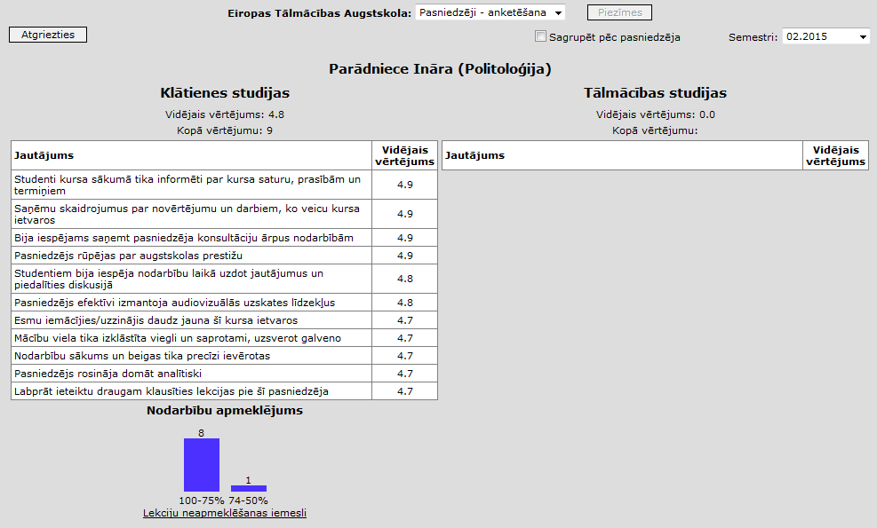
The University cares about the quality of teaching and regularly updates the ratings of the academic staff. Updates take place with the help of the students – at the end of each course they are asked to fill out a small questionnaire (see screenshot example) regarding the quality of teaching. Ratings of the academic staff are taken into account when making plans for the lectures for the next semester. The academic staff members are regularly introduced to their ratings in order to timely respond to the situation. The survey results show that students are generally satisfied with their studies.

Surveys of graduates and analysis of surveys
Graduates are not yet.

Participation of students in the improvement of the study process
The participation of students in the implementation of the study process is ensured by the Student Government. One student is elected to the Senate of the University College who will then ensure the participation of the students in making decisions on all matters relating to the organisation and improvement of the study process.
The students can express their opinion regarding the improvement of the study process to the administration during their meetings and to the teachers during classes. The students’ opinions, recommendations and survey results are summarised in the Study Information Centre and regularly presented to the administration. The students’ suggestions for improving the study process are discussed at the council meetings.
During the academic year, the Student Government, together with the administration of the University College, organises various events for the students, thus ensuring an active social life in order to find new insights for joint projects. Funds from the budget of the University College are allocated for organisation of different events and implementation of projects.

Description of the Programme of Study Personnel Management

Objectives and tasks for implementation of the programme of study
The University College study program “Personnel Management” (code 42345) professional bachelor's degree in management science and qualification of the personnel manager was licensed on 24.04.2014., License No. 04065-4 and it was included in the field of study „Management, Administration and Real Estate Managemen” by the accreditation deadline until 17.12.2015, Accreditation Certificate No. 273, issued on 30.05.2014.
The strategic goal of the study program is to provide students the opportunity to gain knowledge, skills and competences that are necessary for competitive professional bachelor’s education of the second level and for qualification of personnel manager. Conformity of the study program learning outcomes with the European Qualifications Framework (EQF) descriptions contributes to achieving the goals.
Objectives:
- to encourage students' analytical skills, develop professional skills to raise a concern and to solve the related problems;
- to encourage the future personnel managers’ ability to apply theoretical knowledge in practice by establishing companies and managing organizations or their structural units and other employees, creating a product or service production, or realizing the commercial activities in different economic areas; in accordance to labour market needs;
- to develop students' skills to carry out scientific research work;
- to maintain students' interest in the novelties in the business management sector;
- to develop the study process so that students can develop their intelligence, promote their spiritual perfection, contribute to the use of their intellectual abilities in practical activities;
- to stimulate students' communication, the ability to manage and work in a team, defend a personal opinion.

Expected study results of the programme of study
Planned study results correspond to the basic tasks established in the employment description of a Personnel Manager of the occupation standard by the CM regulations No.461 of 18 May 2010 “Regulations Regarding the Classification of Occupations, Basic Tasks Corresponding to the Occupation, Basic Qualification Requirements and Procedures for the Use and Updating of the Classification of Occupations”. Personnel manager (occupation code 2423 03):
    - establishes and formulates the company’s personnel management strategy, policy and objectives in the dynamic economic environment in accordance with the company’s aims;
    - analyses, evaluates and improves the company’s personnel management system;
    - plans and forecasts the company’s personnel resources,
    - recruits necessary personnel for the company;
    - organises and manages the work of the personnel of the company’s structural unit;
    - participates in creating the labour protection system and ensuring its operation but in certain cases controls the creation of the labour protection system and supervises its operation;
    - cooperates with the company’s managers and the managers of other structural units in achievement of the strategic personnel management objectives;
    - consults the company’s managers and the managers of structural units on the requirements of the normative acts regulating labour relations and personnel management processes;
    - monitors observation of the requirements of the normative acts regulating labour relations by the company.

Plan of the programme of study (list of courses and study modules and course credits, broken down by required courses, optional courses and elective courses of the programme of study, indicating the course credits and implementation plan)
Full-time study plan for the programme of study Personnel Management
Course | Cr. | ECTS | 1.s. | 2.s. | 3.s. | 4.s. | 5.s. | 6.s. | 7.s. | 8.s.
General courses | 20 | 30
Business Foreign Language I | 3 | 4.5 | 3
Business Foreign Language II | 3 | 4.5 |  | 3
Business Communication, Presentation and Ethics | 2 | 3 |  | 2
Official Business Language and Record Keeping | 2 | 3 | 2
Rhetoric | 2 | 3 |  |  | 2
Cultural History | 2 | 3 | 2
Pedagogy | 2 | 3 |  |  |  |  |  |  | 2
Environmental, Labour and Civil Protection | 1 | 1.5 |  |  |  | 1
Marketing | 3 | 4.5 | 3
Field-specific basic theoretic courses and Information Technology courses | 36 | 54
Computer Science | 2 | 3 | 2
Microeconomics | 2 | 3 | 2
Macroeconomics | 3 | 4.5 |  | 3
Personality Psychology | 2 | 3 |  |  |  | 2
Conflictology | 1 | 1.5 |  |  |  |  | 1
Mathematics for Economists | 2 | 3 | 2
General economic and company statistics | 2 | 3 |  | 2
World Economics | 2 | 3 |  |  | 2
Globalisation | 2 | 3 |  |  |  | 2
Management Sciences | 2 | 3 | 2
Business Activities | 2 | 3 |  | 2
Business Communication | 2 | 3 |  |  |  |  |  |  | 2
Advertising and Public Relations Management | 2 | 3 |  |  |  |  |  | 2
Advertising Psychology | 2 | 3 |  |  | 2
Banking | 2 | 3 |  |  |  |  |  | 2
Sociology | 2 | 3 |  |  | 2
Personnel Management | 2 | 3 |  | 2
Research Methods and Labour Market Research | 2 | 3 |  | 1 |  |  |  | 1
Field-specific professional specialisation courses | 60 | 90
Personnel Record Keeping | 2 | 3 |  | 2
Management Psychology and Team Building | 3 | 4.5 |  |  |  |  |  | 3
Internal Communication | 1 | 1.5 |  |  |  |  |  |  | 1
Management Information Systems | 2 | 3 |  |  |  |  | 2
Personnel Management System and Specific Functions in the Sectoral Context | 2 | 3 |  |  | 2
Personnel Strategic Planning and Recruitment | 2 | 3 |  |  |  | 2
Project Management | 2 | 3 |  |  |  |  |  | 2
Project Personnel Management | 2 | 3 |  |  |  |  | 2
Strategic Management | 2 | 3 |  |  |  |  |  |  | 2
Innovation and Risk Management | 2 | 3 |  |  |  |  |  |  | 2
Quality Management | 2 | 3 |  |  |  |  |  |  | 2
International Marketing | 2 | 3 |  |  |  | 2
Internet Marketing | 1 | 1.5 |  |  |  |  |  |  | 1
Production and Service Management | 4 | 6 |  |  |  |  | 4
Marketing Research | 2 | 3 |  |  | 2
Taxes and Fees | 2 | 3 | 2
Accountancy | 2 | 3 |  |  | 2
Finance and Credit | 2 | 3 |  |  |  | 2
Management Accountancy | 3 | 4.5 |  |  |  |  | 3
Financial Management in Business | 2 | 3 |  |  |  |  |  | 2
Commercial Law | 2 | 3 |  |  | 2
Labour Law | 2 | 3 |  |  |  | 2
Social Rights | 2 | 3 |  |  |  |  | 2
Corporate Social Responsibility and Social Dialogue | 2 | 3 |  |  |  |  | 2
Study Paper I | 3 | 4.5 |  | 3
Study Paper II | 3 | 4.5 |  |  |  | 3
Study Paper III | 4 | 6 |  |  |  |  |  | 4
Elective courses | 6 | 9 |  |  |  |  |  |  | 6
Intercultural Communication | 2 | 3
Personnel Marketing | 2 | 3
Insurance | 2 | 3
Logistics | 2 | 3
Work Placement | 26 | 39
No.1 | 8 | 12 |  |  | 4 | 4
No.2 | 8 | 12 |  |  |  |  | 4 | 4
No.3 | 10 | 15 |  |  |  |  |  |  | 2 | 8
Qualification Examination (Bachelor’s Paper) | 12 | 18 |  |  |  |  |  |  |  | 12
Total credits by semester: | 160 | 240 | 20 | 20 | 20 | 20 | 20 | 20 | 20 | 20

Part-time study plan for the programme of study Personnel Management
Course | Cr. | ECTS | 1.s. | 2.s. | 3.s. | 4.s. | 5.s. | 6.s. | 7.s. | 8.s. | 9.s.
General courses | 20 | 30
Business Foreign Language I | 3 | 4.5 | 3
Business Foreign Language II | 3 | 4.5 |  | 3
Business Communication, Presentation and Ethics | 2 | 3 |  | 2
Official Business Language and Record Keeping | 2 | 3 | 2
Rhetoric | 2 | 3 |  |  | 2
Cultural History | 2 | 3 | 2
Pedagogy | 2 | 3 |  |  |  |  |  | 2
Environmental, Labour and Civil Protection | 1 | 1.5 |  |  |  |  |  |  | 1
Marketing | 3 | 4.5 | 3
Field-specific basic theoretic courses and Information Technology courses | 36 | 54
Computer Science | 2 | 3 | 2
Microeconomics | 2 | 3 | 2
Macroeconomics | 3 | 4.5 |  | 3
Personality Psychology | 2 | 3 |  |  | 2
Conflictology | 1 | 1.5 |  |  | 1
Mathematics for Economists | 2 | 3 | 2
General economic and company statistics | 2 | 3 |  | 2
World Economics | 2 | 3 |  |  | 2
Globalisation | 2 | 3 |  |  |  | 2
Management Sciences | 2 | 3 |  | 2
Business Activities | 2 | 3 | 2
Business Communication | 2 | 3 |  |  | 2
Advertising and Public Relations Management | 2 | 3 |  |  |  |  |  |  | 2
Advertising Psychology | 2 | 3 |  |  |  |  |  |  | 2
Banking | 2 | 3 |  |  |  |  |  |  |  | 2
Sociology | 2 | 3 |  |  |  | 2
Personnel Management | 2 | 3 |  | 2
Research Methods and Labour Market Research | 2 | 3 |  | 1 |  |  |  |  |  | 1
Field-specific professional specialisation courses | 60 | 90
Personnel Record Keeping | 2 | 3 |  | 2
Management Psychology and Team Building | 3 | 4.5 |  |  |  | 3
Internal Communication | 1 | 1.5 |  |  |  |  | 1
Management Information Systems | 2 | 3 |  |  |  |  | 2
Personnel Management System and Specific Functions in the Sectoral Context | 2 | 3 |  |  | 2
Personnel Strategic Planning and Recruitment | 2 | 3 |  |  |  | 2
Project Management | 2 | 3 |  |  |  |  | 2
Project Personnel Management | 2 | 3 |  |  |  |  |  | 2
Strategic Management | 2 | 3 |  |  |  |  |  |  | 2
Innovation and Risk Management | 2 | 3 |  |  |  |  |  |  | 2
Quality Management | 2 | 3 |  |  |  |  |  | 2
International Marketing | 2 | 3 |  |  |  | 2
Internet Marketing | 1 | 1.5 |  |  |  |  |  | 1
Production and Service Management | 4 | 6 |  |  |  |  |  | 4
Marketing Research | 2 | 3 |  |  |  | 2
Taxes and Fees | 2 | 3 |  | 2
Accountancy | 2 | 3 |  |  | 2
Finance and Credit | 2 | 3 |  |  |  |  | 2
Management Accountancy | 3 | 4.5 |  |  |  |  | 3
Financial Management in Business | 2 | 3 |  |  |  |  |  | 2
Commercial Law | 2 | 3 |  |  | 2
Labour Law | 2 | 3 |  |  |  | 2
Social Rights | 2 | 3 |  |  |  |  |  |  |  | 2
Corporate Social Responsibility and Social Dialogue | 2 | 3 |  |  |  |  |  |  |  | 2
Study Paper I | 3 | 4.5 |  |  | 3
Study Paper II | 3 | 4.5 |  |  |  |  | 3
Study Paper III | 4 | 6 |  |  |  |  |  |  | 4
Elective courses | 6 | 9 |  |  |  |  |  |  |  | 6
Intercultural Communication | 2 | 3
Personnel Marketing | 2 | 3
Insurance | 2 | 3
Logistics | 2 | 3
Work Placement | 26 | 39
No.1 | 8 | 12 |  |  |  | 4 | 4
No.2 | 8 | 12 |  |  |  |  |  | 4 | 4
No.3 | 10 | 15 |  |  |  |  |  |  |  | 4 | 6
Qualification Examination (Bachelor’s Paper) | 12 | 18 |  |  |  |  |  |  |  |  | 12
Total credits by semester: | 160 | 240 | 18 | 19 | 18 | 19 | 17 | 17 | 17 | 17 | 18

Description of the courses and modules of study (if any)
There is no division into modules within the programme of study Personnel Management. Course descriptions of the programme of study see Annex 9. Academic staff update their course content at the beginning of each academic year, or up to date in case of changes.

Organisation of the programme of study
The study process is organised in accordance with the Law on Education, Law on Institutions of Higher Education, the binding regulations of the Cabinet, as well as the regulations of the University College and study planning documents (the implementation plan of the programme of study, study timetable, work placement plan, etc.).
The scope of the implementation of the programme of study – 160 KP (240ECTS).
Duration of the programme of study, mode and form of study – full-time intramural studies (2 years), part-time intramural studies and part-time extramural studies (2,5 years).
Venue for implementation of the programme of study: Kr.Valdemāra iela 26, Riga.
Professional qualification to be obtained under the programme of study – Personnel manager.
Implementation of the programme of study involves a variety of study methods and forms to achieve the objectives set and complete the corresponding tasks. The study process is designed so that the largest possible scope of the courses is implemented through practice by solving problems, doing practical work, as well as holding discussions and case simulations. Particular attention is paid to ensure that theoretical knowledge is not only acquired in the professional subjects, but also tested in practice. The assignments of the independent work and the methods of their supervision are identified in the descriptions of the course, which can be found in the e-learning environment.
The professional qualification practice is an indispensable part of the study program "Personnel Management". The overall objective of practice is to improve the students' theoretical knowledge, as well as give an opportunity to acquire and strengthen the practical skills that are needed for the profession of the tourism and recreation organization manager. The specific goals and objectives have been developed for each semester practice. The total volume practice - 26 credits or 26 weeks.
Within the study programme the students are envisaged to have three practices, in total 26 CP. The first practice (during the 3rd and 4th term of full-time studies, the 4th and 5th term of part-time studies) in the amount of 8 CP is planned for studying personnel record keeping. The second practice (during the 5th and 6th term of full-time studies, the 6th and 7th term of part-time studies) in the amount of 8 CP is planned for analysing and comparing the basic issues in the work of the company’s personnel department. The third practice (during the 7th and 8th term of full-time studies, the 8th and 9th term of part-time studies) in the amount of 10 CP is planned as a qualification practice.
The practice is carried out in accordance with the practice contracts for the provision of practice placements. Before going into practice, the students have to conclude trilateral agreements with the University College and a company of internship. The internship company determines the practice mentor from the practice placement for a student, the mentor is responsible for:
- to ensure the traineeship according to the student's practice tasks and to create the necessary working conditions;
- at the end of practice to provide students with a written assessment of practice.
Within a week after the end of practice, students submit the practice report to the supervisor of practice on the part of the University College, who evaluates the practice report and governs the practice defense in the presence of the commission. The commission, on the basis of the assessment of the practice placement and the assessment of the supervisor of the University College as well as the public defense of the practice report, evaluates the student’s practice results in 10 –point grading system.

Admission requirements for the programme of study
Potential students who have submitted all necessary documents will be admitted to the second level professional higher education programme Personnel Management implemented by the University College based on the results of the centralised exams (Level A, B, C, D or E) and academic records in the certificate of secondary education.

Practical implementation of the programme of study (methods and modes of study used; use of distance education methods)
To implement the content of the programme of study, the academic staff members choose the methods and forms which are most appropriate to the special character of the course.
Classroom (on-site) training – lectures, seminars, workshops, discussions, case studies and business role plays. The students can work individually, in pairs or groups, which contributes to the development of the students’ managing competences, ability to work as a team, overcome conflicts and defend their views, as well as promotes the students’ communication. During business role plays, the students are expected to apply their theoretical knowledge in practice and be ready to analyse problems and address various non-standard situations. Leading specialists in the sector are invited to carry out simulations of economic situations and scientists are invited as guest lecturers to deliver lectures on particular topics.
Individual work – the students learn the subject independently, using materials prepared by teachers and their instructions. The students’ knowledge is checked through tests, practical assignments, study papers and term papers, library-research papers, presentations, etc. The students take the final exam on-site.
Work placement – an opportunity for the students to consolidate their theoretical knowledge and gain practical skills, as well as get acquainted with the work processes of the chosen profession.
Qualification paper – independent research work for obtaining the qualification, which is conducted when the academic obligations have been completed.
Distance education is organised through the interactive multimedia learning environment designed for the University College where students are provided with a personalised access to learning materials (including video lectures), counselling (online or by sending questions), control of knowledge (assignments, tests, etc. at the end of a topic or a course) and clarifying various topical issues in connection with the study process. Requirements for distance learning environment materials are governed by EDU Distance Education methodological materials control rules approved by University College Senate on 7 October 2013, the decision No.16.
For acquisition and strengthening of skills the lecturers take advantage of discussions, debates, group work, competitions (tendering) method, problem -solving (case study), independent work (reports, essays). Students acquire and develop competencies through such methods as self-confrontation and situation simulation and modeling (involving students in situations that give them experience, on the basis of which they can then draw principal conclusions).
During the study process great attention is paid to the integration of honesty, creative use of knowledge, scientific inquiry methods to the study content. To promote the students' scientific and research work the students' research work competition is organized, its conduct and outcome is governed by the "Student Research Paper Competition Regulations", approved by the University College Senate on 18th April, 2012, Decision No.6.

Assessment system (education criteria and assessment methods for achievement and evaluation of the study results, test forms and procedures)
The basic principles of assessment of the study program comply with the Cabinet of Ministers of the Republic of Latvia Regulations Nr.512 of 26th August, 2014: "Regulations regarding the Second Level Professional Higher Education State Standard" and the Law on Higher Education.
- the principle of openness of assessment - according to the specified program goals and objectives, as well as the course goals and objectives, a set of requirements for assessment of learning outcomes to be reached is determined;
- the principle of mandatory assessment - it is necessary to obtain successful assessment of the entire program content acquisition;
- the principle of an opportunity to review the assessment – the University College prescribes the procedures for the resulting assessment review;
- the principle of diversity of assessment methods – for assessment of the program acquisition various types of testing are used.
A 10-point grading scale is used to assess the achieved student’s performance in tests to be assessed with mark as well as for assessment of the state tests and examinations:
The level of acquisition | Assessment | Transcript | Explanation
very high | 10 | with distinction | knowledge, skills and competence exceed the requirements of the program or study course, a student demonstrates the ability to carry out independent research and shows a deep understanding of the problems;
very high | 9 | excellent | knowledge, skills and competence completely correspond to the requirements of the program or study course, a student has acquired skills to apply knowledge in practice independently;
high | 8 | very good | knowledge, skills and competence completely correspond to the requirements of the program or study course, however, a student does not have sufficiently deep awareness of certain issues, in order to use the acquired knowledge for solving more complicated problems;
high | 7 | good | the requirements of the study program or study course have been completed in general, but a student sometimes shows inability to use the acquired knowledge independently;
average | 6 | almost good | the requirements of the study program or study course have been completed, but at the same time a student shows a lack of deep understanding of the problems and the inability to use the acquired knowledge in practice;
average | 5 | satisfactory | the requirements of the study program or study course have been completed in general,  however, a student has insufficient knowledge of certain problems and the inability to use the acquired knowledge in practice;
average | 4 | almost satisfactory | the requirements of the study program or study course have been completed in general, however,  however, a student manifests an insufficient understanding of some fundamental concepts and experiences considerable difficulties in the practical application of the acquired knowledge;
low | 3 | poor | the student’s knowledge is superficial and incomplete, the student is unable to use it in particular situations;
low | 2 | very poor | a student has only superficial knowledge about some problems, the major part of the program, study module or course has not been acquired;
low | 1 | very, very poor | a student has no understanding of the subject fundamentals, there is almost no knowledge of the course or program.
The assessment of the acquisition level of the study course and the practice achievement is a "pass" or "fail," or the assessment in 10-point grading scale.
The assistant professor of each course develops an assessment system based on these principles and presents them to students. The content volume that is incorporated for inspections shall correspond to the content specified in the course programs and the professional standard set out for skills and knowledge, ensuring learning outcomes correspondence with the European Qualifications Framework descriptions.
The main forms of assessment of the students’ knowledge are set out in the curriculum of the programme of study. They include:
- qualification examinations – a written qualification exam and defence of the bachelor’s paper;
- semester control – exams and tests in subjects learnt during the semester, library-research papers and work placement, defence of study papers;
- inter-semester control – assessment of tests, assignments, independent work and library-research papers (essays), as well as assessment of participation in workshops and seminars.
The personalized knowledge control (tasks, tests, etc.) is provided for distance learning students at the end of the themes and study courses. The students take final exams as full-time students.
The students are transferred to next semester, who have no more than 3 academic debts. Enrolment takes place twice a year, so the majority of students continue to learn again in the same semester.
The final attestation commission of graduates (chairman and no less than half of its membership) comprises the representatives of professional organizations and employers.
Tests and examinations in written form allow the use of modern assessment technology of students' knowledge according to the ECTS achievement scale. For this purpose control tests have been developed for the part of the subjects, for the other part - individual tasks that change every semester.
To increase motivation for studying, students are offered the opportunity to take an additional test at the end of each semester. The students with the highest score will be awarded a scholarship or the right to study on a budget-funded basis during the next semester.

Costs of the programme of study
Tuition fee is approved annually by the University College Senate in agreement with the founders.
Tuition fee per year
Study form | Tuition fee  2013/2014th academic year | Tuition fee  2014/2015th academic year
Full-time intramural studies | 794,00 LVL/1129,76 EUR | 1130 EUR
Part-time intramural studies | 730,00 LVL/1038,70 EUR | 1038 EUR
Part-time extramural studies | 840,00 LVL/1195,22 EUR | 1194 EUR
The costs have been calculated for one group of students (20 students) for the entire period of study (acquisition of 160 credits).
The cost of a full-time student group (20 students)
Type of costs | Unit | No. of units | Payment per unit | Total costs (EUR) w/o tax
Subjects (116 credits) | acad. h | 1624 | 8.5 - 11.50 EUR/ acad. h | 17143
Examinations/tests in subjects | pcs. | 58 | 0.25 acad. h per student | 3335
Semester paper | pcs. | 60 | 2 acad. h per student | 1380
Work placement | pcs. | 100 | 0.25 acad. h per student | 5000
Qualification exams and bachelor’s paper | pcs. | 20 | 1.25 acad. h per student | 288
Administration costs | pcs. | 20 | 382,71 EUR a year per student | 30617
Employer SSICP | pcs. |  | 23.59 % | 13626
Infrastructure, material and technical resources and advertising costs | pcs. | 20 | 115.00 EUR a year per student | 9200
Total for a group of 20 students for entire period of study (w/o tax) |  |  |  | 80588
Revenue from the group of 20 students in 4 years (1130 EUR per year from 1 student) |  |  |  | 90400

Compliance of the programme of study with the state standards of academic education or the professional standard and professional higher education state standards and other regulations in regard to higher education
The programme Personnel Management designed by the University College has been developed in accordance with the requirements of the State Standard for the Second Level Higher Professional Education (Cabinet’s Regulations No. 512; August 26, 2014). The entire scope of the programme of study, the distribution of courses and the scope of the work placement and qualification paper correspond to the provisions of the Cabinet’s Regulations.
Compliance of the programme of study Personnel Management with the state standard for the second level higher professional education
Criteria | Standard requirements | Programme of study Business Management implemented by the University College
Total scope of the programme | At least 160 Cr. | 160 Cr.
Scope of general courses | At least 20 Cr. | 20 Cr.
The industry (professional scope) theoretical basic courses and information technology courses | At least 36 Cr. | 36 Cr.
The industry (professional scope) professional specialization courses | At least 60 Cr. | 60 Cr.
The business professional competence development module | At least 6 Cr. | Commercial Law 2 Cr.
The business professional competence development module | At least 6 Cr. | Project Management 2 Cr.
The business professional competence development module | At least 6 Cr. | Taxes and Fees 2 Cr.
The optional courses | At least 6 Cr. | 8 Cr.
Work placement | At least 20 Cr. | 26 Cr.
Qualification examination (including bachelor’s paper) | At least 12 Cr. | 12 Cr.

Compliance of the study program "Personnel Management" with the qualification "Personnel Manager" professional standard
The occupational standard of the qualification „Personnel Manager” is established by the CM regulations No.461 of 18 May 2010 “Regulations Regarding the Classification of Occupations, Basic Tasks Corresponding to the Occupation, Basic Qualification Requirements and Procedures for the Use and Updating of the Classification of Occupations”, the title of the occupation: “Personnel Manager”, the fifth level professional qualification, occupation code: 2423 03. The study programme of the University College envisages acquisition of professional competences necessary for professional activity; the contents of the study courses of the programme correspond to the acquisition of necessary knowledge and skills as well as execute the requirements of the occupational standard and ensure the opportunity of acquiring comprehensive skills of a personnel manager.
Professional competences necessary for professional activity | Study courses ensuring thereof
1. Ability to analyse and evaluate the domestic and international economic environment as well as the development tendencies of labour market. | Globalisation; Strategic Management; Research Methods and Labour Market Research
2. Ability to define the objectives and basic directions of the activity of the company’s personnel. | Management; Commercial Activity; Strategic Management; Personnel Strategic Planning and Selection; Personnel Management System and Functional Peculiarities in the Context of Industries
3. Ability to analyse the statistical data of the company’s personnel. | General Economic and Company Statistics
4. Ability to develop the optimisation plans for the company’s personnel management system. | Management; Strategic Management; Personnel Strategic Planning and Selection; Personnel Management System and Functional Peculiarities in the Context of Industries
5. Ability to understand the indicators of the company’s economic activity. | Microeconomics; Macroeconomics; Management Accounting
6. Ability to plan the company’s personnel budget, personnel resources as well as necessary competences and allocation of responsibilities of the personnel. | Personnel Strategic Planning and Selection; Financial Management for Business; Personnel Management System and Functional Peculiarities in the Context of Industries
7. Ability to manage the work of the personnel of the company’s structural unit. | Management; Personnel Management; Strategic Management
8. Ability to ensure the function of the company’s personnel management (personnel record keeping, personnel selection, training, personnel development, wage payment system, the system of motivation, evaluation system, etc.). | Personnel Management; Personnel Record Keeping; Personnel Strategic Planning and Selection; Personnel Management System and Functional Peculiarities in the Context of Industries
9. Ability to understand the labour protection system and manage the work of labour protection specialists. | Environmental, Labour and Civil Protection
10. Ability to develop the company’s organisational structure. | Management; Strategic Management
11. Ability to organise and manage the company’s processes of change. | Management; Strategic Management; Psychology of Management and Team Building
12. Ability to conduct and organise collective bargaining as well as reach agreement. | Personnel Management; Internal Communication; Business Communication; Psychology of Management and Team Building
13. Ability to understand and direct the information exchange flow in the company. | Personnel Management; Internal Communication; Business Communication, Presentation and Ethics
14. Ability to understand the requirements of the normative acts regulating labour relations and ability to ensure their execution. | Labour Law; Social Rights
15. Ability to manage employees. | Management; Personnel Management; Strategic Management; Project Personnel Management
16. Ability to communicate in the state language at the highest level and two foreign languages. | State Language and Record Keeping; Business Communication; Business Foreign Language I; Business Foreign Language II

Skills necessary for execution of the basic tasks of professional activity | Study courses ensuring thereof
1. To understand the processes in the labour market and take decisions in accordance with changing situation. | Globalisation, Macroeconomics, World Economy, Innovations and Risk Management, Research Methods and Labour Market Research, Marketing Research, General Economic and Company Statistics
2. To plan and organise the work. | Management, Strategic Management
3. To apply the knowledge acquired in personnel management. | Personnel Strategic Planning and Selection, Corporate Social Responsibility and Social Dialogue, Personnel Management, Personnel Record Keeping, Psychology of Management and Team Building
4. To draw up the company’s short and long-term personnel plans. | Strategic Management, Personnel Strategic Planning and Selection, Project Personnel Management, Marketing Research, Management Accounting
5. To be able to work in complicated psychological situations and solve problem situations. | Management, Conflictology, Pedagogy, Personality Psychology, Psychology of Management and Team Building
6. To be able to take decisions. | Management, Quality Management
7. To understand the interrelationship of the company’s activity. | Microeconomics, Commercial Activity, Management Information Systems, Marketing, Marketing Research
8. To formulate the aims of the company’s personnel management. | Management, Personnel Management, Quality Management
9. To organise and manage the work of the personnel of the structural unit. | Management, Personnel Management, Internal Communication, Personnel Management System and Functional Peculiarities in the Context of Industries
10. To use management information systems to ensure the company’s personnel management. | Management Information Systems, Internal Communication
11. To introduce progressive solutions and methods in the company’s personnel management. | Personnel Management, Strategic Management,  Innovations and Risk Management, Marketing Research
12. To be able to provide reasoned opinion. | Business Communication, Presentation and Ethics, Business Communication
13. To acquire new knowledge independently. | Practice
14. To prepare and give presentations. | Business Communication, Presentation and Ethics
15. To use the latest forms of labour management and information technologies. | Management Information Systems, Computer Science
16. To know the documents regulating the company’s activity and the normative acts regulating labour relations and labour protection. | Commercial Law, Labour Law , Social Rights, Environmental, Labour and Civil Protection
17. To be able to work in a team/group. | Psychology of Management and Team Building, Internal Communication
18. To know the state language at the highest level. | State Language and Record Keeping
19. To be able to communicate in two foreign languages orally and in writing. | Business Foreign Language II (German, Russian)
20. To use professional terminology in the state language and two foreign languages. | Business Foreign Language II (German, Russian)
21. To cooperate with the employees and employee representatives, partners, owners, mass media, state and municipal institutions, non-governmental organisations. | Business Communication, Internal Communication, Advertising and Public Relations Management
22. To act in accordance with existing normative acts and ethical standards. | Commercial Law, Labour Law, Social Rights, Environmental, Labour and Civil Protection, Business Communication, Presentation and Ethics
23. To be able to work with computer. | Computer Science

Knowledge necessary for execution of the basic tasks of professional activity | Subject of the study programme | CP
Knowledge necessary for execution of the basic tasks of professional activity at the level of idea:
Quality Management Systems | Quality Management | 2
Quality Management Systems | Innovations and Risk Management | 2
Financial Accounting | Accountancy | 2
Financial Accounting | Financial Management for Business | 2
Marketing | Marketing | 3
Marketing | Internet Marketing | 1
Marketing | Marketing Research | 2
Marketing | Personnel Marketing | 2
Marketing | International Marketing | 2
Environmental Protection | Environmental, Labour and Civil Protection | 1
Knowledge necessary for execution of the basic tasks of professional activity at the level of understanding:
Record Keeping | State Language and Record Keeping | 2
Personnel Record Keeping | Personnel Record Keeping | 2
Personnel Record Keeping | Personnel Management System and Functional Peculiarities in the Context of Industries | 2
Statistics | General Economic and Company Statistics | 2
Statistics | Mathematics for Economists | 2
Sociology | Sociology | 2
Sociology | Research Methods and Labour Market Research | 2
Legal Basis of Commercial Activity | Commercial Law | 2
Economics | Macroeconomics | 3
Economics | Microeconomics | 2
Economics | Taxes and Duties | 2
Economics | World Economy | 2
Economics | Finances and Credit | 2
Economics | Banking Activity | 2
Economics | Foundations of Insurance | 2
Economics | Commercial Activity | 2
Internal and External Communication | Internal Communication | 1
Internal and External Communication | Business Communication | 2
Internal and External Communication | Advertising and Public Relations Management | 2
Information Technologies | Computer Science | 2
Information Technologies | Internet Marketing | 1
Information Technologies | Management Information Systems | 2
Management Accounting | Management Accounting | 3
Professional Terminology in the State Language and Two Foreign Languages | State Language and Record Keeping | 2
 | Business Foreign Language I | 3

Knowledge necessary for execution of the basic tasks of professional activity at the level of usage:
Personnel Management | Personnel Management | 2
Personnel Management | Personnel Strategic Planning and Selection | 2
Personnel Management | Personnel Marketing | 2
Project Management | Project Management | 2
Project Management | Project Personnel Management | 2
Professional Ethics | Pedagogy | 2
Professional Ethics | Conflictology | 1
Professional Ethics | History of Culture | 2
Organisational Psychology | Psychology of Management and Team Building | 3
Organisational Psychology | Psychology of Advertising | 2
Personality Psychology | Personality Psychology | 2
Labour Relations and Social Rights | Labour Law | 2
Labour Relations and Social Rights | Social Rights | 2
Labour Protection | Environmental, Labour and Civil Protection | 1
Business Communication | Business Communication, Presentation and Ethics | 2
Business Communication | Intercultural Communication | 2
Two Foreign Languages at the Level of Communication | Business Foreign Language II (German, Russian) | 3
State Language at the Highest Level | Rhetoric | 2
Management | Management | 2
Management | Strategic Management | 2
Management | Management of Production and Services | 4
Management | Logistics | 2
Corporate Social Responsibility | Corporate Social Responsibility and Social Dialogue | 2
Corporate Social Responsibility | Globalisation | 2

Comparison with one programme of study of the same level and similar field of study in Latvia (if a similar programme of study is implemented in Latvia) and at least two programmes of study at universities or colleges recognised by the European Union countries
Comparison of the programme with higher education programmes of the same level implemented in other countries
The study programme “Personnel Management” of the University College has been compared with the four-year study programme Human Resource Management of Kaunas University of Technology in Lithuania that envisages conferring bachelor’s degree in Human Resource Management as well as with the four-year study programme Business Administration-Concentration in Human Resource Management of the University of Nicosia in Cyprus that envisages conferring bachelor’s degree in Business Administration in the area of Human Resource Management. The total amount of three study programmes is 160 CP (240 ECTS). In comparison report the study courses and their amount have been specified in credit points.
University College | ECTS | Kaunas University of Technology | ECTS
Business Foreign Language I | 4,5 | Foreign Language Electives (English, German, French, Russian) | 6
Business Foreign Language II | 4,5 | Culture of Professional Language | 3
Rhetoric | 3 | Communication and Rhetorics | 3
Conflictology | 1,5 | Conflict Management | 6
Management Psychology and Team Building | 3 | Applied Psychology | 3
Management Psychology and Team Building | 3 | Teamwork | 6
Management Psychology and Team Building | 3 | Behaviour in Organizations | 6
Computer Science | 3 | Information Technologies 1, 3 | 12
Mathematics for Economists | 3 | Mathematics 1, 2 | 12
General economic and company statistics | 3 | Economic Statistics | 6
Microeconomics | 3 | Microeconomics | 6
Macroeconomics | 4,5 | Macroeconomics | 6
World Economics | 3 | Economics of International Business | 6
Globalisation | 3 | Labor Economics | 6
Management Sciences | 3 | Management | 6
Management Sciences | 3 | Knowledge Management | 6
Business Activities | 3 | Business Organization and Planning | 6
Personnel Management | 3 | Human Resources Management | 6
Personnel Management System and Specific Functions in the Sectoral Context | 3 | Labour Resource Management | 6
Personnel Strategic Planning and Recruitment | 3 | Human Resource Recruitment and Retention | 6
Personnel Strategic Planning and Recruitment | 3 | Human Resource Organizations | 6
Project Management | 3 | Project Management | 6
Quality Management | 3 | Quality Management | 6
Marketing | 4,5 | Marketing | 6
Accountancy | 3 | Basics of Accounting | 6
Accountancy | 3 | Salary and Compensation | 6
Finance and Credit | 3 | Fundamentals of Finance | 6
Management Accountancy | 4,5 | Management Accounting and Business Analysis | 6
Commercial Law | 3 | Business Law | 6
Labour Law | 3 | Basis of Labour Law | 6
Corporate Social Responsibility and Social Dialogue | 3 | Social Responsibility of Enterprise | 6
Environmental, Labour and Civil Protection | 1,5 | Personal Health Education | 3
E-commerce | 4,5 | Networked Business | 6
Social Rights | 3 | Law Basics | 3

University College | ECTS | Universityof Nicosia | ECTS
Lietišķā svešvaloda I | 4,5 | English Composition | 6
Lietišķā svešvaloda II | 4,5 | French Language and Culture I, II | 12
Management Psychology and Team Building | 3 | Leadership in Organizations | 6
Management Psychology and Team Building | 3 | Organizational Behavior | 6
Management Psychology and Team Building | 3 | Business Communications | 6
Computer Science | 3 | Computer Fundamentals | 6
Management Information Systems | 3 | Human Resource Information Systems | 6
Mathematics for Economists | 3 | Finite Maths with Applied Calculus | 6
General economic and company statistics | 3 | Statistics I, II | 12
Microeconomics | 3 | Principles of Microeconomics | 6
Macroeconomics | 4,5 | Principles of Macroeconomics | 6
Management Sciences | 3 | Introduction to Management | 6
Management Sciences | 3 | Performance Management | 6
Management Sciences | 3 | Operations Management | 6
Business Activities | 3 | Senior Simulation in Business | 6
Personnel Management | 3 | Human Resource Management | 6
Personnel Management System and Specific Functions in the Sectoral Context | 3 | Labor-Management Relations | 6
Personnel Strategic Planning and Recruitment | 3 | Planning, Recruitment and Selection | 6
Project Management | 3 | Project Management | 6
Strategic Management | 3 | Strategy and Business Policy | 6
Innovation and Risk Management | 3 | Change Management | 6
Marketing | 4,5 | Marketing | 6
Research Methods and Labour Market Research | 3 | Research Methods in Business | 6
Research Methods and Labour Market Research | 3 | Quantitative Methods | 6
Accountancy | 3 | Accounting I, II | 12
Accountancy | 3 | Compensation and Rewards Systems | 6
Finance and Credit | 3 | Managerial Finance | 6
Management Accountancy | 4,5 | Managerial Accounting | 6
Commercial Law | 3 | Business Law | 6
Labour Law | 3 | Employment Law | 6
Sociology | 3 | Principles of Sociology | 6
Environmental, Labour and Civil Protection | 1,5 | Health and Safety | 6

After comparing the programme of the University College with the study programmes of both Universities we can make the conclusion that they focus on general theoretical study courses which are absolutely necessary and included into the programme of the European Distance University College but not in so big amount. The study courses Communication and Rhetoric, Conflict Management, International Business Economics, Quality Management, Company’s Corporate Social Responsibility of Kaunas University of Technology coincide with the study courses of the European Distance University College but such study courses are not offered by the University of Nicosia. In its turn, the University of Nicosia implements the study courses Business Communication, Strategic Management, Change Management, Research Methods in Business and Foundations of Sociology that coincide with the study courses of the European Distance University College but there are no such study courses in the programme of Kaunas University of Technology.

Information on students

Number of students
A new program, for the first time students enrollment will take place in 2015/2016th academic year.

Number of students enrolled in the first year of study
None.

Number of graduates (if any)
None.

Surveys of students and analysis of surveys
Surveys have been carried out as a tool for sharing information with students (see the questionnaire in Annex 11). Polls encourage cooperation and allow duly reveal the issues that should be crucial for the study process.

Surveys of graduates and analysis of surveys
Graduates are not yet.

Participation of students in the improvement of the study process
The participation of students in the implementation of the study process is ensured by the Student Government. One student is elected to the Senate of the University College who will then ensure the participation of the students in making decisions on all matters relating to the organisation and improvement of the study process.
The students can express their opinion regarding the improvement of the study process to the administration during their meetings and to the teachers during classes. The students’ opinions, recommendations and survey results are summarised in the Study Information Centre and regularly presented to the administration. The students’ suggestions for improving the study process are discussed at the council meetings.
During the academic year, the Student Government, together with the administration of the University College, organises various events for the students, thus ensuring an active social life in order to find new insights for joint projects. Funds from the budget of the University College are allocated for organisation of different events and implementation of projects.

Summary of the Development Plans for the Field of Study

Prospective evaluation of the field of study and programmes of study having regard to the tasks of the Republic of Latvia in implementation of the common strategies of the European Union

Compliance of the programme of study with laws and regulations and recommendations for establishment of the European Higher Education Area
- Communication from the Commission. EUROPE 2020. A strategy for smart, sustainable and inclusive growth (2010);
- Communication from the Commission. Supporting growth and jobs – an agenda for the modernisation of Europe’s higher education systems (2011);
- Sustainable Development Strategy of Latvia until 2030 (2010);
- National Development Plan of Latvia for 2014-2020 (2011);
- National Reform Programme of Latvia for the Implementation of the Europe 2020 Strategy (2011);
- Guidelines for the Development of Education 2014–2020 (2014).
The programmes of study included in the field of study comply with the provisions of the following laws and regulations of the Republic of Latvia:
- Republic of Latvia Law on Institutions of Higher Education;
- Vocational Education Law;
- Regulations No. 512 of the Cabinet of the Republic of Latvia of 26 August 2014 – Regulations regarding the State Standard for Second Level Professional Higher Education;
- Regulations No. 461 of the Cabinet of the Republic of Latvia of 18 May 2010 – Regulations Regarding the Classification of Occupations, Basic Tasks Corresponding to the Occupation, Basic Qualification Requirements and Procedures for the Use and Updating of the Classification of Occupations.
- Regulations No. 990 of the Cabinet of the Republic of Latvia of 2 December 2008 – Regulations on the Latvian Education Classification (tables in Annex 1 with the comparison of the classification levels of the European Qualifications Framework (EQF) and corresponding knowledge, skills and competences);
- Cabinet’s Regulations No. 662 of 28 October 2014 – Regulations on the Education and Professional Qualifications Required for Teachers and Development Procedures for Teachers’ Professional Competence;
- Cabinet’s Regulations No. 846 of 10 October 2006 – Regulations Regarding the Requirements, Criteria and Procedures for Admission to Study Programmes;
- Cabinet’s Regulations No. 202 of 16 April 2013 – Procedures for Issuing State-Recognised Education Documents Certifying Higher Education.
The programmes of study implemented under the field of study comply with the recommendations for establishment of the European Higher Education Area:
- The Bologna Declaration and the Bologna Process Guidelines: introduction of tools to facilitate recognition of qualifications, the European Credit Transfer System (ECTS) and the single European Diploma Supplement; the learning outcomes (knowledge, skills and competences), which are formulated in the descriptions of the programmes of study, comply with the requirements of the European Qualifications Framework and Latvian Qualifications Framework;
- Lisbon Recognition Convention (1999);
- European Commission’s Higher Education Reform Strategy (Brussels, 2011) – improved access to various levels of education and planning of measures aimed at reducing the number of students who drop out without completing their courses and obtaining qualifications; increased number of employers involved in the development of the programme of study and other activities.

Information provided by employers and professional organisations regarding the prospects for the employment of graduates over at least the next six years
The academic staff involved in the activities of the University College, employers and social partners, as well as the University College students - potential graduates - help to maintain ties between the University College and employers. In order to determine the employer’s opinion on the opportunities of the study program "Tourism Management" graduates to find jobs, the University College carries out the employers' survey (see the questionnaire in Annex 11), clarifying the employer’s company needs, readiness to offer work / practice placements, as well as the University College study quality assessment. Mostly employers believe that the part-time form of studies provides the best learning outcomes of knowledge, skills and competence, for the reason that such a mode of work and study allows students to combine study with work.. The surveyed employers believe their employees need additional knowledge and extra skills of information technology and foreign languages, there was also called such feature as accuracy.
The graduates employment opportunities are discussed in this report 1.4. The correspondence of the field of study and study programs to the labour market demand.
The document "Latvian Sustainable Development Strategy by 2030” as one of the priority directions of long-term action is accentuated a business friendly environment in general, as a precondition to setting human capital developmentby creating high-quality and accessible education.

Annexes to the Self-Assessment Report of the Field of Study

ANNEX 1. Study direction “Management, Administration and Real Estate Management” Accreditation Certificate 72

ANNEX 2. Study program Personnel Management license 73

ANNEX 3. Latvian Association of Academic Libraries acknowledgment 74

ANNEX 4. Documents proving that if the study program eliminates, the applicant shall provide the relevant study program students with the opportunity to continue their studies in another university 75

ANNEX 5. The Cooperation Agreements with foreign universities 76

ANNEX 6. Agreements on work placement or statements of the future work placement providers, as well as the work placement procedure 85

ANNEX 7. Diploma and Diploma Supplement sample 141

ANNEX 8. CVs of the academic staff involved in the implementation of the field of study as regards their scientific research and creative work 8

ANNEX 9. Descriptions of the programme of study “Business Administration 138

ANNEX 10. Descriptions of the programme of study “Personnel Managementi 162

ANNEX 11. Students, graduates, employers questionnaire materials 187

ANNEX 12. List of key scientific publications designed by the academic staff members involved in the implementation of the field of study 193

- Study direction “Management, Administration and Real Estate Management” Accreditation Certificate
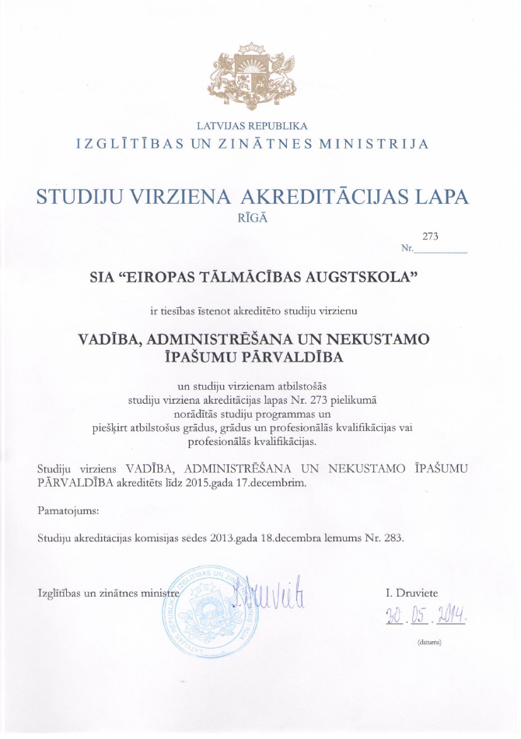
- Study program Personnel Management license
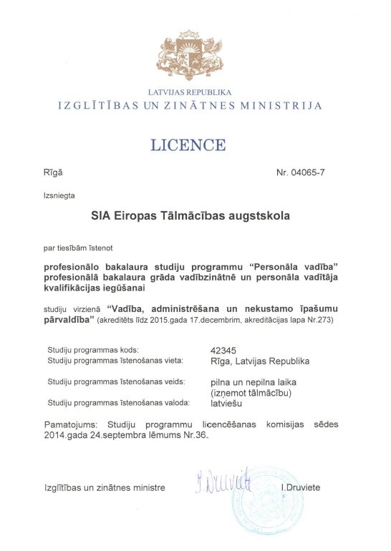
- Latvian Association of Academic Libraries acknowledgment
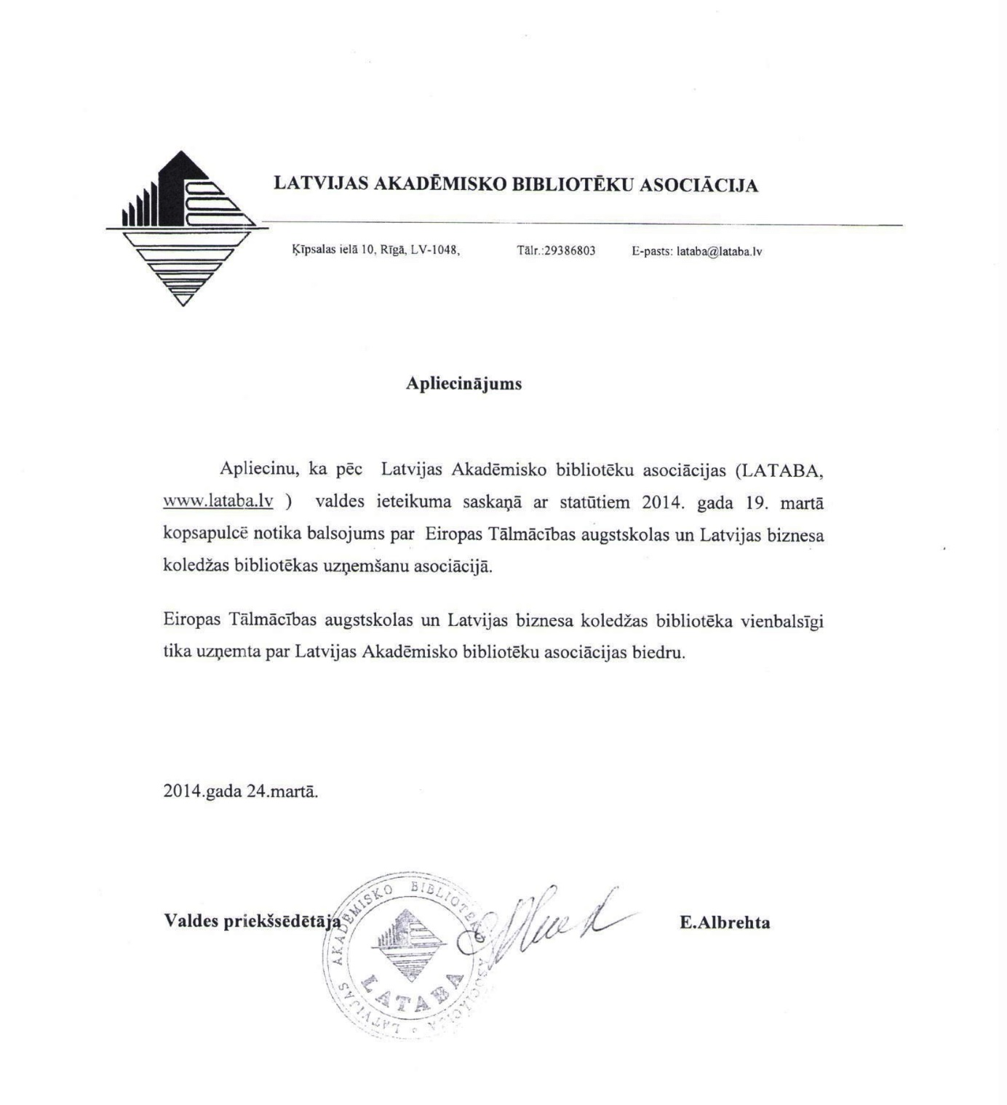

- Documents proving that if the study program eliminates, the applicant shall provide the relevant study program students with the opportunity to continue their studies in another university
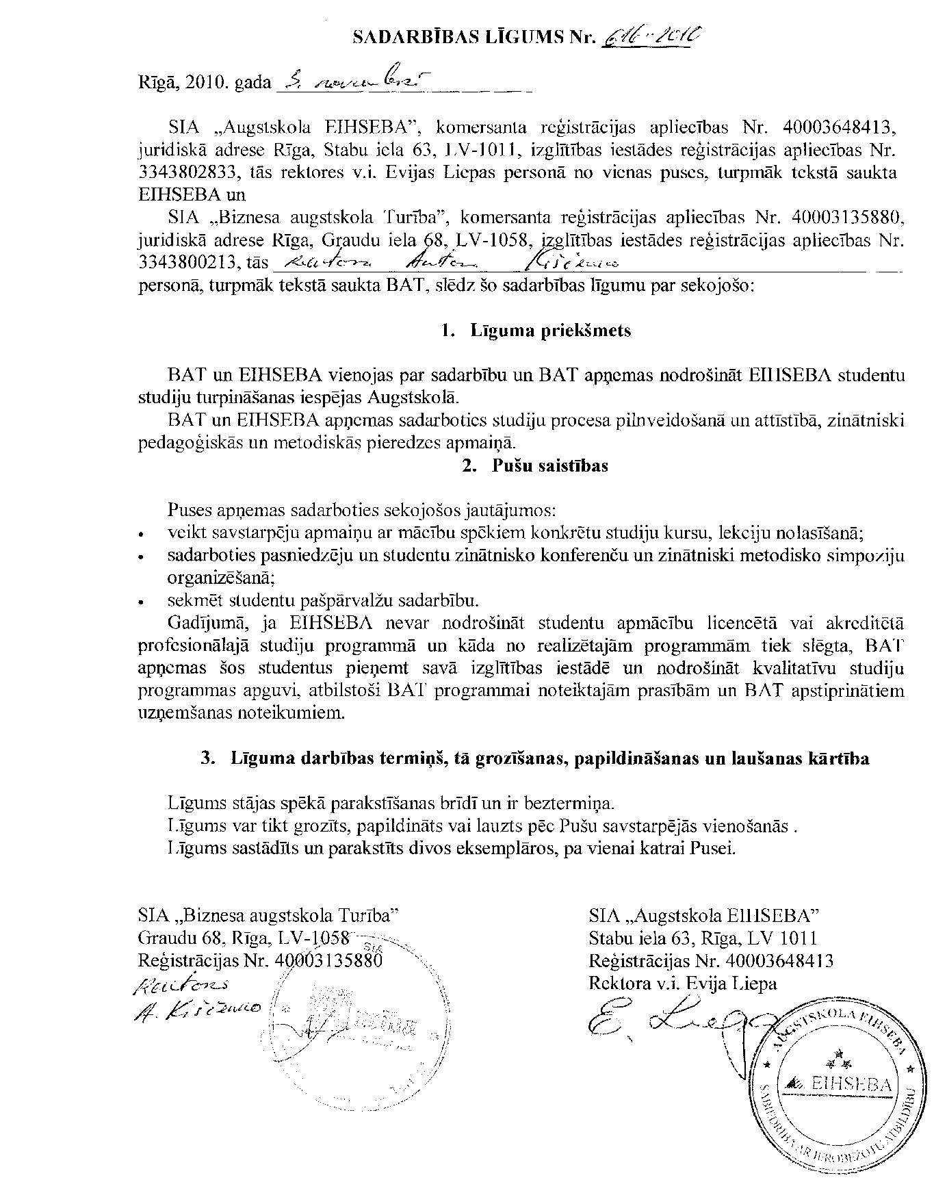

- The Cooperation Agreements with foreign universities

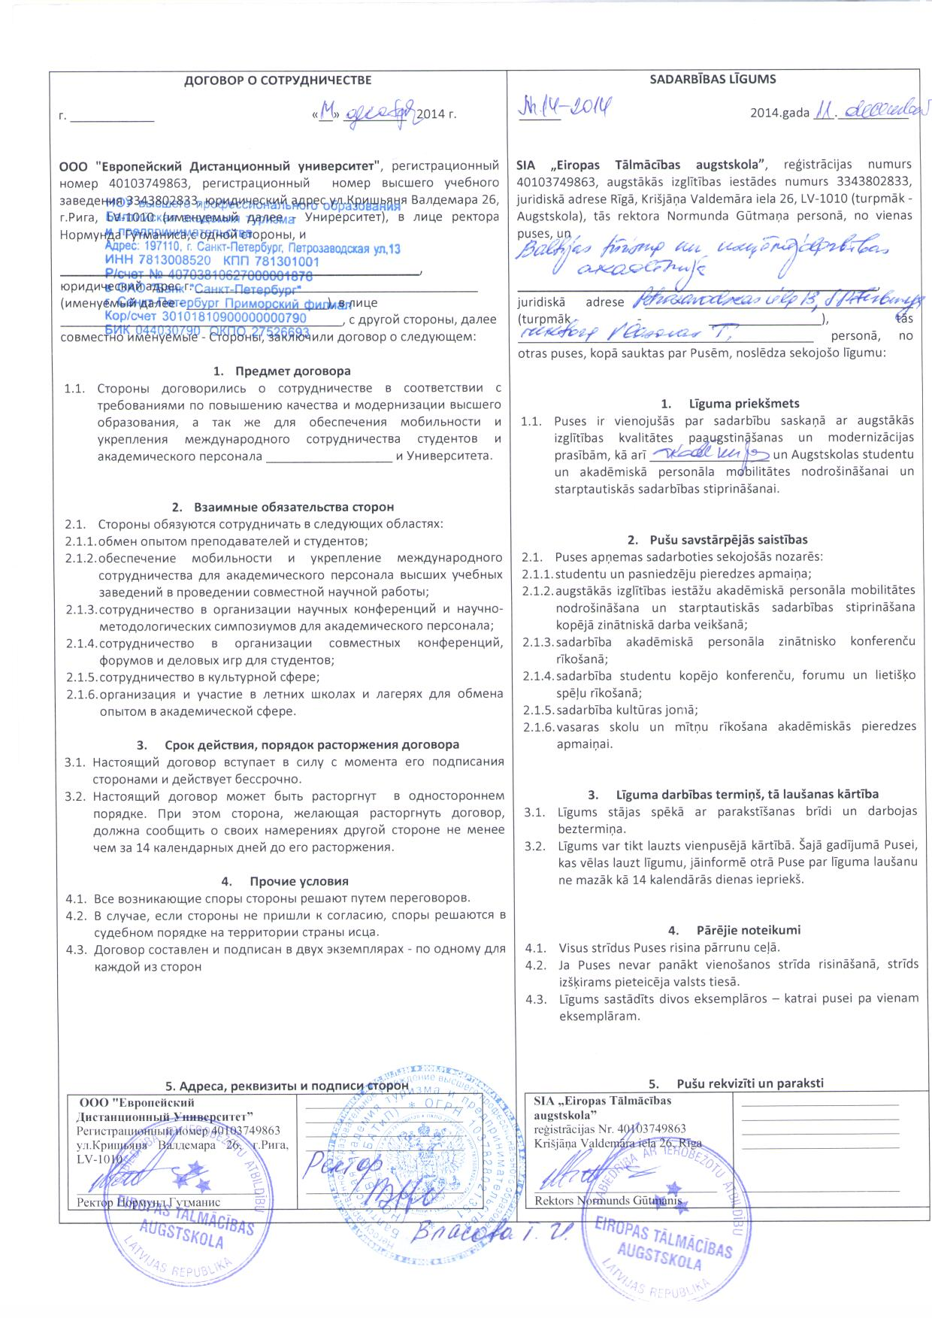
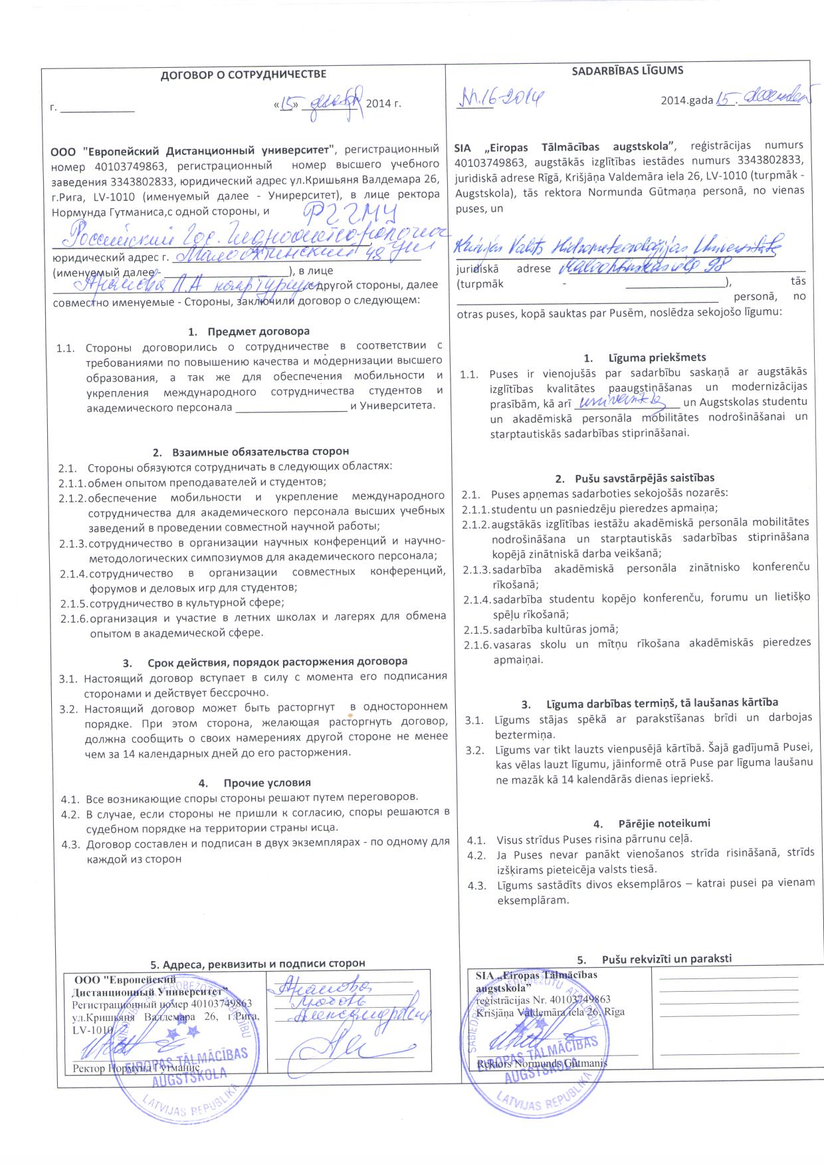
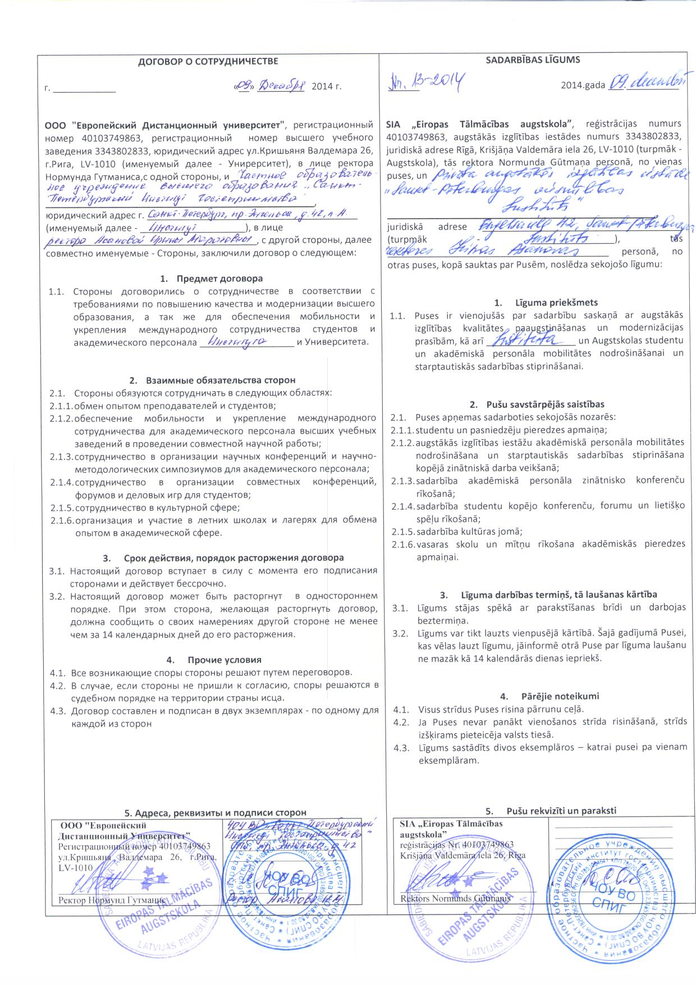
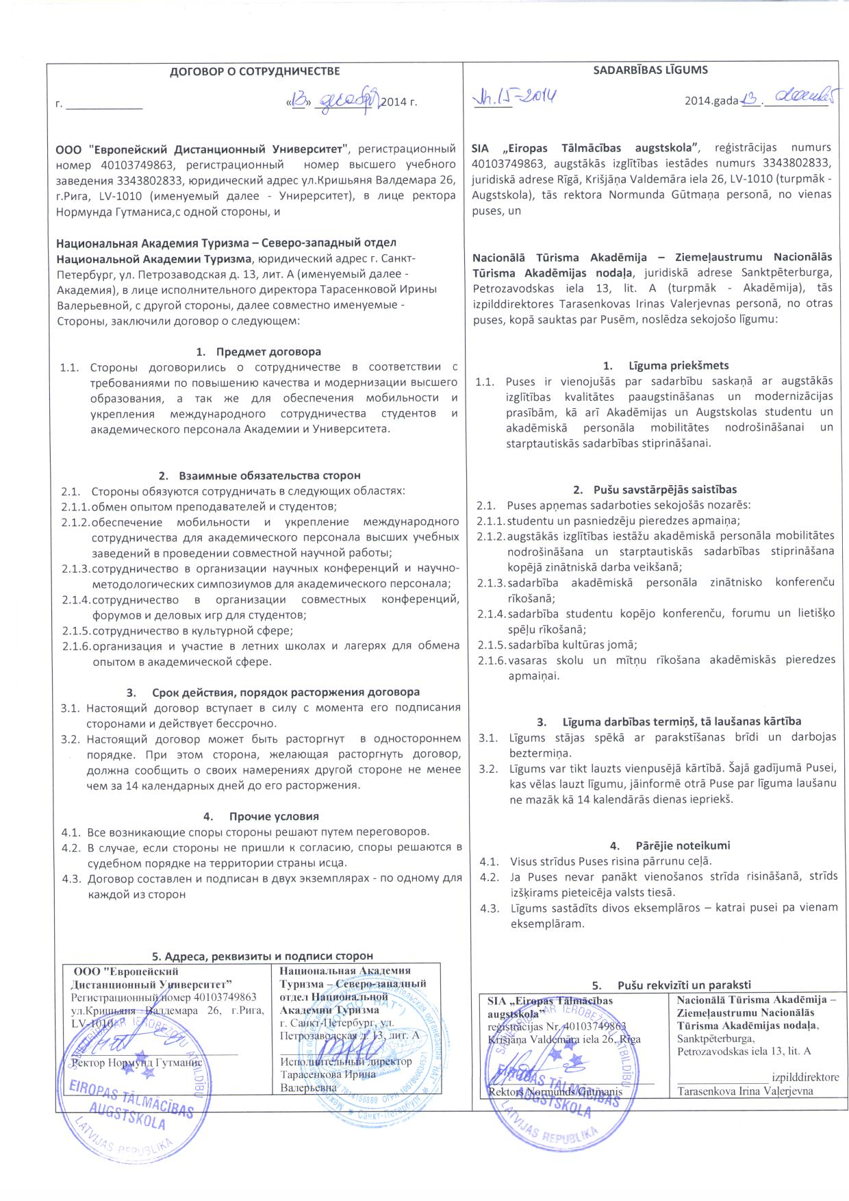
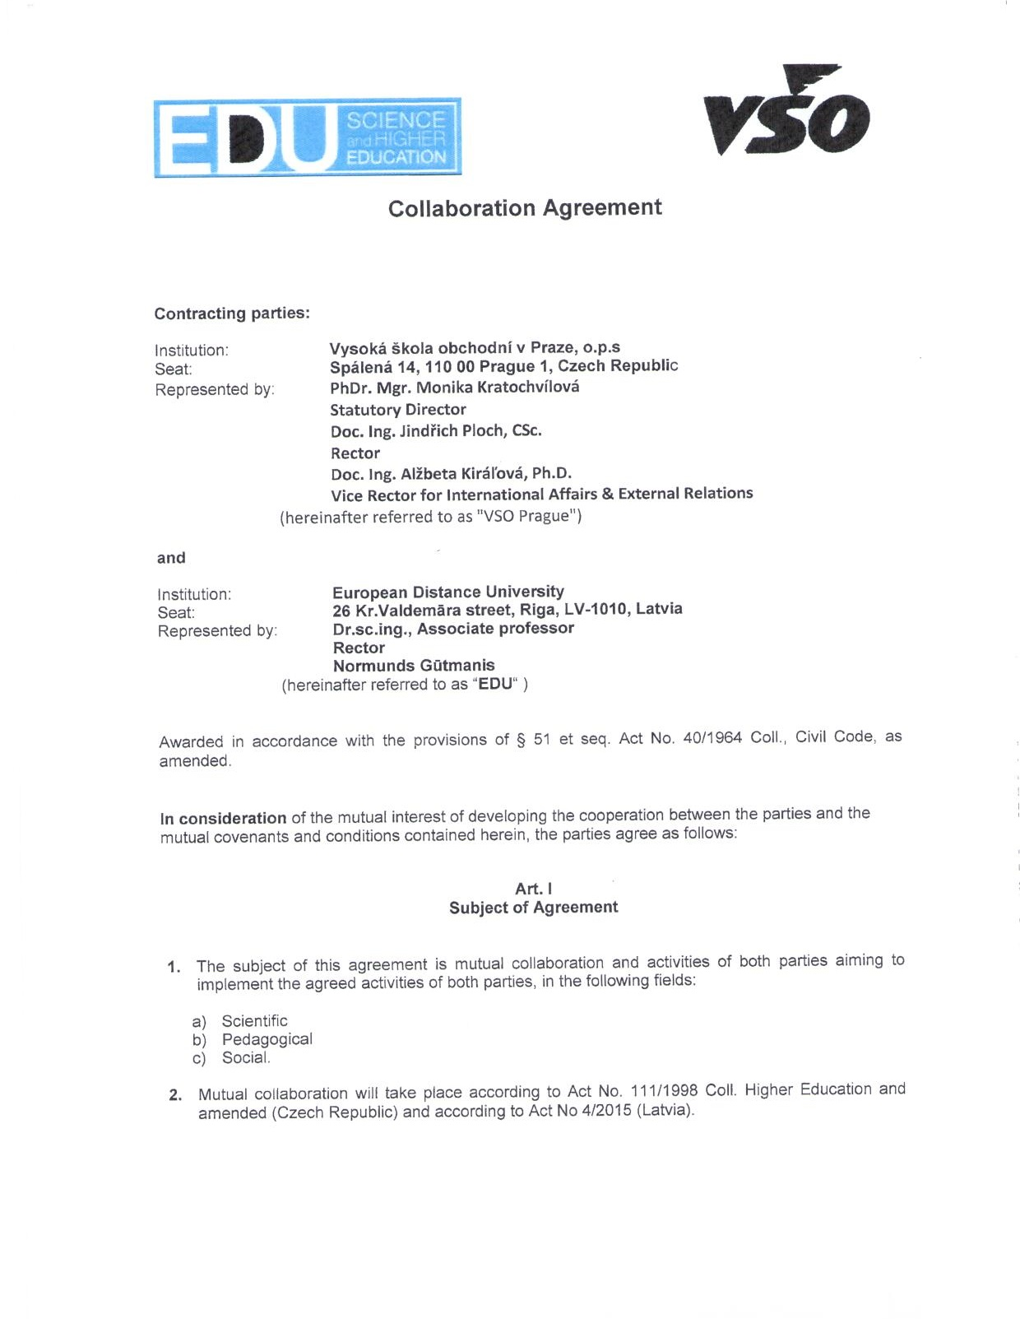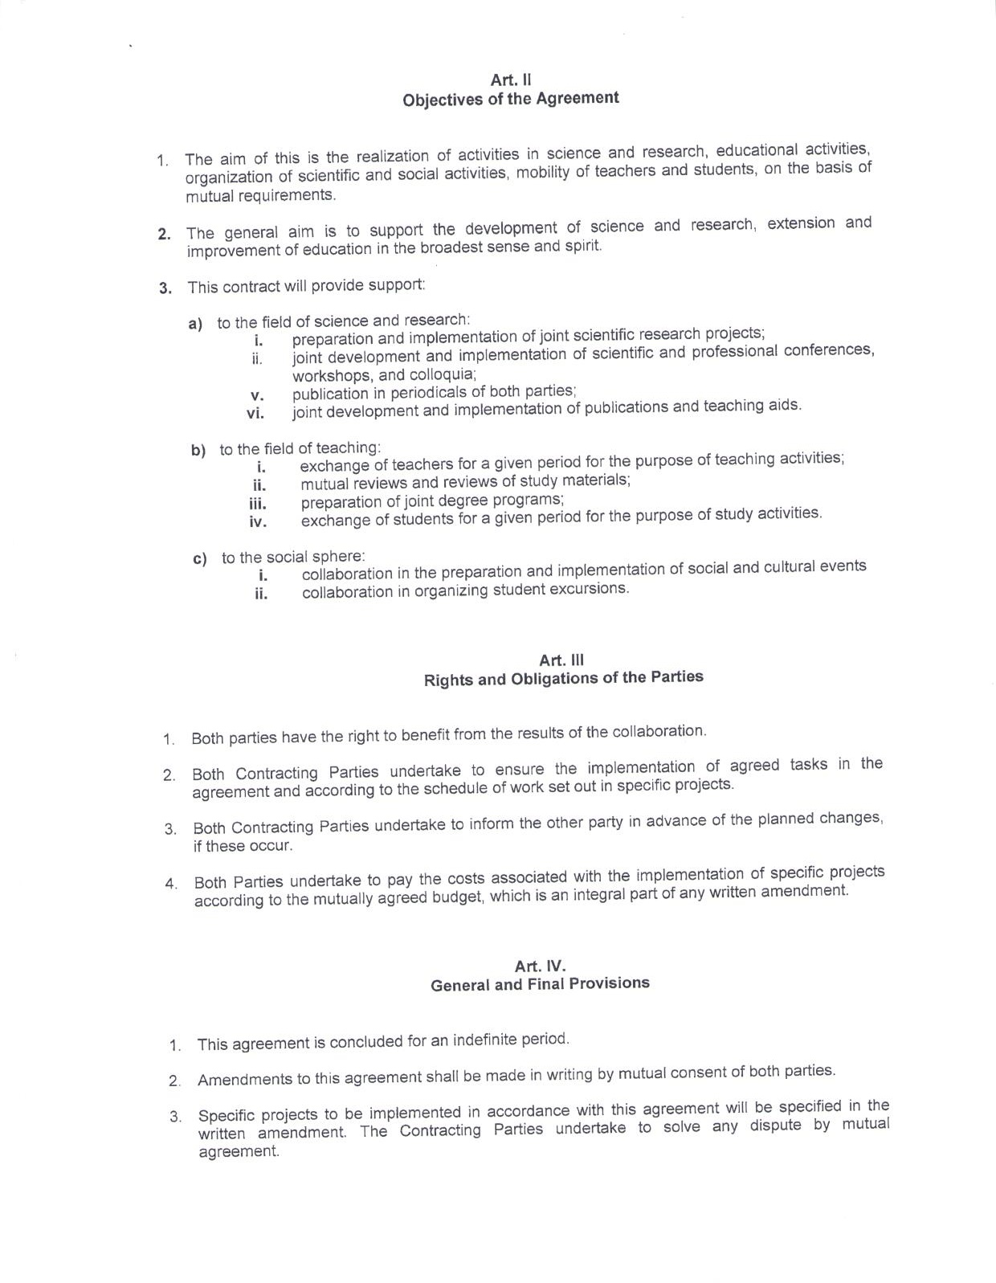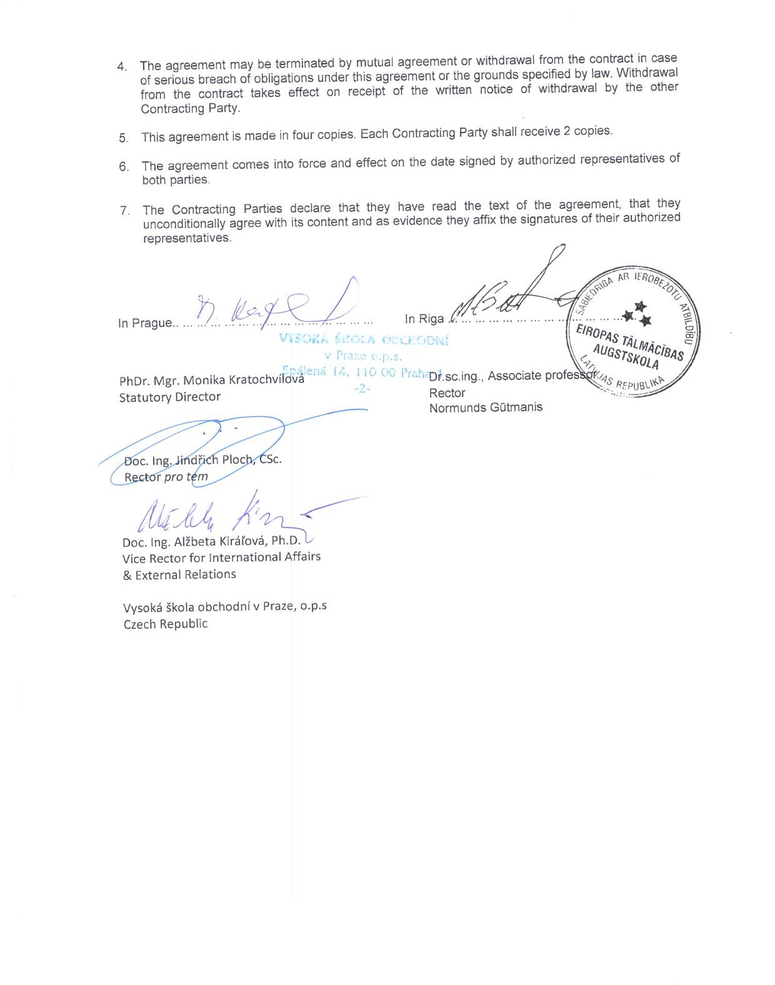

- Agreements on work placement or statements of the future work placement providers, as well as the work placement procedure
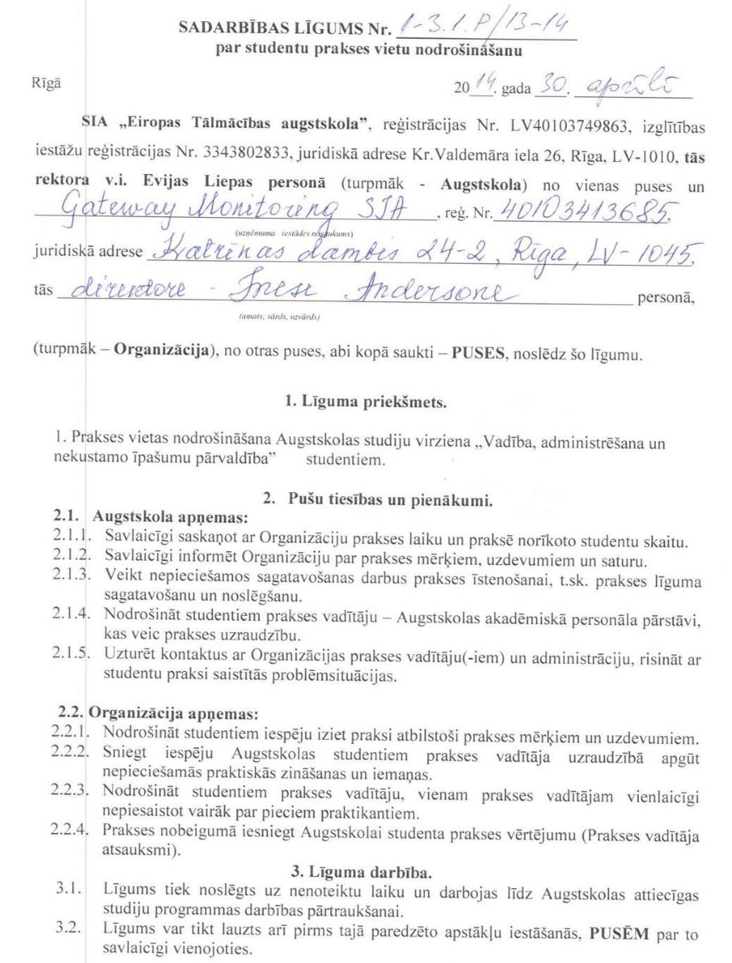
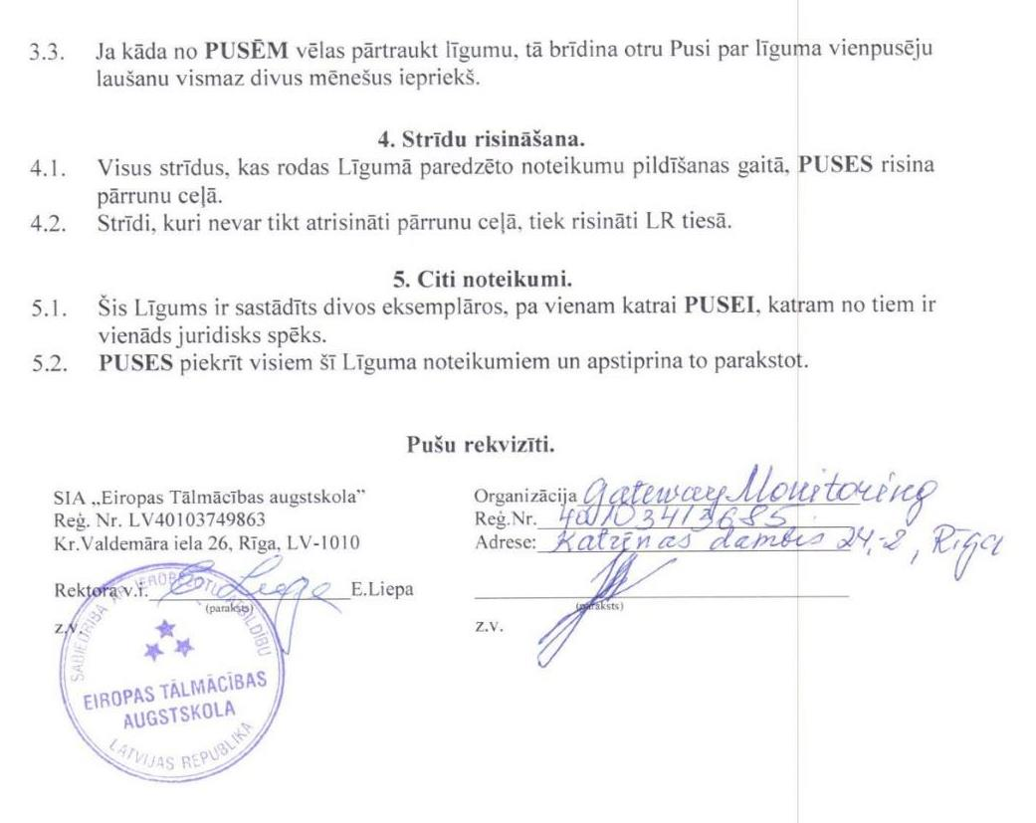
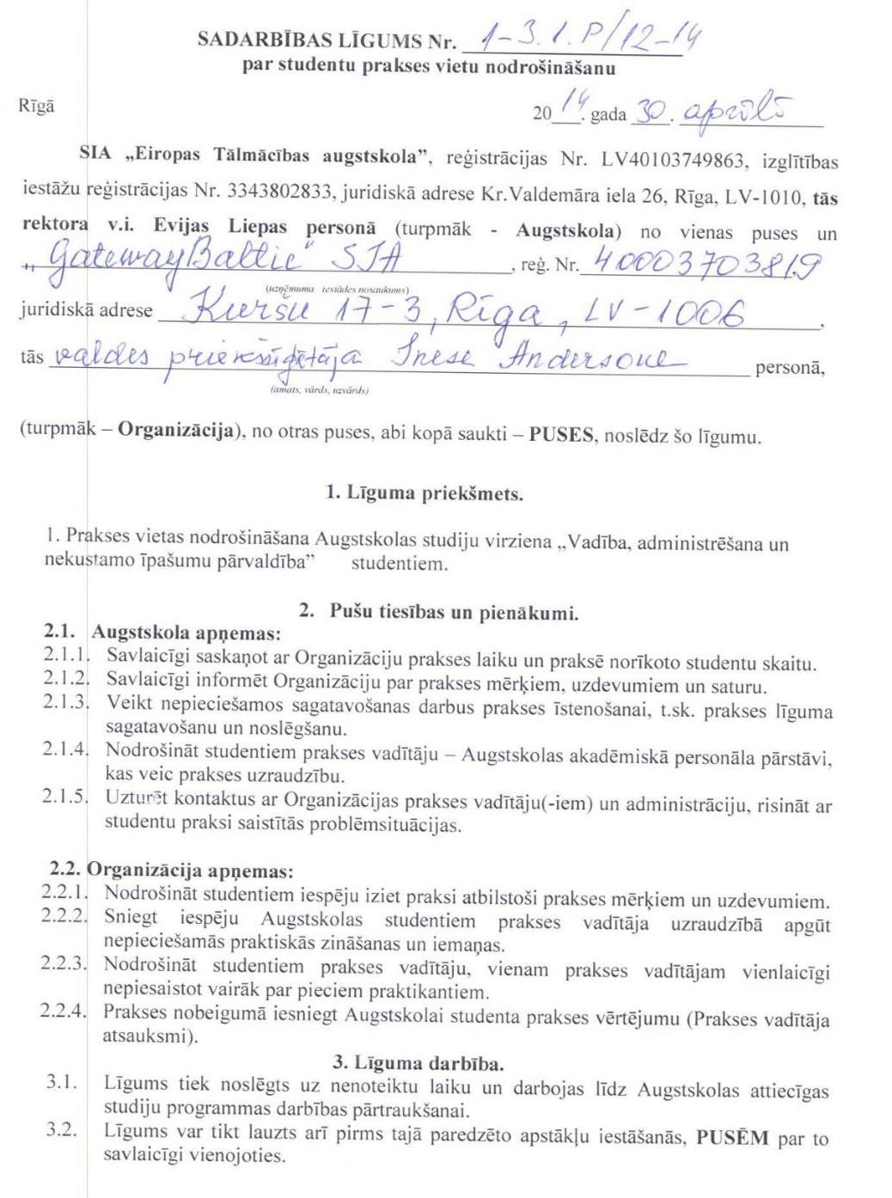
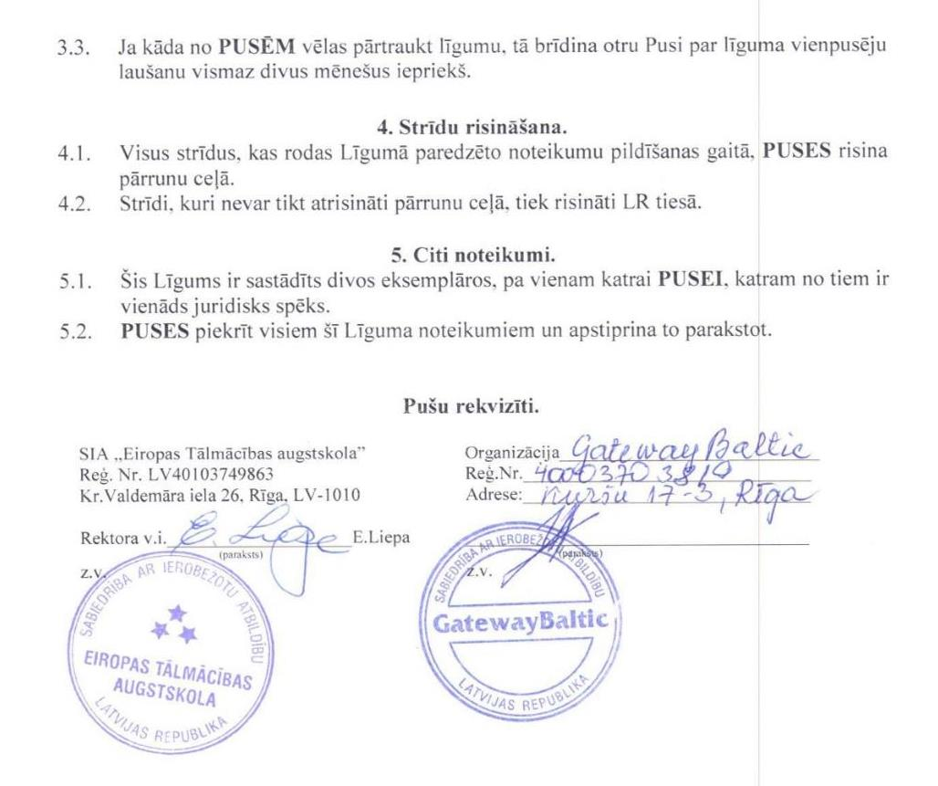
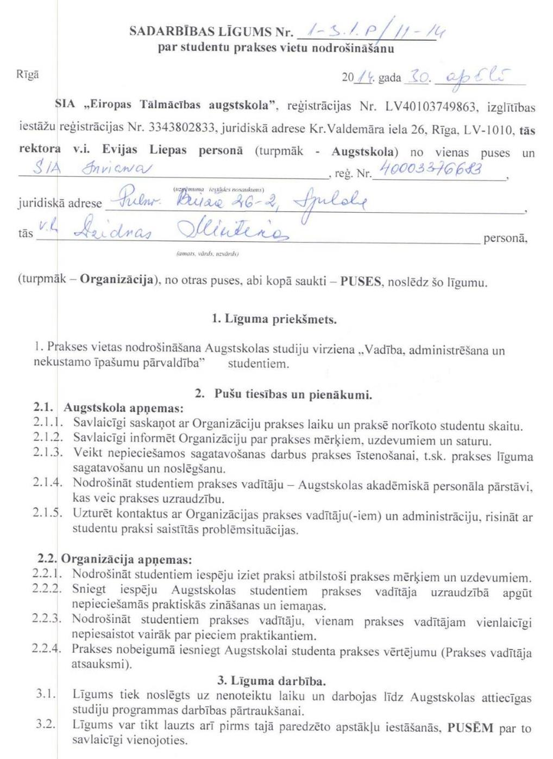
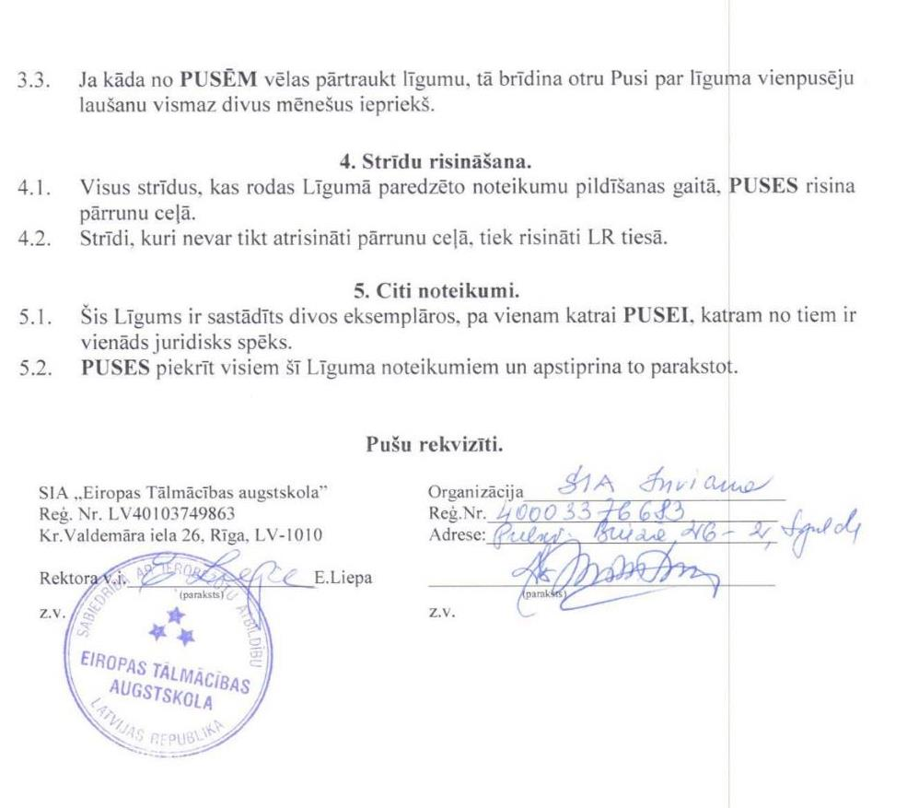
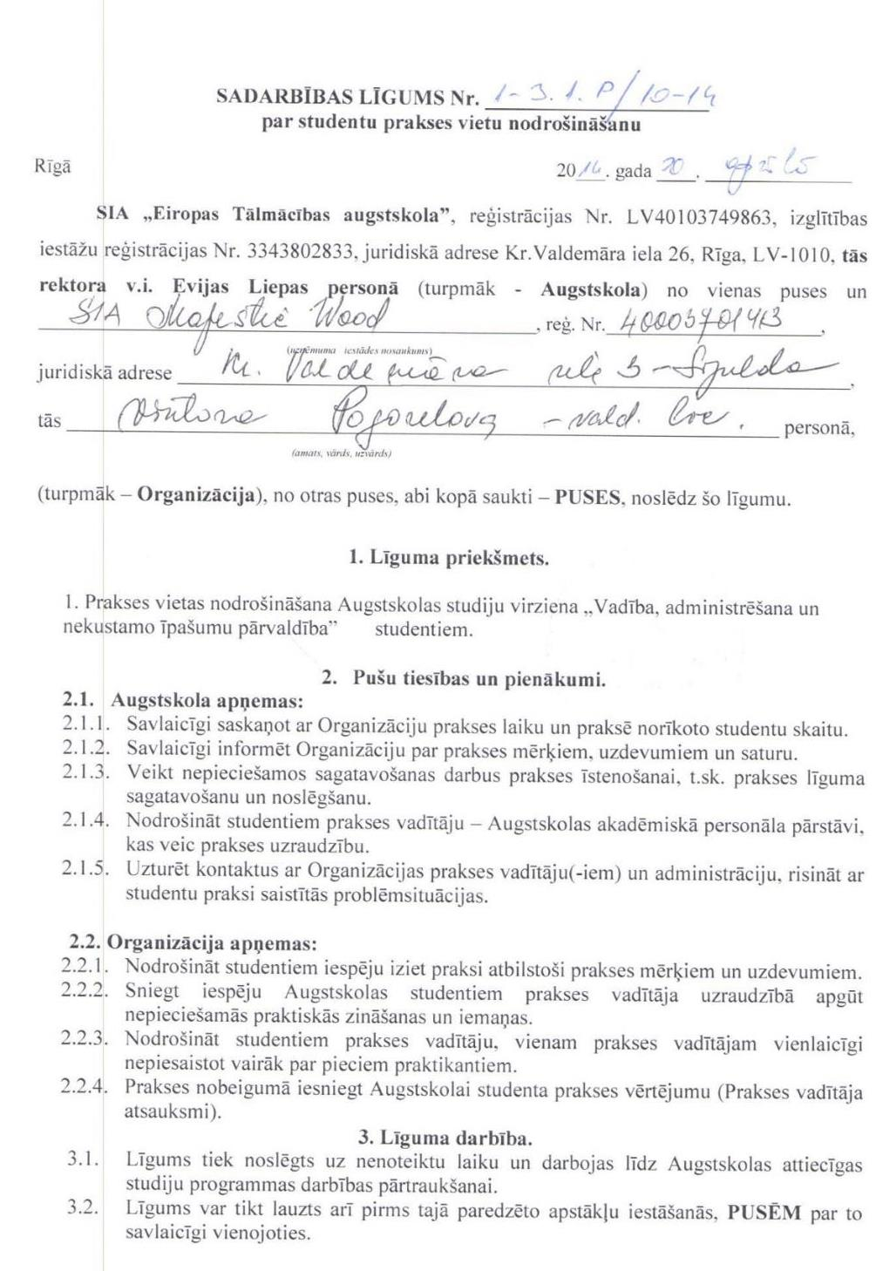
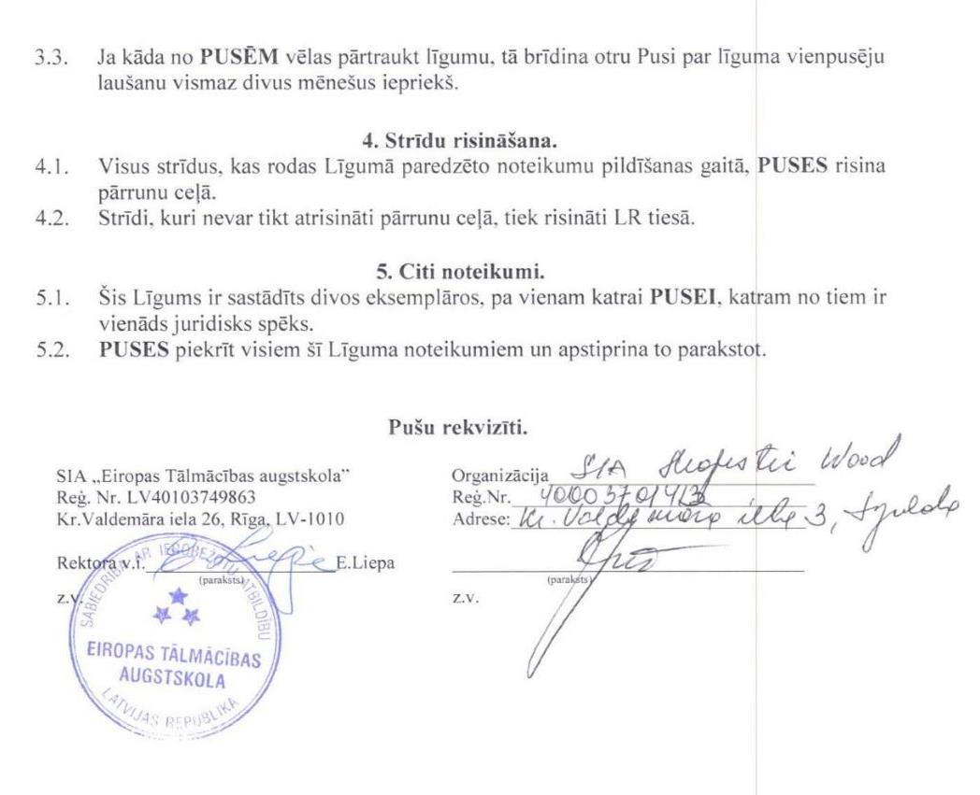
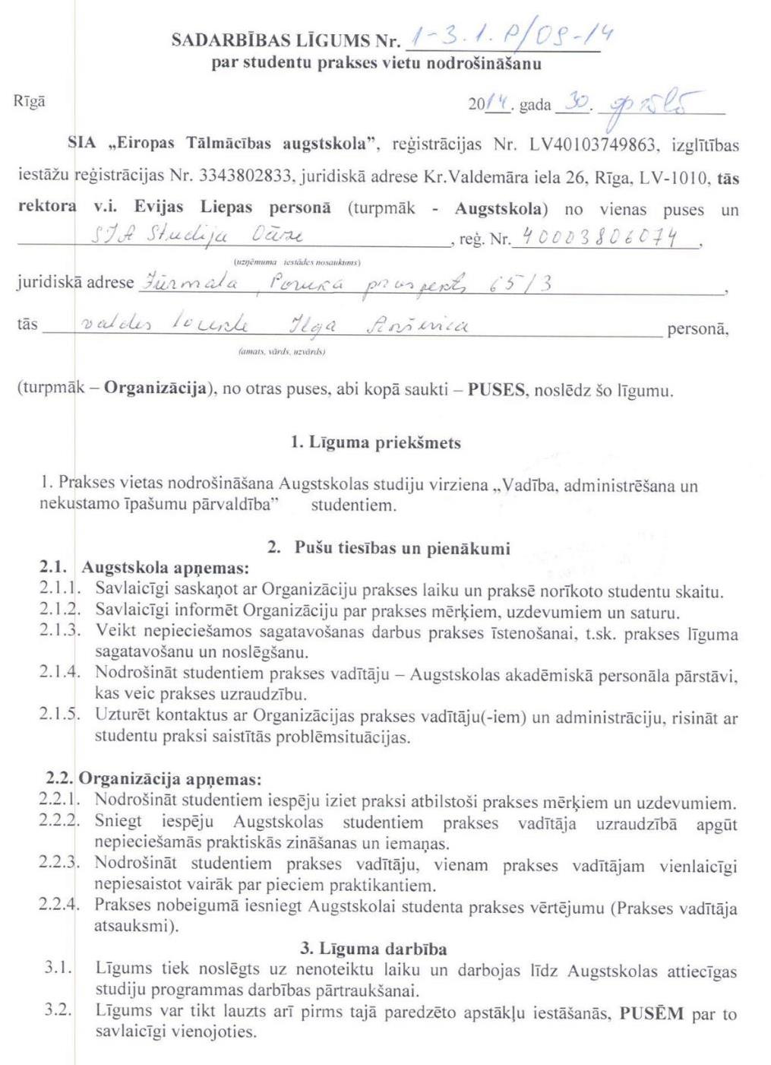
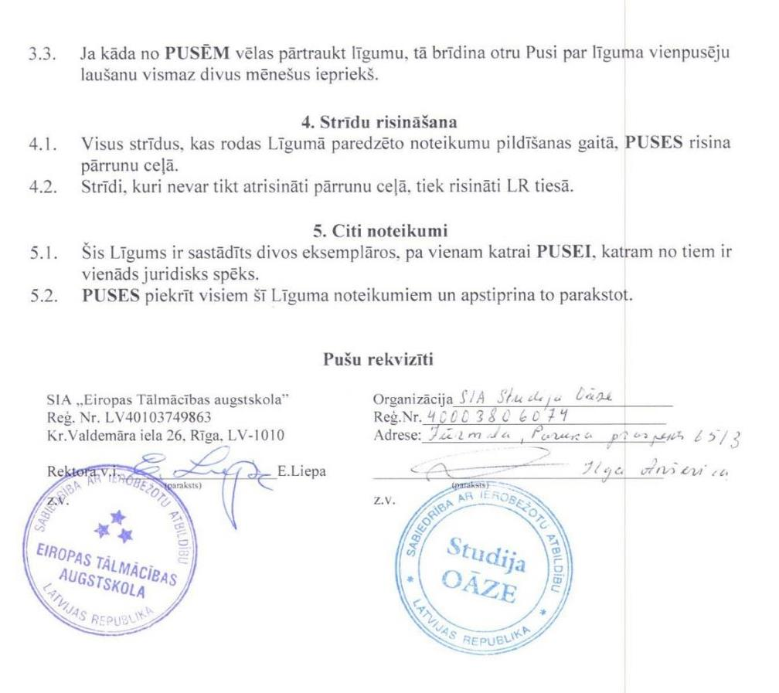
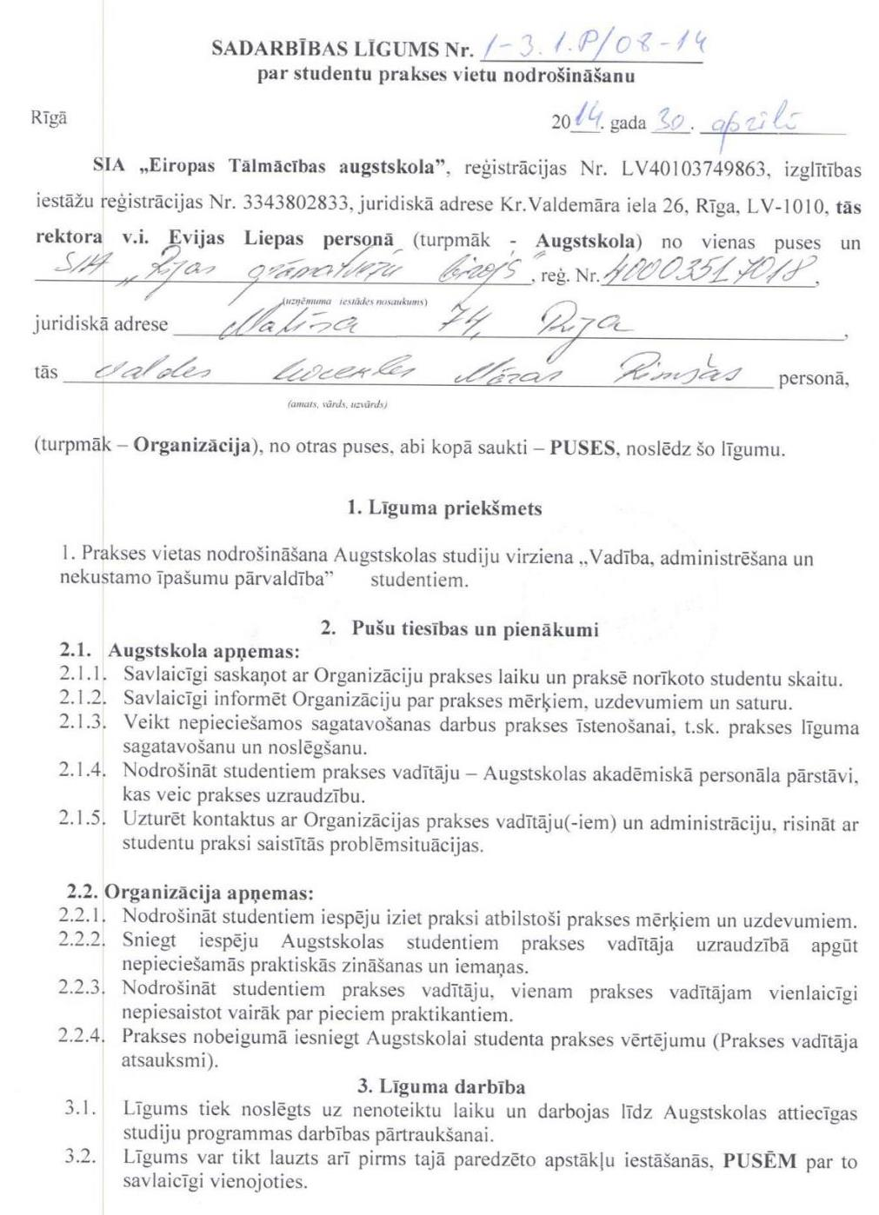
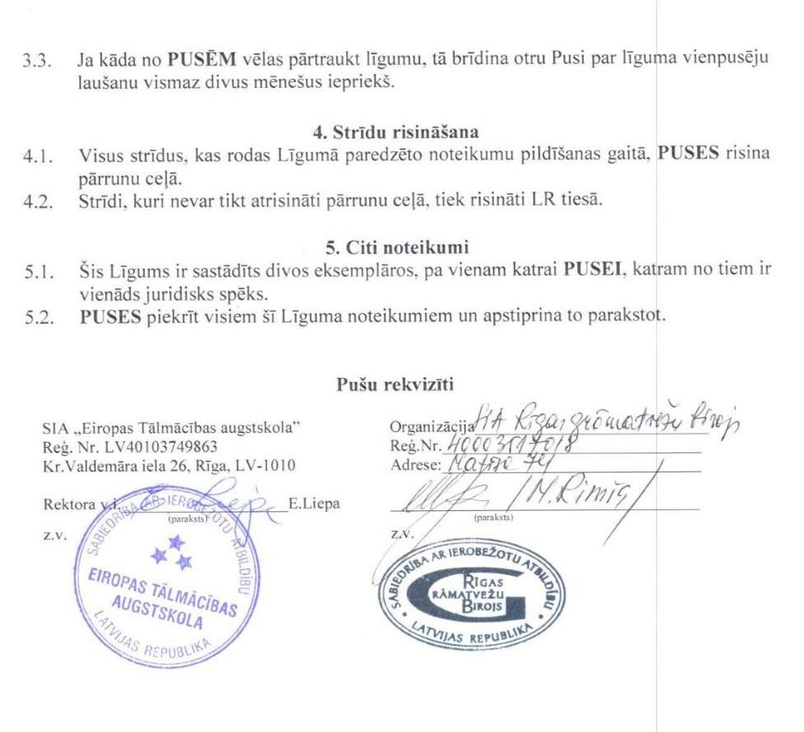
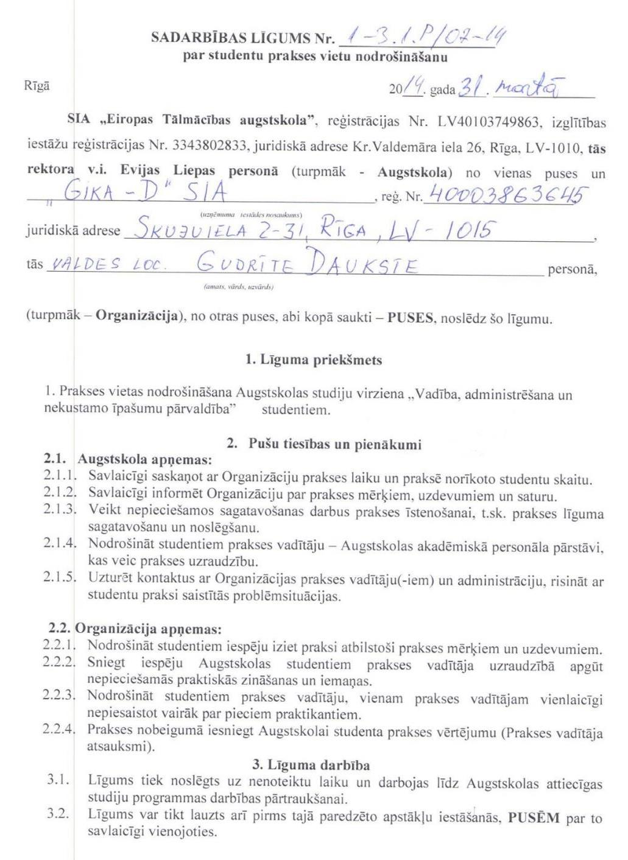
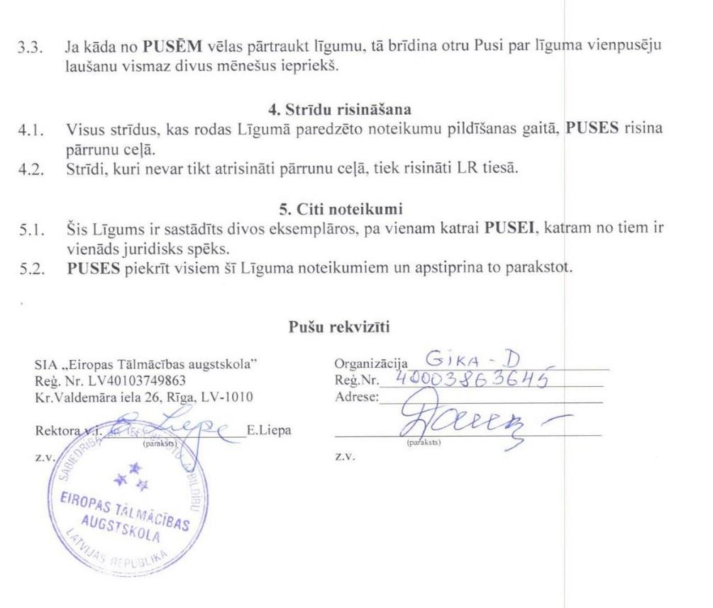
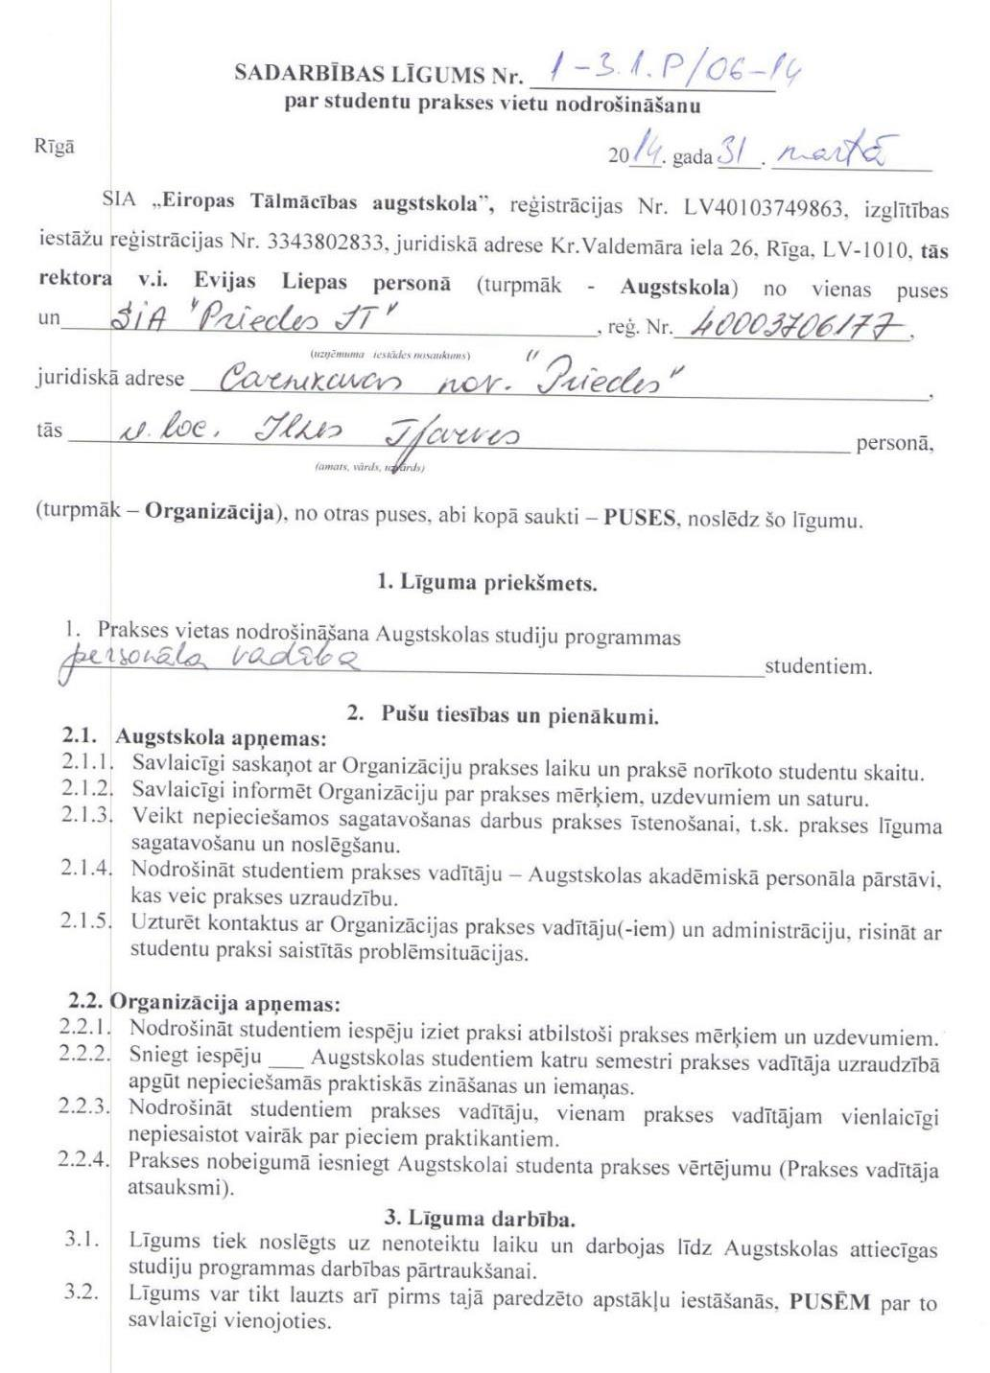
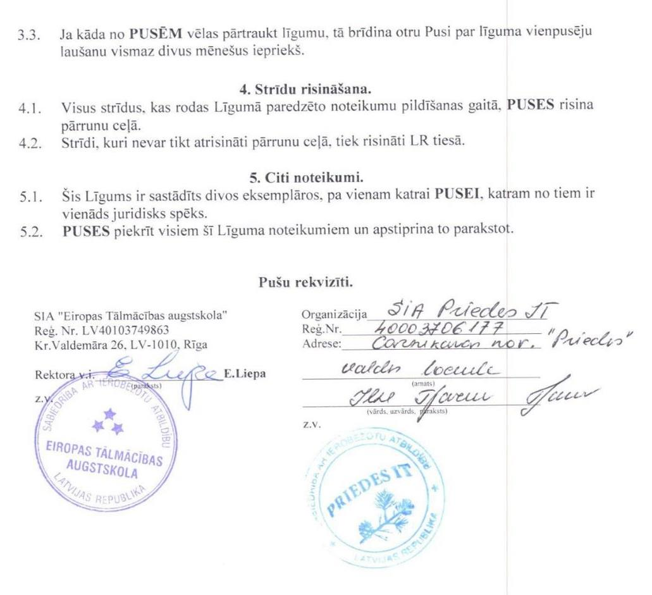
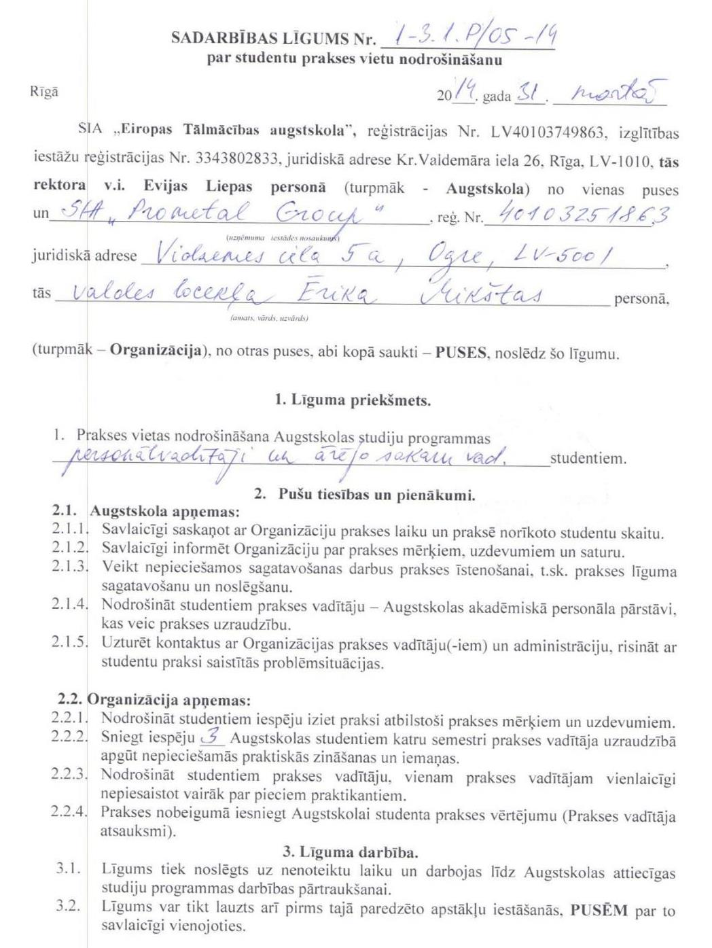
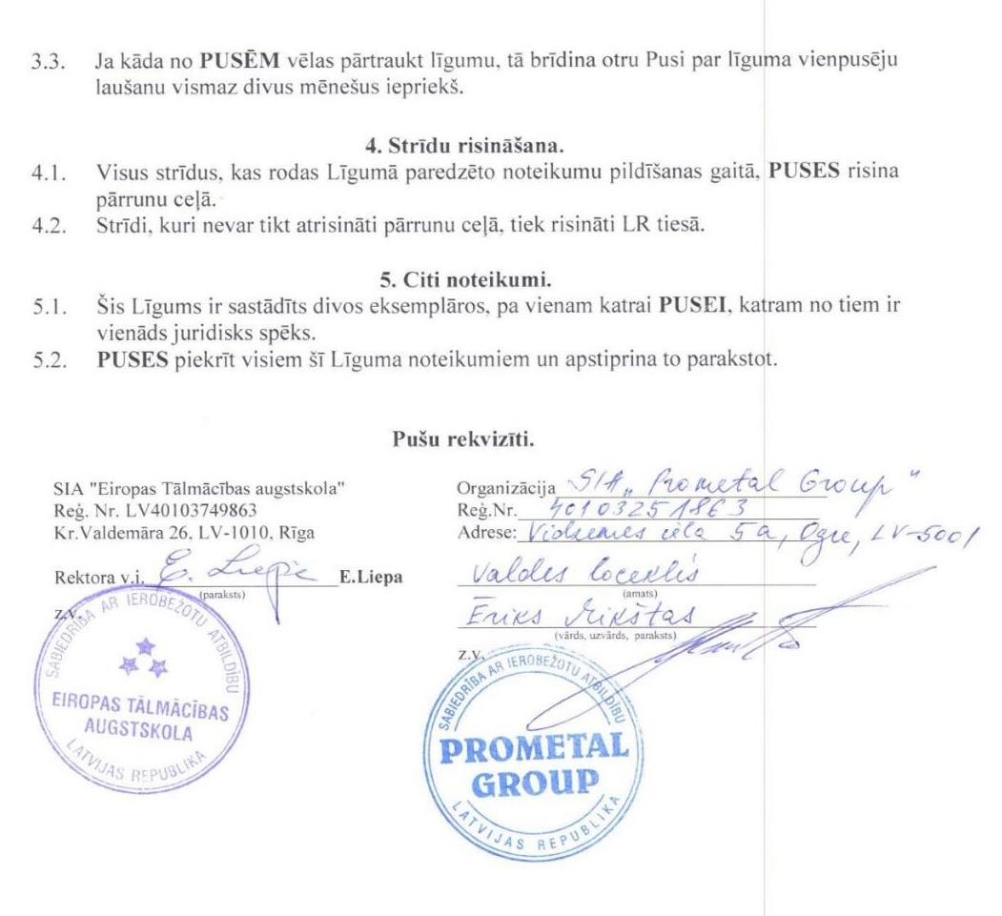
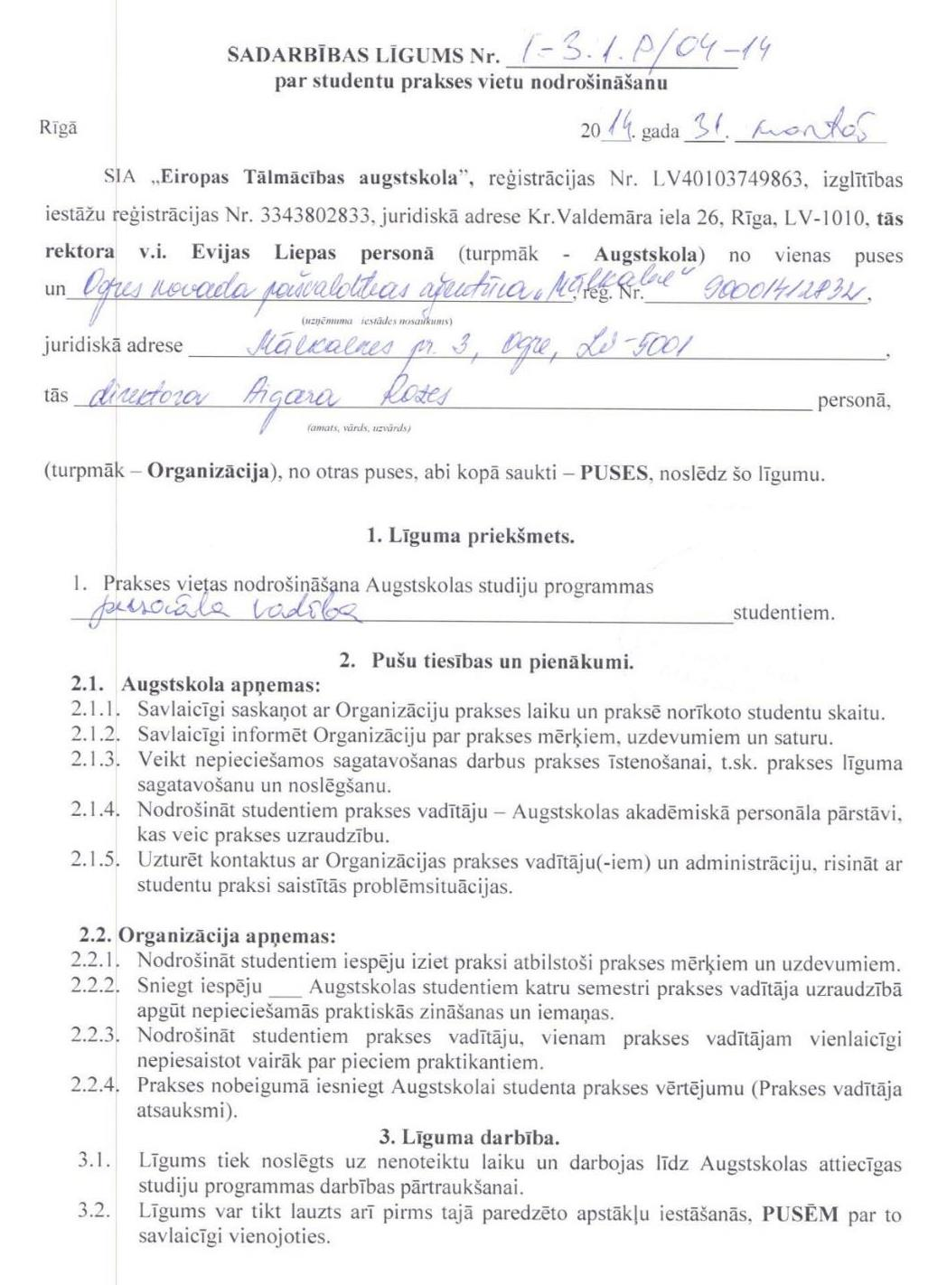
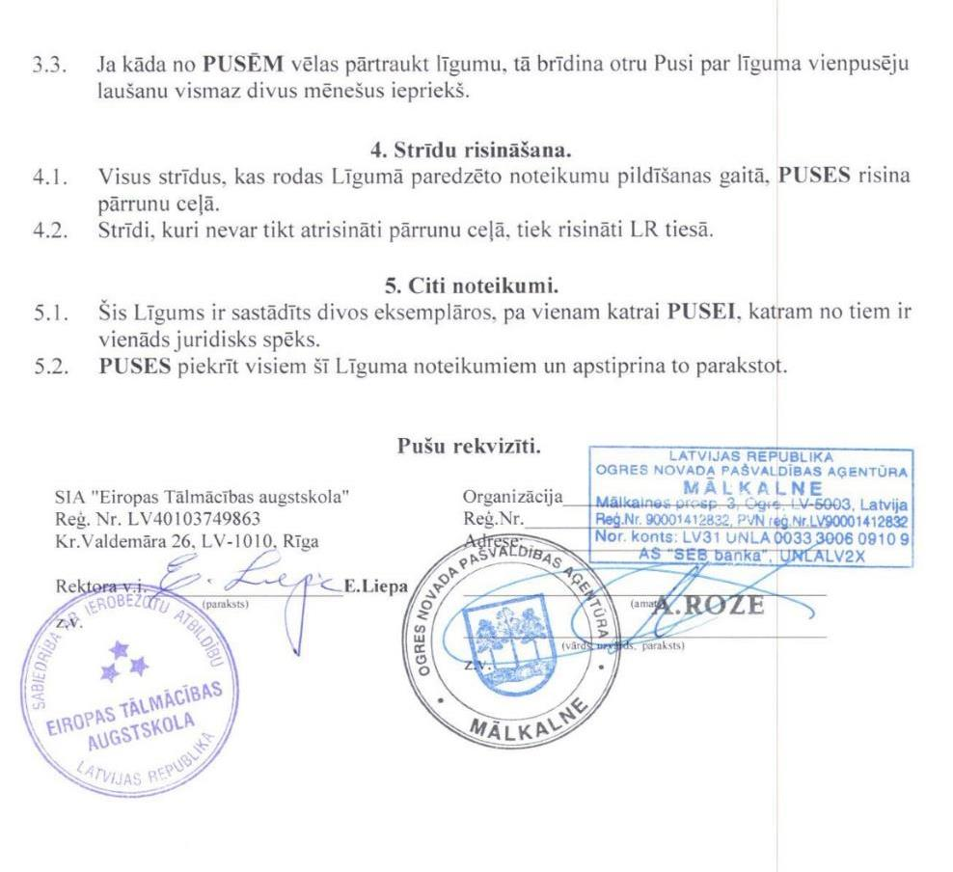
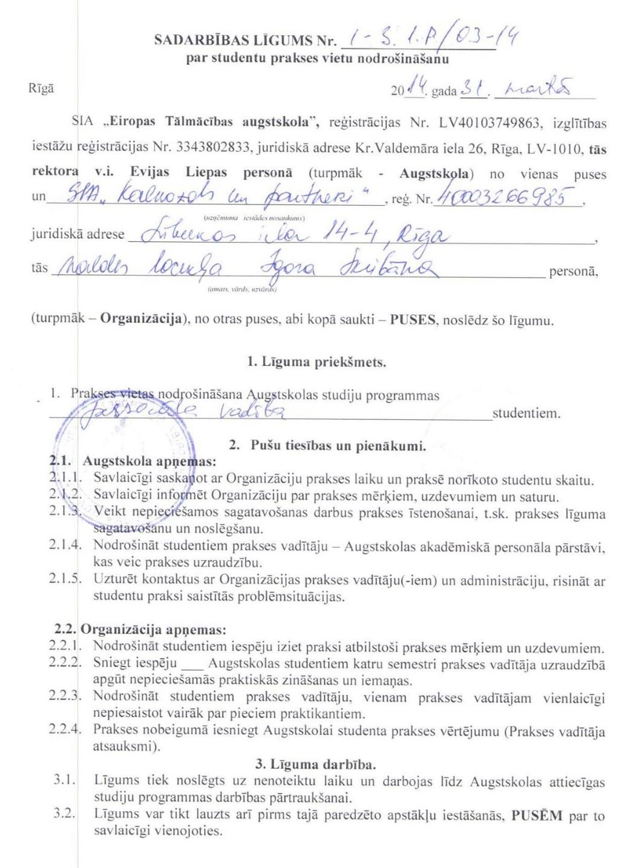
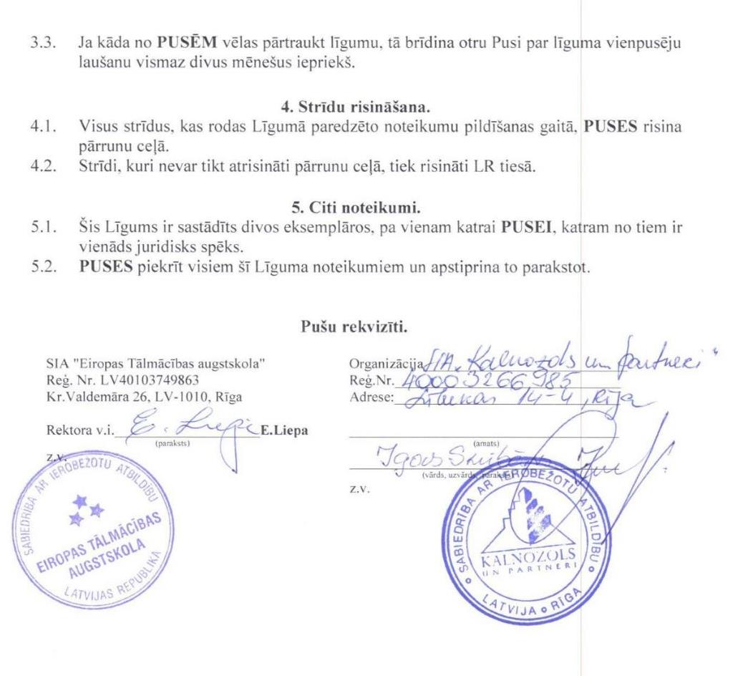
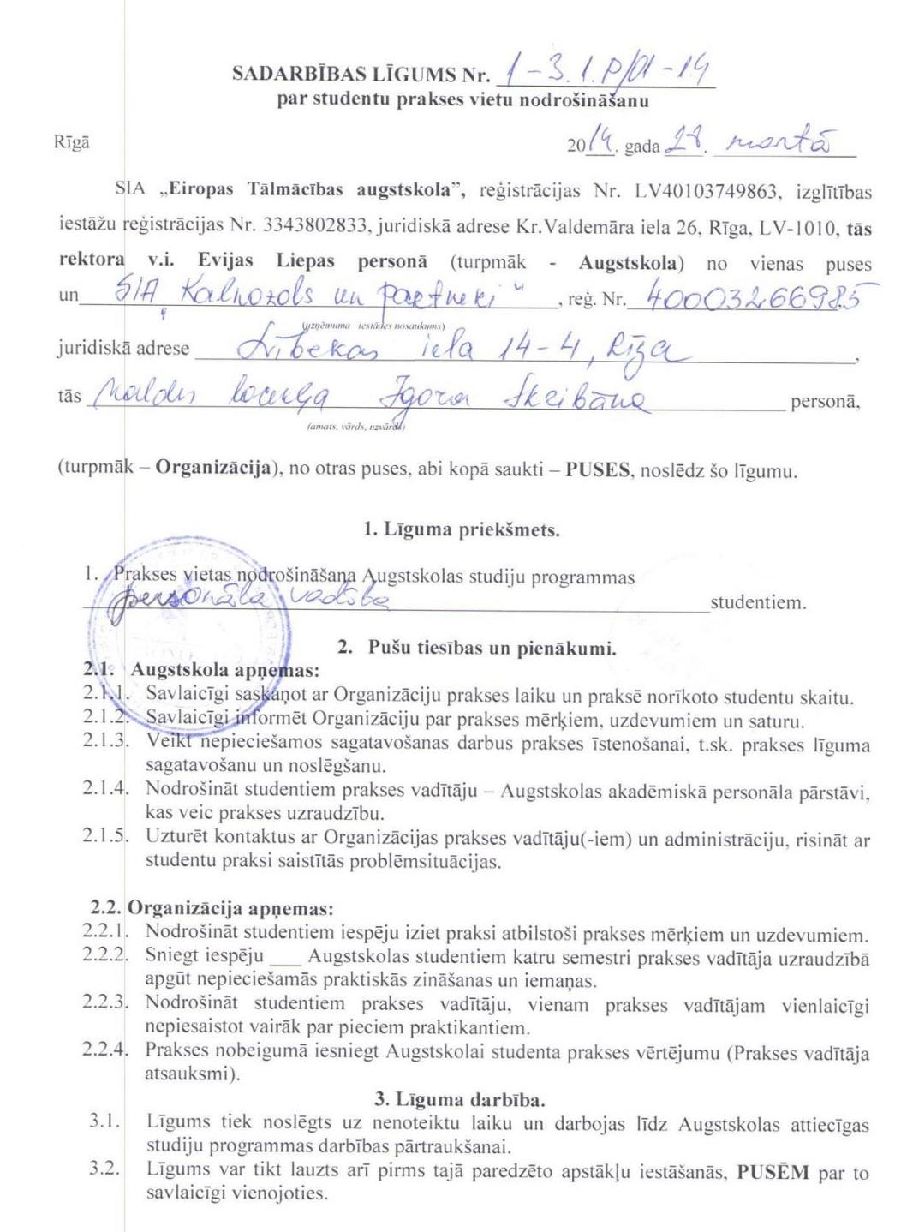
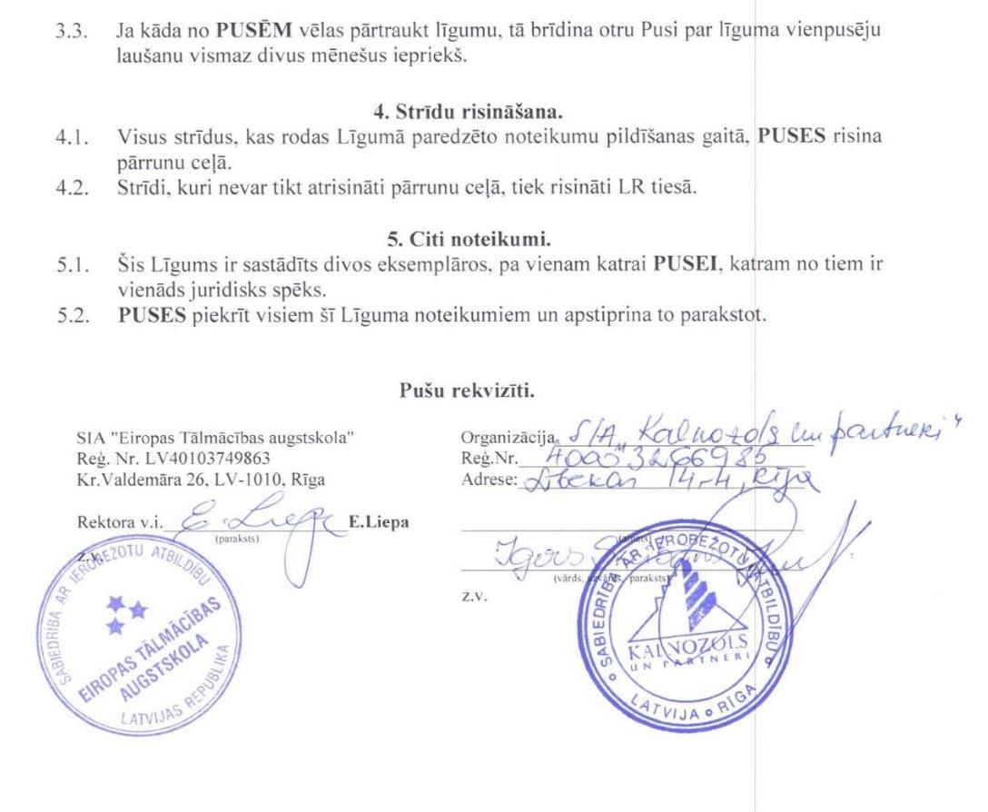
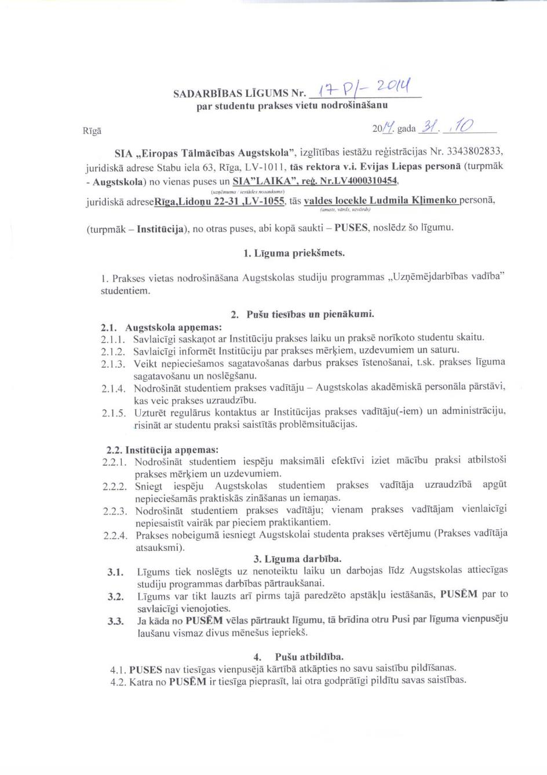
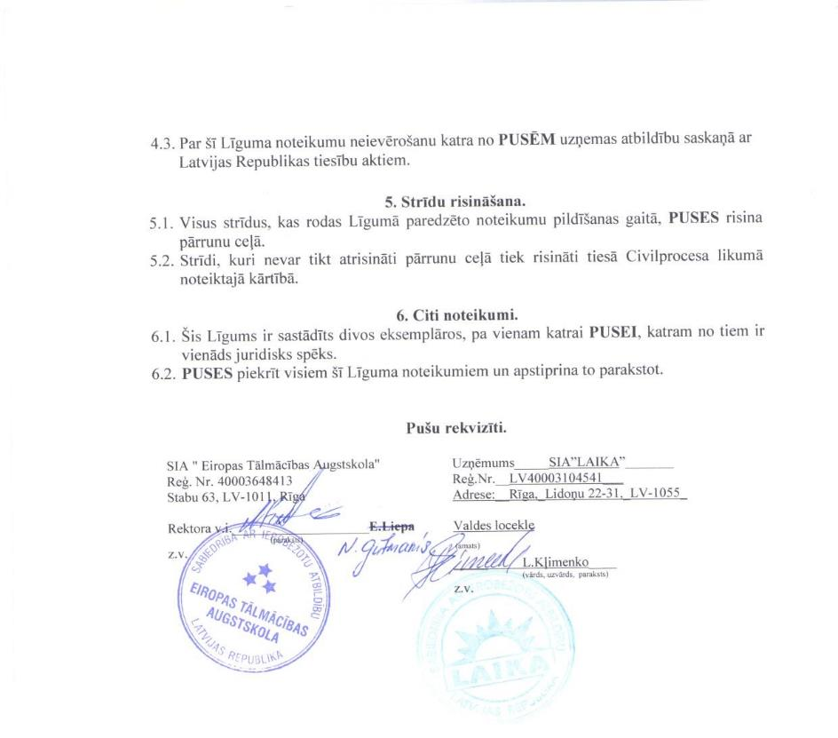
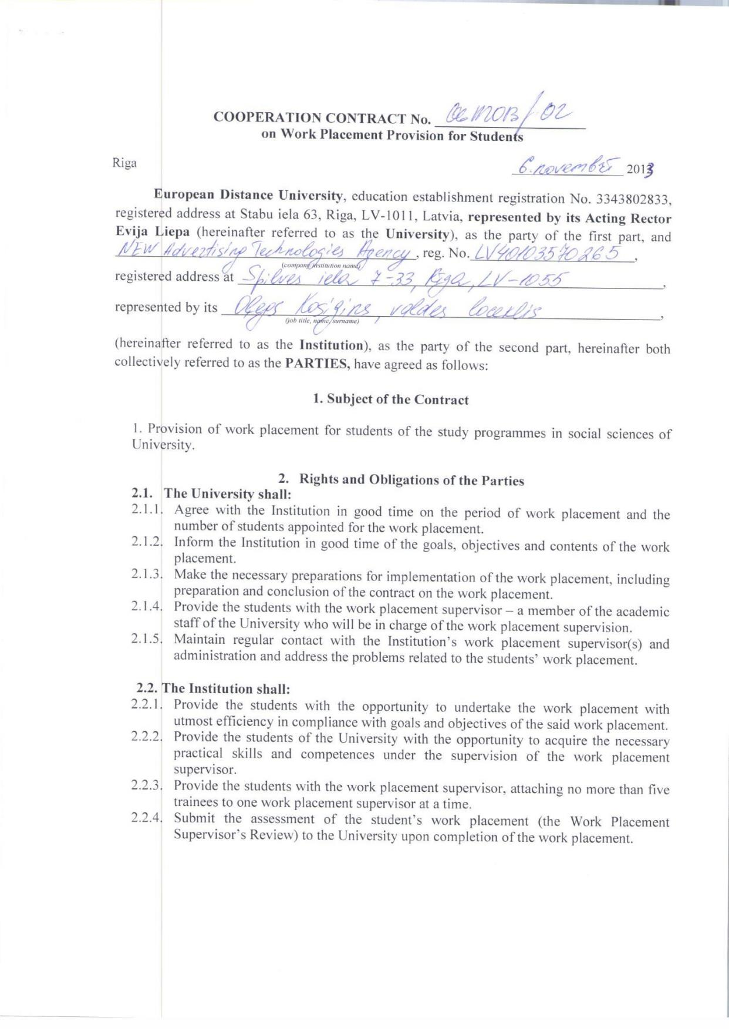
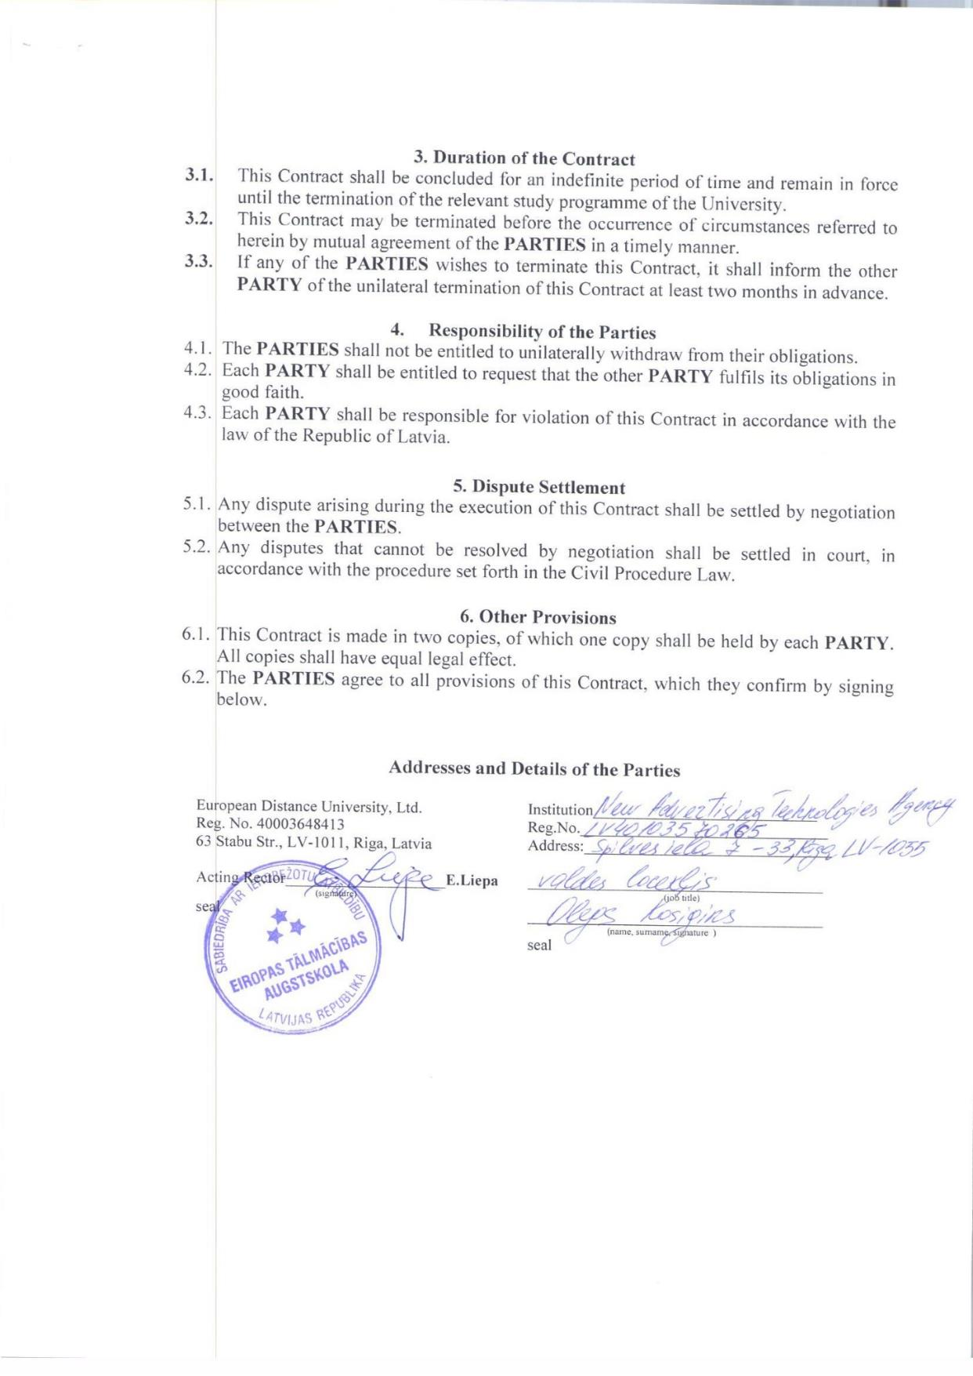
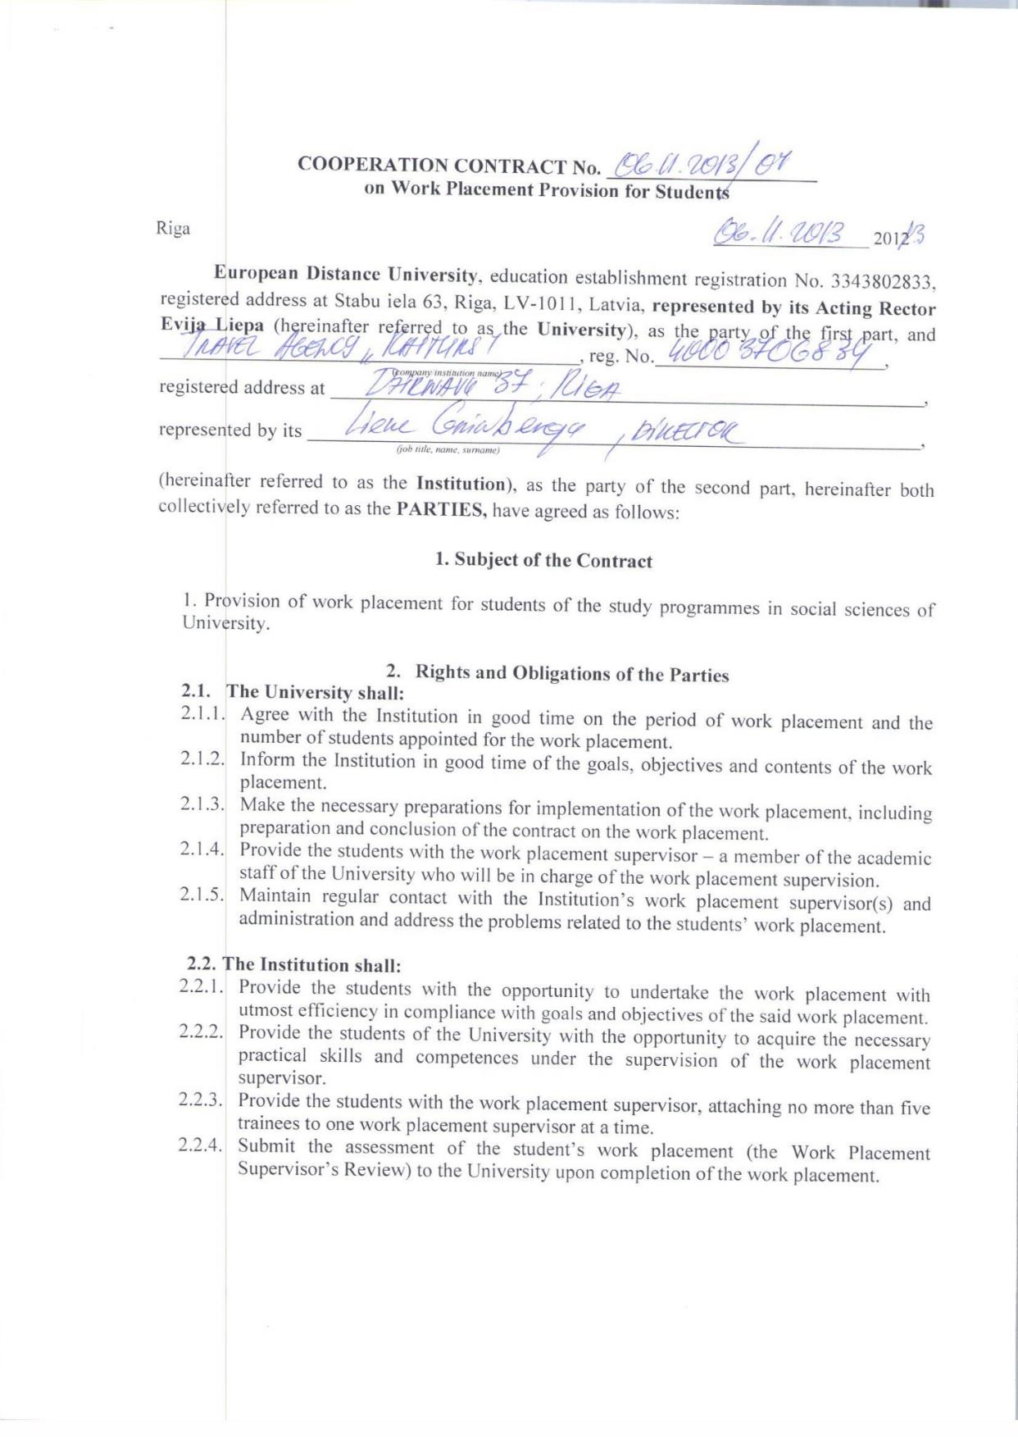
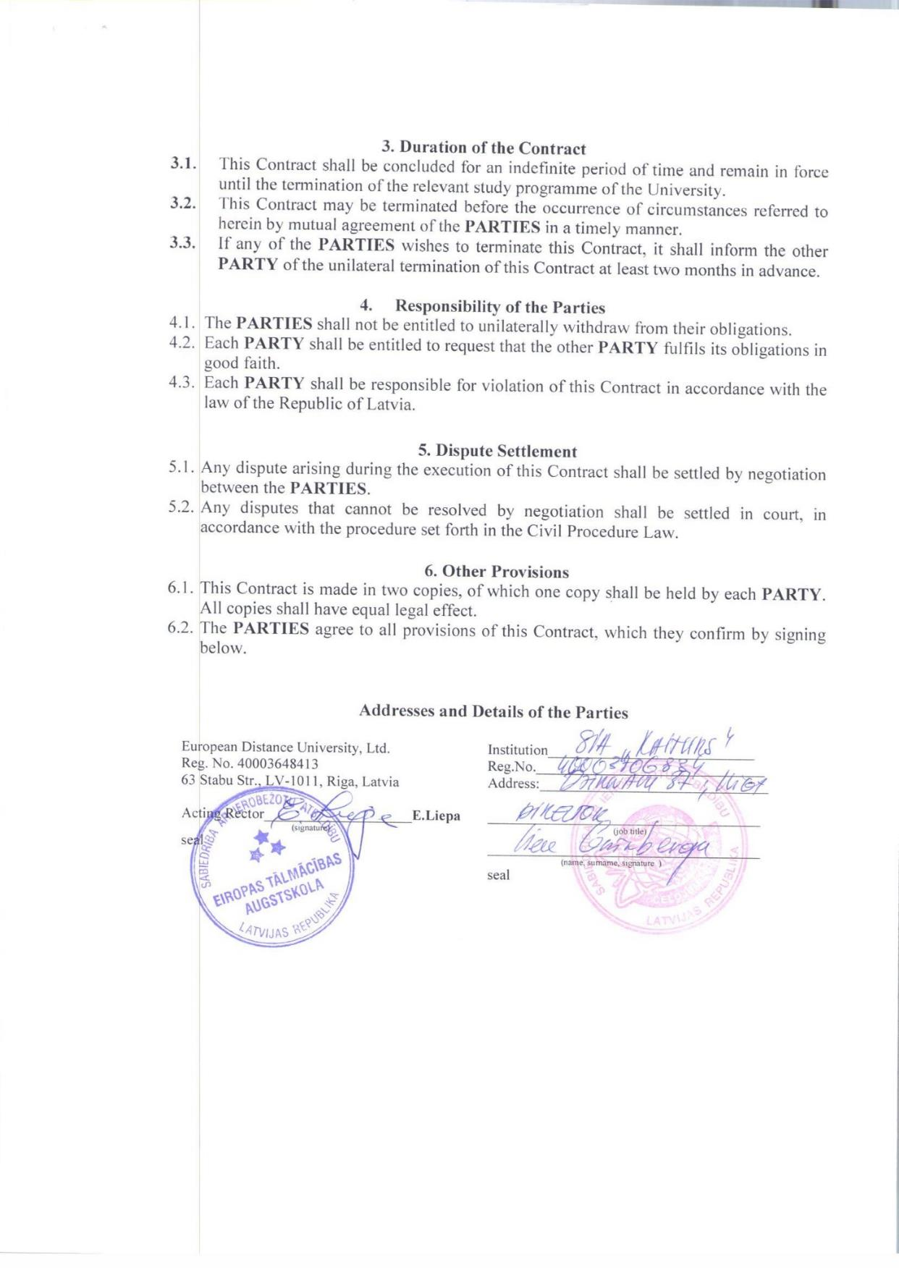
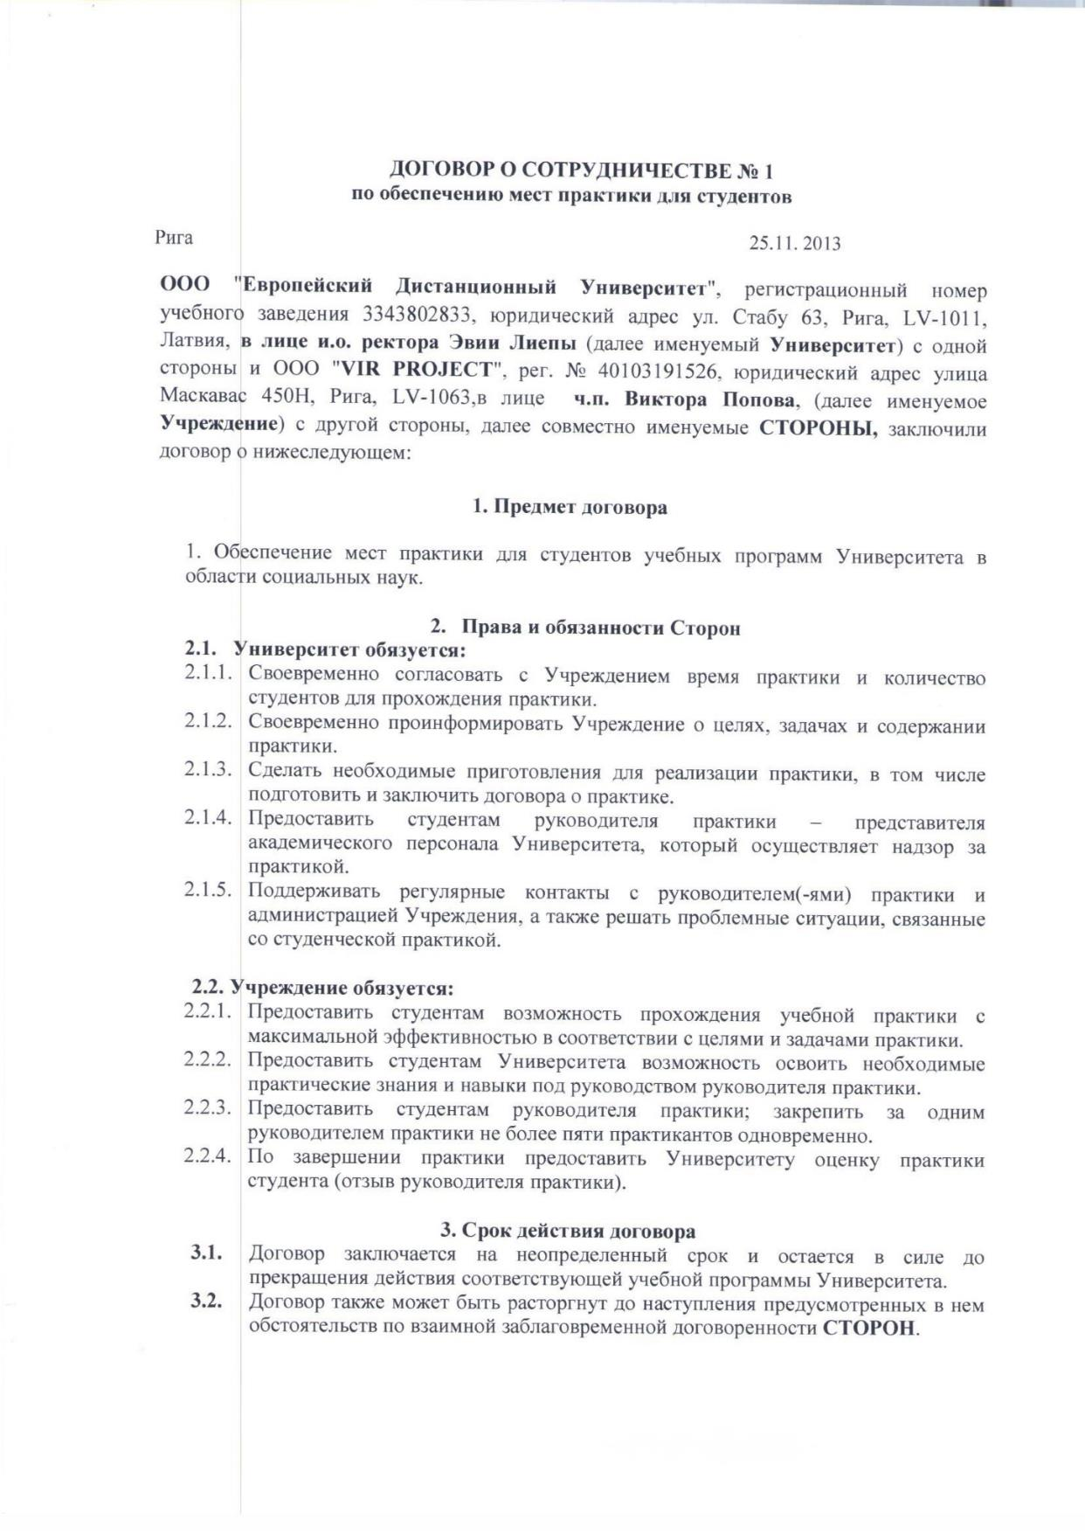
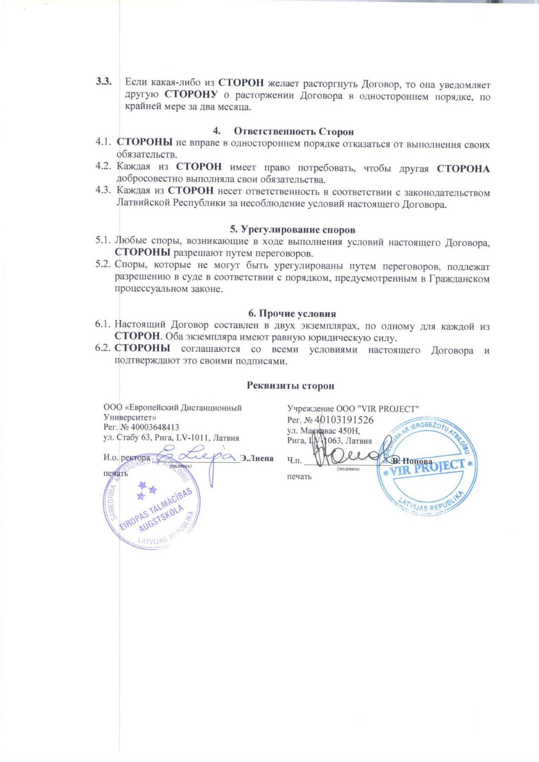
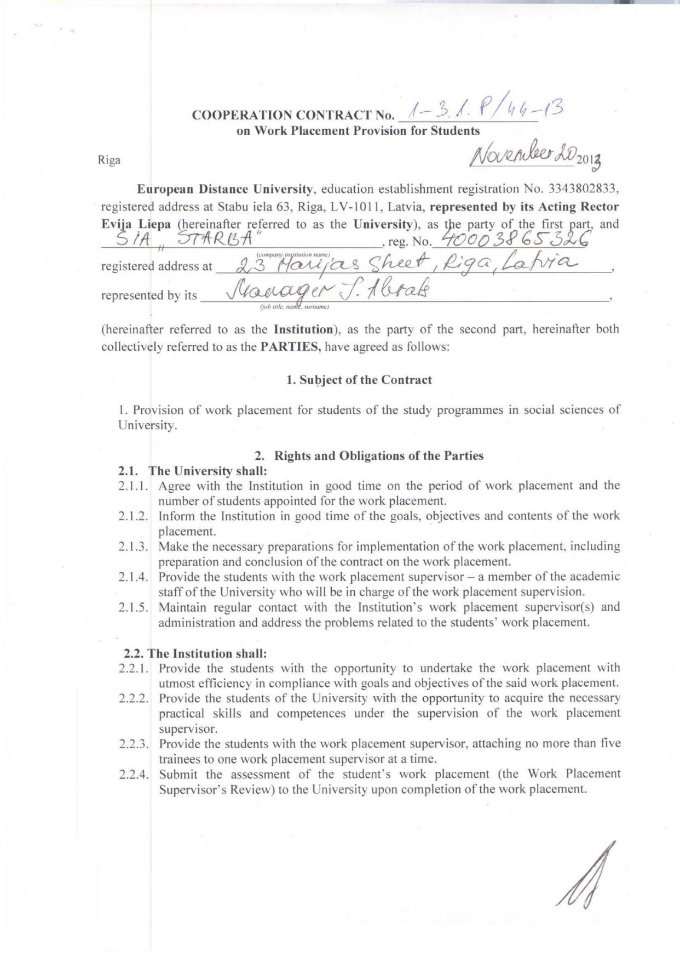
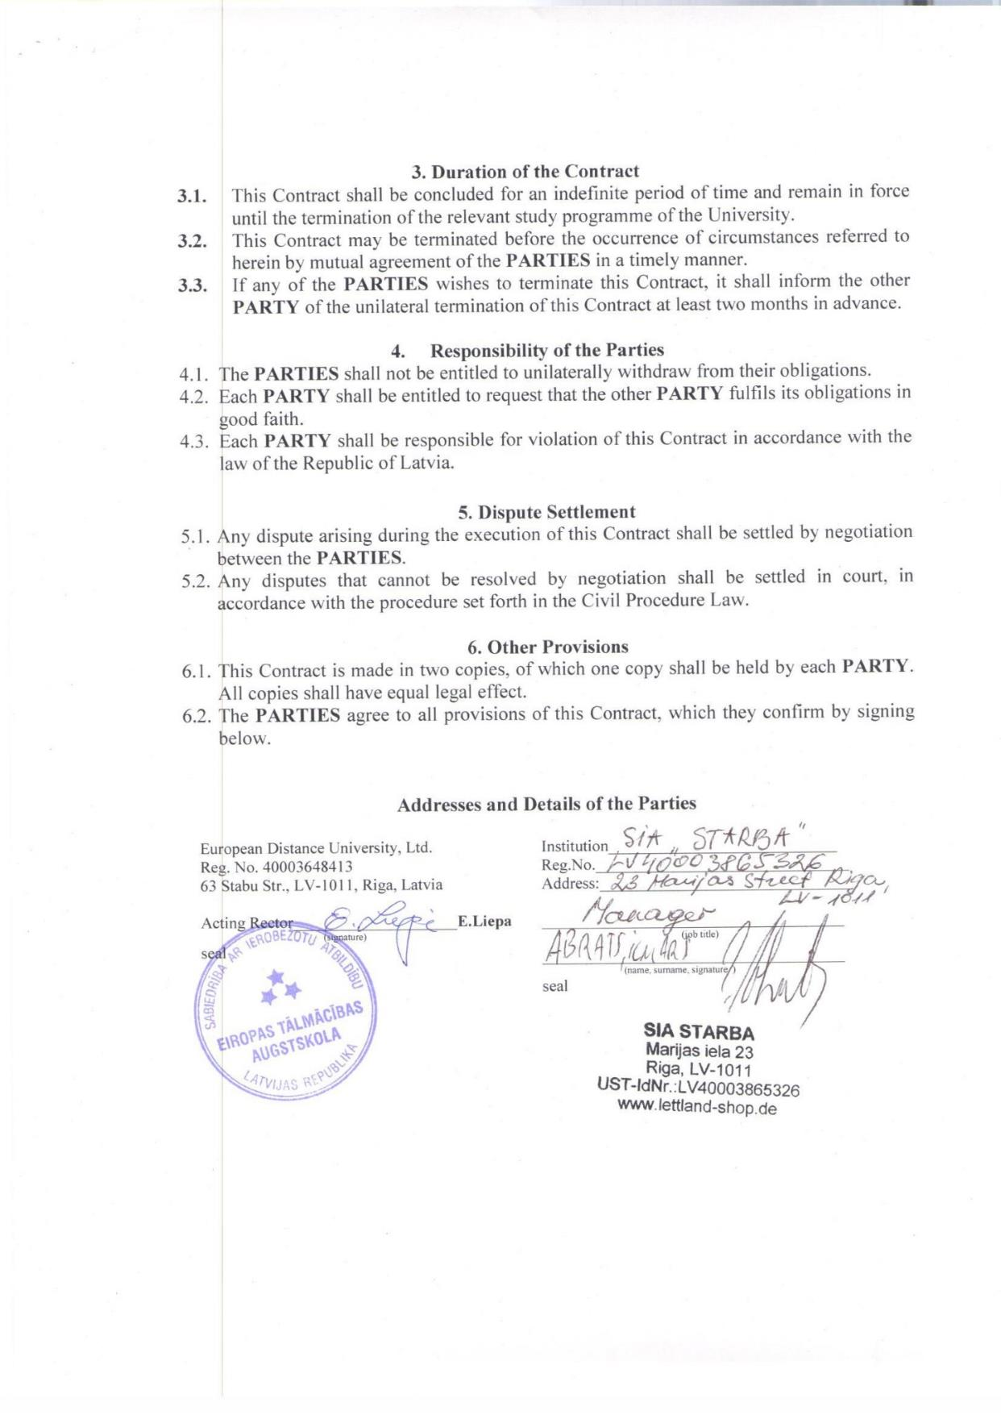
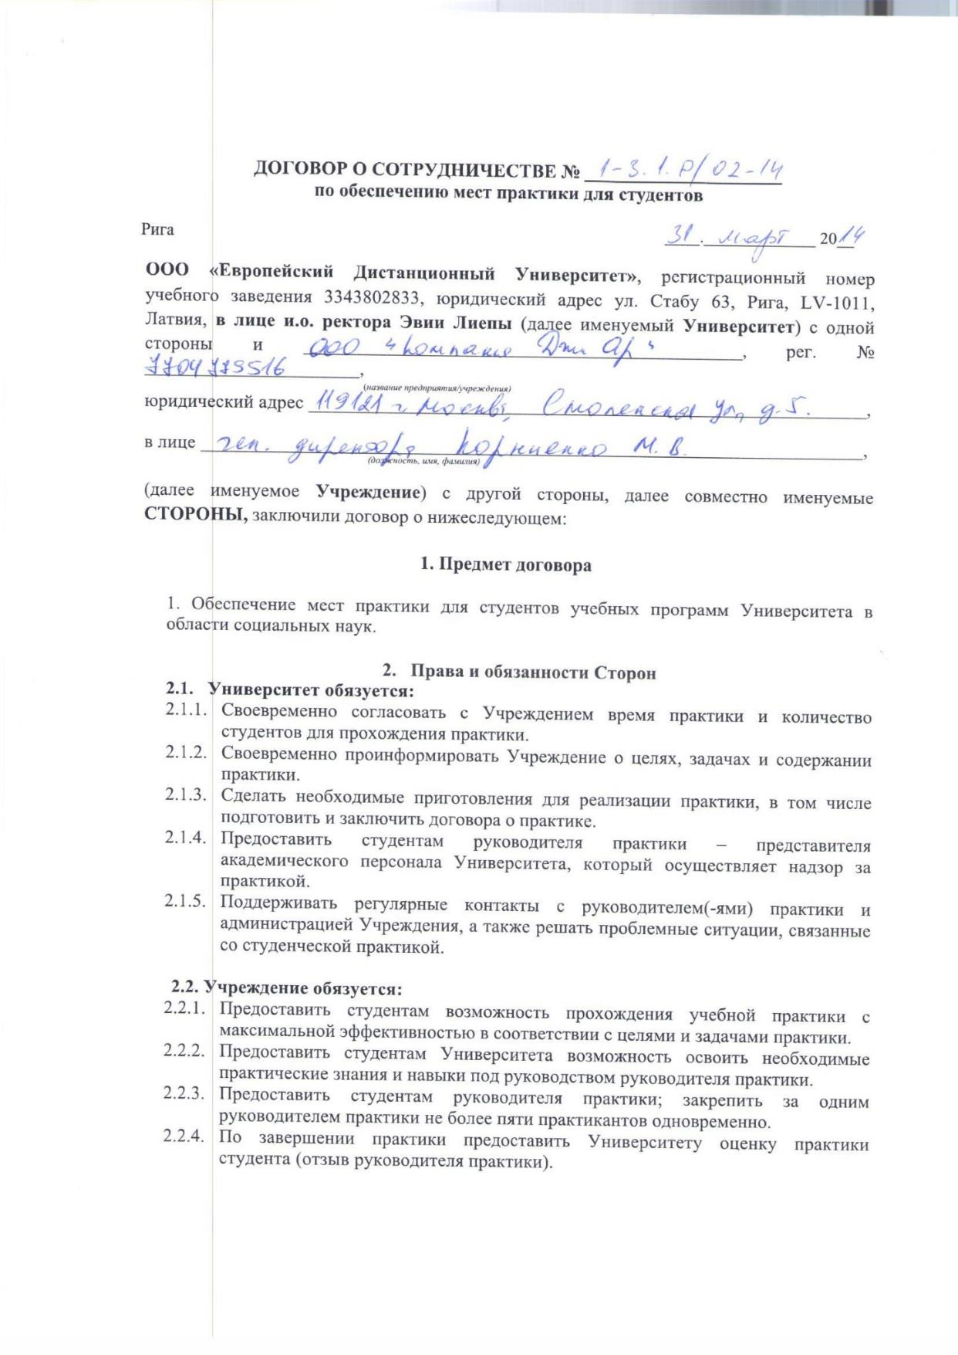
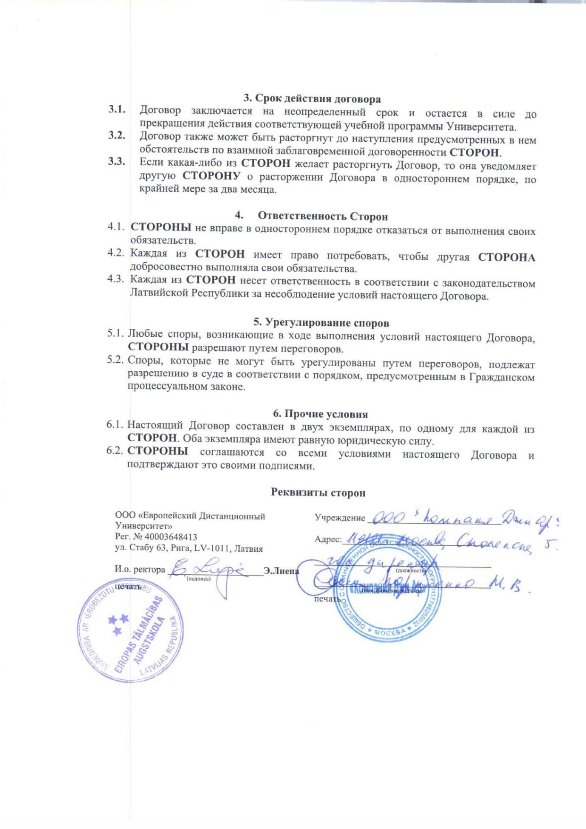

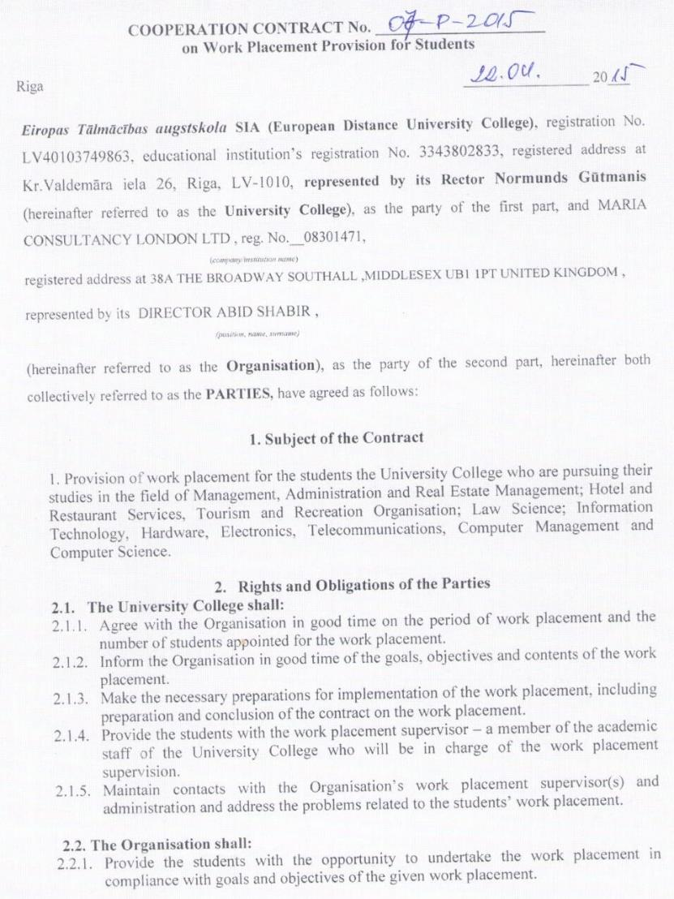
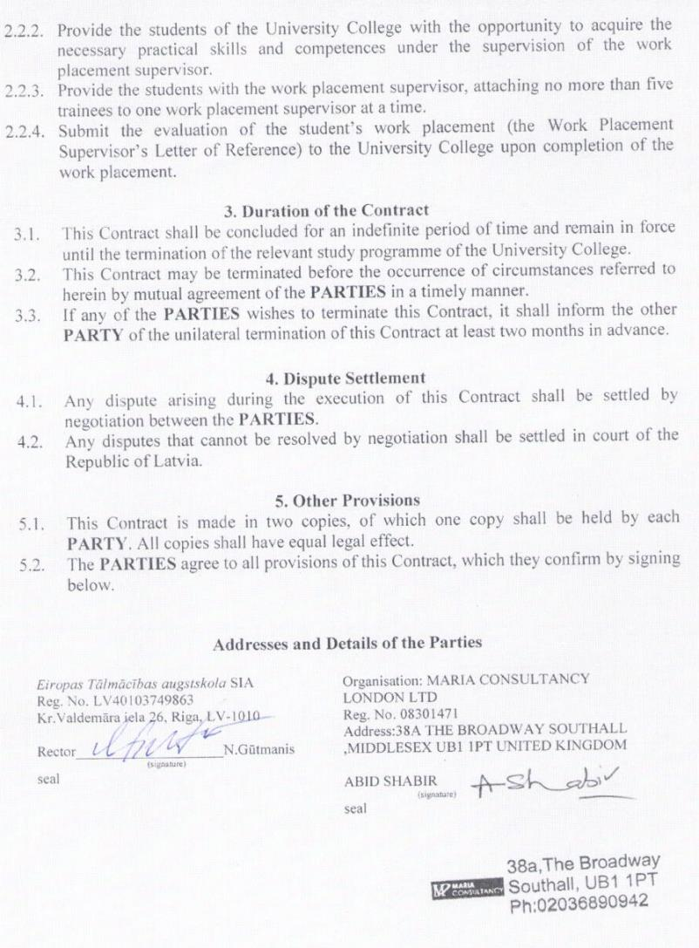
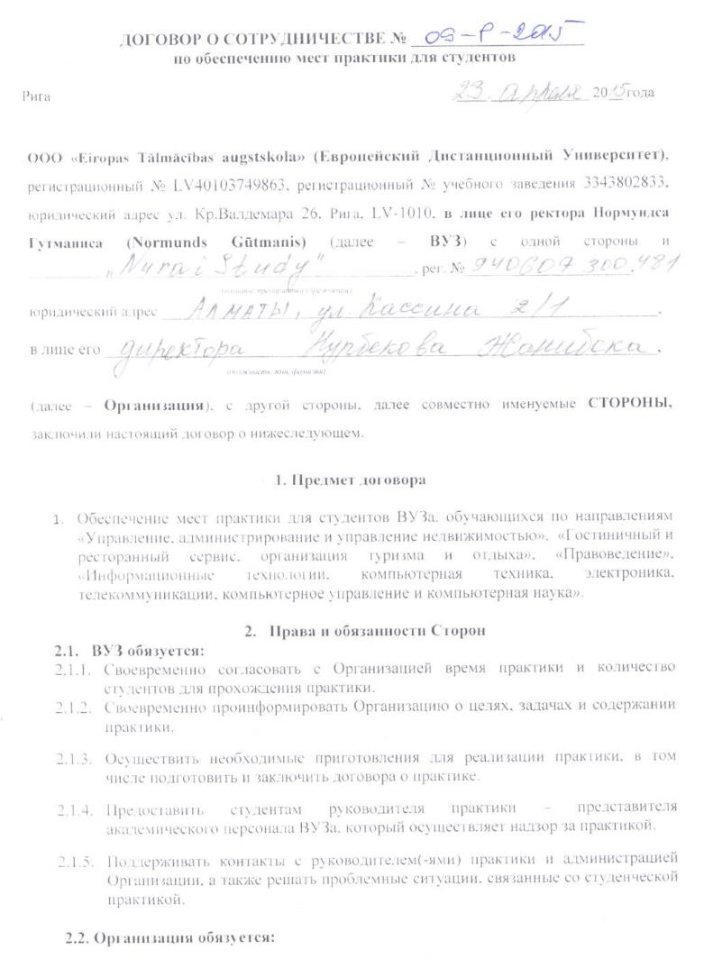
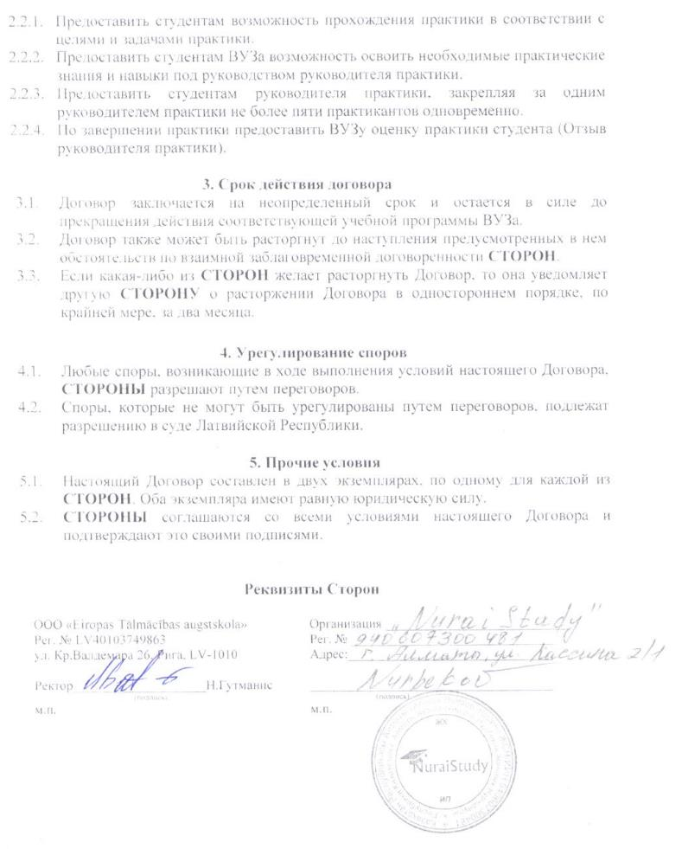
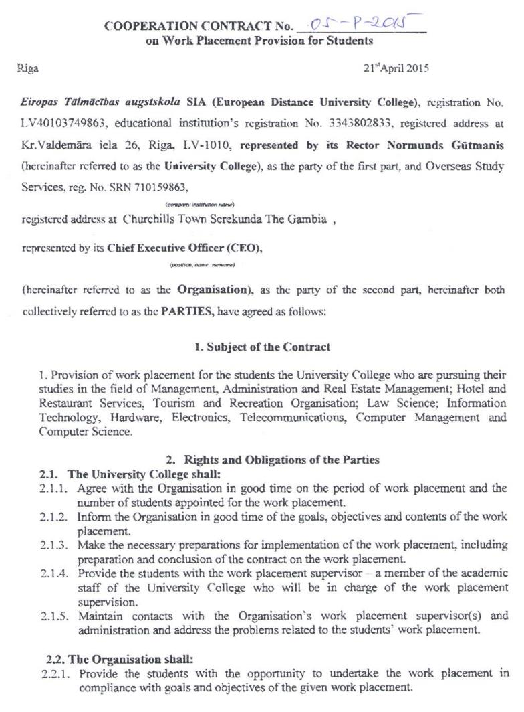
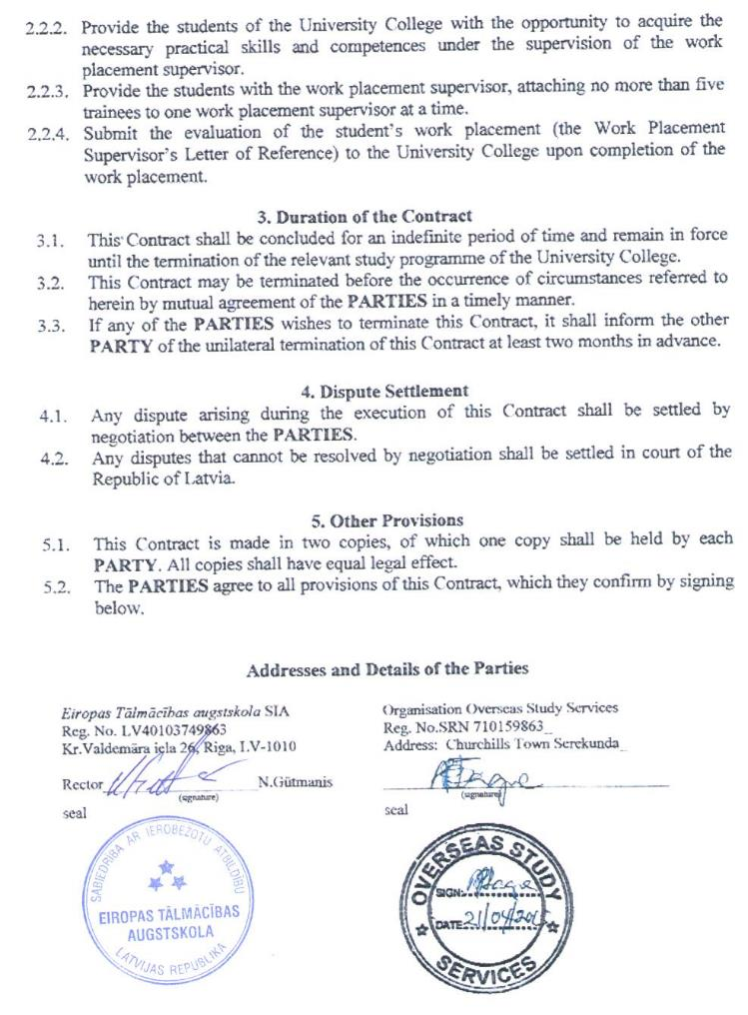
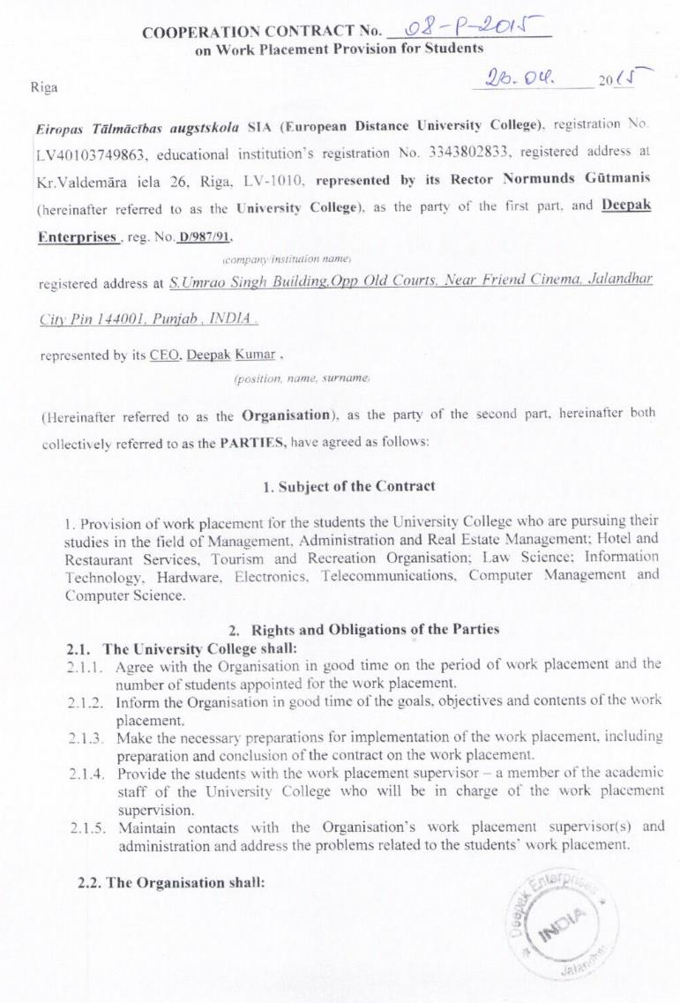
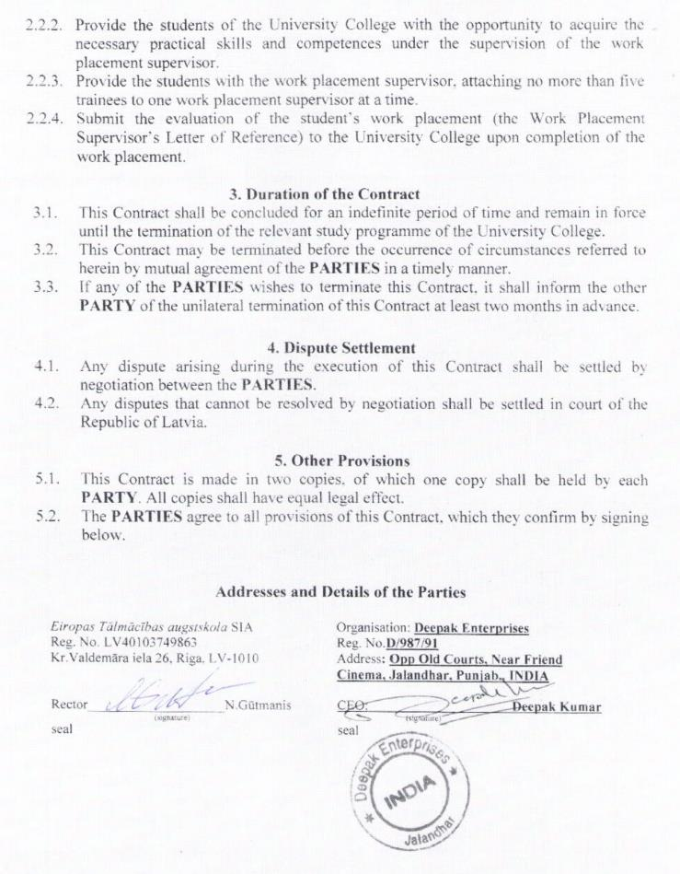
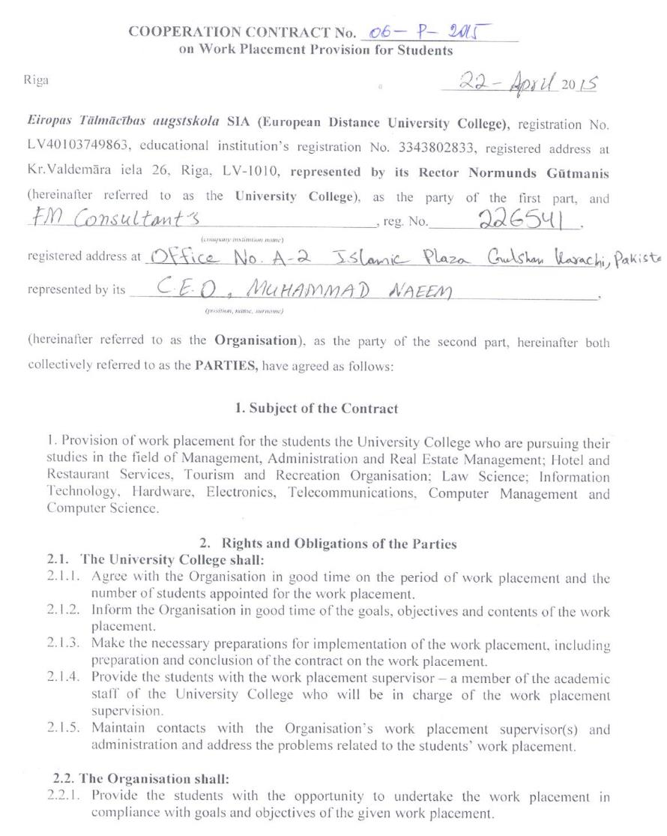
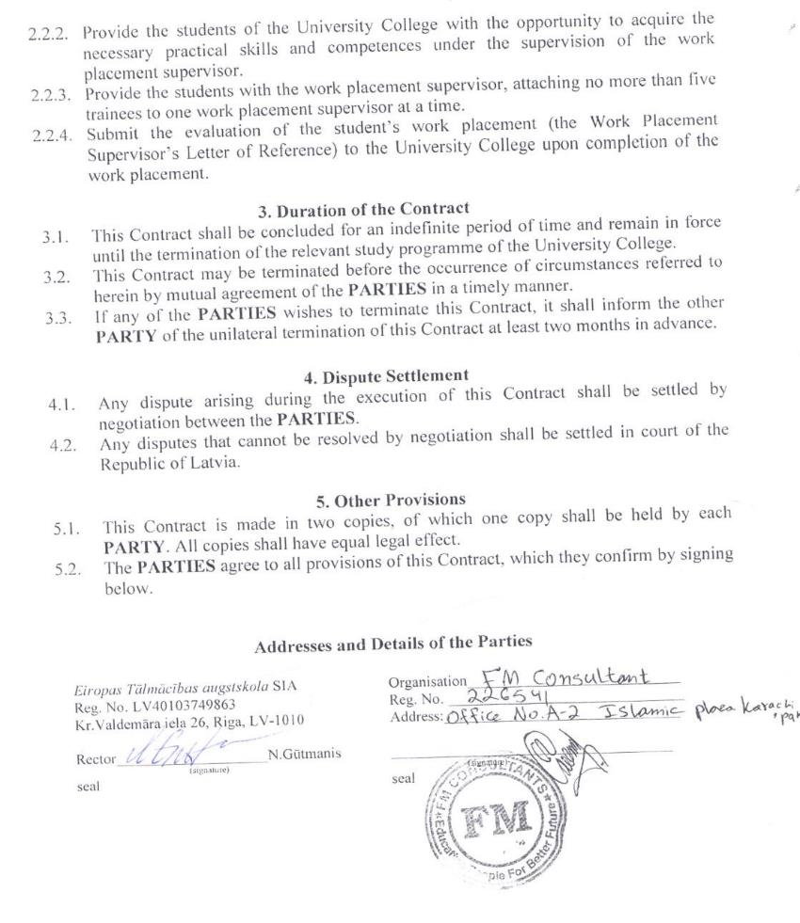

Work Placement Procedure
APPROVED
by Decision No.1 – 1.1./03-14
of the Senate of European Distance University
on 17 June 2014
WORK PLACEMENT PROCEDURE

Study Program "Business Administration"/Study Program "Personnel Management"

Content

1. GENERAL ISSUES 2
2. WORK PLACEMENT ORGANISATION AND CONDUCT 2
3. REPORT ON WORK PLACEMENT 3
4. ASSESSMENT OF WORK PLACEMENT 4
ANEXES 5

1. GENERAL ISSUES

  - The Work Placement Procedure of European Distance University (hereinafter referred to as the University) sets forth the key principles for the organisation, conduct and assessment of work placement within the programmes of study.
  - The work placement is organised outside the University, having regard to Cabinet’s Regulations No.512 of 16 August 2014 – State Standard for the Second Level Higher Professional Education and the professional standard for the relevant programme of study. The work placement is an integral part of the professional programme of study and its total duration is 26 weeks (equal to 26 credits) in bachelor’s programmes of study. In accordance with the requirements of the programme of study, the work placement may consist of several parts.
  - The strategic goal of the work placement is to contribute to improvement of theoretical knowledge, professional skills and competencies and obtain empirical material for the preparation of study papers and bachelor’s paper.

2. WORK PLACEMENT ORGANISATION AND CONDUCT

  - Every work placement has its objectives and tasks. They are drawn up by the director of the programme of study and approved by the council of the programme not later than two weeks before the start of the relevant work placement.
  - The Academic Office provides the students with the information on the tasks for the work placement by publishing them in the internal network of the University, under the section Documents. The student’s responsibility is to get acquainted with this information.
  - The student shall choose the work placement independently, in coordination with the director of the programme of study (the form of the Application for Work Placement is given in Annex 1). The student may also choose his/her own place of employment as the venue for work placement.
  - The University shall sign an agreement (Annex 2) with the institution regarding the provision of the work placement for the students. The student shall submit the signed agreement and the form of the Application for Work Placement to the Information Centre within the period specified in the Study Calendar.
  - The work placement shall be supervised by a representative of the academic staff appointed by the director of the programme of study. The University’s supervisor of the work placement shall provide methodological guidance as regards the work placement, student advice and methodological assistance.
  - At its venue, the work placement shall be supervised by the work placement supervisor duly appointed in the institution (company, organisation or authority), who shall be referred to as the Work Placement Supervisor.
  - The Work Placement Supervisor shall:
    - ensure the supervision of the student’s work placement and opportunity to fulfil specific tasks;
    - ensure that the working conditions are in compliance with the occupational health and safety requirements;
    - contact the University if the work placement tasks cannot be fulfilled or there are obstacles to the fulfilment thereof;
    - watch that the student follows the internal code of conduct and notify the University in case of violation thereof;
    - upon the completion of the work placement, evaluate the student’s work placement on a 10-point scale, make and sign a reference letter (Annex 3).
  - The trainee shall respect the confidentiality as regards the venue of the work placement, i.e. the trainee shall not disclose information to third parties that has become known to him or her while fulfilling the tasks of the work placement, as well as the information to which access is restricted at the venue of the work placement.
  - The trainee shall, within the period specified in the Study Calendar, submit a report to the Information Centre describing the results of the tasks fulfilled during the work placement and summarising the conclusions and recommendations. The reference letter made by the Work Placement Supervisor shall be attached to the Report on Work Placement as the last page.

3. REPORT ON WORK PLACEMENT
  - The work placement shall complete with the preparation and defence of the Report on Work Placement. The Report on Work Placement shall consist of 10 to 20 pages, excluding annexes.
  - The mandatory components of the Report on Work Placement:
- title page (Annex 4);
- table of content (in accordance with the tasks of the work placement; 1 task = 1 item on the plan);
- main part (specifying the fulfilment of the tasks), divided into chapters;
- conclusions and recommendations;
- list of literature and sources used (if necessary);
- annexes.
  - Technical requirements to the Report on Work Placement: the Report shall be written in accordance with the Methodological Guidelines for the Presentation of Study Papers.

4. ASSESSMENT OF WORK PLACEMENT

  - The Students shall prepare a presentation in MS Power Point or other suitable programme for the defence of their work placement (4 to 5 minutes).
  - The type of assessment of the defence of the work placement is a test with an evaluation on a 10-point scale. The student shall defend the Report on Work Placement in the particular semester before the board appointed by the director of the programme of study, and the board will evaluate the work placement results on a 10-point scale after reviewing the reference letter made by the Work Placement Supervisor, the content of the Report on Work Placement, the presentation and the student’s answers to questions about the work placement.
  - If the Work Placement Supervisor has assessed the student’s achievements during the work placement as inconsistent with the tasks of the work placement, the board appointed for the defence of the work placement may not take a contrary decision, and the particular work placement shall be regarded as an academic failure.
  - The Students who have failed to fulfil the tasks of the qualification work placement (of the final semester), have not submitted a report or have defended their work placement with an assessment of less than 4 points shall not be admitted to the defence of the bachelor’s paper.

ANNEXES

Annex 1 (Work Placement Procedure)

Attn.: Director of the programme of study
________________________________________ of European Distance University
___________________________
^{(student’s name, surname)}
___________________________
^{(ID No.)}
___________________________
^{(group code)}
___________________________
^{(contact phone, email)}

APPLICATION FOR WORK PLACEMENT

Please provide me with work placement at_____________________________________________________
(full name of the work placement provider )

_____________________________________________________________________

_____________________________________________________________________

Riga, ______________________20___

_________________
^{(student’s signature)}
Annex 2 (Work Placement Procedure)
COOPERATION AGREEMENT No. _____________________
on ensuring the places of practice for the students

Riga ____ ___________20__

The LLC „European Distance University College”, registration No. of the educational institution 3343802833, legal address 26 Kr.Valdemara Street, Riga, LV-1010, represented by the acting rector Normunds Gūtmanis (hereinafter referred to as the University College), as the party of the first part, and ______________________________________, registration No.______________________,
(company / institution name)
legal address _____________________________________________________________,

represented by ________________________________________________________________,
(position, name, surname)
(hereinafter referred to as the Institution), as the party of the second part, both collectively referred to as the PARTIES, enter into the following agreement.
1. Scope of Agreement

1. To ensure the places of practice for the students of the study programme “Business Administration”/ “Personnel Management” of the University College.

- Rights and Obligations of the Parties

  - The University College obliges:
    - to timely agree the time of practice and the number of students sent to practice with the Institution;
    - to timely notify the Institution of the aims, objectives and contents of practice;
    - to perform necessary preparatory work for implementation of practice which includes preparing and entering into the practice agreement;
    - to ensure the practice manager for the students, i.e. the representative of the academic staff of the University College who will supervise the practice;
    - to keep regular contacts with the practice manager (-s) and administration of the Institution, to solve problem situations related to the students’ practice.
2.2. The Institution obliges:
    - to ensure students’ opportunity to have as efficient training practice as possible in accordance with the aims and objectives of practice;
    - to provide the students of the University College with the opportunity of acquiring necessary practical knowledge and skills under supervision of the practice manager;
    - to ensure the practice manager for the students; one practice manager at the same time can supervise not more than five trainees;
    - at the end of the practice to provide the University College with the student’s practice assessment (the reference of the practice manager).

3. Validity of Agreement

  - The Agreement has been concluded for an indefinite period of time and remains valid till the respective study programme of the University College ceases to exist.
  - The Agreement can also be terminated before the occurrence of the conditions mentioned therein, by timely agreement of the PARTIES.
  - If any of the PARTIES wants to terminate the Agreement it must notify the other Party of the unilateral termination of the Agreement at least two months in advance.

- Liability of the Parties

  - The PARTIES cannot unilaterally refuse to fulfil their obligations.
  - Every PARTY can demand the other party to fulfil its obligations in good faith.
  - Every PARTY shall assume liability for violation of the terms and conditions of this Agreement in accordance with the legislation of the Republic of Latvia.

5. Dispute Resolution
  - The PARTIES shall settle all the disputes resulting from the execution of the terms and conditions of the Agreement in negotiations.
  - Disputes which cannot be solved in negotiations shall be settled in the court in accordance with the procedure established by the Civil Procedure Law.

6. Other Provisions
  - This Agreement has been made in duplicate, every PARTY receives one copy, every copy has equal legal force.
  - When signing this Agreement, the PARTIES agree with all the terms and conditions thereof.

Requisites of the Parties
LLC "European Distance University College"  Reg. No. 40003648413  26 Kr.Valdemara Street, Riga  Acting Rector ____________________E.Liepa  (signature) Place of the Seal | Company____________________________  Reg. No._______________________________  Address:_______________________________  _____________________________________  (position)  _____________________________________  (name, surname, signature)  Place of the Seal
Annex 3 (Work Placement Procedure)

EUROPEAN DISTANCE UNIVERSITY COLLEGE

REFERENCE OF THE PRACTICE MANAGER

The trainee ____________________________________________________________________
(name, surname, identity number)
performed practice tasks in _______________________________________________________
(name of the institution)

in the period from ___________________________ to _________________________________

1. The trainee has acquired / improved the following knowledge: _________________________________________________________________________________________________________________________________________________________________________________________________________________________________

2. The trainee has acquired / improved the following skills: _________________________________________________________________________________________________________________________________________________________________________________________________________________________________

3. The trainee has acquired / improved the following competences: _________________________________________________________________________________________________________________________________________________________________________________________________________________________________

4. Overall assessment of the tasks performed during the practice (1-10 points) ____________

___ ____ 20___

Practice Manager ____________________________________________________________
(signature, name, surname, position held)

Place of the Seal
Annex 4 (Work Placement Procedure)

EUROPEAN DISTANCE UNIVERSITY

Professional Study Program
„Business Management”/„Human Resource Management”

REPORT ON PRACTICAL TRAINING

LLC „Zelta disks”

________ group student
Name Surname

Institution of Practice Supervisor:
Name Surname

Higher School of Practice Supervisor:
Dr.oec. Gunta Grīnberga – Zālīte

2015

- Diploma and Diploma Supplement sample

EIROPAS TĀLMĀCĪBAS AUGSTSKOLA  PROFESIONĀLĀ BAKALAURA  DIPLOMS  Sērija PD <X>  Nr. <0000> | Ar valsts pārbaudījuma komisijas  20XX. gada XX. jūlija lēmumu Nr. 2-4.7.2.2.  Vita Ozola  personas kods 000000-00000  ieguvusi  PROFESIONĀLĀ BAKALAURA GRĀDU  VADĪBZINĀTNĒ  un  UZŅĒMUMA VADĪTĀJA KVALIFIKĀCIJU  Iegūtā kvalifikācija atbilst piektajam profesionālās  kvalifikācijas līmenim  Z. v.  Rektors Normunds Gūtmanis  Valsts pārbaudījuma  komisijas priekšsēdētājs Jānis Aļļis  Rīgā, 0000. gada 00. jūlijā  Reģistrācijas Nr. 00

DIPLOMA SUPPLEMENT
Diploma serial <XX><X> Nr.<0000>
This Diploma Supplement follows the model developed by the European Commission, Council of Europe and the United Nations Educational, Scientific and Cultural Organization (UNESCO/CEPES). The purpose of the supplement is to provide sufficient independent data and ensure academic and professional recognition of qualifications (diplomas, degrees, certificates etc.). It is designed to provide a description of the nature, level, context and status of the studies that were pursued and successfully completed by the individual named on the original qualification to which this supplement is appended. It should be free from any value judgements, equivalence statements or suggestions about recognition. Information in all eight sections should be provided. Where information is not provided, the reason should be explained.
1. INFORMATION IDENTIFYING THE HOLDER OF THE QUALIFICATION:

1.1 family name: | Ozola
1.2 given name: | Vita
1.3 date of birth: | dd.mm.yy.
1.4 student identification number or personal identification number: | 000000-00000

2. INFORMATION IDENTIFYING THE QUALIFICATION:

2.1 name of qualification (in original language): | Professional Bachelor’s Degree in Management and Qualification of a Business Manager
2.2 main field(s) of study for the qualification: | Management
2.3 name (in original language) and status of awarding institution (in case of a joint diploma – in original language): | Eiropas Tālmācības augstskola, state accredited dd.mm.yy., University founded by juridical person
2.4 name (in original language) and status of institution administering studies in Latvian (in original language): | See 2.3.
2.5 language(s) of instruction/examination: | Latvian

3. INFORMATION ON THE LEVEL OF THE QUALIFICATION:

3.1 level of qualification: | Fifth-level higher professional education diploma, see p. 6.1.
3.2 official length of programme (years and credits), start and end date of the acquisition of the programme: | 4 years full-time studies, 160 Latvian credit points, 240 ECTS credit points
3.3 admission requirements: | General secondary education or 9-year basic education plus 4-year secondary vocational education

4. INFORMATION ON THE CONTENTS AND RESULTS GAINED:

4.1 mode of study: | Full-time
4.2 programme requirements:
- To complete theoretical courses in the field of business which are necessary for a business manager and test the knowledge in practice in order to be able to organize the work and management of a company and its departments;
- To gain knowledge and skills in order to be able to develop a company’s business strategy, mission and objectives for the benefit of the state, the owners and the society. To plan and forecast a company’s effective operation in accordance with the set objectives, the economic environment and the labour market situation;
- To gain experience which is needed to understand the correlations of a company’s operations, as well as to analyze the current processes in the economic environment and make decisions according to the changing circumstances;
- Independent research in management (at least 26 weeks or 26 credits) and presentation of the results in the Term Paper and Bachelor’s Paper.

4.3 programme details (e.g. modules or units studied) and the individual grades/marks/credits obtained;
Nr. | Name of study course | CP | ECTS CP | Evaluation
General education curses
 | Total | 20 | 30
Basic theoretical courses and information technology courses
 | Total | 36 | 54
Courses of professional specialization
 | Total | 60 | 90
Optional courses
 | Total | 6 | 9
Practice
 | Total | 26 | 39
Qualification examination and bachelor’s assessment “…”
 |  | 12 | 18
Total |  | 160 | 240

4.4 grading scheme and, if available, grade distribution guidance: | Examinations: 10 - with distinction, 9 - excellent, 8 - very good, 7 - good, 6 - almost good, 5 - satisfactory, 4-almost satisfactory, 3-1 - not satisfactory
 | Tests (with mark): pass (10); pass (9); pass (8); pass (7); pass (6); pass (5); pass (4); not pass (3-1)
 | Tests (without mark): pass; not pass
4.5 overall classification of the qualification (in original language): | nav

5. INFORMATION ON THE QUALIFICATION:

5.1 access to further study: | Access to Master programmes and to professional programmes designed for studies after award of bachelor degree
5.2 professional status (if applicable): | Level 5 of professional qualification gives the right to work as a business manager

6. ADDITIONAL INFORMATION AND SOURCES.
6.1. additional information: | European distance university second level professional Bachelor’s study programme “Management” is accredited till 17.12.2015
6.2. further information sources: | Kr.Valdemara Str. 26, Riga, LV-1010, Latvia. Phone +371 20200700, e-mail: ic@universitymail.eu; www.augstskola.com

7. CERTIFICATION OF THE SUPPLEMENT:

7.1 date: |  | dd.mm.yy.
7.2 signature: |  | Normunds Gutmanis
7.3 capacity:
7.4 official stamp:

8. INFORMATION ON THE NATIONAL HIGHER EDUCATION SYSTEM.
Certificate of general secondary education and diploma of vocational secondary education gives the right to continue education at higher education level. However, the universities/colleges are free to set specific admission requirements, e.g. additional subjects that had to be taken at the secondary school level to quality for admission to a particular programme.
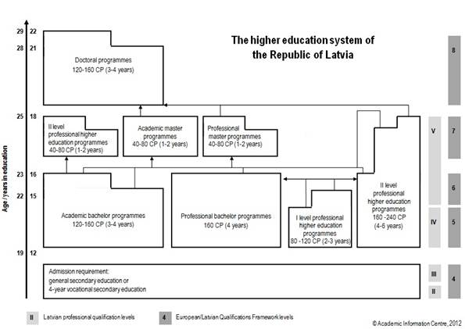
According to the Latvian legislation, higher education programmes are placed in the Latvian Qualifications Framework (henceforth – LQF) and comply with eight levels of the European Qualifications Framework (henceforth – EQF).
The Placement of Higher Education Certifying Education Documents in the LQF and EQF
Education documents certifying higher education | LQF and EQF level
Diploma of first level professional higher education | 5
Bachelor’s diploma  Professional Bachelor’s diploma  Diploma of professional higher education, diploma of higher professional qualification (second level professional higher education, the length of full-time studies – at least 4 years) | 6
Master’s diploma  Professional Master’s diploma  Diploma of professional higher education, diploma of higher education, diploma of higher professional qualification (second level professional higher education, the total length of full-time studies – at least 5 years) | 7
Doctor’s diploma | 8
Higher education system comprises both academic higher education and professional higher education. Bakalaurs (Bachelor's) and maģistrs (Master's) degrees are awarded both in academic and professional higher education programmes.
The objectives of the academic higher education (HE) are to prepare graduates for an independent research work, as well as to provide theoretical background for professional activities.
Academic programmes leading to a bakalaurs (Bachelor's) degree comprise 120–160 credit points (henceforth – CP) (160–240 ECTS). The duration of full-time studies is 6–8 semesters (3–4 years).
Academic programmes leading to maģistrs (Master's) degree comprise 40–80 CP (60–120 ECTS). The duration of full-time studies is 2–4 semesters (1–2 years).
Total duration of full-time Bachelor's and Master's studies is at least 5 years.
Academic education programmes are implemented according to the state standard of the academic education.
The objectives of the professional HE are to provide in-depth knowledge in a particular field, preparing graduates for design or improvement of systems, products and technologies, as well as to prepare them for creative, research and teaching activities in this field.
Professional HE programmes leading to a professional bakalaurs (Bachelor's) degree are designed to ensure a professional competence, they comprise at least 160 CP (240 ECTS) including practical placement of ≤ 26 CP (39 ECTS). The duration of full-time studies is at least 8 semesters (4 years).
Professional HE programmes leading to a professional maģistrs (Master's) degree comprise no less than 40 CP (60 ECTS) including practical placements of ≤ 6 CP (9 ECTS). The duration of full-time studies is at least 2 semesters (1 year).
Total duration of full-time Bachelor's and Master's studies is at least 5 years.
Graduates of both types of bakalaurs (Bachelor's) degree have access to Master's studies, graduates of the maģistrs (Master's) degree – to doctoral studies.
Degrees obtained in medicine, dentistry and pharmacy professional studies (5 and 6 years of studies) are referenced to the maģistrs (Master's) degree and the graduates can continue their studies in doctoral level programmes.
In the professional HE there are other types of programmes apart from Bachelor's and Master's study programmes.
• First level professional HE (college) study programmes that lead to the 4th level professional qualification (LQF level 5). Programmes comprise 80–120 CP (120–180 ECTS), and these programmes are mainly targeted at labour market, yet the graduates can continue their studies in second level professional HE programmes.
• Second level professional HE study programmes that lead to the 5th level professional qualification (LQF level 6–7). These programmes can comprise either at least 40 CP (60 ECTS) for holders of bakalaurs (Bachelor's) degree or at least 160 CP (240 ECTS) for secondary school leavers. In both cases programmes should include a practical placement and graduation examinations. If study programme comprises 160 CP (240 ECTS) and the compulsory part of a bakalaurs (Bachelor's) programme, graduates obtain access to Master's studies.
Doctoral studies. Since January 1, 2000 a single type of doctoral degree – doktors – is awarded in Latvia. The degree of maģistrs (Master's degree) is required for admission to doctoral studies. Doktors (Doctoral) degree is awarded after public defence of doctoral thesis and successfully passed exams in the chosen scientific branch or sub-branch. The doctoral thesis has to include original results of the research and new cognitions in the scientific discipline and may be a result of three to four years of doctoral studies at a higher education institution or an equivalent amount of independent research. The doctoral thesis may be a dissertation, a set of scientific publications or a monograph. The rights to award the doktors (Doctoral) degree are delegated by decision of the Cabinet of Ministers to promotion councils established at the universities. The procedure for awarding the doktors (Doctoral) degree is controlled by the Commission of the Scientific Qualification.
Grading system. Degree of achieved study results is assessed by 10-point degree system or PASS/FAIL.
10-point Degree System
Achievement level | Grade | Meaning | Approx. ECTS grade
very high | 10 | izcili (with distinction) | A
very high | 9 | teicami (excellent) | A
high | 8 | ļoti labi (very good) | B
high | 7 | labi (good) | C
medium | 6 | gandrīz labi (almost good) | D
medium | 5 | viduvēji (satisfactory) | E
medium | 4 | gandrīz viduvēji (almost satisfactory) | E/FX
low | 3–1 | negatīvs vērtējums (unsatisfactory) | Fail
Quality assurance. According to the Latvian legislation, state-recognized degrees/diplomas may be awarded upon the completion of an accredited programme in an accredited HE institution holding a state-approved Satversme (by-law) or college statute. Decisions on programme accreditation are taken by the Study Accreditation Commission, while those on the institutional accreditation – by the Higher Education Council.
More information:
1. On educational system – http://www.izm.gov.lv;
2. On recognition diplomas – http://www.aic.lv;
3. On status of programmes/institutions – http://www.aiknc.lv
4. On study possibilities in Latvia – http://studyinlatvia.lv
5. On European education systems and policies – www.eurydice.org

EIROPAS TĀLMĀCĪBAS AUGSTSKOLA  PROFESIONĀLĀ BAKALAURA  DIPLOMS  Sērija PD <X>  Nr. <0000> | Ar valsts pārbaudījuma komisijas  20XX. gada XX. jūlija lēmumu Nr. 2-4.7.2.5.  Vita Ozola  personas kods 000000-00000  ieguvusi  PROFESIONĀLĀ BAKALAURA GRĀDU  VADĪBZINĀTNĒ  un  PERSONĀLA VADĪTĀJA KVALIFIKĀCIJU  Iegūtā kvalifikācija atbilst piektajam profesionālās  kvalifikācijas līmenim  Z. v.  Rektors Normunds Gūtmanis  Valsts pārbaudījuma  komisijas priekšsēdētājs Jānis Aļļis  Rīgā, 0000. gada 00. jūlijā  Reģistrācijas Nr. 00

DIPLOMA SUPPLEMENT
Diploma serial <XX><X> Nr.<0000>
This Diploma Supplement follows the model developed by the European Commission, Council of Europe and the United Nations Educational, Scientific and Cultural Organization (UNESCO/CEPES). The purpose of the supplement is to provide sufficient independent data and ensure academic and professional recognition of qualifications (diplomas, degrees, certificates etc.). It is designed to provide a description of the nature, level, context and status of the studies that were pursued and successfully completed by the individual named on the original qualification to which this supplement is appended. It should be free from any value judgements, equivalence statements or suggestions about recognition. Information in all eight sections should be provided. Where information is not provided, the reason should be explained.
1. INFORMATION IDENTIFYING THE HOLDER OF THE QUALIFICATION:

1.1 family name: | Ozola
1.2 given name: | Vita
1.3 date of birth: | dd.mm.yy.
1.4 student identification number or personal identification number: | 000000-00000

2. INFORMATION IDENTIFYING THE QUALIFICATION:

2.1 name of qualification (in original language): | Professional Bachelor's degree in Business Administration and Human Resource Manager qualification
2.2 main field(s) of study for the qualification: | Human Resource Management
2.3 name (in original language) and status of awarding institution (in case of a joint diploma – in original language): | Eiropas Tālmācības augstskola, state accredited dd.mm.yy., University founded by juridical person
2.4 name (in original language) and status of institution administering studies in Latvian (in original language): | See 2.3.
2.5 language(s) of instruction/examination: | Latvian

3. INFORMATION ON THE LEVEL OF THE QUALIFICATION:

3.1 level of qualification: | Fifth-level higher professional education diploma, see p. 6.1.
3.2 official length of programme (years and credits), start and end date of the acquisition of the programme: | 4 years full-time studies, 160 Latvian credit points, 240 ECTS credit points
3.3 admission requirements: | General secondary education or 9-year basic education plus 4-year secondary vocational education

4. INFORMATION ON THE CONTENTS AND RESULTS GAINED:

4.1 mode of study: | Full-time
4.2 programme requirements:
- Mastering theoretical courses in human resource management, management sciences, internal and external communication as well as general education courses;
- Acquisition of knowledge and skills to be able to ensure the company's human resource management functions, to plan the company’s personnel budget, personnel resources and the necessary expertise of the personnel as well as the division of responsibilities;
- Acquiring the experience necessary to understand the processes that take place in the labor market and make decisions according to changes in the situation;
- Independent research in the field of human resource management (at least 26 weeks or 26 credits) and summary of the results in the term paper and in the bachelor’s thesis.

4.3 programme details (e.g. modules or units studied) and the individual grades/marks/credits obtained;
Nr. | Name of study course | CP | ECTS CP | Evaluation
General education curses
 | Total | 20 | 30
Basic theoretical courses and information technology courses
 | Total | 36 | 54
Courses of professional specialization
 | Total | 60 | 90
Optional courses
 | Total | 6 | 9
Practice
 | Total | 26 | 39
Qualification examination and bachelor’s assessment “…”
 |  | 12 | 18
Total |  | 160 | 240

4.4 grading scheme and, if available, grade distribution guidance: | Examinations: 10 - with distinction, 9 - excellent, 8 - very good, 7 - good, 6 - almost good, 5 - satisfactory, 4-almost satisfactory, 3-1 - not satisfactory
 | Tests (with mark): pass (10); pass (9); pass (8); pass (7); pass (6); pass (5); pass (4); not pass (3-1)
 | Tests (without mark): pass; not pass
4.5 overall classification of the qualification (in original language): | nav

5. INFORMATION ON THE QUALIFICATION:

5.1 access to further study: | Access to Master programmes and to professional programmes designed for studies after award of bachelor degree
5.2 professional status (if applicable): | Level 5 of professional qualification gives the right to work in the Human Resource Manager specialization

6. ADDITIONAL INFORMATION AND SOURCES.
6.1. additional information: | European distance university second level professional Bachelor’s study programme “Human Resource Management” is accredited till 17.12.2015
6.2. further information sources: | Kr.Valdemara Str. 26, Riga, LV-1010, Latvia. Phone +371 20200700, e-mail: ic@universitymail.eu; www.augstskola.com

7. CERTIFICATION OF THE SUPPLEMENT:

7.1 date: |  | dd.mm.yy.
7.2 signature: |  | Normunds Gutmanis
7.3 capacity:
7.4 official stamp:

8. INFORMATION ON THE NATIONAL HIGHER EDUCATION SYSTEM.
Certificate of general secondary education and diploma of vocational secondary education gives the right to continue education at higher education level. However, the universities/colleges are free to set specific admission requirements, e.g. additional subjects that had to be taken at the secondary school level to quality for admission to a particular programme.
According to the Latvian legislation, higher education programmes are placed in the Latvian Qualifications Framework (henceforth – LQF) and comply with eight levels of the European Qualifications Framework (henceforth – EQF).
The Placement of Higher Education Certifying Education Documents in the LQF and EQF
Education documents certifying higher education | LQF and EQF level
Diploma of first level professional higher education | 5
Bachelor’s diploma  Professional Bachelor’s diploma  Diploma of professional higher education, diploma of higher professional qualification (second level professional higher education, the length of full-time studies – at least 4 years) | 6
Master’s diploma  Professional Master’s diploma  Diploma of professional higher education, diploma of higher education, diploma of higher professional qualification (second level professional higher education, the total length of full-time studies – at least 5 years) | 7
Doctor’s diploma | 8
Higher education system comprises both academic higher education and professional higher education. Bakalaurs (Bachelor's) and maģistrs (Master's) degrees are awarded both in academic and professional higher education programmes.
The objectives of the academic higher education (HE) are to prepare graduates for an independent research work, as well as to provide theoretical background for professional activities.
Academic programmes leading to a bakalaurs (Bachelor's) degree comprise 120–160 credit points (henceforth – CP) (160–240 ECTS). The duration of full-time studies is 6–8 semesters (3–4 years).
Academic programmes leading to maģistrs (Master's) degree comprise 40–80 CP (60–120 ECTS). The duration of full-time studies is 2–4 semesters (1–2 years).
Total duration of full-time Bachelor's and Master's studies is at least 5 years.
Academic education programmes are implemented according to the state standard of the academic education.
The objectives of the professional HE are to provide in-depth knowledge in a particular field, preparing graduates for design or improvement of systems, products and technologies, as well as to prepare them for creative, research and teaching activities in this field.
Professional HE programmes leading to a professional bakalaurs (Bachelor's) degree are designed to ensure a professional competence, they comprise at least 160 CP (240 ECTS) including practical placement of ≤ 26 CP (39 ECTS). The duration of full-time studies is at least 8 semesters (4 years).
Professional HE programmes leading to a professional maģistrs (Master's) degree comprise no less than 40 CP (60 ECTS) including practical placements of ≤ 6 CP (9 ECTS). The duration of full-time studies is at least 2 semesters (1 year).
Total duration of full-time Bachelor's and Master's studies is at least 5 years.
Graduates of both types of bakalaurs (Bachelor's) degree have access to Master's studies, graduates of the maģistrs (Master's) degree – to doctoral studies.
Degrees obtained in medicine, dentistry and pharmacy professional studies (5 and 6 years of studies) are referenced to the maģistrs (Master's) degree and the graduates can continue their studies in doctoral level programmes.
In the professional HE there are other types of programmes apart from Bachelor's and Master's study programmes.
• First level professional HE (college) study programmes that lead to the 4th level professional qualification (LQF level 5). Programmes comprise 80–120 CP (120–180 ECTS), and these programmes are mainly targeted at labour market, yet the graduates can continue their studies in second level professional HE programmes.
• Second level professional HE study programmes that lead to the 5th level professional qualification (LQF level 6–7). These programmes can comprise either at least 40 CP (60 ECTS) for holders of bakalaurs (Bachelor's) degree or at least 160 CP (240 ECTS) for secondary school leavers. In both cases programmes should include a practical placement and graduation examinations. If study programme comprises 160 CP (240 ECTS) and the compulsory part of a bakalaurs (Bachelor's) programme, graduates obtain access to Master's studies.
Doctoral studies. Since January 1, 2000 a single type of doctoral degree – doktors – is awarded in Latvia. The degree of maģistrs (Master's degree) is required for admission to doctoral studies. Doktors (Doctoral) degree is awarded after public defence of doctoral thesis and successfully passed exams in the chosen scientific branch or sub-branch. The doctoral thesis has to include original results of the research and new cognitions in the scientific discipline and may be a result of three to four years of doctoral studies at a higher education institution or an equivalent amount of independent research. The doctoral thesis may be a dissertation, a set of scientific publications or a monograph. The rights to award the doktors (Doctoral) degree are delegated by decision of the Cabinet of Ministers to promotion councils established at the universities. The procedure for awarding the doktors (Doctoral) degree is controlled by the Commission of the Scientific Qualification.
Grading system. Degree of achieved study results is assessed by 10-point degree system or PASS/FAIL.
10-point Degree System
Achievement level | Grade | Meaning | Approx. ECTS grade
very high | 10 | izcili (with distinction) | A
very high | 9 | teicami (excellent) | A
high | 8 | ļoti labi (very good) | B
high | 7 | labi (good) | C
medium | 6 | gandrīz labi (almost good) | D
medium | 5 | viduvēji (satisfactory) | E
medium | 4 | gandrīz viduvēji (almost satisfactory) | E/FX
low | 3–1 | negatīvs vērtējums (unsatisfactory) | Fail
Quality assurance. According to the Latvian legislation, state-recognized degrees/diplomas may be awarded upon the completion of an accredited programme in an accredited HE institution holding a state-approved Satversme (by-law) or college statute. Decisions on programme accreditation are taken by the Study Accreditation Commission, while those on the institutional accreditation – by the Higher Education Council.
More information:
1. On educational system – http://www.izm.gov.lv;
2. On recognition diplomas – http://www.aic.lv;
3. On status of programmes/institutions – http://www.aiknc.lv
4. On study possibilities in Latvia – http://studyinlatvia.lv
5. On European education systems and policies – www.eurydice.org
- CVs of the academic staff involved in the implementation of the field of study as regards their scientific research and creative work
Europass  Curriculum Vitae | 
Personal information
Surname / Name | Antane Marija
Address | Stabu iela 50-16, Riga, LV 1011, Latvia
Phone | 29435206
E-Mail | Marija.antane@gmail.com
Date of birth | 14.09.1952.
Work experience
Period | 2012 – till now
Position held | Visiting Lecturer, Travel Program Consultant
Main duties | Give lectures, conduct classes, compile and update the program,  ensure consultations for students.
Company/institution | LBK - Latvian Business College, European School of Distance Education
Period | 1998.- 2012.
Position held | Department of Languages - Lecturer
Main duties | Give lectures, conduct classes, compile and update the program,  ensure consultations for students.
Company/institution | School of Business Administration Turiba
Period | 1997.-1998.
Position held | Lecturer
Main duties | Give lectures, conduct classes, compile and update the program,  ensure consultations for students.
Company/institution | School of International Tourism
Period | 1995.-1998.
Position held | Head of union
Main duties  Company/institution | Manage and organize seminars for district teachers to develop methodological recommendations, organize and manage student Olympiads.  Head of German teachers’ methodological union of Ogre Region
Period | 1989.-1998.
Position held | German and Russian language teacher
Main duties | German and Russian language teacher, prepare students to study Olympiads.
Company/institution | Jumpravas Secondary School
Period | 1981.-1983.
Position held | Deputy director for extracurricular activities
Main duties | Extracurricular work organization, event organization,consulting the class teachers
Company/institution | Aizkraukles secondary school No.2
Education  Period | 2012.
Specialization / Qualification | Academic Information Centre's decision (LU Faculty of Foreign Languages in 1978 acquired education equivalent to a master's degree in Philology) Master of Philology / Mag.phil /.
Establishment | Academic Information Center
Period | 1998.-2001.
Specialization / Qualification | Discontinued
Establishment | University of Latvia Institute of Pedagogy and Psychology  Phd. studies (dissertation topic “Profesionālā saskarsme”)
Period | 1994.-1995.
Specialization / Qualification | Head of Department of International Relations
Establishment | University of Latvia International Relations Institute
Period | 1996.-1997.
Specialization / Qualification | Master’s degree in Pedagogy (Mag.paed.)
Establishment | University of Latvia Institute of Pedagogy and Psychology
Period | 1971.-1978.
Specialization / Qualification | Philologist, German language teacher
Establishment | University of Latvia Faculty of Foreign Languages
Languages:
Mother tongue  Other languages | Latvian
 |  | Understanding | Speaking skills |  | Writing skills
Russian language |  | excellent | excellent |  | excellent
English language |  | good | average |  | average
German language |  | excellent | excellent |  | excellent
French language |  | excellent | excellent |  | excellent
Spanish language |  | good | good |  | good
Computer skills | MS Word, Excel, Power Point
Driving Licence | B category driving licence
Scientific research, projects  Participant in International projects:  Participation in conferences | Scientific research activity:  The role of foreign languages in project work and studies regarding  state (Landeskunde);  Foreign language teaching for adults  Developing tourism education  Lecturer/participant as BAT representative in EU Leonardo da Vinci project “Eiropas ceļojumu un tūrisma koordinators”, in cooperation with German enterprise “Comhard” Ltd.  9-10th December 2014 The National Academy of Tourism „International tourism conference” in St.Petersburg.  4-5th May 2014 The Russian International Academy for Tourism „ International tourism conference” in Pskov.  2013 9-10th October report „Tūrisma un tūrisma izglītības aktualitātes Latvijā” Baltic Academy of Tourism and Entrepreneurship organized by the international scientific practical conference on the modernization of tourism education (St. Petersburg, Russia).  2011.14.04. Research paper “Die Rolle der Motivation beim Erwerb der Fachfremdsprache im Bereich des Tourismus” Daugavpils University 53.th International scientific conference.  2010 Report “Valodu apguves motivācijas veicināšana profesionālās vācu valodas apguvē” in the 7th International scientific methodological conference “Valodu apguve: problēmas un perspektīva”. University of Liepāja.  2009 Research paper “Projektunterricht im Bereich Landeskunde” Daugavpils University 50th International conference. 15. -18.04.2009.  2008 Research paper Vācu valodas pasniedzēju starptautiskajos kursos Lībekā, Germany  2008 Research paper “Projektu loma lietišķajā vācu valodā” International scientific conference “Sabiedrība, integrācija, izglītība” Rēzeknē, Rēzeknes Augstskolā. 22.-23.2008.  2007 Research paper ”The Role of Project Work in Teaching German for Special Purposes at the International Tourism Faculty” // Publicēts kppsavilkums. Abstract Book of the 7th Conference on Baltic Studies in Europe “The Baltic Region between Germany and Russia. Dependence and Independence in Past and Present” Nordost - Institut Luneburg, Germany . 08.-10.06.2007.  2004 Research paper “Projektu loma studentu iztēles un kreativitātes attīstīšanā”.IX International Creativity conference “Kreativitātes izpēte un atraisīšana”. RPIVA, Rīga.  2004 Research paper “Tūrisma attīstības iespējas Latvijā” 109. Eiropas skolotāju seminārā “Europa – Lehrer – Seminars” Strasburg, France. 14.-19.10.2004.
Study courses (subjects)  Methodological work  Scientific publications: | Foreign languages (German) for special purposes,  Professional terminology (German, French, Russian),  Intercultural communication,  Communication and Culture,  Intercultural interaction,  Business etiquette  Hotel management  World market forces and tourism management  Forms of tourism  Tourism economics  Tourism geography  Travel organization  Excursion management  8 – 12th December, 2014 Baltic Tourism and Business Academy in St.Petersburg. Lectures in Tourism for local students.  Study courses designed  2013 Rural tourism ETA  2013 Excursion management ETA  2012 World market forces and tourism management EIHSEBA  2011 Travel organization LBK  2011 Professional Terminology (Russian) 4 CP 2nd level higher professional bachelor study programme “Public Relationship and Public Communication”  - Intercultural communication  - Intercultural interaction  - Communication and culture  - Professional Terminology (French) 4CP BAT, 2nd level higher professional bachelor study programme “ Business and Recreation Events Management”  - Professional Terminology (French) 4CP BAT,2nd level higher professional bachelor study programme “ Tourism and Hospitality Management”  - German language programme for A1, A2, B1, B2 levels, BAT Lifelong learning department  - French language programme for A1, A2, B1, B2 levels, BAT Lifelong learning department  Number of publications –9  2012 “Die Rolle der Motivation beim Erwerb der Fachfremdsprache im Bereich des Tourismus” Daugavpils University 53rd international  scientific conference`s scientific papers.  2011 Motivation beim Erwerb der Fachsprache Deutsch im Bereich des Tourismus. // Proceedings of the 7.th International scientific metod. conference in Liepāja ''Valodu apguve, problēmas un perspektīva'' Volume, 2011.  2010 Projektunterricht als ein Wichtiger Bestandteil des Fremdsprachlichen und Landeskundlichen Lernens. // Proceedings of the 51st scientific conference. Volume 1. Daugavpils Universitātes Akadēmiskais Apgāds “Saule”, s.230-235. ISBN 978-9984-14-480-1.
Other articles:  Most significant publications  Further education and professional development | 2009 Nov. Publication “Projektunterricht im Bereich Landeskunde”  Daugavpils University 51st International scientific conference proceedings. (submitted for publishing).  2008 Publication “Projektu loma lietišķajā vācu valodā” International scientific conference “Sabiedrība, integrācija, izglītība” proceedings. Rēzekne: Rēzeknes Augstskola, 2008. 18.-24. p.  2007 Summary of research paper ”The Role of Project Work in Teaching German for Special Purposes at the International Tourism Faculty”” International conference Lineburgā (Germany) proceedings 08.-10.06.2007  2006 Publication “Projektu loma studenu iztēles un kreativitātes attīstīšanā lietišķajā vācu valodā” // Zinātnisko rakstu krājums “Radoša personība IV”. Rīga: Publishing house “Kreativitātes centrs”. 234. – 239. p.  2010 Valodu katedras pasniedzēja viesojas Sanktpēterburgā. Uploaded on BAT webpage. http://www.turiba.lv/lat/dzive_turiba/aktualitates/valodu_katedras_pasniedzeja_vi Uploaded on 17th May, 2010.  2007 Article „Baltijas reģions starp Vāciju un Krieviju. Atkarība un neatkarība pagātnē un tagadnē” Lineburgā (Germany) BAT webpage. www.turiba.lv Published on 15th June 2007.  2008 Research paper “Projektu loma lietišķajā vācu valodā” International scientific conference “Sabiedrība, integrācija, izglītība” Rēzeknē, Rēzeknes Augstskolā. 22.-23.2008.  2004 Research paper “Projektu loma studentu iztēles un kreativitātes attīstīšanā”.IX International Creativity conference “Kreativitātes izpēte un atraisīšana”. RPIVA, Rīga.  April 26-30, 2010 givin lectures in Applied Linguistics (German), pedagogy, foreign language teaching methodology:  in St.Petersburgh State University, for the students of the Faculty of International Relations,  in St.Petersburgh Engineering Economic University, for the students of the Faculty of Economics and management, the specialization of Tourism and Hospitality,  in St.Petersburgh Baltic Tourism and Business Academy students.  2009 LU International methodological seminar “Eiropas Savienības juridiskā terminoloģija”  2009 LU concluding conference on European language days  2008 Spanish language courses BAT PIC  2008 International courses for German language teachers Lubeck, Germany “Landeskunde”  2007 Participation in German Language teachers’ annual meeting  2006 LVAVA courses on teaching methodology for teaching Latvian as a second language  2005/2006 Methodological courses “Augstskolu mācību spēku pedagoģiskā pilnveide/inovācija augstskolu izglītības sistēmā/izglītības darba vadība” . Certificate No.0896, 14.02.2006.  2000-2004 French language courses at the French Cultural Academy  2002 Internship (Visiting and conducting lectures) German language for foreigners at Lesing gymnasium Uelzen (Germany)  2001 Participated in seminar, Faculty of pedagogy Kārļa University Minstere (Germany)  1998 Seminar – courses for German language teachers Bremen (Germany)  1997 International Research seminar – conference “Fremdsprachenerwerb -Fremdsprachenvermittlung”  1996 Courses for German teachers, Linneburg, Germany
Participation in academic and associations, elected professional positions | Board member of Latvian Guides Association;  Organising excursions for German, French and Russian tourists;  Participation in clean up activities at German soldiers’ cemetery in Latvia  Participation in International Tourism trade fair “Balttour”  Participation in German and Swiss culture societies
11.06.2015.
Dr. iur. Alexander Baikov
(curriculum vitae)

Date of birth: | 1951
Education: | 1981 – 1985  1974 – 1980  1966 – 1971  1958 – 1966 | Moscow State University, post-graduate course, the degree of legal science candidate in civil law  State University of Latvia, lawyer’s diploma with honours  USSR Sea float ministry Riga sea school, diploma of universal ship’s engineer  Riga Secondary school № 53
Academic titles and research degrees:
2007  2005.  1993.  1992. | Asoc.professor in legal sciences, civil law sub-sector, University of Latvia, UL professors’ committee  Asoc.professor, Senate of Baltic International Academy  Doctor degree in legal sciences, University of Latvia, UL habilitation and doctorate committee  Docent, docent diploma
Experience:
1980 - 1981  1984 – 1985  1985 – 1988  1988 – 1989  1989 – 1991  1991 – 1992  1992  1992 – 1993  1993 – 1994  1994 – 1996  1995 – 1997  1995 – 1997  1997– 1998  1997 - 2005  2005 – 2006  1998  1998 - 2009  2008 – 2010  2006 – 2007  2007 - till the present moment  2007 - till the present moment  2008 - till the present moment  2012 - till the present moment | SUL senior methodologist of study-resource room.  SUL Soviet Law department, lecturer.  SUL Soviet Law department, senior lecturer.  SUL Soviet Law department, docent.  Minsk militia higher school, Faculty of Riga, the Head of the State Legal Science Department.  LVU (Latvian State University), Faculty of Law, Department of Civil Rights, lecturer.  Baltic Russian Institute, juridical programme manager, docent.  “RCR” Ltd, lawyer.  “Bonus Line” Ltd, lawyer.  “Bonus Consulting” Ltd, director.  Institute of Social Technology the Head of Law Department.  Institute of Social Technology rector.  Joint-stock company “Trastu Komerciāla Pārvālde”, lawyer and the head of juridical department.  Baltic Russian Institute, lecturer.  Baltic Russian Institute, as. professor.  Joint-stock company “Baltijas Finānsu Partnieri”, lawyer.  Joint-stock company “SEVERSTALAT”, the head of juridical department.  “Armatūras servisa centrs” Ltd, Head of administration.  Daugavpils University, lecturer.  Daugavpils University, asoc.professor.  Daugavpils University the Head of Law Department.  Daugavpils University, director of the professional master programme “Law science”.  EIHSEBA

- Байков А. Принцип равенства в контексте обеспечения единства и дифференциации правового регулирования труда в ЕС и Латвии // Daugavpils Universitātes 51.starptautiskas zinātniskas konferences materiāli. Proceedings of The 51st International Scientific Conference of Daugavpils University /Volume 2. - Daugavpils Universitātes Akadēmiskais Apgāds „SAULE”, 2010. - c.40 – 60. – (1,637 a. lpp.) - [ISBN 978 –9984 – 14 – 481 - 8]
- Байков А. Социально-партнерские отношения в Латвии // Daugavpils Universitātes 52.starptautiskas zinātniskas konferences tēzes. Daugavpils, Latvija 2010.g. Abstracts of the 51st International Scientific Conference of Daugavpils University – Daugavpils Universitāte, 2010. - (0,10. a.lpp.) - [ISBN 978 –9984 – 14 – 482 – 8]
- Байков А. Рецензия на монографию В.А. Багирова «Правовой режим интеллектуальной собственности // Балтийский юридический журнал. 2010, № 1 (19). – с.106 - (0,1. a.lpp.) - [ISSN 1691 – 0702]
- Байков А. Актуальные проблемы теории обязательственного права // Балтийский юридический журнал. 2010, № 1 (19). – с.17 – 36 - (1,999. a.lpp.) – [ISSN 1691 – 0702]
- Байков А. ПРИМЕЧАНИЯ КАК НЕТИПИЧНОЕ СРЕДСТВО МЕХАНИЗМА ГРАЖДАНСКО-ПРАВОВОГО РЕГУЛИРОВАНИЯ // 17-я научно-практическая и учебно-методическая конференция «НАУКА И ТЕХНОЛОГИЯ – ШАГ В БУДУЩЕЕ». Рига, 22 – 23 апреля 2010 года. 17. zinātniski praktiskā un mācību metodiskā konference „ZINĀTNE UN TEHNOLOĢIJA – SOLIS NĀKOTNE”. 2010. gada 22.-23. aprīlis, Rīga //Volume 5. Nr.2 - 2010 – c.135 – - (0,2. a.lpp.) - [ISSN 1691 –2853,- ISSN 1691 – 2861 (On line: www.tsi.lv)]
- Байков А. МЕХАНИЗМ ПРАВОВОГО РЕГУЛИРОВАНИЯ ЛИЗИНГА ПЕРСОНАЛА В ЛАТВИИ .// PARTNERSTWO I WSPOLPRASA A KRYZYS GOSPODARCZO-SPOLECZY W EUROPIE SRODKOWEJ I WSCHODNIEJ. Tom II . Pod redakcija Slawomira PARTYCKIEGO. – Wydawnictwo KUL, Lublin, 2010. – 74. – 80. lpp. (KATOLICKI UNIWERSYTET LUBELSKI JANA PAWLA II WYDZIAL NAUK Katedra Mikrostruktur polecznych i Wspolczesnych Teorii Socjologicznych Instytut Spoleczenstwa i Kultury Europy Wschodniej. Paanstwowa Szkola Wyzsza im.Papieza Jana Pawla II w Bialej Podlaskiej Instytut Socjlogii - (0.503 a.lpp.) – [ISSN 978-83-7702-016-6]
- Байков А.М. ЗАКОНОДАТЕЛЬСТВО О ТРУДЕ И НАУКА ТРУДОВОГО ПРАВА ЛАТВИИ: СОВРЕМЕННОЕ СОСТОЯНИЕ И ПЕРСПЕКТИВЫ РАЗВИТИЯ // - (0.513 a.lpp.)
- Байков А.М. Защита трудовых прав работников в Латвии в случаях коллективного увольнения работников, перехода предприятия к другому лицу и неплатежеспособности // Российский ежегодник трудового права. №5. 2009 / Под ред. д-ра юрид.наук Е.Б.Хохлова. – СПб.: ООО «Университетский издательский консорциум «Юридическая книга», 2010. – с.294 - 313 - (1.548 a.lpp.) – [ISSN 2077 -5644]
- Байков А.М. Соотношение и взаимость права на труд, свободы труда и свободы трудового договора // Spoleczenstwo i ekonomia. Dwudziestolecie przemian w panstwach baltyckich 1991 – 2010. Redakcja naukowa Ryszard Droba, Jacek Zielinski. – Wydawnictwo AP Akademii Podlaskiej, Siedlce. 2010. – c.237 –250 - (0.903 a.lpp.) – [ISBN 978-83-7051-582-9]
- Baikovs A. Kolektīvo sarunu tiesiskais mehānisms Latvijā. Legal Mechanism of Collective Negotiations in Latvia // Latgales Tautsaimniecibas petijumi. Sociālo zinātņu zurnāls. Latgale National Economy research. Journal of Social Sciences. Nr. 1 (2), Rezekne: RA Izdevniecība, 2010. – 16. – 29.lpp. - (0.905 a.lpp.). – [ISSN 1691 – 5828]
- Baikovs A. Tiesiskā kultūra: normas un vērtības // 12. starptautiskā zinātniskā konference “Sabiedrība un kultūra”: Citādība un mazākuma intereses. 2009.gada 23. un 24. aprīlis. Liepājas Universitātes Sociālo zinātņu katedra un Vadībzinātņu katedra (Latvija) // Rakstu krājums "Sabiedrība un kultūra" nr. XII. – Liepāja. - 111 - 119.lpp. - (0,693. a.lpp.). – [ISSN 1407-6918]
- Байков А. Правовые проблемы регулирования инновационной деятельности // Reģionālās ekonomikas inovatīvās attīstības stratēģijas un mehānismu veidošana. Starptautiskās zinātniskās konferences materiāli 2009.gada 4. – 5. decembris. Formation of innovative development strategies and mechanisms of regional economy. International Scientific Conference materials the 4 th and 5 th december 2009. – Daugavpils: Daugavpils Universitātes Akadēmiskais apgāds “SAULE”, 2010. – c.287 – 307. - (1,15 a.lpp.) – [ISBN 978 – 9984 – 14 – 501 – 3]
- Байков А. Правовое регулирование долговых ценных бумаг: понятие, виды // Starptautiskās zinātniskās konferences “VALSTS UN TIESĪBU AKTUĀLĀS PROBLĒMAS” zinātnisko rakstu krājums. International Scientific Conferenceb “CURRENT PROBLEMS OF STATE AND LAW” List of Scientific Articles – Daugavpils: Daugavpils Universitates Aksdēmiskais apgāds “Saule”/ 2010. – 15. – 37.lpp. - (1.224 a.lpp.) – [ISBN 978-9984-14-505-1]
- Байков А. Договор лизинга как организационно-правовая форма сбыта продукции в маркетинге // Starptautiskās zinātniskās konferences “Starpreģionālas ekonomiskās integrācijas attīstības stratēģija ES apstākļos”, tēzēs. Abstracts of The International Scientific Conference “Strategies of the Interregional Economic Integration Development in the Context of the EU”– Daugavpils: Daugavpils Universitātes Akadēmiskais apgāds “SAULE”, 2010. – 46. –47.lpp. (0,1) - [ISBN 978-9984-14-508-2]
- Байков А.Право на коллективные переговоры – основа социального партнерства // 18-я научно-практическая и учебно-методическая конференция «НАУКА И ТЕХНОЛОГИЯ – ШАГ В БУДУЩЕЕ». Рига, 10 – 11 декабря 2010 года. 18. zinātniski praktiskā un mācību metodiskā konference „ZINĀTNE UN TEHNOLOĢIJA – SOLIS NĀKOTNE”. 2010. gada 10. -11. decembris, Rīga // RESEARCH and TEHNOLODOGY – STEP into the FUTURE. Volume 5. Nr.3 - 2010 – c.69 – 70 - (0,2. a.lpp.) - [ISSN 1691 –2853,- ISSN 1691 – 2861 (On line: www.tsi.lv)]
- Байков А. Правовой механизм социального партнерства в Латвии: теория, история, практика // Балтийский юридический журнал. 2010, № 3/4 (21). – с.32 – 55 - (2,675. a. lpp.) – [ISSN 1691 – 0702]
- Байков А. Право на информацию – новый институт трудового права // Daugavpils Universitātes 53.starptautiskās zinātniskās konferences tēzes. Abstracts of the 53rd International Scientific Conference of Daugavpils University – Daugavpils: Daugavpils Universitāte, Akadēmiskais apgāds “SAULE”, 2011. – lpp. 120 – (0,10. a.lpp.) - [ISBN 978-9984-14-522-8]
- Байков А. Правовое обеспечение социального партнерства в Латвии // Daugavpils Universitātes 52.starptautiskās zinātniskās konferences materiāli. Proceedings of the 52rd International Scientific Conference of Daugavpils University – Daugavpils: Daugavpils Universitāte, 2011. – lpp. 914 -927– (0,95. a.lpp.) - [ISBN 978-9984-14- 521-1]
- Байков А. Право работников на информацию в сфере труда // Starptautisko un nacionālo tiesību attīstība mūsu dienās: starptautiskā zinātniski praktiskā konference, veltīta augstskolas 20 gadu jubilejai // Rakstu krājums. – Rīga: Sociālo tehnoloģiju augstskola, 2011. – 108. – 110. lpp. – (0,33. a.lpp.) - [ISBN 978-9984- 748-38-2]
- Байков А.М. Коммерческая тайна: понятие и правовой режим // Балтийский юридический журнал. 2011, № 1 (22). – с.45 - 59 - (1,487. a.lpp.) – [ISSN 1691 – 0702]
- Байков А.М. ПРАВО НА ЗАБАСТОВКУ В ЛАТВИИ // Международное, российское и зарубежное законодательство о труде и социальном обеспечении: современное состояние (сравнительный анализ). Материалы VII Международной научно-практической конференции. Под редакцией Президента Российской ассоциации трудового права и социального обеспечения, заведующего кафедрой трудового права и права социального обеспечения МГЮА им. О.Е. Кутафина, заслуженного деятеля науки РФ, доктора юридических наук, профессора, академика РАСН К.Н. Гусова. – М.: «Проспект», 2011. – с.362 – 368. - (0,512 п.л.) - [ISSN 978 – 5 – 392 – 02599 – 2]
- Байков А. М. Гибкое рабочее время как правовое средство индивидуализации режимов труда в ЕС // The Baltic course. International magazine for decision
makers. 14.06.2011. // http:// www.baltic-course.com/rus/opinion/? doc=42428 (1.39 a.lpp.)
- Baikovs A., Ņikiforova I. Starptautiskā zinātniskā konference “Valsts un tiesību aktuālas problēmas” // Sociālo zinātņu vēstnesis. Social Sciences Bulletin. Вестник социальных наук. 2011. Nr. 1 (12). – 141 –160 lpp. - (1,527) – [ISSN 1691 – 1881]
- Байков А.М. Проблемы функционирования правового механизма защиты коммерческой тайны на предприятии // The Baltic course. International magazine for decision makers. 06.09.2011. // http: // www. balticcourse.com/rus/opinion/?doc= 45420&underline=%D0%91% D0% B0%D0%B9%D0%BA%D0%BE%D0%B2 - (1.288 a.lpp.)
- Байков А. К вопросу о свободе гражданско-правового договора // Журнал юриста и нотариуса «Де – Юре», 2011, №9, сентябрь. С.38 – 41 (Казахстан) – (0.41 a.lpp.)
- Baikovs A. Politiskā kultūra metodoloģiskās problēmas juridiskās zinātnes kontekstā // Sabiedrība un kultūra. Rakstu krājums, XIII.Sastād., atbildīgais redaktors Arturs Medvedckis. – Liepāja: LiePA, 2011. - 107 - 118.lpp. - (0,976. a.lpp.). – [ISSN 1407- 6918]
- Байков А. Особые юридические конструкции (аксиомы, презумпции, фикции и преференции) в гражданском праве Латвии // Administratīva un kriminālā justīcija. 2011, Nr.2/3 (55/56). – 172. – 181. lpp. - (1.17 a.lpp.) – [ISSN 1407-2971]
- Байков А.М. Проблемы унификации и гармонизации законодательства Латвии cо стандартами ЕС в контексте развития производственной демократии // Starptautiskās zinātniskās konferences “Eiropas integrācijas sociālā un ekonomiskā dimensija: problēmas, risinājumi. Perspektīvas. Tēzes. – Daugavpils universitātes
akadēmiskais apgāds “Saule”, 2011. – 91. – 92. lpp. – [ISBN 978-9984-14-545-7] – (0,1a. lpp.)
- Байков А.М Правовое регулирование электронных сделок в ЕС и Латвии: проблемы теории и правоприменительной практики // Starptautiskās zinātniskās konferences “Eiropas integrācijas sociālā un ekonomiskā dimensija: problēmas, risinājumi. Perspektīvas. Tēzes. – Daugavpils universitātes akadēmiskais apgāds “Saule”, 2011. – 92. – 94. lpp. – [ISBN 978-9984-14-545-7] - (0,155 a. lpp.)
- Байков А. Договор лизинга как форма сбыта продукции в маркетинге: правовая природа и юридическая квалификация // Starpreģionālās ekonomiskās integrācijas attīstības stratēģija ES apstākļos. Starptautiskās zinātniskās konferences materiāli 2010. gada 3. –4. decembris. Strategies of interregional economic integration development in the context of the EU, International Scientific Conference materials the 3rd abd 4th decemder 2010. – 211. – 223. lpp. – Daugavpils universitātes akadēmiskais apgāds “Saule”, 2011. – 211. – 223. lpp. – [ISBN 978-9984-14-540-2] - (1,852 a .lpp.)
- .Байков А. Корпоративное правоотношение: понятие, структура, состояние // Starptautiskās zinātniskās konferences “Valsts un tiesību aktuālās problēmas” zinātnisko rakstu krājums. International Scientific Conference “Current Problems of Srare and Law. List of Scientific Articles –Daugavpils universitātes akadēmiskais apgāds “Saule”, 2011. – 156. – 170. lpp. – [ISBN 978-9984-14-543-3] - (1,424. a. lpp.)
- Байков А, Зелинский Я. Методологические проблемы теории политической культуры в свете юридической науки //.Starptautiskās zinātniskās konferences “Valsts un tiesību aktuālās problēmas” zinātnisko rakstu krājums. International Scientific Conference “Current Problems of Srare and Law. List of Scientific Articles –Daugavpils universitātes akadēmiskais apgāds “Saule”, 2011 – [ISBN 978-9984-14-543-3] - (1,304 a.lpp.)
- Байков А. Телеработа как одна из разновидностей гибкой занятости в Латвии // The Baltic course. International magazine for decision makers. 14.11.2011. // http:// www.baltic -course.com /rus/opinion/&doc=48651 - (1,719. a.lpp.)
- Байков А.М. Проблемы правового регулирования нестандартных форм занятости в Латвии (лизинг персонала и телеработа) // Актуальные проблемы науки, практики и вероисповеданий на современном этапе: Сборник материалов ВОСЬМОЙ заочной международной научно- практической конференции «Актуальные проблемы науки, практики и вероисповеданий на современном этапе», состоявшейся 06 октября 2011 года (г. Красноярск, Россия) / Под ред. проф., академика РАЮН А.Н. Попова. Вып. 1. – Красноярск, 2011. – С.21 - 26. – [УДК – 300 – 399, ББК – Я4 94] – (0.448. a.lpp.)
- Байков А.М. Зелинский Я. Политическая и правовая культура: взаимодействие и взаимозависимость // Балтийский юридический журнал. 2011, № 2 – 3. – С.3 – 24 – (2,19 a.lpp) – [ISSN 1691 – 0702]
- Байков А.М. Проблемы правового регулирования рынка труда в Латвии // The Baltic course. International magazine for decision makers. 08.12.2011. // http:// www.baltic- course.com/rus/kruglij_stol/?dddoc=49718 - (0,17 a.lpp)
- Байков А.М. Наука гражданского права Латвии: история и современное состояние // Юрист. №12 (126), декабрь 2011. – С.76 – 80. – (0,965 a.lpp) – [ISSN 2075 – 7417]
- Baikovs A. Korporatīvo tiesisko attiecību jēdziens, juridiskā daba, veidi un īpatnības // Valsts Policijas koledžas 1. Starptautiska zinātniskas konferences materiāli. Proceedings of the I International Scientific conference of State Police College. – Riga, 2012. – 53. – 69. lpp. - (1,06. a.lpp.)
- Байков А. М. Cделки, противные добрым нравам в праве и законодательстве Латвии // http: // mspa7520.ru/poznavatelnoe – (0.35 a.lpp); baykov.- a.m. – cdelki. protivnye - dobry – (Красноярск)
- Baikovs A., Zariņš I. Juridiskās atbildības teoretiskās un praktiskās problēmas.Theoretical and Practical Problems of Legal Liability // XIII starptautiskā zinātniska konference „Ilgtspējīga uzņemējdarbība mainīgos ekonomiskos apstākļos” Rīga, 2012.gada 30. marts. XIII International Scientific Conference „Sustainable Business Under Changing Economic Conditions”. Riga. 30 March 2012. – Rīga: SIA „Biznesa augstskola Turība”, 2012. lpp. – (0.873 a.lpp.) – [ISSN 1691 - 6069]
- Байков А.М. Правовое регулирование защиты прав потребителей в Латвии // Актуальные проблемы науки, практики и вероисповеданий на современном этапе: Сборник материалов ДЕВЯТОЙ заочной международной научно-практической конференции «Актуальные проблемы науки, практики и вероисповеданий на современном этапе», состоявшейся 08 февраля 2012 года (г. Красноярск, Россия) / Под ред. проф., академика РАЮН А.Н. Попова. Вып. 1. – Красноярск, 2012. – С.54 - 60. – [УДК – 300 – 399, ББК – Я4 94] – (0.441 a.lpp)
Actual problems of a science, practice and religions at the present stage: theCollection of marerials of the NINTH correspondence international scientifically – practical conference “Actual problems of a science, practice and religions at the present stage” taken place on February, 08th, 2012 (Krasnoyarsk, Russua) / Under edition of tne professor, academician РАЮН A.N. Popov. Release 1. – Krasnojask, 2012. - С.54 - 60. – [УДК – 300 – 399, ББК – Я4 94] – (0.441 a.lpp)
- Байков А.М. Правовой режим гибкого рабочего времени в Латвии // «Национальные и региональые экономики в ЕС: «Стратегия стран Балтийского моря Nordic-Baltic-8». II международная научно-практическая конференция. Сборник статей. Рига, 2011. - c.343 – 358.- (1,22 a.lpp) – [УДК 33(4) (063) (082); ISВN 978-9984-47-47-058-0]
- Байков А. Деньги и денежные обязательства // Daugavpils Universitātes 54. starptautiskās zinātniskās konferences tēzes = Abstract of the 54th International Scientific Conference of Daugavpils University. Daugavpils: Daugavpils Universitātes Akademiskais apgāds „Saule”, 2012. – 111. – 112.lpp. – [ISBN 978 – 9984 – 14 – 564 - 8] – (0,1 a.lpp.)
- Байков А. Деньги и денежные обязательства // Daugavpils Universitātes 54. starptautiskās zinātniskās konferences tēzes = Abstract of the 54th International Scientific Conference of Daugavpils University. Daugavpils: Daugavpils Universitātes Akademiskais apgāds „Saule”, 2012. – 111. – 112.lpp. // http: dukonference.lv/public/programme/Tezes_2012.pdf. – [ISBN 978 – 9984 – 14 – 564 - 8]
- Baikov A. Rozumienie i cechy papierow wartosciowego jako przedmiotu praw cywilnych // Administracja i spotectwo. Edukacja i Gospodarka. Redakcija naukowa TADEUSZ OKRASA, zeszyt 6, Warszawa Wyzsza Szkola Administracyjno- Spoleczney w Warszawie. 2011. – (1.903 a.lpp.) - 289 – 313. - [ISSN 2083 - 0831]
- Байков А. Право субъектов правового регулирования труда на информацию и его защита – новый институт трудового права Латвии = The Right of Labour Legal Regulation Subject to Information and its Protection – New Institution of Labour Law in Latvia // Daugavpils Universitātes 53. starptautiskās zinātniskās konferences materiāli. Proceedings of the 53rd International Scientific Conference of Daugavpils University – Daugavpils: Daugavpils Universitāte, 2012. – (0,873. a. lpp.) - [ISBN 978-9984-14-563-1]
- Байков А.М. Трансформация парадигмы трудового права Латвии в Постиндустриальную эпоху // The Baltic course. International magazine for decision makers. 24.04.2012. //http://www.baltic-course.com/rus/kruglij stol/?doc=56417 - ( 1,215 a.lpp.) - (круглый стол-семинар «Закончился ли кризис в Балтийских странах: желаемое и действительное»)
- Baikovs A. Civiltiesību realizēšanas un aizsardzības termiņi // Administratīva un kriminālā justīcija. 2012, Nr.1. – 82. – 92. lpp. - (1.384 a.lpp.) – [ISSN 1407-2971]
- .Байков А.М. Доктрины юридического лица: опыт аналитического исследования // Zinātniski – praktiskās konferences „Uzņēmējdarbības ekonomiskie, juridiskie un tehnoloģiskie aspekti” rakstu krājums. Atbildīgais redaktors: Ph.D. Daina Vasiļevska. Rīga: Latvijas biznesa koledža, Augstskola EIHSEBA, 2012. – 88. – 103. lpp. - ( 1,483 a.lpp.) – [ISBN 978-9984-895-00-0]
- Байков А.М. Коллективный трудовой договор в Латвии // Zinātniski – praktiskās konferences „Uzņēmējdarbības ekonomiskie, juridiskie un tehnoloģiskie aspekti” rakstu krājums. Atbildīgais redaktors: Ph.D. Daina Vasiļevska. Rīga: Latvijas biznesa koledža, Augstskola EIHSEBA, 2012. – 123. – 138. lpp. - (1,51 a.lpp) – [ISBN 978-9984-895-00-0]
- Байков А.М. Международное коммерческое право. – Рига: SIA „JUMI”, 2011. – 624 с. – (40,273. a. lpp.) – [ISBN 978-9984-30-206-5]
- Байков А. Качество трудовой жизни в Латвии: опыт комплексного исследования // Sabiedrība un kultūra. Rakstu krājums, XIV / Sastād., atbildīgais redaktors Arturs Medveckis. Liepāja: LiePA, 2012. – 23. – 32. lpp. - (0,753 a.lpp.) – [ISSN 1407-6918]
- Байков А.М. Наука гражданского права Латвии: история и современное состояние // журнал "Российское право: образование, практика, наука". 2011. № 6 (77). – С.87 – 94. – (0,975 a.lpp) – [российское-право «Роспечать» 18105; свидетельство ПИ № ТУ 66-00425 от 18 марта 2010 г.] (Издательский дом «Уральская государственная юридическая академия»):
http://www.zakon.kz/4470173-nauka-grazhdanskogo-prava-latvii.html
- Байков А. Правовое регулирование электронных сделок в ЕС и Латвии: проблемы теории и правоприменительной практики // Daugavpils Universitātes Sociālo zinātņu fakultātes starptautisko zinātnisko konferenču rakstu krājums. Starptautiskās zinātniskās konferences „Eiropas integrācijas sociālā un ekonomiskā dimensijā: problēmas, risinājumi, perspektīvas” materiāli (2011. gada 3. – 5. novembris). II DAĻA. VALSTS UN TIESĪBU AKTUĀLĀS PROBLĒMAS. Proceedings of the International Scientific Conferences of Faculty of Social Sciences of Daugavpils University. The materiāls of the International Scientific Conference „Social and Economic Dimension of European Integration: problems, solutions, perspectives” (3 rd – 5 th November, 2011). PART II. VURRENT PROBLEMS of STATE and LAW. – Daugavpils: Daugavpils universitātes Akadēmiskais apgāds „SAULE”, 2012. – 133. – 149.lpp. [ISSN 2255- 8853; ISBN 978-9984-14-585-3] - (0,983. a.lpp.) - GESIS SocioGuide - http:// www. cee socialsciece. net/journal/index. asp?stock=journals @select= Latvia @slice=1#11474
- Байков А. Проблемы унификации и гармонизации законодательства Латвии со стандартами ЕС в контексте развития производственной демократии // Daugavpils Universitātes Sociālo zinātņu fakultātes starptautisko zinātnisko konferenču rakstu krājums. Starptautiskās zinātniskās konferences „Eiropas integrācijas sociālā un ekonomiskā dimensijā: problēmas, risinājumi, perspektīvas” materiāli (2011. gada 3. – 5. novembris). II DAĻA. VALSTS UN TIESĪBU AKTUĀLĀs PROBLĒMAS. Proceedings of the International Scientific Conferences of Faculty of Social Sciences of Daugavpils University. The materiāls of the International Scientific Conference „Social and Economic Dimension of European Integration: problems, solutions, perspectives” (3 rd – 5 th November, 2011). PART II. VURRENT PROBLEMS of STATE and LAW. – Daugavpils: Daugavpils universitātes Akadēmiskais apgāds „SAULE”, 2012. – 295. – 308.lpp. [ISSN 2255-8853; ISBN 978-9984-14-585-3] - (0,774. a.lpp.) – GESIS SocioGuide – http://www.cee-socialsciece.net/journal/index.asp?stock= journals @select=Latvia@slice=1#11474
- Байков А.М. Правовые аспекты обеспечения занятости в Латвии: понятие, теория, история, прспективы развития // 7. Starptautiskās zinātniskās konferences”Sociālās zinātnes reģionālajai attīstībai 2012: finanšu kapitāla ietekme uz reģiona konkurētspēju” tēzes. Abstracts of the 7th International Scientific
Conference „Social Sciences for Regional Development 2012: Impact of the financial Capital on the Region,s Economic Competitiveness”.– Daugavpils: Daugavpils Universitātes Akadēmiskais apgāds „Saule”, 2012. – 36. – 37. lpp. – (0,11. a.lpp.) – [ISBN 978-9984-14-589-1]
- Baikovs А., Ivanovska А. Starptautiskais preču pirkuma – pārdevums: galvenās problēmas tiesiskajā regulējumā // 7. Starptautiskās zinātniskās konferences ”Sociālās zinātnes reģionālajai attīstībai 2012: finanšu kapitāla ietekme uz reģiona konkurētspēju” tēzes. Abstracts of the 7th International Scientific Conference „Social Sciences for Regional Development 2012: Impact of the financial Capital on the Region,s Economic Competitiveness”. – Daugavpils: Daugavpils Universitātes Akadēmiskais apgāds „Saule”, 2012. – 33. – 35. lpp. – (0,254. a.lpp.) – [ISBN 978-9984-14-589-1]
- Байков А. Исходные начала теории гражданско-правовой ответственности // 7. Starptautiskās zinātniskās konferences ”Sociālās zinātnes reģionālajai attīstībai 2012: finanšu kapitāla ietekme uz reģiona konkurētspēju” tēzes. Abstracts of the 7th International Scientific Conference „Social Sciences for Regional Development 2012: Impact of the financial Capital on the Region,s Economic Competitiveness”. – Daugavpils: Daugavpils Universitātes Akadēmiskais apgāds „Saule”, 2012. - 37. lpp. - (0,1.a.lpp.) – [ISBN 978-9984-14-589-1]
- Байков А.М. Проблемы злоупотребления субъективными трудовыми правами в Латвии // Актуальные проблемы развития правовой системы Республики Беларусь: материалы Республиканской научно-практической конференции с международным участием (Минск, 26 октября 2012 года). – Минск: БГЭУ, 2012. – С. 8 – 10. – (0,154.a.lpp.) – [ISBN 978-985-484-890-7]
- Байков А.М. Обеспечение (подкрепление) обязательственного права (обязательств) – институт гражданского права Латвии // Актуальные проблемы науки, практики и вероисповеданий на современном этапе: Сборник материалов ДЕСЯТОЙ заочной международной научно-практической конференции «Актуальные проблемы науки, практики ивероисповеданий на современном этапе» (состоявшейся 10 октября 2012 года (г. Красноярск, Россия)) / Под ред. проф., академика РАЮН А.Н. Попова. Вып. 1. – Красноярск, 2012. – С.32 - 37. – [УДК – 300 – 399, ББК – Я4 94] - (0,43 a.lpp.) Actual problems of a science, practice and religions at the present stage: the collection of materials of the TENTH correspondence international scientifically – practical conference «Actual problems of a science, practice and religions at the present stage”, taken place on October, 10th, 2012 (Krasnoyarsk (Russua) / Under edition of tne professor, academician РАЮН A.N. Popov. Release 1. – Krasnojask, 012. – С.32 - 37. – [УДК – 300 – 399, ББК – Я4 94] – (0.43 a.lpp)
- Байков А.М. Проблемы защиты прав потребителей в Латвии: теория и практика // Право и его реализация в веке. Сборник научных трудов (по материалам Международной научно-практической конференции, посвященной 80-летию Саратовский государственной юридической академии, Саратов 29-30 сентября 2011 года) в 2-х ч. / под общ. ред. С.Н. Туманова; ФГБОУ ВПО «Саратовская государственная юридическая академия». – Саратов, Изд-во ФГБОУ ВПО «Саратовская государственная юридическая академия», 2011. – Ч. 1. – с.68 – 69 - [ISBN 978-5-7924-0992-7 (ч. 1); ISBN 978-5-7924-0966-8] – (0,285 a.lpp.)
- Байков А.М. Правовое регулирование труда несовершеннолетних работников в Латвии – Трудовое право в России и за рубежом. 2013, №1. С.62 – 64 – [ISBN 2221-3295] – (0,302 a.lpp)
- Lukasina O.V., Baikovs A.M.. Research of Rights of Staff Shareholders: Contradictions Between theory and Practice // Information Tehnologies Management and Society. The 11th International Scientific Conference Information Tehnologies and Management 2013 April 18-19. ISMA University of Applied Sciences. Riga, Latvia. Riga, 2013. - p.181 - 182 - (0,2 a. lpp) – [ISSN 1691-2489] - (A.Baikovs – 0,1 a.lpp.)
- Байков А.М. ДЕНЬГИ И ДЕНЕЖНЫЕ ОБЯЗАТЕЛЬСТВА: ОПЫТ КОМПЛЕКСНОГО ИССЛЕДОВАНИЯ ПРАВОВОЙ ПРИРОДЫ // DAUGAVPILS UNIVERSITĀTES 54. STARPTAUTISKĀS ZINĀTNISKĀ KONFERENCES MATERIĀLI PROCEEDINGS OF THE 54th INTERNATIONAL SCIENTIFIC CONFERENCE OF DAUGAVPILS UNIVERSITY. DAUGAVPILS: Daugavpils Universitāte Akadēmiskais apgāds „SAULE”, 2013. - C. 283 – 300 - [ISBN 978- 9984-14-613-3] - (1,116 a.lpp.) http://www.dukonference.lv/en/Proceedings_of_Conference [54konf_ proceedings.pdf]
- Байков А.М. Понятие и виды международных коммерческих сделок // Daugavpils Universitātes 55. starptautiskās zinātniskās konferences tēzes = Abstract of the 55th International Scientific Conference of Daugavpils University (2013.gada 10. – 12. aprīlī). Daugavpils: Daugavpils Universitātes Akademiskais apgāds „Saule”, 2012. – 85. – 86.lpp. – [ISBN 978 – 9984 – 14 – 612 - 8] – (0,1 a.lpp.)
- Байков А.М. Разрешение международных коммерческих споров // Daugavpils Universitātes 55. starptautiskās zinātniskās konferences tēzes = Abstract of the 55th International Scientific Conference of Daugavpils University (2013.gada 10. – 12. aprīlī). Daugavpils: Daugavpils Universitātes Akademiskais apgāds „Saule”, 2012. – 86.lpp. – [ISBN 978 – 9984 – 14 – 612 - 8] – (0,1 a.lpp.)
- Байков А.М. Ценные бумаги: основные признаки // Daugavpils Universitātes 55. starptautiskās zinātniskās konferences tēzes = Abstract of the 55th International Scientific Conference of Daugavpils University (2013.gada 10. – 12. aprīlī). Daugavpils: Daugavpils Universitātes Akademiskais apgāds „Saule”, 2012. – 87.lpp. – [ISBN 978 – 9984 – 14 – 612 – 8] – (0,1 a.lpp.)
- Байков А.М. Правовой статус субъектов коммерческого права Латвии - (0,295 a.lpp) СБОРНИК МАТЕРИАЛОВ ОДИННАДЦАТОЙ заочной международной научно-практической конференции «Актуальные проблемы науки, практики и вероисповеданий на современном этапе» (состоялась 27 февраля 2013 года в Красноярске Россия)) / Под ред. проф. академика РАЮН А.Н. Попова. Вып 1.- Красноярск. – С.26 – 31 – [УДК - 300 – 399; ББК Я4 94] – (0,419 a.lpp.) THE COLLECTION OF MATERIAS The ELEVENTH correspondence international scientifically-practical vonference „Actual problems of science, practice and religions at the present stage” (taken place on February 27, 2013 in Krasnoyarsk (Russia)) / Under edition of the professor, akademician РАЮН A.N.Popov. Release 1. – Krasnoyarsk, 2013. – P. 26 - 31
- Байков А. Введение в логику права // Sabiedrība un kultūra. Rakstu krājums, XV / Sastād., atbildīgais redaktors Arturs Medveckis. Liepāja: LiePA, 2013. – 319. – 328. lpp. - (0,787 a. lpp.) – [ISSN 1407-6918]115.
- Байков А.М. Правовое регулирование коммерческой деятельности в Латвии: история, теория, тенденции развития // Гражданское право и предпринимательство: Материалы международной научно-практической конференции в рамках ежегодных цивилистических чтений, посвященной 90- летию видного казахстанского ученого- цивилиста Бориса Владимировича Покровского и 20-летию Юридической фирмы «Зангер» (Алматы, 31 мая — 01 июня 2012 г.). / Отв. ред. М.К. Сулейменов. - Алматы, 2012. – С.64 -78 - (1,018 a.lpp.) – [ISBN - 978-601-80147-9-6]
- Байков А.М. Институциональные аспекты проблемы реализации программы достойного труда в Латвии // Пути реализации в России программы достойного труда и достойного социального обеспечения. Андреевские чтения, посвященные 90-летию со дня рождения крупнейшего ученого, заслуженного деятеля науки РСФСР Виталия Семеновича Андреева: материалы IX международной научно-практической конференции / под общ. ред. К.Н. Гусова; сост. rанд. юрид. наук, доц. О.А. Шевченко, канд. юрид. наук, ст. преп. М.И. Акатова. – М.: Проспект. 2013. – С. 85 - 90 - (0,508. a.lpp.) – [ 978-5-392-10870-1] – (Электронная версия на сайте www.prospekt.org)
- Байков А.М. Проблемы дифференциации правового регулирования труда пожилых работников в контексте “пенсионной экономики” 20.05.2013. // The Baltic course. International magazine for decision makers. // http://www.baltic- course. com/rus/ kruglij-stol/?doc=76728 - (0,872. a.lpp.) - (круглый стол- семинар «Способна ли пенсионная экономика поддерживать полную занятость?». - Рига, 15 мая 2013 года)
- Байков А. Категории доброй совести и запрета злоупотребления субъективными правами в гражданском праве Латвии: постановка проблемы // The Baltic Journal of Law. Scientific-Practical International Journal of Law. Baltijas juridiskais žurnāls. Zinātniski praktiskais starptautiskais žurnāls. Балтийский Юридический Журнал. Научно-практический международный юридический журнал. 2013, № 1/2. - С.11 – 22 - (1,432. a.lpp.) – [ISSN 1691- 07702]
- Baikovs А., Ivanovska А. Starptautiskā preču pirkuma-pārdevuma līgums: sistemātiski-strukturālā analizē // Daugavpils Universitātes Sociālo zinātņu fakultātes starptautisko zinātnisko konferenču rakstu krājums. 7. Starptautiskās zinātniskās konferences ”Sociālās zinātnes reģionālajai attīstībai 2012: finanšu kapitāla ietekme uz reģiona konkurētspēju” materiāli (2012.gada 8. - 11. novembris) II. Daļa. Valsts un tiesību aktuālās problēmas. Proceedings of the International Scientific Conferences of Faculty of Social Sciences of Daugavpils University. The materiāls of the International Scientific Conference „Social Sciences for Regional Development 2012: Impact of the Finacial Capital on the Region’s Economic Competitiveness” (8th – 11th November, 2012). Part II. Current Problems of State and Law. Daugavpils Universitātes Akademiskais apgāds „Saule”, 2013. – 63 – 86. lpp. – (1,53. a.lpp.) – [ISSN 2255-8853; ISBN 978-9984-14-638-6] - [GESIS SocioGuide –http:// www.cee-socialsciece.net/journal/index.asp?stock=journals@select=Latvia @slice=1#11474]
- Байков A. Исходные начала теории гражданско-правовой ответственности: критическое осмысление концепции // Daugavpils Universitātes Sociālo zinātņu fakultātes starptautisko zinātnisko konferenču rakstu krājums. 7. Starptautiskās zinātniskās konferences ”Sociālās zinātnes reģionālajai attīstībai 2012: Finanšu kapitāla ietekme uz reģiona konkurētspēju” materiāli (2012.gada 8. - 11. novembris). II. Daļa. Valsts un tiesību aktuālās problēmas. Proceedings of the International Scientific Conferences of Faculty of Social Sciences of Daugavpils University. The materiāls of the International Scientific Conference „Social Sciences for Regional Development 2012: Impact of the Finacial Capital on the Region’s Economic Competitiveness” (8th – 11th November, 2012). Part II. Current Problems of State and Law. Daugavpils Universitātes Akademiskais apgāds „Saule”,2013. – 5. – 26. lpp. (1,331.a.lpp.) – [ISSN 2255-8853; ISBN 978-9984-14-638-6] - [GESIS SocioGuide –http: //www. cee-socialsciece.net/journal/index.asp?stock=journals@select =Latvia@slice=1#11474]
- Байков А.М. Правовые аспекты обеспечения занятости в Латвии: теория, история, перспективы развития в юридико-позитивистском подходе // Daugavpils Universitātes Sociālo zinātņu fakultātes starptautisko zinātnisko konferenču rakstu krājums. 7. Starptautiskās zinātniskās konferences ”Sociālās zinātnes reģionālajai attīstībai 2012: finanšu kapitāla ietekme uz reģiona konkurētspēju” materiāli (2012.gada 8. - 11. novembris) II. Daļa. Valsts un tiesību aktuālās problēmas. Proceedings of the International Scientific Conferences of Faculty of Social Sciences of Daugavpils University. The materiāls of the International Scientific Conference „2012: Impact of the Finacial Capital on the Region’s Economic Competitiveness” (8th – 11th November, 2012). Part II. Current Problems of State and Law. Daugavpils Universitātes Akademiskais apgāds „Saule”,2013. – 133. – 154. lpp. - (1,294. a.lpp.) – [ISSN 2255-8853; ISBN 978-9984-14-638-6] - [GESIS SocioGuide –http:// www.cee-socialsciece. net/journal/index.asp?stock=journals@select=Latvia@slice=1#11474]
- Baikovs A., Leikuma I. Pamatidejas – Latvijas civiltiesību fundumentālās vērtības // 8. starptautiskās zinātniskās konferences “Sociālās zinātnes reģionālajai attīstībai 2013” tēzes. Abstracts of the 8th International Scientific Conference “Social Sciences for Regional Development 2013”. Daugavpils Universitātes Akademiskais apgāds „Saule”,2013. – 24. – 25. lpp. - (0,108 a.lpp.) - [ISBN 978- 9984-14-639-3]
- Baikovs A., Ruskule A. Labvēlīgas investīciju vides radīšanas un investīciju pievilcības problemātika valstī: starptautiski - tiesiskie aspekti // 8. Starptautiskās zinātniskās konferences “Sociālās zinātnes reģionālajai attīstībai 2013” tēzes. Abstracts of the 8th International Scientific Conference “Social Sciences for Regional Development 2013”. Daugavpils Universitātes Akademiskais apgāds „Saule”,2013. – 26. – 27. lpp. - (0,105 a.lpp.) - [ISBN 978-9984-14- 639-3]
- Baikovs А.Конструкция трудового договора в трудовом праве и законодательстве Латвии. Cobstruction of an employmemnt contract in the labour law and legislation of Latviia // Spoleczny wymiar regionalizacji / Redakcija naukowa Ryszard Droba, Jacek Zielinski. – Siedlce: Wydawnictwo UPH w Siedlcach, 2013. – 17. – 41. lpp. - (1,55 a.lpp.) – [ISBN 978- 83-7051-716-8]
- Baikov A. Representation of Workerʼs in Latvia: Problems of the Implementation of the Works Councils Workerʼs // Workerʼs Representation in Central and Eastern Europe. Challenges and Opportunities for the Works Councilʼs System / Ed. Roger Blanpain, Guest ed. Nikita Lyutov. Wolters Kluwer. Law @Business: Printed and Boud By CPI Group (UK) LTd, Croydon, CP0 4 YY, 2014.- P. 121 – 137. – Bulletin of Comparative Labour Relations, 85. – (1,216. a.lpp.) – [ISBN 978-90- 411-4746-2]
- Baikovs A., Zariņš I. PHILOSOPHIC, LEGAL AND GENERAL THEORETICAL ISSUES OF LEGAL LIABILITY // ENTREPRENEURSHIP AND SUSTAINABILITY ISSUES ISSN 2345-0282 (online) http: // jssidoi.org/jesi/aims-and-scope-of- research/2013 Volume 1(1): 23–36. http://dx.doi.org/10.9770/jesi.2013.1.1 (3); http://dx.doi.org/10.9770/jesi.2013.1.1(3) – (1,83, a.lpp.) – [EBSCO Publishing www.ebscobost.com http:// search.ebscobost.com]

Research / scientific work:
1980 – till the present moment | Labour law, general law theory, civil law, commercial law.

Academic courses:
Course title | Part of programme (A, B, C) | Credit points (CP)
Law of property  Labour law  Commercial law  International commercial law  Modern problems of commercial law | B  B  B  B  B | 4  3  4  4  4

Additional information on profesional activities:
2005 – 2009 Member of editing committee of the journal “CommunicatoR”.
2010 Expert of UL and “School of Business Administration Turiba” Ltd study programme “Legal science”

12.06.2015.

CURRICULUM VITAE
PERSONAL DATA
Name, surname: | Nikolajs Baranovskis  Dr. oec. habil., member of the International Academy of Science (IARLPS), professor
Date of birth: | 21 September 1943
Address: | 17 Taures Street, Riga, LV-1004
Phone numbers: | 67860299, mob. 29480889
E-mail: | nikolajs.baranovskis@inbox.lv
EDUCATION
From 1968 | to 1971 | Latvian State University
PROFESSIONAL DEVELOPMENT
From 1976 | PhD Candidate in Economics
From 1986 | Doctor of Economics
From 1992 | Habilitated Doctor of Economics
From 2002 | Member of the International Academy of Science
From 2001 | Professor
LANGUAGE SKILLS
Latvian: | native language | German: | at the level of colloquial speech
Russian: | fluent | English: | with a dictionary
WORK EXPERIENCE
From 1971 | to 1991 | The Head of the Laboratory of the Latvian Department of the Scientific Research Institute of CSB of USSR
From 1991 | to 1994 | The Director of the Latvian Information Centre of the Ministry of Economics of the Republic of Latvia (former LATINTI) and the First Deputy Director of the Latvian Institute of National Economy
From 1994 | to 1997 | The Director of the State Social Insurance Fund (currently VSAA) of the Ministry of Welfare of the Republic of Latvia
From 1996 | to 1997 | The advisor to the minister of the Ministry of Agriculture of the Republic of Latvia in the sphere of economics and the Head of the Baltic Free Trade Department
From 1997 | to 2010 | RTU professor and the Head of the Professor Group
From 2010 | to 01.06. 2012 | The Head of the Department of Economics of the Higher School of Social Technologies
From 2012 | up to now | The lecturer of Latvia Business College (LBC)
PEDAGOGICAL EXPERIENCE
From 1971 | to 1974 | Latvian State University
From 1978 | to 1992 | Institute for Professional Development of the Specialists of National Economy of the Republic of Latvia
From 1997 | to 2010 | Riga Technical University (RTU)
From 2010 | to July 2012 | Higher School of Social Technologies (STA)
From 2005 | to 2009 | Daugavpils University (DU)
From 2012 | up to now | Latvia Business College
SCIENTIFIC ACTIVITY
Publications (in whole 196 publications)
Year | Title, edition, volume
2006 | Effective Deposit Insurance System as a Tool in Ensuring  Financial Stability of the Latvian Banking Sector (co-author M.Maskaļovs). Vysoka skola ekonomicka v Praze. Nova teotie ekonomicy a managementu organizaci. Rijen, p. 957-966
2007 | Assessment of Investment Projects Financed with Borrowed Capital in Risk Circumstances: New Approach (in Latvian - Ar aizņemto kapitālu finansētu investīciju projektu novērtēšana riska apstākļos: jauna pieeja) (co-author M.Maskaļovs). Economics and Management. Scientific articles of RTU. Riga, p.9 - 15
2007 | Tendencies and Prospects of the Regional Development of Latvia. Przeglad potityczno – gospodarczy Europy Šrodkowej i Wschodniej. Wlastawek 2007. Volume 3 (2007), p. 79-87./ Uniwersytet Mikolaja Kopernika
2007 | Regional Development Indicators of the State of Latvia, Their National Economic Significance. Economic Development of Central and Eastern Europe in the Context of European Integration (in Latvian - Latvijas valsts reģionālās attīstības indeksi, to tautsaimnieciskā nozīmība. Centrālās un Austrumeiropas ekonomiskā attīstība Eiropas integrācijas kontekstā). Daugavpils, p.62-67
2008 | The Problems of National Economic Development in Latvia (in Latvian - Latvijas tautsaimniecības attīstības problēmas).//The problems of national economic and business development. Scientific articles of the international scientific conference. Riga, p.7-10
2010 | Latvian Insurance Market Development as Member of the European Insurance and Reinsurance Federation (co-author S.Polovko).//International Scientific Conference of Nikolaus Copernicus University, Poland, Torun, 2010. Prezeglad polityczno, p. 114-123/Uniwersytet Milolaja Kopernika.
Participation in the international scientific conferences with a report
Year | Title, edition, volume
2005 | Assessment of the Economic Efficiency of Using Risk Reduction Techniques (in Latvian - Riska pakāpes samazināšanas paņēmienu izmantošanas ekonomiskās efektivitātes novērtēšana). The problems of national economic and business development. Scientific articles of the international scientific conference. Riga, RTU.
2005 | Assessment of the Economic Efficiency of Using Insurance (in Latvian - Apdrošināšanas izmantošanas ekonomiskās efektivitātes novērtēšana). The problems of national economic and business development. Scientific articles of the international scientific conference. Riga, RTU.
2006 | Quality and Quality Systems (in Latvian - Kvalitāte un kvalitātes sistēmas). International scientific conference. Daugavpils, DU.
2006 | Effective deposit insurance system – A crucial precondition for a successful economics. International conference. Opportunities and Problems of Economic Development. Rezekne.
2006 | Regional Development Indicators of the State of Latvia, Their National Economic Significance. International scientific conference. Daugavpils, DU.
2009 | Insurance and Reinsurance in the Baltic States. Latvian Insurers Association, XIII annual international conference, Latvia, Riga, 11 September 2009.
2009 | The 50th „Scientific Conference on Economics and Entrepreneurship” (SCEE) of RTU 2009, Latvia, Riga, 15-16 October 2009.
2010 | „International Scientific Conference European Financial Systems 2010”. Faculty of Economics and Administration, Masaryk University, CZECH REPUBLIC, Brno, May 2010.
2010 | International scientific conference „The Problems of Legal Support in Crisis Circumstances”, STA, Latvia, Riga, April 2010.
2010 | Integration Problems of the Baltic Region Countries on Their Way to the European Union. International scientific conference. Rezekne, RA 2010.

PEDAGOGICAL ACTIVITY WITHIN PREVIOUS 10 YEARS
Study courses taught
Educational institution | Name of a study course, number of credit points
RTU | Organisation of Business Resources – 4 CP  Theory of Business Organisation – 4 CP  Insurance System in Latvia – 3 CP  Business Administration – 4 CP  Concepts and Methods of Business Development – 3 CP  Demography – 4 CP
STA | Crisis Management – 4 CP  Environmental Economics and Protection – 3 CP
LBC | Management – 3 CP
Study programmes developed
Educational institution | Name of a study course, number of credit points
RTU | Organisation of Business Resources – 4 CP  Theory of Business Organisation – 4 CP  Insurance System in Latvia – 3 CP  Business Administration – 4 CP  Concepts and Methods of Business Development – 3 CP  Demography – 4 CP
STA | Crisis Management – 4 CP  Environmental Economics and Protection – 3 CP  Environmental Economics and Ecology – 3 CP  Regional Economics – 3 CP
LBC | Management – 3 CP
LBC | Foundations of Entrepreneurship – 2 CP
ADDITIONAL INFORMATION
Educational institution | Activity
LU | The Member of the Council of Professors up to 2010
RTU | The Member of the Promotion Council up to 2010  The Member of the Council of Professors up to 2010  The Member of the Senate and the Head of the Senate Committee up to 2009
DU | The Member of the Promotion Council and the Director of a Doctoral Programme (in the area of “Economics”)
STA | The Member of the Senate up to 01.06.2012
LZP | The expert of the Latvian Council of Science (LCS) up to 2013 in the following realms of science:  - Microeconomics and Business Administration (the expert since 26 April 2005, LCS decision No. 3-1-5)  - Regional Economics (the expert since 23 May 2006, LCS decision No. 2-2-11)
10.06.2015.

Curriculum Vitae

Name, surname Irēna Baraškina
Address Asteru ielā 14A – 4, Jelgava,LV-3001
E-pasts irena.baraskina@gmail.com
Education
Higher education, Master’s studies, doctoral studies. Educational Establishment, country | Study period | Specialty | Qualification
Latvia University of Agriculture, Jelgava, Latvia, Diploma of PhD | 2001 - 2010 | Economics with specialization in Agrarian Economics | Doctor's degree in Economics
Latvia University of Agriculture, Jelgava, Latvia, Diploma of Master No 001739 | 1996 - 2001 | Master’s degree in economics with specialization in economics and agriculture of European Union | Master’s degree in Economics
Latvia University of Agriculture, Jelgava, Latvia, diploma No 404313 | 1992 - 1996 | Qualification of Economist with specialization in business management, diploma of bachelor No 001021 | Bachelor’s degree in Economics
Research degrees
Institution awarding degree | Year | Specialty | Degree | Diploma No.
Latvia University of Agriculture, Jelgava, Latvia | 2010 | Agriculture Economics | Dr.oec. | D Nr.0080 December 23, 2010
Employment
Mart 2012-present Docent European Distance University
Oct’2010 – present Travelodge Hotels Ltd., Scarborough, UK
Type of company: hotels and hospitality
Post: administrator
Responsibilities: dealing with customer needs, auditing, administration of office and restaurant, security of the hotel
Sept’1996 – 2010 Latvia University of Agriculture, Jelgava, Latvia
Type of company: education and science
Post: lecturer
Responsibilities: teaching “Principles of Marketing”, “International Marketing”, “Advertising” etc. to undergraduates, also to give consultations to undergraduates on their Bachelors’ Thesis
Sept’1998 – Aug’2000 Riga municipal Non – profit Health Commissioning Company “Rigas novada slimokase”, Riga, Latvia
Type of company: commissioning of state budget for health services in Riga
Post: contract auditor
Responsibilities: audit of managing state budget for health services
Jan’1997 – Sept’1998 Latvia State Revenue Service, Jelgava division, Jelgava, Latvia
Type of company: state institution
Post: Information Department, manager of Analytical Research Sector
Responsibilities: managing work of the Analytical research sector, planning and analyzing trend of tax revenues, making risk analysis for auditing of tax payers, to find and interrupt possible illegal activities with tax payments
Sept’1996 – Dec’1996 Latvia State Revenue Service, Jelgava division, Jelgava, Latvia
Type of company: state institution
Post: Customs Department, junior customs expert
Responsibilities: prepare reports on different kinds of customs control effectivity, making risk analysis to rise customs control effectiveness
Scientific research interests
- SIA „AA Active” market research „Optimization of Catering Service System in „Rigas Austrumu Clinical University Hospital” Ltd.” (2008.);
- Organization and implementation of ‘’Business Development Course’’ to students in Latvia University of Agriculture in collaboration with Latvian Investment and Development Agency and EU Business consultancy company ASSYSTEM (Oct – Dec, 2006, 2007);
- Leonardo da Vinchi Pilot Project LT/04/B/F/PP-171000 ‘’Transfer of Competencies for Vocational Training in Ecological Agrarian Sector of Baltic States (TracoEcoBalt)”, development of study curricula and study means (since Sept, 2004);
- Curricula expert in ESF 3.2.4.2 activity project ‘’Continuing Education Based on ICT and Knowledge Management in Strengthening of Capacity of SME’’ (May 1, 2006 – Apr 30, 2007);
- Expert in the PHARE 2002 project ‘’Availability of Innovative E-studies to Further Development of Knowledge Based Economics in Latvia’’, Riga Technical University (March 1, 2005 – Dec 31, 2005);
- Research in EC 6th Framework project ‘’Impact of Environmental Agreements on the Common Agricultural Policy’’ (MEACAP) (Nov 1, 2004 – Aug 31, 2006);
- Marketing Expert in EU PHARE 2001 project ‘’Nature Friendly Rural Management in the Mid-Baltic Area’’, 2003 – 2004;
- Grant from Latvian Council of Sciences ‘’ Market and Competitiveness of Organic Products’’ (Sept 1, 2002 –Aug 31, 2004);
- Supervisor of Master Thesis to Liga Paniznika “Interrelation of Consumer Society and Environment Economics” (2008);
- Supervisor of Master Thesis to Ginta Petrova „Development of land prices in Latvia” (2008.);
- Supervisor of Master Thesis to Inga Zolmane „Trends in land use in Latvia’s rural areas” (2008.)
- Supervisor of Master Thesis to Inga Matule ‘’Development of Marketing Communications in Latvia” (2007);
- Supervisor of Master Thesis to Juta Čamāne ‘’Development of Sector of Fisheries in Latvia” (2007)
- Supervisor of Master Thesis to Sanita Strade ‘’Development of Organic Agriculture in Latvia’’ (2006)
Contributions at conferences
- Baraškina I. Brand Knowledge and development of Organic Farming in Latvia: abstract. Marie Currie framework 4th Green Week Scientific Conference 2010 Challenges of Education and Innovation. Berlin, Germany: MACE, 2010, 13th-14th January
- Baraškina I. Development of Organic Agriculture in Europe: from Origins to the Current Level of Life-Cycle. International Scientific Conference Economic Science for Rural Development - 2009, Jelgava: Latvia University of Agriculture, 2009, 23 – 24 April
- Baraškina I. Impact of Institutionalization on the Development of Organic Agriculture. Marie Currie framework 3rd Green Week Scientific Conference 2009 Multi-level Processes of Integration and Disintegration. Berlin, Germany: MACE, 2009, January 14-15
- Baraškina I. Brand Knowledge and Use of Communication Tools in the Marketing of Organic Products in Latvia. International Scientific Conference New Dimensions in the Development of Society. Jelgava: Latvia University of Agriculture, 2008, 25 – 26 september
- Baraškina I. Brand Recognition and Market Trends of Organic Products in Latvia: abstract. Marie Currie framework 2nd Green Week Scientific Conference 2008 Enhancing the Capacities of Agriculture Systems and Production. Berlin (Germany): MACE, 2008, 16 – 17 January
- Buģina V., Baraškina I. The Development of Co-operation in Agriculture in Latvia. International Scientific Conference Problems of Enterprise Development in Rural Areas and Small Cities un Aspect of Sustainable Development. Sczecin (Poland): Sczecin Agriculture University, 2004, 2 – 6 June
- Baraškina I., Eglīte A. Bioloģiskā lauksaimniecība – kultūras izpausmes forma. Starptautiskā zinātniskā konference Sabiedrība un kultūra, Liepāja: Liepājas Pedagoģijas akadēmija, 2003, 15. - 16.maijs
- Baraškina I. Economic and Financial Conditions of Organic Farm Development in Latvia. International Scientific Conference Economic Science for Rural Development. Jelgava: Latvia University of Agriculture, 2003, 9 – 10 April
- Rivža B., Baraškina I. Institutionalizing and Marketing of Organic Food Production. International Scientific Conference Future Challenges for the Polish Food Sector and Nutrition. Warsaw (Poland): Warsaw Agricultural University, 2002, 24 – 26 October
- Baraškina I., Kaufmane D. Bioloģiskās lauksaimniecības sociālie aspekti. Starptautiskā zinātniskā konference Sociālais kapitāls. Jelgava: Latvijas Lauksaimniecības universitāte, Sociālo zinātņu fakultāte, 2002, 13. - 14.jūnijs
- Baraškina I. Bioloģiskās lauksaimniecības loma ilgtspējīgā tautsaimniecības attīstībā. Liepājas Pedagoģijas akadēmijas un Melardalenas augstskolas 5.starptautiskā zinātniskā konference Sabiedrība un kultūra. Liepāja: Liepājas Pedagoģijas akadēmija, 2002, 23. – 24.maijs
- Baraškina I. Bioloģiskās lauksaimniecības attīstība un mārketinga stratēģija. Baltijas valstu un Polijas lauksaimniecības augstskolu Ekonomikas fakultāšu un Latvijas Lauksaimniecības un Meža Zinātņu akadēmijas starptautiskā konference Lauku attīstības iespējas un risinājumi XXI gs. sākumā. Jelgava: Latvijas Lauksaimniecības universitāte, 2002, 18. - 19.aprīlis
- Baraškina I. Development and Marketing Initiatives of Organic Production in Latvia. Starptautiskā zinātniski praktiskā konference Bioloģiskās lauksaimniecības zinātniskie aspekti. Jelgava: Latvijas Lauksaimniecības universitāte, Lauksaimniecības fakultāte, 2002, 21. - 22.marts
- Rivža B., Baraškina I. Infrastruktūras nozīme Latvijas lauku attīstībā. Starptautiskā zinātniskā konference Tradicionālais un novatoriskais sabiedrības ilgtspējīgā attīstībā. Rēzekne: Rēzeknes Augstskola, 2002, 28.februāris - 2.marts
National conferences
- Baraškina I. Bioloģiskās lauksaimniecības tirgus attīstības tendences. Zemgales attīstības aģentūras organizētā reģionālā konference Lauku attīstības programmas pasākumi ekonomikas lejupslīdes laikā Zemgalē. Jelgava: Jelgavas Reģionālais pieaugušo izglītības centrs, 2009, 20.marts
- Baraškina I. Efektīvas tirdzniecības priekšnosacījumi. LLU organizētās lauksaimniecības izstādes Vecauce ietvaros bioloģiskās lauksaimniecības seminārs. Vecauce: LLU, 2007, 1.jūlijs
- Baraškina I. Tiešais mārketings lauksaimniecības produkcijas noieta organizēšanā. INTERREG III projekta R.E.N.E. konference. Mosonmagiarovara (Ungārija): Mosonmagiarovaras Lauksaimniecības augstskola, 2007, 15.februāris
- Baraškina I. Economics and Marketing of Organic Agriculture. LLU ES Leonardo da Vinči programmas Eksperimentālā projekta Nr. LT/04/B/F/PP-171000 Pieredzes apmaiņa bioloģiskās lauksaimniecības profesionālajā apmācībā Baltijas valstīs (TracoEcoBalt) starptautisks seminārs. Dotnava (Lietuva): Lietuvas Lauksaimniecības konsultāciju centrs, 2007, 8.marts
- Baraškina I. Economics and Marketing of Organic Agriculture. LLU ES Leonardo da Vinči programmas Eksperimentālā projekta Nr. LT/04/B/F/PP-171000 Pieredzes apmaiņa bioloģiskās lauksaimniecības profesionālajā apmācībā Baltijas valstīs (TracoEcoBalt) starptautisks seminārs. Tartu (Igaunija): Igaunijas Dzīvības zinātņu universitāte, 2006, 18.-19.decembris
- Baraškina I. Economics and Marketing of Organic Agriculture. LLU ES Leonardo da Vinči programmas Eksperimentālā projekta Nr. LT/04/B/F/PP-171000 Pieredzes apmaiņa bioloģiskās lauksaimniecības profesionālajā apmācībā Baltijas valstīs (TracoEcoBalt) Latvijas, Lietuvas un Igaunijas videokonference. Rīga: LU Matemātikas un informātikas institūts, 2006, 4.decembris
- Baraškina I. Economics and Marketing of Organic Agriculture. LLU ES Leonardo da Vinči programmas Eksperimentālā projekta Nr. LT/04/B/F/PP-171000 Pieredzes apmaiņa bioloģiskās lauksaimniecības profesionālajā apmācībā Baltijas valstīs (TracoEcoBalt) seminārs. Kauņa (Lietuva): 2006, 12.maijs
- Šeļegovska E., Degola L., Baraškina I. Organic Farming in Latvia: poster presentation. International seminar of European Commision funded project Sustaining Animal Health and Food Safety in Organic Farming. Florence (Italy), 2003, 5 – 7 September
- Rivža B., Rivža P., Baraškina I. Organic Food Production and Market Development in Latvia. International conference New Vision on European and Agricultural Research. Athens (Greece), 2003, 8 – 9 May
- Baraškina I. Market Conditions of Organic Farming in Latvia. 12th International Trade Fair for the Agricultural, Food Stuff and Packaging Industries AgroBalt 2003. Vilnius (Lithuania), 2003, 7 May
- Baraškina I. Bioloģiskās lauksaimniecības produktu tirgus attīstība. Latvijas bioloģiskās lauksaimniecības organizāciju apvienības organizēta Nacionālā konference Bioloģiskā lauksaimniecība un mūsu veselībai. Jelgava: LLU, 2003, 21.marts
- Baraškina I. Kreišmane Dz. Market Conjuncture of Organic Farming in Latvia. International Conference organized by, Lithuanian Association of Ecological Agriculture The situation, problems and perspectives of ecological agriculture in Baltic countries. Kaunas (Lithuania): Lithuanian Chamber of Agriculture, 2002, 12 December
- Baraškina I. Communication of Organic Farming. Starptautiskā zinātniski praktiskā konference Zemkopība un daba. Nieuwegein (Nīderlande): Eiropas lauksaimniecības un lauku informācijas centru organizācija “Carrefour”, 2002, 13. - 15.jūnijs
Courses delivered
Marketing, Advertising, Integrated Marketing Communications, International Marketing, E-commerce, Agromarketing

Publications
- Baraškina I. (2009) Development of Organic Agriculture in Europe: from Origins to the Current Level of Life-Cycle. In: Economic Science for Rural Development: proceedings of international scientific conference. Jelgava, 23-24 April, 2009. Latvia University of Agriculture, Faculty of Economics. Jelgava, 2009. Nr.19 : Primary and secondary production, consumption, p.269.-274.
- Baraškina I. (2008) Brand Knowledge and Use of Communication Tools in the Marketing of Organic Products in Latvia. In: New Dimensions in the Development of Society. 4th International Scientific Conference: proceedings. Jelgava, 25–26 September 2008. Latvia University of Agriculture, Faculty of Social Sciences. Jelgava: LLU, p. 112 – 119.
- Baraškina I., Eglīte A. (2004) Bioloģiskā lauksaimniecība – kultūras izpausmes formas. No: Sabiedrība un kultūra, starptautiskās zinātniskās konferences rakstu krājums, VI. Liepāja: LiePA, 22.- 27.lpp.
- Baraškina I. (2003) Economic and Financial Conditions of Organic Farm Development in Latvia. In: Economic Science for Rural Development: proceedings of international scientific conference. Jelgava, 9th and 10th April, 2003. Latvia University of Agriculture, Faculty of Economics. Jelgava: LLU, p.375-380.
- Baraškina I. (2009) Development of Organic Agriculture in Europe: from Origins to the Current Level of Life-Cycle. In: Economic Science for Rural Development: proceedings of international scientific conference. Jelgava, 23-24 April, 2009. Latvia University of Agriculture, Faculty of Economics. Jelgava, 2009. Nr.19 : Primary and secondary production, consumption, p.269.-274.
- Baraškina I. (2008) Brand Knowledge and Use of Communication Tools in the Marketing of Organic Products in Latvia. In: New Dimensions in the Development of Society. 4th International Scientific Conference: proceedings. Jelgava, 25–26 September 2008. Latvia University of Agriculture, Faculty of Social Sciences. Jelgava: LLU, p. 112 – 119.
- Baraškina I., Eglīte A. (2004) Bioloģiskā lauksaimniecība – kultūras izpausmes formas. No: Sabiedrība un kultūra, starptautiskās zinātniskās konferences rakstu krājums, VI. Liepāja: LiePA, 22.- 27.lpp.
- Baraškina I. (2003) Economic and Financial Conditions of Organic Farm Development in Latvia. In: Economic Science for Rural Development: proceedings of international scientific conference. Jelgava, 9th and 10th April, 2003. Latvia University of Agriculture, Faculty of Economics. Jelgava: LLU, p.375-380.
- Baraškina I. (2003) Bioloģiskās lauksaimniecības loma ilgspējīgā tautsaimniecības Baraškina I. (2003) Economic and Financial Conditions of Organic Farm Development in Latvia. In: Economic Science for Rural Development: proceedings of international scientific conference. Jelgava, 9th and 10th April, 2003. Latvia University of Agriculture, Faculty of Economics. Jelgava: LLU, p.375-380.
- Baraškina I. (2003) Bioloģiskās lauksaimniecības loma ilgspējīgā tautsaimniecības akadēmijas starptautiskās zinātniskās konferences materiāli, Jelgava, 18.-19.aprīlis, 2002. Jelgava: Latvijas Lauksaimniecības universitāte, 286. - 293.lpp.
- Rivža B., Baraškina I. (2002) Infrastruktūras nozīme Latvijas lauku attīstībā. No: Tradicionālais un novatoriskais sabiedrības ilgtspējīgā attīstībā: starptautiskās zinātniskās konferences rakstu krājums, 28.februāris – 2.marts, 2002. Rēzeknes Augstskola. Rēzekne, 314. - 320.lpp.
- Baraškina I. (2002) Development and Marketing Initiatives of Organic Production in Latvia. No: International scientific conference "Scientific aspects of organic farming" : proceeding of the conference held in Jelgava, Latvia, March 21-22, 2002 = Bioloģiskās lauksaimniecības zinātniski aspekti: konferences materiāli, Latvija, Jelgava, 21.-22. marts, 2002. Jelgava: LLU, 26.-29.lpp.
- Strīķis V., Špoģis K., Rivža B., Kozlinskis V., Baraškina I. (2002) Latvijas lauksaimniecības diversifikācija integrējoties Eiropas Savienībā. No: LZP Ekonomikas un Juridiskās zinātnes galvenie pētījumu virzieni 2001.gadā. Rīga: LZP Ekonomikas un Juridiskās zinātnes ekspertu komisija. Rīga. Nr.7, 151. - 156.lpp.
Other publications
- Baraškina I. (2008) Brand Recognition and Market Trends of Organic Products in Latvia. In: Green Week scientific conference 2008 abstracts "Enhancing the capacities of agricultural systems and producers" Berlin , January, 16th and 17th, 2008. Humboldt-Universität zu Berlin. Berlin
- Baraškina I. (2007) Ekonomika un mārketings bioloģiskajā lauksaimniecībā: profesionālās apmācības studiju līdzeklis. Papildinātais izdevums. Jelgava: LLU. 64 lpp. ISBN – 9984-784-16-9
- Baraškina I. (2006) Economics and Marketing in Organic Farming. Vocational training study material. Jelgava: LLU. 56. ISBN – 9984-784-17-7
- Baraškina I. (2006) Economics and Marketing in Organic Farming: vocational training study material. Jelgava: LLU. CD in HTML formatting, available also on internet address: http://www.lzuu.lt/tracoecobalt
- Baraškina I. (2006) Ekonomika un mārketings bioloģiskajā lauksaimniecībā: profesionālās apmācības studiju līdzeklis. Jelgava: LLU. CD ieraksts HTML formātā, pieejams arī tīmekļa vietnē http://www.lzuu.lt/tracoecobalt
- Baraškina I. (2005) Tirgzinība bioloģiskajā lauksaimniecībā. Jelgava: Latvijas Bioloģiskās lauksaimniecības organizāciju apvienība. 24 lpp.
- Rivža B., Baraškina I. (2005) Mārketinga pētījumu metodes. No: Pētījumu metodes ekonomikā un biznesā: mācību līdzeklis Ekonomikas un Vadības fakultāšu studentiem. Jelgava: LLU, 56.-70.lpp.

Baraškina I. (2003) Bioloģiskās lauksaimniecības produktu preču zīmes Latvijā un citur Eiropā. Latvija ES, Nr.9 (12), septembris, 11.lpp.
- Baraškina I. (2004) Top rīcības plāns bioloģiskās lauksaimniecības attīstībai. Latvija ES, Nr.2 (17), februāris, 1.lpp.; 4.lpp.
- Baraškina I. (2002) Bioloģiskā lauksaimniecība – lauksaimniecība jaunā kvalitātē. Zemgales Ziņas, Nr.69, 11.aprīlis, 5.lpp.
- Baraškina I. (2002) Šie produkti mūs vieno ar mūsu zemi. Zemgales Ziņas, Nr.74, 18.aprīlis, 5.lpp.
- Baraškina I. (2002) Mēdz teikt: tu esi tas, ko tu ēd. Zemgales Ziņas, Nr.79, 25.aprīlis, 5.lpp.
- Baraškina I. (2002) Kas veicina bioloģiskās lauksaimniecības attīstību? Zemgales Ziņas, Nr.87, 9.maijs, 6.lpp.
Continuing education, in-service training (last three years)
- Nov 17, 2008 – Nov 22, 2008 Erasmus guest lecturer within the teachers’ exchange program in the University of National and World Economy, Sofia, Bulgaria;
- May 12, 2008 – May 16, 2008 Socrates/ Erasmus guest lecturer within the teachers’ exchange program in Bragansa Politechnic Institute, Portugal;
- May 8, 2007 – May 12, 2007 Socrates/ Erasmus guest lecturer within the teachers’ exchange program in Bragansa Politechnic Institute, Portugal;
- Apr 10, 2007 – Apr 13, 2007 Continuing education course in pedagogy, Dronten Professional Agriculture Shhool, Netherlands;
- Sept 1, 2001 – Aug 31, 2006 Latvia University of Agriculture, Jelgava, Latvia, diploma of Master No 001739, Master’s degree in economics with specialization in Economics and Agriculture of European Union;
- June 5, 2006 – June 7, 2006 Intercultural Communication, guest lecturer from Dronten Professional Agricultural High School Mr. K.Schipper, LUA, Jelgava, Latvia;
- May 29, 2006 – June 2, 2006 Socrates/ Erasmus guest lecturer within the teachers’ exchange program in HAS Den Bosch High School, Netherlands;
- Apr 10, 2006 – June 08, 2006 Norwegian language course (level A1), Centre for Nordic Studies at Latvian Academy of Culture, Riga, Latvia

Academic and social societies (membership)
Member of Association of Latvian Organic Agriculture
Awards
- Dec 23, 2008 Latvia University of Agriculture, 3 rd place for elaboration of study material “Advertising” (CD format) in the competition of study books and materials 2008;
- Aug 20, 2005 Association of Latvian Organic Agriculture, gratitude for promotion of organic agriculture in Latvia
- Feb 2, 2003 Association of Latvian Organic Agriculture, gratitude for incentive and selfless work in the development and popularization of organic agriculture idea
- Dec 15, 2001 Latvia Science Academy and holding company “Grindeks” award of the Young Scientist 2001
Aug 15, 1997 Latvia State Revenue Service, Jelgava division, gratitude for conscientious work

Languages: Reading skills Writing skills Speaking skills
excellent good average excellent good average excellent good average
Latvian
Russian
English
Norvegian

12.06.2015.

Europass
Curriculum Vitae
Personal information
Surname(s) / First name(s) | Celmina Ieva
Address | Skolas iela 30-25, Jurmala, LV-LV-2016 (Latvia)
Mobile | +37129441413
E-mail(s) | ieva.celmina@inbox.lv
Date of birth | 19/02/1979
Gender | Female
Work experience
Dates | 01/2012 →
Occupation or position held | Professor
Type of business or sector | Science and Higher Education
Dates | 2011 →
Occupation or position held | Founder
Type of business or sector | Ltd. IC Service
Dates | 09/2010 →
Occupation or position held | Professor
Type of business or sector | Business College Of Latvia
Dates | 04/2008 - 11/2012
Occupation or position held | DDV Education Centre Manager; Quality and environmental management systems manager; Health and safety competent specialist;
Type of business or sector | Ltd. DDV
Dates | 05/2006 - 09/2008
Occupation or position held | Health and safety section manager
Type of business or sector | VSIA Traumatology and Orthopedic Hospital
Dates | 02/2003 - 05/2006
Occupation or position held | health and safety specialist
Type of business or sector | Ltd Livland
Dates | 06/2000 - 04/2002
Occupation or position held | Nurse
Type of business or sector | B/O Ltd. Clinical Hospital Gaiļezers
Dates | 09/1998 - 06/1999
Occupation or position held | Nurse assistant
Type of business or sector | Corp. Hospital Linezers
Education
Dates | December 2013
Principal subjects / occupational skills | Project Managament
Educational institutions name and type | Riga International School of Economics and Business Administration
Dates | June 2005
Principal subjects / occupational skills | Professional higher education diploma No. 3309, issued on June 28, UL 2005.  Specialty - Senior expert analyst
Educational institutions name and type | University of Latvia
Dates | September 2000 to June 2004
Principal subjects / occupational skills | Professional Higher Diploma in Education No. 0330, issued on June 21, 2004, specialty - a public health specialist.
Educational institutions name and type | Riga Stradins University
Training
Dates | 04/04/2014
Seminar / Workshop | Personal Protective Equipment application depending on the pollution of the environment.  (Individuālo aizsardzības līdzekļu piemērošana atkarībā no darba vides piesārņojuma)
Name of educational institution | Learning centre „Liepa”
Dates | 13/03/2014
Seminar / Workshop | Chemical movement of substances of European Union laws and regulations in the context.  (Ķīmisko vielu aprite Eiropas Savienības normatīvo aktu kontekstā)
Name of educational institution | Learning centre „Liepa”
Dates | 23rd of November 2012
Seminar / Workshop | Employment law
Name of educational institution | Learning centre „Liepa”
Dates | 16/06/2011 →
Title of qualification awarded | Work Environment biological risk factors
Name and type of organisation providing education and training | Rigas Stradins University
Dates | 28/05/2010 →
Title of qualification awarded | Competent specialist occupational health and safety certification
Name and type of organisation providing education and training | PSI Group
Dates | 14/10/2009 →
Title of qualification awarded | Hazardous equipment - pressure equipment and assemblies
Name and type of organisation providing education and training | Education Centre Liepa
Dates | 18/09/2009 →
Title of qualification awarded | Work accidents investigation and recording procedure
Name and type of organisation providing education and training | Individual multi-company FABER
Dates | 03/06/2008 →
Title of qualification awarded | Quality Manager
Name and type of organisation providing education and training | Ltd. Zygon Baltic Consulting Training Centre
Dates | 28/02/2008 →
Title of qualification awarded | The aging workforce in Latvia; News and ergonomic solutions
Name and type of organisation providing education and training | Latvian Ergonomics Society
Dates | 12/09/2007 →
Title of qualification awarded | Healthy Workplace Initiative
Name and type of organisation providing education and training | PSI Group
Dates | 13/01/2006 →
Title of qualification awarded | Quality Internal Auditor
Name and type of organisation providing education and training | Ltd. Zygon Baltic Consulting Training Centre
Dates | 21/10/2005 →
Title of qualification awarded | Noise and vibration in the working environment
Name and type of organisation providing education and training | Ministry of Welfare and the State Labour Inspectorate
Dates | 20/10/2005 →
Title of qualification awarded | International Conference Effective labor protection system organization
Name and type of organisation providing education and training | Ministry of Welfare and the State Labour Inspectorate
Dates | 20/05/2005 →
Title of qualification awarded | Ergonomic working role in maintaining health
Name and type of organisation providing education and training | Latvian Doctor Association of Occupational Health
Dates | 17/05/2005 →
Title of qualification awarded | Professional development training program for fire protection
Name and type of organisation providing education and training | Training Centre ABC
Dates | 16/03/2005 →
Title of qualification awarded | Practical Occupational Health Service Managment in Public Institucions in Spain
Name and type of organisation providing education and training | Faculty of Chemistry, University of Latvia
Dates | 01/12/2004 →
Title of qualification awarded | Workplace safety in construction
Name and type of organisation providing education and training | JSC IBNA
Dates | 15/03/2004 →
Title of qualification awarded | Professional development training program for labor protection
Name and type of organisation providing education and training | KOMIN training center
Personal skills and competences
Mother tongue(s) | Latvian
Other language(s)
Self-assessment |  | Understanding |  |  |  | Speaking |  |  |  | W r i t i n g
European level (*) |  | Listening |  | Reading |  | Spoken interaction |  | Spoken production
Russian |  | C2 | Proficient user | C2 | Proficient user | C2 | Proficient user | C2 | Proficient user | C2 | Proficient user
 | (*) Common European Framework of Reference (CEF) level
Publication of the relevant scientific discipline  Articles in peer-reviewed publications  Textbooks | I.Celmiņa "The security arrangements of the various industrial enterprises", LBCand EIHSEBA conferences "The business of the economic, legal andtechnological aspects", Riga, 04.28.2012 (accepted for publication)
Teaching materials (published register of supply)  Popular science publications | No  No
Other publications | Co-author of the Latvian State Labour Inspectorate guidelines "labor protection requirements, through logging and forest restoration work," issued by the ESF national program "Support for implementation of labor market and gender equality policy, dissemination of information and raising awareness" project"Safety and labor relations supervision "VPDI1/ESF/NVA/04?NP/3.1.4./0001/0006 framework.
 | Co-author of the Latvian Employers' Confederation of the material "The protection of the company.Help new businesses ", issued in the EuropeanSocial Fund-funded" labor relations and occupational safety laws and regulations of the practical application of sectors and enterprises "within1DP/1.3.1.3.2./08/IPIA/NVA/002.

Europass
Curriculum Vitae
Personas dati
Uzvārds / Vārds | Ieva Berkmane
Adrese | Rīga, Augļu iela 2 - 22.
Mobilais tālrunis | +(371)27188285
E-pasts | ieva.berkmane@gmail.com
Dzimšanas datums | 13.10.1973
Darba pieredze
Laika periods | 2012.02.- līdz šim brīdim
Profesija vai ieņemamais amats | Lektore( Sociālā psiholoģija, pedagoģija, saskarsmes psiholoģija, konfliktoloģijas pamati)
Darba vietas nosaukums | „Augstskola EIHSEBA”
Laika periods | 2002.09.- 2012.01.
Profesija vai ieņemamais amats | Lektore, (personāla vadība, biznesa komunikācijas, sociālais menedžments, sociāli-psiholoģiskais treniņš, reklāmas psiholoģija)
Darba vietas nosaukums | BSA - Baltijas Starptautiskā akadēmija (Baltijas Krievu institūts)
Laika periods | 2008.11. – 2009.07.
Profesija vai ieņemamais amats | Lektore ( komunikāciju psiholoģija)
Darba vietas nosaukums | RSEBAA- Rīgas Starptautiskā ekonomikas un biznesa administrācijas augstskola
Laika periods | 1999. - 2006.
Profesija vai ieņemamais amats | Lektore (saskarsmes psiholoģija, stresa menedžments, konfliktoloģija organizāciju psiholoģija, personāla vadība)
Darba vietas nosaukums | Profesionālās izglītības centrs – Studija
Laika periods | 2003 02. – 2005.08.
Profesija vai ieņemamais amats | Lektore, supervizors (attīstības psiholoģija)
Darba vietas nosaukums | IM Valsts jaunatnes iniciatīvas centrs
Laika periods | 2001.-2002.
Profesija vai ieņemamais amats | Lektore (personāla vadība, saskarsmes psiholoģija, video-treniņš, lietišķā komunikācija)
Darba vietas nosaukums | Rīgas Pedagoģijas un izglītības vadības augstskola
Laika periods | 1999.- 2002.
Profesija vai ieņemamais amats | Lektore (personāla vadība, saskarsmes  psiholoģija, video-treniņš, uzņēmējdarbības psiholoģija)
Darba vietas nosaukums | Biznesa augstskola “Turība”
Laika periods | 1999.- 2002.
Profesija vai ieņemamais amats | Lektore (saskarsmes psiholoģija, stresa menedžments, video-treniņš)  Vecākā referente mācību jautājumos
Darba vietas nosaukums | Latvijas Tautsaimniecības vadītāju un speciālistu valsts  institūts
Laika periods | 1999.-2002.
Profesija vai ieņemamais amats | Direktore
Darba vietas nosaukums | SIA “Ģimenes atbalsta centrs” ( atbalsts ģimenēm, kurās ir bērns ar īpašām vajadzībām)
Laika periods | 1998.-1999.
Profesija vai ieņemamais amats | Supervizors, psihologs
Darba vietas nosaukums | B/O SIA “Cerību ligzda”
Laika periods | 1997.-1998.
Profesija vai ieņemamais amats | Psiholoģijas skolotāja, psihologs
Darba vietas nosaukums | Natālijas Draudziņas ģimnāzija
Laika periods | 1991.-1997.
Profesija vai ieņemamais amats | Pedagogs, mūzikas pedagogs
Darba vietas nosaukums | Rīgas 225. bērnu dārzs
Izglītība
Laika periods | 2010.8.30. -līdz šim brīdim
 | Doktorantūra ( augstskolu pedagoģija)
Izglītības iestādes nosaukums un veids | Rīgas Pedagoģijas un izglītības vadības akadēmija
Laika periods | 2007.02.01.- 2009.02.01.
Izglītības iestādes nosaukums un veids | Francijas psiho-organiskās analīzes institūts ( psihoterapija)
Laika periods | 1996.-1997.
Piešķirtā izglītības dokumenta nosaukums / Piešķirtā kvalifikācija | Pedagoģijas maģistrs, maģistra diploms Nr. 002572 ,  izdots LU 1997. 06. 05.
Izglītības iestādes nosaukums un veids | LU Pedagoģijas un psiholoģijas institūts
Laika periods | 1992.-1996.
Piešķirtā izglītības dokumenta nosaukums / Piešķirtā kvalifikācija | Pedagoģijas bakalaurs , bakalaura diploms Nr. 000157, izdots RPIVA 1996. 06.19.  Pirmsskolas un sākumskolas skolotāja kvalifikācija. Diploma Nr. 000236, izdots RPIVA 1996. 12. 06.
Izglītības iestādes nosaukums un veids | RPIVA- Rīgas Pedagoģijas un izglītības vadības augstskola
Papildu izglītība
Laika periods | 2007.g. 8.-9. februāris
Izglītības veids | Seminārs: BKI (BSA): attīstības perspektīvas un izaicinājumi  Baltijas Starptautiskā akadēmija
Laika periods | 2007. g. 5.-8. jūlijā
Izglītības veids | Starptautiskā konference: „Psihes un ķermeņa vienotība- jaunākais teorijā un praksē” ( 24 stundas)  Baltijas Psihoorganiskās analīzes centrs un Latvijas Psihoorganiskās analīzes psihoterapeitu biedrība
Laika periods | 2007. 11. – 2008. 04.
Izglītības veids | Teorētiski- praktiskie kursi „Psihiatrija psihoterapeitiem”  (80 stundas). Apliecības Nr. 96, izdots LPA 2008. 04. 10.  Latvijas Psihiatrijas asociācija
Konferences /dalība konferencēs ar referātu | RPIVA 4. Starptautiskā zinātniskā konference (13.03.2008.-15.03.2008.) „Teorija praksei mūsdienu sabiedrības izglītībā”, Rīga, Latvija  „Kultūras un izglītības mijiedarbība un sinerģija” (12.03.2009.-13.03.2009) Brisele, Beļģija  „Human Rights and Violent Behaviour: The Social and Educational Perspective” (18.11.2011. – 19.11.2011.) Nicosia, Kipra (raksts iesniegts publicēšanai)  „Profesionālo kompetenču paradigma inovāciju laikmetā” (11.04.2012. – 12.04.2012.) Rīga, Latvija  Referāts: „Augstskolu docētāju pedagoģiskās atbilstības struktūras dinamika” (sagatavots publicēšanai)  LU 70. zinātniskā konference  Pedagoģijas zinātnes nozares plenārsēde  Augstskolu docētāju karjera: individuālā un institucionālā sinerģija  Academic Staff Career: Individual and Institutional Synergy  ( 2.02.2012.- 18. 02. 2012. )  Raksts: „Augstskolu docētāju pedagoģiskās kompetences kritēriju aprobācija uzņēmējdarbības studiju programmu mācībspēkiem” ( raksts iesniegs publicēšanai)  Rīgas Pedagoģijas un izglītības vadības akadēmija  6. starptautiskā zinātniskā conference  TEORIJA PRAKSEI MŪSDIENU SABIEDRĪBAS IZGLĪTĪBĀ  RĪGA, LATVIJA 29.–31. MARTS, 2012 Raksts: “AUGSTSKOLU DOCĒTĀJU PEDAGOĢISKĀS KOMPETENCES KRITĒRIJI: DIMENSIONĀLĀS PIEEJAS TEORĒTISKĀ STRUKTŪRA”
imtā valoda | Latviešu
Citas valodas
Pašnovērtējums |  | Sapratne | Runāšana |  | Rakstīšana
Krievu |  | Izcili | Izcili |  | Izcili
Angļu |  | Viduvēji | Viduvēji |  | Viduvēji
Dalība projektos
Laika periods | 2010. 1.10. - līdz šim brīdim
Projekts „NVO kapacitātes stiprināšana riska bērnu integrēšanai sabiedrībā” - supervizors
Biedrība Asociācija „Dzīvesprieks”
Pedagoģiskā darbība
Vadītie darbi | Maģistra darbi-1  Diplomdarbi – 64  Bakalaura darbi – 9

 | Curriculum Vitae
Personal data
Surname/ first name | Ināra Brante
Personal ID No. | 240261-10969
Place of birth | Riga
Address (registration and residential address) | 17 Jaunpils Street
Telephone | 29205597
E-mail | Inara.brante@inbox.lv
Nationality | Latvian
Academic and scientific degrees | Mg.iur.
Work experience
Period of time | from 2005 up to now
Occupation or position held | Lawyer
Name of employer | LLC "Aris Karte"
Period of time | from 2008 up to now
Occupation or position held | Lawyer
Name of employer | Latvia Business College
Period of time | from 2008 up to now
Occupation or position held | Lecturer
Name of employer | LLC "Auto Grupa TBF"
Period of time | from 1998 to 2005
Occupation or position held | Lawyer
Name of employer | JSC "GUTTA"
Period of time | 1994-1998
Occupation or position held | Lawyer
Name of employer
Education
Period of time | 1982-1988
Title of educational document / qualification awarded | Obtained a lawyer’s diploma in Jurisprudence  Mg.iur.
Name and type of organisation providing education and training | FACULTY OF LAW OF THE UNIVERSITY OF LATVIA
Period of time | 2007
Title of educational document / qualification awarded | The Degree of Bachelor of Social Science in Management
Name and type of organisation providing education and training | RIGA TECHNICAL UNIVERSITY
Period of time | 2011
Title of educational document / qualification awarded | doctoral study programme „Legal Science”  doctoral student
Name and type of organisation providing education and training | BALTIC INTERNATIONAL ACADEMY
Advanced professional training

Period of time | 2012
Name of a seminar/ training | Seminar “Amendments to the Commercial Law”
Name of organisation providing education and training | Educational Consultative Centre “Funditus”
Period of time | 2011
Name of a seminar/ training | Conference “Practical Aspects of the Labour Law”
Name of organisation providing education and training | Free Trade Union Confederation of Latvia

Skills
Mother tongue | Latvian
Other languages | Russian, English
Self-assessment |  | Understanding |  | Speaking |  | Writing
 |  | very good | good | very good | good | very good | good
Latvian |  | x |  | x |  | x
Russian |  | x |  | x |  | x
Scientific activity | Development of the educational materials for the study course “Commercial Law” (distance education) (in Latvian and Russian)
 | 2009
 | Development of the educational materials for the study course “Labour Law” (distance education) (in Latvian and Russian)
 | 2010
 | Development of the educational materials for the study course “Foundations of Law and Standards of the IT Sphere” (distance education) (in Latvian and Russian)
 | 2010
 | Development of the educational materials for the study course “Law of Obligations” (distance education) (in Latvian)
 | 2012
 | Development of the educational materials for the study course “Copyright” (distance education) (in Latvian)
Presentation of the report “Legal Regulation of Lease Agreements in Latvia” | 2013  Baltic International Academy 15.02.-16.02.2013. The international scientific and practical conference “The Development Prospects and Transformation Problems of the Private Law in Modern Society”.
Accepted for publication | Preparation of the scientific article “Legal Regulation of Lease Agreements in Latvia” and its submission for publication in the scientific theoretical journal of BIA “Baltijas juridiskais žurnāls”.
Presentation of the report “Legal Regulation of Financial Leases in the Aspect of Commercial Transactions” | 2013  Baltic International Academy, Riga Stradins University 10.12.2013. The international scientific and practical conference “Transformational Processes in Law, Regional Economics and Economic Policies: Topical Problems of Economic, Political and Legal Relations”.
Accepted for publication | Preparation of the scientific article “Legal Regulation of Financial Leases in the Aspect of Commercial Transactions” and its submission for publication in the scientific theoretical journal of BIA “Baltijas juridiskais žurnāls”.

12.06.2015.
CURRICULUM VITAE

GENERAL INFORMATION:

First name, Surname | GUDRITE DAUKSTE
Address | Skuju iela 2-31, Riga, Latvia, LV-1015
Mobile Telephone | +371 291 029 44
E-mail | gika1@inbox.lv
Date of Birth | April 26,1962
Place of Birth | Irlava, Tukums region, Latvia

EDUCATION:

09.2004 – 06.2006 | RISEBAA (Riga International School of Economics and Business Administration)  The Master studies of Human Resource Management, Riga, Latvija
 | Human Resource Management
09.1998– 06.2004 | RISEBAA (Riga International School of Economics and Business Administration),  „Business Studies, Project Management, Economics and Finances”, Riga, Latvia
 | Business Studies, Project Management and Finances
09.1981 – 06.1983 | Riga Condominium Technical School, Food Technology
 | Catering Services, Technician, Technologist
09.1979 – 05.1981 | Eleja Secondary School, Jelgava region, Latvia
 | Secondary Education

WORK EXPERIENCE:

09.2012 – | University LBK, Latvia
 | University lecturer
05.2011 – | SIA "Gateway Monitoring", Latvia
Occupation  Main activities and responsibilities | Chief Accountant  Accounting organization in according with laws of Latvia.  Full accounting, cost control of company, debtor and creditor management.  Financial report and operational balance sheet management.
03.2008. – 04.2011. | SIA “HMOSH”, Erevan, Armenia
Occupation  Main activities and responsibilities | Designing, manufacturing and installation of Glass constructions  The Director  The establishment of the company in Armenia, including the attraction of investments, project development and the control of these processes.  Legal issues with the state, local governments and other institutions as well as the control of legal processes related to the company and its development. Daily operation managing for the company.
09.2004. – 02.2008. | SIA “Krone Poly- tech”, Marupe, Riga region, Latvia
Occupation  Main activities and responsibilities | Designing, manufacturing and installation of Glass constructions  Chairman of the Board, Managing Director  The development and planning of the company and the control of these processes. Personal management. Finance resource management.  Daily operation managing for the company.
02.2002 – 09.2004. | Latvian – Germany cooperation „Krone”, Marupe, Riga region, Latvia
Occupation  Main activities and responsibilities | Designing, manufacturing and installation of Glass constructions  Commercial Director  Office organization, customer sales and services. Personal management and control. Market research and analysis of it. The monitoring and control of company’s development. Generation of new areas of development.
03.1997 – 02.2002 | SIA “L&Z Nekustamā Īpašuma Serviss”, Riga, Latvia  Property Management
Occupation  Main activities and responsibilities | Chief Accountant  Accounting organization in according with laws of Latvia.  Preparation of clients’ declarations, statements, reports. Tax calculation. The main finance report for the company.

Skills and Qualifications:

Computer skills and competences | Microsoft Word, Excel, Internet  Accounting software Kentaurs Integra, Tildes Jumis and 1C.  Experience with an Office equipment.
Driver License | B category (since January1995)

LANGUAGE SKILLS:

Latvian | Native
English  German  Russian | Good  Good  Excellent
12.06.2015.

Europass
Curriculum Vitae
Personal data
Name/Surname | Andrejs Ermuiza
Identity Code | 100834-10418
Place of birth
Address | Strenci, Valkas distr., Latvia
Telephone | 37129602796
Fax
E-mail | andrejs.ermuiza@inbox.lv
Nationality | latvian
Gender | male
Academic and Scientific grades | Docent, Dr. sci. comp., IEEE membership
Work Experience
Dates | From 09.2009.
Occupation or position held | Docent
Name of employer | EIHSEBA University
Dates | 10.1963. – 02.2010.
Occupation or position held | Graduate student, engineer-constructor, researcher
Name of employer | Institute of Electronics and Computer science
Dates | 09.2001. – 09.2009
Occupation or position held | docent
Name of employer | Technical university Riga, faculty computer sciences and information technologies
Dates | 09.2006. – 09.2009
Occupation or position held | docent
Name of employer | Latvian Agro culture university, faculty of information technologies
Dates | 09.1962. – 09.1963
Occupation or position held | lecturer
Name of employer | Electro technical college of Riga
Dates | 07.1960. – 09.1962
Occupation or position held | engineer-constructor
Name of employer | Factory VEF, division of technical research
Dates | 09.1957. – 07.1960
Occupation or position held | electrician
Name of employer | Cement and slate factory of Riga
Dates  Occupation or position held  Name of employer  Education and Training | 09.1954. – 07.1957  electrician  Electromechanical factory of Tomsk, Russia
Dates | 10. 1963 – 06.1966
Title of qualification awarded | Candidate of technical sciences in technical cyberneticsDiplom KД Nr.028769 1990 and doctor of computing sciences (Dr. Sci. Comp.)_ diplom C-D Nr.000126 after nostrification 1992.
Name and type of organization providing education and training | Institute of Electronics and Computer science and nostrification in Latvian university
Dates | 09.1957. – 07.1960
Title of qualification awarded | Engineer-electromechanic Diplom O Nr. 415850
Name and type of organization providing education and training | Politechnical institute of Riga (now Technical university Riga)

Training
Dates  Title of qualification training  Name and type of organization | 08.-09.02.2007.  Improvement of pedagogical mastery, guest lecturer L. Mannig (Otava university, Canada)
Dates | 05-09.02.2007
Title of qualification training | Application of electronic resources in universities
Name and type of organization | Business school Riga, Technical university Riga
Personal Skills and Competences
Mother tongue | Latvian
Other Languages | English, Russian, German
Self-assessment |  | Understanding |  | Speaking |  | Writing
 |  | very good | good | very good | good | very good | good
English |  | X |  |  | X |  | X
Russian |  | X |  | X |  | X
German |  |  | X |  | X |  | X
Other skills | Car driving
Scientific research  Institute of Electronics and Computer science, Latvian university | Provide information for the last 6 years  Latvian science council (LZP) grant project Nr.05.1393 ”Simulation and application of control and protection systems for potential endangered object collections as multi agent systems”- project manager A. Ermuiza (2005-2008);
Publications in corresponding scientific field  Proceedings and abstracts  Other publication | - A. Ermuiza, I. Kalnina, I. Kazaine Implementation options of additional professional study subjects in secondary schools (pieņemts uz 2014 Joint International Conference on Engineering Education & International Conference on Information Technology, 2 – 6 June, 2014, Riga, Latvia)  - Andrejs Ermuiža, Ilze Kalniņa, Ilze Kazaine, Aleksejs Zacepins Papildu profesionālo mācību priekšmetu īstenošanas iespējas vidusskolās. Scientific conference Society. Creativity.Labor EDU, LBK Chairman of conference Dr. sci. ing. N.Gutmanis, 25 april 2014 Riga, Latvia  - A. Ermuiza. Opportunities of learning process improvement with application of mind maps visualisation tools. Proceedings of scientific-practical conference ‘’Economic, juridical and technological aspects of business’’. Ed. Ph. D. Daina Vasilevska. Riga, Latvia, Latvian Business College, university EIHSEBA, 2012, pp. 82-87(in Latvian).  - Agris Pentjušs, Andrejs Ermuiža, Irina Arhipova, Ingus Šmits, Vitālijs Osadčuks IMPROVING THE ENERGY EFFICIENCY IN DWELLING BUILDINGS USING MULTI-AGENTS MODULS. Proceedings of the 4-th International Scientific Conference, Jelgava, Latvia, april 22-23, 2010. pp. 301-308.  - A.Ermuiza. Applications of Agent Technologies in Computer Networks and in Decision Support Systems. Scientific Proceedings of Riga Technical university, ser. 5 Computer science, vol.39. Riga, 2009, pp. 59-64.  - A.Ermuiza, E. Ishchenko. Applications of multi-agent systems in the middleware of computer networks. Scientific Proceedings of Riga Technical University, ser.5 Computer science, vol.35. Riga, 2008, pp.86-95.  - Ermuiža A. Using Multi-Agent Simulation Tools for Modelling Distributed Systems // Applied Information and Communication Technologies: Proceedings of International Scietific Conference, Jelgava, Latvia, April 10-12, 2008. - Jelgava, Latvija: Latvijas Lauksaimniecības universitāte, 2008. - 29.-33. lpp.  - A.Ermuiza. Perspective of internet access infrastructure choice in rural regions of Latvia and possible ways of its implementing. Information Technologies for Rural Development, Proceedings of the International Scientific Conference, Jelgava, Latvia, october 19-20, 2006,pp 67 -70.  - A.Ermuiza. Knowledge management problems in the collections of risky objects. International Conference on Operational Research: Simulation and Optimisation in Business and Industry. H. Pranevicius, O. Vaarmann and E. Zavadskas (Eds), May 17-20, 2006, Tallinn, Estonia, pp. 235-238.
Participation with a report (any kind) in International scientific conferences and congresses | - Andrejs Ermuiža, Ilze Kalniņa, Ilze Kazaine, Aleksejs Zacepins Implementation options of additional professional study subjects in secondary schools Scientific conference Society. Creativity.Labor EDU, LBK Chairman of conference Dr. sci. ing. N.Gutmanis, 25 april 2014 Riga, Latvia  - A. Ermuiza. Opportunities of learning process improvement with application of mind maps visualisation tools Collected articles of scientific-practical conference ‘’Economic, juridical and technological aspects of business’’ Riga, Latvia, Latvian Business college, university EIHSEBA, 28.04.2012.  - Agris Pentjušs, Andrejs Ermuiža, Irina Arhipova, Ingus Šmits, Vitālijs Osadčuks IMPROVING THE ENERGY EFFICIENCY IN DWELLING BUILDINGS USING MULTI-AGENTS MODULS. International Scientific Conference, Jelgava, Latvia, april 22-23, 2010.  - Ermuiza. Applications of Agent Technologies in Computer Networks and in Decision Support Systems, 50th Scientific Conference of Riga Technical university, October 14, 2009.  - A.Ermuiza, E. Ishchenko. Applications of multi-agent systems in the middleware of computer networks. , 49th Scientific Conference of Riga Technical university, October 13-15, 2008.  - Ermuiža A. Using Multi-Agent Simulation Tools for Modelling Distributed Systems // Applied Information and Communication Technologies, International Scietific Conference, Jelgava, Latvia, April 10-12, 2008.  - A.Ermuiza. Perspective of internet access infrastructure choice in rural regions of Latvia and possible ways of its implementing. Information Technologies for Rural Development, International Scientific Conference, Jelgava, Latvia, octob.19-20, 2006.  - A.Ermuiza. Knowledge management problems in the collections of risky objects. International Conference on Operational Research: Simulation and Optimisation in Business and Industry. May 17-20, 2006, Tallinn, Estonia,
10.06.2015.
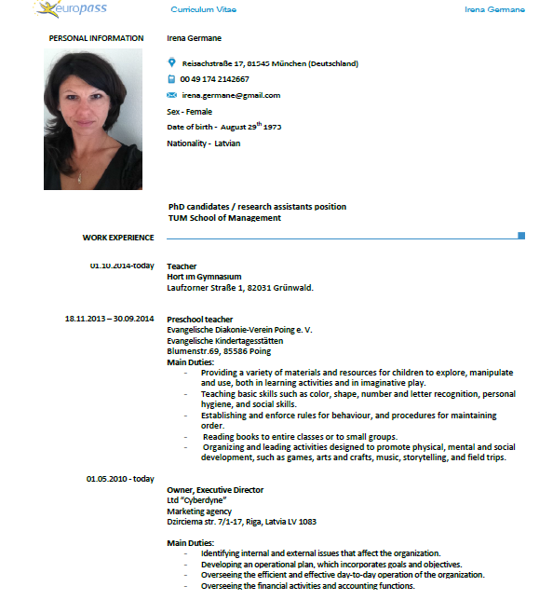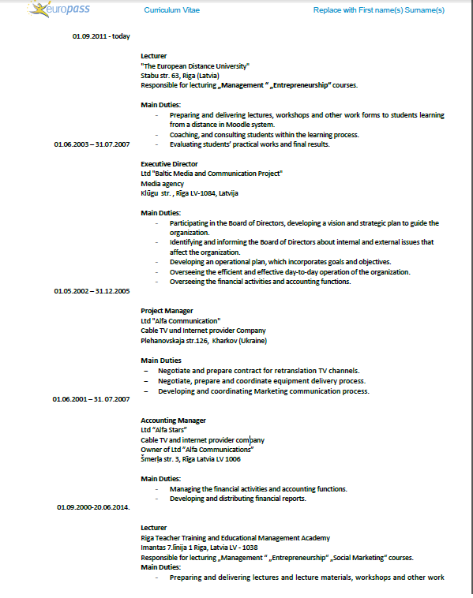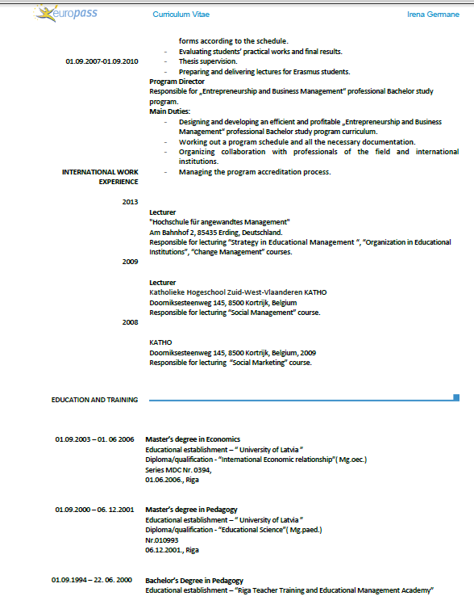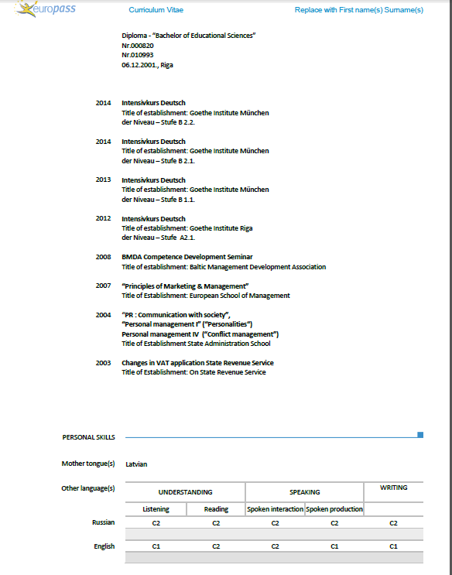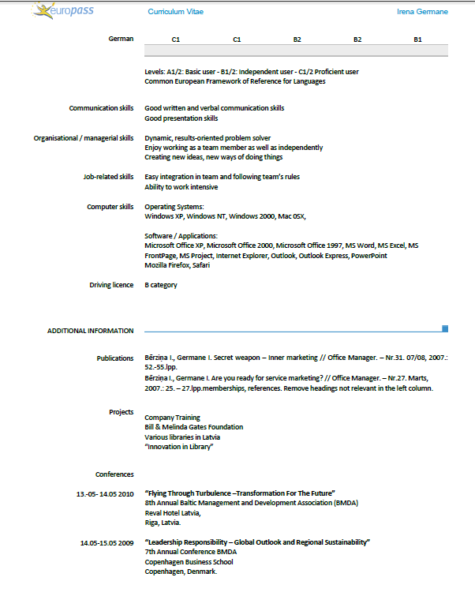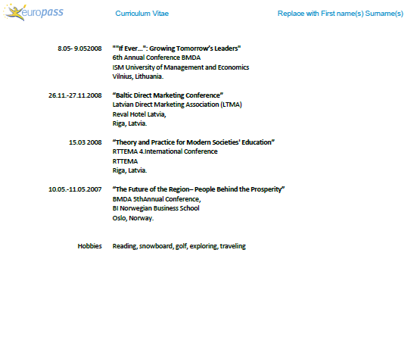
04.06.2015.

Europass
Curriculum Vitae
Personal information
First name / Surname | Gunta grīnberga-zālīte
Address | Jomas Street 46-2, Jurmala, Latvia, LV-2114
Telephone | +371 29463545
E-mail | gunta.birojs@gmail.com
Date of birth | 26 May 1972
Gender | female
Work experience
Dates  Occupation or position held  Main activities and responsibilities  Name and address of employer  Dates  Occupation or position held  Main activities and responsibilities  Name and address of employer | 2005 to date  Associate Professor, Leading Researcher (2005-2011 – lecturer, 2011-2014 – assistant professor, since 2014 – associate professor and leading researcher)  Pedagogical work. Responsibility of the subjects: Globalization of Business, Marketing, International Marketing, Social and Economic Environment of Projects, Social Marketing, International Business Management. Supervision and reviewing of bachelor, master, and doctoral theses. Scientific work in scope of scientific research projects, pedagogical work. Administrative work – organizing scientific conference events, editing of scientific conference proceedings.  Latvia University of Agriculture, Faculty of Economics and Social Development  Svētes Street 18, Jelgava, Latvia  2006 to date  Assistant Professor  Supervision and management of scientific research projects, pedagogical work Responsibility of the subject “Marketing”, Latvian Business College, Stabu Street 63, Riga, Latvia
Dates | 2000 - 2003
Occupation or position held | Marketing manager
Main activities and responsibilities | Promotion and advertising of company products
Name and address of employer | TVINS26 Ltd., Brīvības Street 155, Riga
Dates  Title of qualification awarded  Principal subjects covered  Dates | Higher University education  2011  Doctor of Social Sciences in Economics (Dr.oec)  Regional Economics, Marketing, International Business Environment  1990 – 1995; 2002 – 2003 ; 2003 – 2005
Title of qualification awarded | Bachelor of English Philology; 2nd level higher professional education and qualification of International Relations Manager; Master of Social Sciences in Economics
Principal subjects/occupational skills covered | Main Subjects: English Language and Literature; IT, Economics, Agricultural Economics, Business Management, Entrepreneurship, Theories of Organisations, Marketing, Market Research
Name and type of organisation providing education and training | Latvia University, Latvia University of Agriculture
Personal skills and competences
Mother tongue(s) | Latvian
Other language(s) | English, Russian
Self-assessment |  | Understanding |  |  |  |  | Speaking |  |  |  |  | Writing
 |  | Listening |  |  | Reading |  | Spoken interaction |  |  | Spoken production
 |  | L | 5 | L |  | 5 | L | 5 |  | L | 5 | L | 5
 |  | E | 5 | E |  | 5 | E | 5 |  | E | 5 | E | 5
 |  | R | 5 | R |  | 5 | R | 5 |  | R | 5 | R | 4
 | (*) Common European Framework of Reference for Languages
Computer skills and competences | Good
Driving licence | B category
Additional information | Lecturer of Socrates/Erasmus international education programmes:  - Stulginskis University, Lithuania – November 12-13, lecture course “Social Marketing for Sustainable Development of Rural Communities” 5 hours;  - West Pomeranian University of Technology, Poland – January 2014, lecture course “Corporate Social Responsibility Topicalities in Latvia” 5 hours;  - West Pomeranian University of Technology, Poland – January 2013, lecture course “Social marketing development issues in global and national context” 5 hours;  - Braganca Polytechnic Institute, Portugal – May 2009, lecture course “Advisory Services in Agriculture” 5 hours;  - Braganca Polytechnic Institute, Portugal – May 2008, lecture course “Development of Services’ Marketing” 5 hours;  Lecturer of further education training programmes:  Latvian Rural Advisory and Training Centre – 27 November 2011, lecture course „Marketing of Agricultural Products” 4 hours.  Published books:  1) Gunta Grīnberga-Zālīte. “Social Marketing for Harmonization of Rural Population Interests” (in Latvian) (2014). Reviewers: Dr.oec., prof. A.Vilciņa, Dr.oec., asoc. prof. G.Mazūre. Latvia University of Agriculture, CD, 46 p.  2) Irina Pilvere, Aleksejs Nipers, Agnese Krieviņa, Ilze Upīte, Gunta Grīnberga-Zālīte.  “Comparative Analysis of Latvian Food Industry Competitiveness Indicators in Latvia, Lithuania, Estonia, Poland and Russia”(in Latvian), 200 p.  3) Handbook of Research on Consumerism in Business and Marketing: Concepts and Practices. (2014) Editors: Hans-Ruediger Kaufmann (University of Nicosia, Cyprus & International Business School at Vilnius University, Lithuania) and Mohammad Fateh Ali Khan Panni (City University, Bangladesh) Chapter “Consumerism in Business and Marketing: Concepts and Practices.” Dzene, S., Eglite, A., Grinberga-Zalite, G. Sustainable Food Consumption Macro Issues: Case Study of Latvia Consumer Behaviour., pp. 155-181. IGI Global, 2014, 638 p. ISBN13: 9781466658806, ISBN10: 1466658800  Professional perfection:  - Certificate of participation in Latvia University, Faculty of Pedagogy, Psychology and Arts, Academic Conference “Interdisciplinary, Creativity and Entrepreneurship – Topicalities of Modern Education” (EU SF project “Support for research in education” (2011/001/ DP/1.2.3.2/ 11IPIA/ VIAA/011), 29 October 2014.  - Certificate No. 2.6.-17/14-577 of accomplishing higher education teachers’ professional perfection programme “Innovation in University Didactics”, 160h, Latvia University of Agriculture, 21 February – 9 May 2014.  - Certificate of the faculty of Social Sciences of Klaipeda University for participation at the skill development seminar for academic personnel “Novelties in Developing and Delivering Courses in Economics in Latvia and Lithuania”, 31 May 2013.  - Latvia University of Agriculture, certificate No 11-522 testifying acquiring of “Management System of Moodle e-Course Creation”, 12h, 14-26 January, 2011.

Research projects:
- December 2014-February 2015. Leading researcher and project leader in the National Research Programme project No. 5.2.7. „ “Involvement of the Society in Social Innovation for Providing Sustainable Development of Latvia””. (Project ident. No.EKOSOC-LV, No.02.2-09/13, sub-project 5.2.7.5.).
- October-December 2012. Researcher in the project of the Ministry of Agriculture of the Republic of Latvia “Comparative Analysis of Latvia Food Industry Competitiveness Indicators” and “Comparative Analysis of Fishery Industry Competitiveness Indicators”(Project ident.No. ZM /2012/13_EZF_ELFLA), LLU project implementation No. 2012/54.
- 2011 – to date. Participation in International Centre of Research in Organic Food Systems project CORE Organic II, taking the post of the National Editor of ”Organic E-prints”, http://www.orgprints.org/
Scientific publications in the scientific proceedings during 2010-2014

- Vilcina A., Grinberga-Zalite G., Makovska K. (2014). Development of Hemp Industry in the European Union and Latvia. In: Scientific journal “Regional Formation and Development Studies” (2014, Nr. 3 (14)). Klaipeda University Social Science Faculty, Klaipeda. pp. 199-206. (EBSCO)

- Gunta Grinberga-Zalite. Awarenes of Corporate Social Responsibility Aspects in Latvia and the European Union (2014). In: Economic Science for Rural Development 2014”: Proceedings of the International Scientific Conference - 2013, April 24-25 2014, Latvia University of Agriculture, Faculty of Economics, Jelgava, 2014. Volume 35, pp.16-24. (EBSCO, ISSN 1691-3078)

- Grinberga-Zalite G. (2013). Evaluation of Social Marketing Activities in the Context of Food Consumption. In: “The Proceedings of the LCBR European Marketing Conference 2012” (Frankfurt) archives section on the LCBR homepage HTML: http://www.lcbr-archives.com/2013.html, ISSN 2190-7938
- Gunta Grinberga-Zalite, Evija Liepa, Amanda Avotina (2013). The Role of Social Marketing in Maintaining the Balance between Satisfaction of Immediate and Long-Term Needs in the Context of Food Consumption In: Economic Science for Rural Development 2013”: Proceedings of the International Scientific Conference - 2013, April 25-26 2013, Latvia University of Agriculture, Faculty of Economics, Jelgava, 2013, Volume 32, pp. 152-157. (EBSCO, ISSN 1691-3078)
- Anastasija Vilciņa, Gunta Grīnberga-Zālīte, Raivis Andersons. (2012). The Analysis of Latvia Households’ Consumption Expenditure in Scope of Sustainable Development” . In: ”Journal of Social Sciences” No.3(8), (Regional Formation and Development Studies), Klaipeda University Social Science Faculty, Klaipeda. 2012, No.3 (8), pp. 247 –255. (EBSCO) ISSN 2029-9370
- Grinberga-Zalite G. (2012). Evaluation of Green Marketing Activities in Scope of Local Food Systems’ Sustainability Enhancement in Latvia. In: “The Proceedings of the LCBR European Marketing Conference 2012” (Munich) archives section on the LCBR homepage HTML: http://www.lcbr-online.com/index_files/Page321.htm, ISSN 2190-7935
- Grinberga-Zalite G. (2012) Development of Contemporary Customer-Guided Services in Rural Extension. In: “The 11th International Marketing Trends Conference CD ROM” – Services Marketing, January 19-22 2012, Ca’ Foscari University of Venice, HTML: http://www.marketing-trends-congress.com , ISBN 978-2-9532811-3-2
- Vilciņa A., Grīnberga-Zālīte G., Āboliņa T. (2011) Topical Issues in the Extraction and Exploitation of Peat in Latvia. In: “Journal of Social Sciences”. Human Resources – the Main Factor of Regional Development (Regional Formation and Development Studies), Klaipeda University, Faculty of Social Sciences, Klaipeda, 2011, No.5, pp. 300 – 310. (EBSCO) ISSN 2029-5103
- Rivža B., Grīnberga-Zālīte G. (2011) Assessing Gaps in Rural Advisory and Training Services’ Quality. In: “Economic Science for Rural Development 2011”: Proceedings of the International Scientific Conference - 2010, April 28-29 2011, Latvia University of Agriculture, Faculty of Economics, Jelgava, 2011, Volume 25, pp. 238 – 244. (ISI Web of Knowledge, AGRIS, EBSCO) ISSN 1691-3078, ISBN 978-9984-9997-6-0
- Grinberga G., Liepa E. (2010) Customer Guided Services’ Assurance Model for Rural Extension Services. In: “Economic and Management: Current Issues and Perspectives”: Research papers Socioeconomic Development of Rural Areas. Šiauliai University, Faculty of Social Sciences, Šiauliai, 2010. Volume No.1, 2010 3 (19), pp. 261 – 268. (Index Copernicus) ISSN 1648-9098
- Grīnberga G. (2010) Problems of Customer-Guided Services Quality Assurance in Rural Extension. In: “Economic Science for Rural Development 2010”: Proceedings of the International Scientific Conference - 2010, April 22-23 2010, Latvia University of Agriculture, Faculty of Economics, 2010.Volume No.23: Home Economics and Sustainable Consumption, pp.163 – 168. (AGRIS, EBSCO), ISSN 1691-3078, ISBN 978-9984-9997-3-9

Contributions at international scientific conferences during 2010-2014
- Vilciņa A., Gunta Grīnberga-Zālīte G., Makovska K. Development of Hemp Industry in the European Union and Latvia. In: Social Sciences for Regional Development: Influence and Perspectives” – Klaipeda University, Faculty of Social Sciences, September 25, 2014.
- Grinberga-Zalite G. Awareness of Corporate Social Responsibility Aspects in Latvia and the European Union. In: Economic Science for Rural Development 2014” – Jelgava: Latvia University of Agriculture, Faculty of Economics, April 24-25 2014.
- Gunta Grinberga-Zalite. Evaluation of Social Marketing Activities in the Context of Food Consumption. In: the Industrial Marketing Forum of the “LCBR European Marketing Conference 2013” – Frankfurt: Lupcon Center of Business Research, August 14 -15, 2013.
- Gunta Grinberga-Zalite, Evija Liepa, Amanda Avotina. The Role of Social Marketing in Maintaining the Balance between Satisfaction of Immediate and Long-Term Needs in the Context of Food Consumption In: Economic Science for Rural Development 2013” – Jelgava: Latvia University of Agriculture, Faculty of Economics, April 25-26 2013.
- Anastasija Vilciņa, Gunta Grīnberga-Zālīte, Raivis Andersons. The Analysis of Latvia Households’ Consumption Expenditure in Scope of Sustainable Development” . In: The 8th International Conference „Sustainable Development in Regions: Challenges and Perspectives” – 2012, Klaipeda: Klaipeda University, 27 September, 2012.
- Grinberga-Zalite G. Evaluation of Green Marketing Activities in Scope of Local Food Systems’ Sustainability Enhancement in Latvia. In: “The LCBR European Marketing Conference 2012” – Munich: Lupcon Center of Business Research, August 9-10, 2012.
- Grinberga-Zalite G. Development of Contemporary Customer-Guided Services in Rural Extension. In: “The 11th International Marketing Trends Conference” – Venice: Ca’ Foscari University of Venice, January 19 – 22, 2012.
- Grīnberga-Zālīte G., Rivža B. Klientu orientētu tālākizglītības pakalpojumu nodrošināšanas metodoloģija (poster presentation). Apvienotais Pasaules Latviešu zinātnieku 3.kongress un letonikas 4.kongress. Lauksaimniecības un meža zinātnes: iespējas un izaicinājumi sabiedrības attīstībai – 2011, Jelgava: Latvia University of Agriculture, 25 September, 2011.
- Vilciņa A., Grīnberga-Zālīte G., Āboliņa T. Topical Issues in the Extraction and Exploitation of Peat in Latvia. The 7th International Conference “Urban and Regional Development in Global Context” – 2011, Klaipeda: Klaipeda University, 29 – 30 September, 2011.
- Rivža B., Grīnberga-Zālīte G. Assessing Gaps in Rural Advisory and Training Services’ Quality International Scientific Conference Economic Science for Rural Development – 2011, Jelgava: Latvia University of Agriculture, 28 – 29 April, 2010.
- Grinberga – Zalite G. Customer Guided Services’ Quality Assurance Methodology for Rural Extension. The 7th International Conference on Leadership, Learning and Education for Sustainable Development “Leadership for an Inclusive and Sustainable World”, Berlin: The Learning Teacher Network, 27 – 29 January, 2011.
- Grinberga G, Liepa E. “Customer Guided Services’ Quality Assurance Model for Rural Extension Services”. The 3rd Jonas Pranas Aleksa International Scientific Conference “Vision of the Modern Village”, Siauliai: The Social Sciences Faculty of Siauliai University, 24 – 25 September, 2010.
- Grīnberga G. Problems of Customer-Guided Services Quality Assurance in Rural Extension. International Scientific Conference Economic Science for Rural Development – 2010, Jelgava: Latvia University of Agriculture, 22 – 23 April, 2010.

12.06.2015. Gunta Grīnberga-Zālīte

Europass
Curriculum Vitae
Personal data
Surname / Name | Gūtmanis Normunds
Personal ID No. | 290770-11912
Place of birth | Liepaja district, Aizpute
Address | Andromedas gatve 7-19, LV- 1084, Riga, Latvia
Telephone |  |  |  |  |  |  | Mobile phone |  |  | 26525233
Fax | none
E-mail | normundsgutmanis@inbox.lv
Citizenship | of the Republic of Latvia
Sex | Male
Academic titles and scientific degrees | Associate professor, Doctor of Engineering (Dr. sc. ing.), Master of Mathematics (Mg. math.)
Work experience
Period of time | From 2014
Profession or taken position | Rector
Name of the place of work | European Distance University
Period of time | From 2013
Profession or taken position | Director
Name of the place of work | Latvia Business College
Period of time | From 2008
Profession or taken position | Associate professor
Name of the place of work | Riga Stradins University
Period of time | 2008 - 2013
Profession or taken position | the Head of the Department of Marketing and Management
Name of the place of work | Riga International School of Economics and Business Administration
Period of time | 2001 - 2013
Profession or taken position | Associate professor
Name of the place of work | Riga International School of Economics and Business Administration
Period of time | 2005-2010
Profession or taken position | Lecturer
Name of the place of work | College of Business Administration
Period of time | 2003 - 2005
Profession or taken position | Lecturer
Name of the place of work | Ventspils University College
Period of time | 1997 - 2002
Profession or taken position | Lecturer
Name of the place of work | Riga Teacher Training and Educational Management Academy
Period of time | 1998 - 2000
Profession or taken position | Lecturer
Name of the place of work | Riga Commercial School
Period of time | 1991 - 1998
Profession or taken position | Teacher
Name of the place of work | Aizpute Secondary School
Education | 2008  Associate professor of RISEBA  in the branch of economics, in the sub-branch of econometrics APR No. 0013  Riga International School of Economics and Business Administration
  Period of time | 2005
  Name of obtained educational document / Obtained qualification | Piešķirts docenta akadēmiskais nosaukums  Vadībzinātnes nozarē uzņēmējdarbības vadības apakšnozarē DO Nr.0003
  Name and type of educational institution | Rīgas Starptautiskā ekonomikas un biznesa administrācijas augstskola
Period of time | 2007
Name of obtained educational document / Obtained qualification | Doctor of Engineering (Dr. sc. ing.)  in the branch of information technologies in the sub-branch of system analysis, simulation and design Series D No.0102
Name and type of educational institution | Riga Technical University
Period of time | 2005
Name of obtained educational document / Obtained qualification | Obtained the academic title of associate professor  in the branch of management, in the sub-branch of business management DO No.0003
Name and type of educational institution | Riga International School of Economics and Business Administration
Period of time | 1993 - 1995
Name of obtained educational document / Obtained qualification | Master’s degree in Mathematics  No.001074
Name and type of educational institution | University of Latvia, Faculty of Physics and Mathematics
Period of time | 1988 -1993
Name of obtained educational document / Obtained qualification | Diploma  Qualification of mathematician No.102753
Name and type of educational institution | University of Latvia, Faculty of Physics and Mathematics
Skills
Native language | Latvian
Other languages
Self-assessment |  | Understanding |  |  | Speaking |  |  |  | Writing
 |  | very good | good | weak | very good | good |  | weak | very good |  | good | weak
English |  |  | x |  |  | x |  |  |  |  | x
Russian |  | x |  |  | x |  |  |  |  |  | x
Scientific activity  Publications in the respective branch of science  articles in reviewed publications | Specify information about previous 6 years, full title, co-authors, publication, year and place of publication and number of pages, mention articles which have been accepted for publication)  1.N. Gūtmanis, E. Liepa, Possibilities to perform RIGIBID indexes prognoses, Collected articles of the international conference, School of Business Administration Turība, Riga, 2001,p.133-136  2.V.Ajevskis, N.Gūtmanis, Identification of interest rate models of Latvian money market, the 2nd World Congress of Latvian Scientists, 2001, p.140  3.V.Ajevskis, N.Gūtmanis, Modelling of the Latvian Term Structure of Interest Rate, Collection of scientific articles of RTU conference, 2001, p. 17-24  4. Pavlenko O., Gūtmanis N., Latvian Financial Market Analysis Using Software WINRATS, the 1st International Conference APLIMAT, 2002, p.327-330  5. Ajevskis V., Gūtmanis N., Modelling of the Latvian Term Structure of Interest Rate, the 1st International Conference APLIMAT, 2002 , p.47-52  6. Ajevskis V., Gūtmanis N., Liepa E., Possibilities to forecast indicators of Latvia’s economics, Collected articles of RHEI international conference, Riga, 2002, p.16-18  7. Carkova V., Gūtmanis N., On Convergence of Garch (p,q), the 17th IWSM International conference, Greece, Crete, 2002, p. 149-152  8. Ajevskis V., Gūtmanis N., Liepa E., Počs R. On Latvian Economic Indicator, the 6th World Multiconference on Systemics, Cybernetics and Informatics. SCI 2002, Orlando, Florida, USA, 14 – 18 July, 2002, p. 462 - 463  9. Carkova V., Gūtmanis N., Control Theory Approach to GARCH Convergence Analysis, The 6th World Multiconference on Systemics, Cybernetics and Informatics. SCI 2002, Orlando, Florida, USA, 14 – 18 July, 2002, p. 464-465  10. Gūtmanis N., Pavlenko O., On Convergence of Stochastic Iterations, the 3rd International Conference Aplimat, collected articles, Bratislava, Slovakia, 2004, p. 445-451  11. Liepa E., Gūtmanis N. On Equilibrium Stability of Markov Evolution Families, the 3rd International Conference Aplimat, collected articles, Bratislava, Slovakia, 2004, p.635-639  12. Počs R., Carkovs J., Gūtmanis N. On asymptotic stationarity of GARCH (p,q) process, International scientific and practical conference Intellectual systems of decision-making and information technologies, Ukraine, 17-19 May, 2006, p. 99- 102  13. Carkovs J., Gūtmanis N. On GARCH (p,q) convergence. International Scientific and Technical journal «Системнi дослiдження та Iнформацiйнi технологiï (System Analysis and Information Technology)», published by Kyiv Polytechnic Institute, Kyiv, Ukraine (submitted for publication, 5 pages)  14. N. Gūtmanis, E. Liepa, On 4th Moment of Stationary GARCH (p,q) Process, the 7th Latvian Mathematical conference, Rezekne, 18-19 April 2008, p.23  15. Carkova Viktorija, Gutmanis Normunds ON CONVERGENCE OF GARCH PROCESS, the 9th International Conference Aplimat, collected articles, Bratislava, Slovakia, 2010, p. 127-130  16. Matvejevs A., Pavlenko O., Gūtmanis N., Estimation and calculation procedures of the provisions for outstanding insurance claims, 7th International Conference on Computational and Financial Econometrics and 6th International Conference of the ERCIM Working Group on Computational and Methodological Statistics, abstracts, London, UK, 2013, p.81.  1. Gūtmanis N., Logistics, Latvian Entrepreneurship and Management Academy”, 2007, p. 285
Participation with report in (any type of) international scientific conferences and congresses | Specify information about previous 6 years, specify venue and time of event, title of report, co-authors, publishing house, place, year of theses publication, pages  - International conference "Transformation of economic and social relations: processes, tendencies, results”. Riga, School of Business Administration Turība, 2001.  Report: Gūtmanis N., Liepa E. Possibilities to perform RIGIBID indexes prognoses  - International conference “The 2nd World Congress of Latvian Scientists”, Riga, 2001.  Report: Ajevskis V., Gūtmanis N., Identification of interest rate models of Latvian money market.  - International conference “The 42nd International scientific conference”, Riga Technical University, 2001.  Report: Ajevskis V., Gūtmanis N., Modelling of the Latvian Term Structure of Interest Rate.  - International conference “The 1st International Conference APLIMAT”, Bratislava, Slovak Republic, 2002.  Report: Ajevskis V., Gūtmanis N., Modelling of the Latvian Term Structure of Interest Rate  - International conference “Traditional and innovative in sustainable development of society. Problems of competitiveness in sustainable development of economics”, Rezekne Higher Education Institution, 2002.  Report: Ajevskis V., Gūtmanis N., Liepa E., Possibilities to forecast indicators of Latvia’s economics.  - International conference “The 3rd International Conference APLIMAT”, Bratislava, Slovak Republic, 2004.  Report: Gūtmanis N., Pavlenko O., On Convergence of Stochastic Iterations.  - International conference Intellectual systems of decision-making and information technologies, Ukraine, 2006.  Report: Počs R., Carkovs J., Gūtmanis N. On asymptotic stationarity of GARCH (p,q) process.  - Conference “The 7th Latvian Mathematical conference”, Rezekne, 2008.  Report: Gūtmanis N., Liepa E., On 4th Moment of Stationary GARCH (p,q) Process  - International Conference “9th International Conference APLIMAT”,  Bratislava, Slovak Republic, 2010.  Report: Carkova V., Gūtmanis N., On Convergence of Garch Process  - International Conference “7th International Conference on Computational and Financial Econometrics (CFE 2013) and 6th International Conference of the ERCIM (European Research Consortium for Informatics and Mathematics) Working Group on Computational and Methodological Statistics (ERCIM 2013)”,  London, United Kingdom, 2013.  Report: Matvejevs A., Pavlenko O., Gūtmanis N., On Estimation and calculation procedures of the provisions for outstanding insurance claims
Most important research | - Participation in the project which was accepted by the Latvian Council of Science “Analysis of dynamic capital asset pricing model”;  - The research “Competition at the lodging market of Baltic rural regions, analysis of market supply and demand” which was performed within the EU financed project „Support to consultations and participation of commercial companies in international exhibitions and trade missions”, ordered by the Limited Liability Company „Rural Support Service”  - Research which was ordered by „Post Nevada” Ltd. „Competition in Latvian gambling business”  - Research which was ordered by „Post Nevada” Ltd. „Competition in Riga gambling business  - Research which was ordered by „Post Nevada” Ltd. „Competitiveness of gambling halls “Labyrinth””  - Research which was ordered by „Post Nevada” Ltd. ”Strategy generation for development of “Vegas” brand”  - Consultant on development of marketing strategy of „Līvu Akvaparka”  - Competition in construction, leading researcher, ordered by the Competition Council of the Republic of Latvia.  - Europe Social fond research „Nozaru kvalifikācijas sistēmas izveide un profesionālās izglītības efektivitātes un kvalitātes paaugstināšana”, agreement Nr. 2010/0274/1DP/1.2.1.1.1/10/  - Nozaru izpēte izglītības vajadzībām elektronisko un optisko iekārtu ražošanas, informācijas un komunikācijas tehnoloģijas nozares un uzņēmējdarbības, finanšu, grāmatvedības,administrēšanas (vairumtirdzniecības un mazumtirdzniecības, komerczinību) nozarēs.VIAA 2011/28 ESF, SIA „ERNST & YOUNG BALTIC”.
10.06.2015.

Curriculum vitae

Aivars |  |  | Kalniņš
Name |  |  | Surname
Latvia |  |  | 190357-12068
Place of birth |  |  | Personal Latvian ID number
19.03.1957 |  |  | Latvian
Date of birth |  |  | Nationality
SIA Jeta , CEO
Institution of employment and position
Work address |  |  | Home address:
Latvia |  |  | Caunes 17-40, Rīga, LV-1006
Čiekurkalna 1 līnija 84-311, LV-1026
Phone: | +371 29454245 |  | Phone: | +371 29454245
Fax: |  |  | E-mail: : mazkalnini@inbox.lv
E-mail: | aivars@jeta.lv
Education
Basic studies, Master’s studies, Doctor’s studies. Educational institution, country | Period | Speciality | Qualification awarded
School of Business Administration “Turība ” | 2001-2003 | Entrepreneurship | Diploma 000104  Master of Professional Science
Riga Technical University | 1975-1980 | Radio engineering | Diploma 262582  Radio Engineer
Work experience
From 2010 | SIA Jeta , CEO , SIA Kalnsetas R Board Member
2006-2009 | SJSC “ Latvijas Pasts”, HR Director
2004 - 2006 | SIA ”Reaton, LTD” , Vice-president
2002-2004 | SIA Lattelekom, HR Strategy Director
1997-2002 | SIA Lattelekom, HR Director
1994-1997 | SIA Lattelekom, Director
Scientific activities and publications
Internet : blogs in Latvian portals (www.diena.lv;www.bizness.lv)
Publications in press
Journal “Kvalitāte” Nr.1, 2005, article “Personāla stratēģija biznesa atbalstam” (HR Strategy for business support), 3 pages, Rīga.
Comparative Analysis of HRM in Europe. The book was published by “European Association for Personnel Management”, article –”Corporate Human Resources Management and Organizational Development in Latvia”, 22 pages.
Explanatory Latvian - Russian - English Dictionary - LPVA „Personāla vadības terminu skaidrojošā vārdnīca” (Dictionary of HR Management terminology), the part of terminology in HR Strategy “Explanation of Strategy terminology”, 16 pages.
Journal “Nodokļi & Komercija “, article : „Eiropas struktūrfondi – uzņēmēja drauga plecs” , 11.2011
Presentations in conferences:
4th international conference, Human Resource in telecoms series - Recruitment, Retention and Pay in Telecoms, 2 December 1998, Kensington, London. Report - Linking performance and pay to motivate key staff in Central and Eastern Europe.
EAPM 23 Conferences, Vienna, 20-22. June, 2007, Austria Trend Event hotel Pyramid.
General Report – “Great place to work – benchmarking ideals”.
8. International HR Conference - 9-11. June, 2004, Reval Hotel Latvija, Rīga.
Entrepreneurship psychology through HR management view.
Report – Psychology of the leader and personality.
9. International HR Conference, Reval Hotel Latvija, Rīga, 7. June, 2005.
Report – Building of Management team, teams role in corporate development.
Pedagogic activity
Consulted Master thesis RISEBA (33)
Consulted diploma papers LBK (16) , Turiba (15), RTK (8)

Design and management of study courses:

Master of Science course “HR Strategic planning and Management “– design as part of professional master program “HR Management “. Prepared and delivered in Riga International School of Economics and Business Administration (RISEBA).
Master of Science course “Project HR Management”- design as part of professional program “Project Management”. Prepared and delivered in Riga International School of Economics and Business Administration (RISEBA).
„Human Rights”, „Labour Law”, „Consumer rights”, design and delivered in Alberta College.
“HR Management”, design and delivered in Latvian and Russian languages in LBK /ETA (Latvian Business College/European Distance University).
“Consumer Behavior in the Market”, “Strategic Management”, “Entrepreneurship”, “Commercial Transactions”, “Theory and Practice of Management”, “Global Marketing”,” Tourism Business”, “Team Building” ,” International Marketing”, design and delivered in Latvian and English languages in Business School Turiba.

Open courses in training companies :

Design and delivered courses „World trends in HR Management”, “Role of HR Management in organization and strategic planning” for the students of Zygon Baltic Consulting Ltd (ZBC) and LTRK (Latvian Chamber of Commerce).
‘Strategy development of Organization and HR management”, design and delivered course for students of SIA “Latvijas lauku konsultāciju un izglītības centrs ” (Latvian rural consultation and education centre).
“Bipartite and tripartite social dialogue and HR“, delivered for students SIA Comperio/ LDDK (Latvian Employers confederation) un other entrepreneurs organizations.
“Improvement of Your Business “for small and medium entrepreneurs in LUAC (Latvian Entrepreneurship Support Centre).

Additional qualification:
Studies in Roffey Park Institute – UK.
Program „Master of science in people and organisational development”.
International training courses:
USTTI (United States Telecommunication training institute), TEMIC (Telecommunications executives training Institute of Canada), Cable & Wireless College (UK), San Francisco State University.

Training in Latvia :
“The company's strategic direction” SIA Perfecta Consulting
“HR Management " , Perfecta Consulting
“Health and Safety, 160 hours, SIA Buts, 2009.
“Fire Safety”, 160hours, SIA Buts, 2009.

Professional, scientific and business activities
 | Time period, year | Theme / topic | Sector / name of company / institution | Please mark the relevant answer
Development of ‘Case studies’ which may be referred to Latvian business environment | 2004-2008 | Lattelekom- learning from irrational corporate culture | EAPM  University of Saarland | Rout ledge, Taylor & Francis Group
Consultations for companies | 2011/2014 | HR management Production  Marketing | SIA „UOT”  SIA „AZZZ”  SIA ‘Lustes  UAB Lunpos  Manpower | Free of charge  Free of charge  Paid service  Paid service  Pid service
Participation in research  (preparation, implementation, presentation) | 2011/2014 | Support from Business Incubator’s for new entrepreneurs | RTV  VBII | Free of charge
Board member of company | 2011-2012 | Parents Council | RTV
Work in business company (except education institutions) | No 1995  No 2010 | The owner  Board Member | z/s Kalnsētas  SIA Kalnsetas R  SIA JETA
Member of professional organisations (according to specialisation) | From 2000  From 2011  From 2012 | HR | LAPM  LUAC  BEA
Important social work | 2000-2004 | Management of Latvian HR professionals organization | LAPM (LPVA)  President
 | 2002-2004 | Management of European HR professionals organization  Improvement activities for Latvian companies Effectiveness | EAPM  Board Member
 | From 2012 |  | BEA
Language skills Reading Writing Speaking
Excellent Good Average Excellent Good Average Excellent Good Average
Latvian x x x
Russian x x x
German
English x x x
11.06.2015.
Date |  | Signature

Europass
Curriculum Vitae
Personal data
Name/Surname | Juris Andrejs Kastiņš
Identity Code | 010746-11213
Place of birth | Riga
Address | Akademiķa Mstislava Keldiša iela 10—4 Riga LV1082
Telephone | 25922073
Fax
E-mail | juriska@latnet.lv
Nationality | Latvian
Gender | M
Academic and Scientific grades | Professor, Habilitated Doctor of Philology
Work Experience
Dates | 09. 1964 – 06. 1969
Occupation or position held | Studies
Name of employer | University of Latvia
Dates | 09.1969. – 07.2012.
Occupation or position held | Professor
Name of employer | University of Latvia
Dates | 03.2012-
Occupation or position held | Professor
Name of employer | University of Liepaja
Dates | 02.2013-
Occupation or position held | Professor  EIHSEBA
Education and Training
Dates | 09. 1972 – 06.1974
Title of qualification awarded | Higher Courses in Pedagogy
Name and type of organization providing education and training | Teacher of University  University of Latvia

Personal Skills and Competences | German Language and Literature Teacher
Mother tongue | Latvian
Other Languages
Self-assessment |  | Understanding |  | Speaking |  | Writing
 |  | very good | good | very good | good | very good | good
English |  |  | X |  | X |  | X
Russian |  | X |  | X |  | X
Scientific research | Development of German Literature after 1945  Literary Activities of Günter Eich, Ingeborg Bachmann, Hans Magnus Enzensberger, Karl Krolow, Gotfried Benn and others  Munich modernism, Vienna Modernism, Berln modernism  Symbolism in German poetry and poetics. Comparative comparison of French and German symbolism  May 2010 - lectures at Universidad Complutense de Madrid in Spain  April 2011 - Lectures at the University of Ataturk in Turkey Erzrum  2012 March - Matthew Bela lectures at the University of Banská Bystrica in Slovakia  2012th July-August International project with the University of Freiburg FRG SPPS (DAAD)  2013 May – lectures at Johanes Gutenberg University in Mainz Germany  2013 - September lectures in JEPurkyně University of Usti nad Labem, Czech Republic  2013 - December Admoni DAAD Scholarship, University of Freiburg, Germany  2014 - June, July, August, KAAD scholarship, John Wolfgang Goethe University, Frankfurt am Main, Institute of General and Comparative Literature  2014 – December Admoni DAAD Scholarship, University of Freiburg,  Germany
Publications in corresponding scientific field  Proceedings and abstracts  Other publication | - "Poetic Truth", Riga: Latvian University, 2004. Monographs and articles. 388 p.  - "Hugo von Hofmannsthal early creative work Poetics." Liepāja Pedagogical Academy Edition article "Aktuālas problēmas literatūras zinātnē.Folklora literature. Foreign Literature. The collection of articles 9. ". Liepaja 2004th  - "Wendepunkt poetics in der der deutschen Literatur (1890-1910)". DU scientific papers "Literature and Culture: The process of interaction problems." Daugavpils: Saule, 2004.  - "Johannes Bobrovska poetry and German poetry after World War II." Latvian University of Posts 678.sējums.Rīga: Latvian University, 2005. 126-p. 131  - "German Expressionist poetry principles." DU collection of scientific papers VII 'Literature and Culture: The process of interaction problems. " Daugavpils: Saule, 2006. 106th - 115.p.  - "Genuss und Tod in der deutschen Millet des Nouveau". DU collection of scientific papers VII 'Literature and Culture: The process of interaction problems. " Daugavpils: Saule, 2006. 116th - 125.p.  - "Benna Gottfried early expressionistic prose". Liepaja Pedagogical Academy Collection of 11 "Actual problems of literary theory." Liepaja 2006, 69th-76. p.  - Deutschen und französischen Symbolismus. "Daugavpils University Faculty of Humanities XVI scientific excavation stock" Language 2006th Language different cultural context. "Daugavpils University Academic Publishing House" Saule ", 2006. 525th-535.p.  - "Poetischer Austritt aus der Gesellschaft. Die Lyrik von Ingeborg Bachmann. " Collection of "Die Wahrheit ist dem Menschen zumutbar" HRSG. von Eve Pormeister und Hans Graubner. Tartu: Tartu University Press Verlag, 2007. S.123, 139th  - "French symbolists - founders of modern poetry." Liepaja Pedagogical Academy Collection of 12 "Actual problems of science literature. ". Liepaja: PAL Publishing, 2007 123. - 132.p.  - "All the cardinal points nasty, beautiful, loud and quiet. Gunter Grass's novel "onion-peeling." Daugavpils University Faculty of Humanities XVII collection of scientific papers on literature 'Literature and Culture: The process of interaction problems. Cardinal points of culture and literature. "Of Daugavpils University, 2008, 100 to 106.p.  - "Wilhelm Leman essays - German Nature lyrics theoretical basis." Liepaja Pedagogical Academy Collection of 13 "Actual problems of science literature." Liepaja: PAL Publishing, 2008. 96 to 103.p  - "Wesenszüge des deutschen Symbolism." Accepted for publication in the Madrid University. zin.rakstu stock. Madrid, 2009.  - "Der Nihlismus als bei Glücksgefühl Gottfried Benn", "Estudios Filologicos Alemanes" volumen 15th Fenix ​​Editor: Sevilla 2008.S.641-650th  - "Ach, Dies Josefina" Kafka's literary heroes and Encensbergera comparison. "Humanities Journal" (ISSN Nr.1407-9607), No. 15, of Daugavpils University, 2009.  - "The journey from the Tralala lalala or from the post-communist postkapitālismu". V.Kaminera prose: "Actual problems of science literature." The collection of articles 14 Liepaja: Liepaja University, 2009, 108-112.  - "Ein Exkurs Kafka und zu Enzensberger." ECR "In gebrochener Synthesis", Bd.1.Hg. Barbara von und Widawska Marola Smolinska. Akademia Pomorska w. Slupsk. Slupsk, 2009. S.95-102.  - "This transcendence beloved beast!" Animals and birds G.Eiha creative work. "Stock culture studies. Animals in culture. Daugavpils: Saule, 2010, 336-343.  - "Günter Grass's novel" camera "virtual narratives tricks". Collection of "Actual problems of science literature. Scripture stocks 15. "LiepU: Liepaja, 2010. 206 to 210.p.  - "The style of pluralism and lyrics of subject polyphonic world." Article published in the Proceedings of the DU "Cultural Studies" in 2011, 154 163.p.  - "Or just a German General in a life alone?" Collection "Aktuālas problēmas literatūras zinātnē ", 16, LiepU: Liepaja, 2011. 159 163.p.  - "Zu Ästhetik und Poetik der Wiener Moderne ." Юбилейный сборник научных и творческих работ. Елецкий госуниверситет. Изд. Елецкого госуд.университета. 2010th Стр. 164-168.  - "Günter Eich Poetics: From tradition to modern." Proceedings "Actual problems of Literature Science 17". University of Liepaja, Liepaja in 2012, 131 to 141.p.  - "Benna Gottfried letters: nihlisma intimate world of 1932-1940." Co-author V.Sokolova. Collection of articles "Cultural studies. Message and culture. " Daugavpils University Academic Publishers "saule", 2013, 238-246.p.  - "Hans Magnus Encenbergera literary epistem". Co-author L.Belozjorova. Collection of articles "Actual problems of Literature Science 18". University of Liepaja, Liepaja 2013th.
Participation with a report (any kind) in International scientific conferences and congresses | December 2007 - German Congress at the University of Seville, Spain, the paper "Der Nihilismus als Glücksgefühl bei Gottfried Benn"  March 2007 - German Congress Universidad Complutense de Madrid in Spain, report "Wesenszüge des deutschen Symbolismus"
Participation with a report (any kind) in International scientific conferences and congresses | March 2008 - German Congress batch of the University of Oradea in Romania report "Grundzüge der Lyrik von Günter Eich"  2008-2014 annual membership DU scientific readings and the University of Liepaja international conferences "Actual problems of literary science", Latvian University Scientific Conference

12.06.2015.
Curriculum Vitae
Personal information
Name, surname: |  | Inta Kulberga
Address: |  | Elkonu Street 5/9 - 36, Liepaja, Latvia, LV3401
Phone: |  | +371 29146491
E-mail: |  | kulberga.inta@gmail.com
Date of birth: |  | 15/03/1972
Work experience
Employer
From: |  | 2014
To: |  | Now
Occupation or position held: |  | teacher
Name of employer: |  | Latvia Business College
Address of employer: |  | Kr. Valdemāra ielā 26, Rīga, Latvija, LV1010
Type of business or sector: |  | Education
Employer
From: |  | 2011
To: |  | Now
Occupation or position held: |  | The Head of the Second Level Professional Bachelor’s Study Programme "ENTREPRENEURSHIP AND BUSINESS MANAGEMENT"
Name of employer: |  | Riga Teacher Training and Educational Management Academy (RTTEMA)
Address of employer: |  | Imantas 7. līnija, Rīga, Latvija, LV1083
Type of business or sector: |  | Education
Employer
From: |  | 2004
To: |  | Now
Occupation or position held: |  | teacher
Name of employer: |  | Riga Teacher Training and Educational Management Academy (RTTEMA)
Address of employer: |  | Imantas 7. līnija, Rīga, Latvija, LV1083
Type of business or sector: |  | Education
Employer
From: |  | 2002
To: |  | 2004
Occupation or position held: |  | Credit Project Manager
Name of employer: |  | Joint Stock Company "Parex Banka", Liepajas branch
Address of employer: |  | Smilšu iela 3, Rīga, Latvija, LV1522
Type of business or sector: |  | Financial and insurance activities
Employer
From: |  | 1998
To: |  | 2002
Occupation or position held: |  | Head of Market Departement
Name of employer: |  | Joint Stock Company "Liepājas patērētāju biedrība"
Address of employer: |  | Brīvības iela 56, Liepāja, Latvija, LV3400
Type of business or sector: |  | Wholesale And Retail Trade, Repair Of Motor Vehicules And Motorcycles
Employer
From: |  | 1990
To: |  | 1998
Occupation or position held: |  | Head of Economics Departement
Name of employer: |  | Co-operative Society "Aizputes patērētāju biedrība"
Address of employer: |  | Atmodas iela 26, Aizpute, Latvija, LV3456
Type of business or sector: |  | Wholesale And Retail Trade, Repair Of Motor Vehicules And Motorcycles
Education
Organization providing education and training
From: |  | 2005
To: |  | 2009
Name of organization: |  | Latvia University
Awarded qualification and/or degree: |  | Ph degree
Study course (specialization)/occupational skills covered: |  | Management / Business Management
Organization providing education and training
From: |  | 1996
To: |  | 1998
Name of organization: |  | Latvia University
Awarded qualification and/or degree: |  | Commercial Master's degree
Study course (specialization)/occupational skills covered: |  | National Economy Pedagogy
Organization providing education and training
From: |  | 1991
To: |  | 1996
Name of organization: |  | Latvia University
Awarded qualification and/or degree: |  | Economic Sciences
Study course (specialization)/occupational skills covered: |  | Trade economist qualification
Skills
Skills of languages
Mother tongue: |  | Latvian
Other language
Language: |  | Russian
Understanding: Listening: |  | Proficient user (C2)
Understanding: Reading: |  | Proficient user (C2)
Speaking: Dialogue: |  | Proficient user (C2)
Speaking: Monologue: |  | Proficient user (C2)
Writting: |  | Proficient user (C2)
Other language
Language: |  | English
Understanding: Listening: |  | Independent user (B2)
Understanding: Reading: |  | Independent user (B2)
Speaking: Dialogue: |  | Independent user (B1)
Speaking: Monologue: |  | Independent user (B1)
Writting: |  | Independent user (B1)
Other language
Language: |  | German
Understanding: Listening: |  | Independent user (B2)
Understanding: Reading: |  | Independent user (B2)
Speaking: Dialogue: |  | Basic User (A2)
Speaking: Monologue: |  | Basic User (A2)
Writting: |  | Basic User (A2)
Computer user’s skills
MS Word: |  | Yes
MS Excel: |  | Yes
MS Access: |  | Yes
MS Outlook: |  | Yes
MS PowerPoint: |  | Yes
Social skills
Teamwork skills: |  | Yes
Experience and ability to work in multicultural environment: |  | Yes
Skills to maintain a dialogue with communication partners: |  | Yes
Social empathy skills: |  | Yes
Social intellect: |  | Yes
Skills to solve conflicts: |  | Yes
Skills to adapt oneself to situations: |  | Yes
Skills to represent group interests: |  | Yes
Organizational skills
Skills to coordinate and lead people: |  | Yes
Skills to coordinate and manage projects: |  | Yes
Skills to organize work in the group according to definite regulations: |  | Yes
Self-organizational skills: |  | Yes
Skills to generate and implement ideas: |  | Yes
Scientific research and artistic activities
Publications
Cited publications in scientific citation index (SCI)/humanities citation index (A&HCI)/social science citation index (SSCI)
Cited publications in scientific citation index (SCI)/humanities citation index (A&HCI)/social science citation index (SSCI)
Author (s) name, initial: |  | Kulberga I.
Submission Year: |  | 2011
Year: |  | 2011
Article Title: |  | Professional Competence of Changes Implementation in Business Management in Latvia
Source name where article published: |  | Management of Organizations: Systematic Research.//Ievietots Central and Eastern European Online Library datu bāzē (http://www.ceeol.com/)
Publication No: |  | 57/2011
Place: |  | Vilnius: Vytautas Magnus University (Lietuva)
Publishing house: |  | Vytautas Magnus University
Pages from-to: |  | 51.-62.
ISSN: |  | 1392-1142
International database: |  | EBSCO
International database: |  | Index Copernicus
Cited publications in scientific citation index (SCI)/humanities citation index (A&HCI)/social science citation index (SSCI)
Author (s) name, initial: |  | Kulberga I.
Submission Year: |  | 2013
Year: |  | 2014
Source name where article published: |  | Sabiedrība un kultūra. Rakstu krājums
Publication No: |  | XVI
Place: |  | Liepāja
Publishing house: |  | LiePA
Pages from-to: |  | 541. - 551.
ISSN: |  | 1407-6918
Cited publications in scientific citation index (SCI)/humanities citation index (A&HCI)/social science citation index (SSCI)
Author (s) name, initial: |  | Kulberga I.
Submission Year: |  | 2012
Year: |  | 2013
Source name where article published: |  | Sabiedrība un kultūra. Rakstu krājums
Publication No: |  | XV
Place: |  | Liepāja
Publishing house: |  | LiePA
Pages from-to: |  | 713.-721.
ISSN: |  | 1407-6918
Cited publications in scientific citation index (SCI)/humanities citation index (A&HCI)/social science citation index (SSCI)
Author (s) name, initial: |  | Kulberga I.
Submission Year: |  | 2010
Year: |  | 2011
Article Title: |  | Pārmaiņu ekonomikas uzņēmuma tēls un reputācija/Image and Reputation of the Company in Economic Changes
Source name where article published: |  | Sabiedrība un kultūra. Rakstu krājums
Publication No: |  | XIII
Place: |  | Liepāja
Publishing house: |  | LiePA
Pages from-to: |  | 702. - 711. lpp.
ISSN: |  | 1407-6918
Cited publications in scientific citation index (SCI)/humanities citation index (A&HCI)/social science citation index (SSCI)
Author (s) name, initial: |  | Kulberga I., Garleja R.
Submission Year: |  | 2009
Year: |  | 2009
Article Title: |  | The Role of Management Studies in Business in the Field of Marketing
Source name where article published: |  | Latvijas Universitātes raksti. EKONOMIKA. VADĪBAS ZINĀTNE
Publication No: |  | 743
Place: |  | Rīga, LU
Publishing house: |  | LU
Pages from-to: |  | 278. - 291.
ISSN: |  | 1407-2157
Cited publications in scientific citation index (SCI)/humanities citation index (A&HCI)/social science citation index (SSCI)
Author (s) name, initial: |  | Kulberga I.
Submission Year: |  | 2008
Year: |  | 2010
Article Title: |  | Profesionalitātes un pārmaiņu izpratnes kompetences Latvijas uzņēmējdarbībā/Comprehension Competences of Professionalism and Changes
Source name where article published: |  | Sabiedrība un kultūra. Rakstu krājums
Publication No: |  | XII
Place: |  | Liepāja, LiePA
Publishing house: |  | LiePA
Pages from-to: |  | 336. – 349.
ISSN: |  | 1407-6918
Cited publications in scientific citation index (SCI)/humanities citation index (A&HCI)/social science citation index (SSCI)
Author (s) name, initial: |  | Kulberga I.
Submission Year: |  | 2007
Year: |  | 2008
Article Title: |  | Tirgvedības profesionālā izglītība Latvijas uzņēmējdarbības vidē/Studies Role of Marketing Expert’s Management in Business
Source name where article published: |  | Latvijas Universitātes raksti, VADĪBAS ZINĀTNE
Publication No: |  | 721
Place: |  | Rīga, LU
Publishing house: |  | LU
Pages from-to: |  | 407. - 426.
ISSN: |  | 1407-2157
Cited publications in scientific citation index (SCI)/humanities citation index (A&HCI)/social science citation index (SSCI)
Author (s) name, initial: |  | Kulberga I.
Submission Year: |  | 2007
Year: |  | 2009
Article Title: |  | Sadarbība un konkurence profesionālās izglītības produktu tirgū: tendences, problēmas, risinājumi/Cooperation and Competition in the Vocational Education Market: Tendencies, Problems, Solutions
Source name where article published: |  | Sabiedrība un kultūra. Rakstu krājums
Publication No: |  | XI
Place: |  | Liepāja, LiePA
Publishing house: |  | LiePA
Pages from-to: |  | 551. - 561.
ISSN: |  | 1407-6918
Cited publications in scientific citation index (SCI)/humanities citation index (A&HCI)/social science citation index (SSCI)
Author (s) name, initial: |  | Kulberga I.
Submission Year: |  | 2006
Year: |  | 2008
Article Title: |  | Komercdarbības speciālistu pašvērtējuma prasmju aktualizācija uzņēmējdarbības un izglītības mijattiecību vidē/Topicality of Commerce Experts’ Self-Evaluation Skills in Business and Educational Interaction Environment
Source name where article published: |  | Sabiedrība un kultūra. Rakstu krājums
Publication No: |  | X
Place: |  | Liepāja, LiePA
Publishing house: |  | LiePA
Pages from-to: |  | 250. - 258.
ISSN: |  | 1407-6918
Cited publications in scientific citation index (SCI)/humanities citation index (A&HCI)/social science citation index (SSCI)
Author (s) name, initial: |  | Kulberga I.
Submission Year: |  | 2005
Year: |  | 2006
Article Title: |  | Profesionālās kompetences veidošanās studiju procesā/Establishment of Professional Competence During the Study Process
Source name where article published: |  | Latvijas Universitātes raksti, EKONOMIKA V
Publication No: |  | 702
Place: |  | Rīga, LU
Publishing house: |  | LU
Pages from-to: |  | 276. - 288.
ISSN: |  | 1407-2157
The original article in the international, peer-reviewed scientific journal anonymous
Author(s) surname, name initial: |  | Kulberga I.
Submission Year: |  | 2013
Year of publication: |  | 2014
Source name where article published: |  | TEORIJA PRAKSEI MŪSDIENU SABIEDRĪBAS IZGLĪTĪBĀ. VII Starptautiskā zinātniskā konference./ Zinātniskie raksti un konferences referāti
Place of issue: |  | Rīga
Publishing house: |  | RPIVA
Pages from-to: |  | 74. -83.
ISBN or ISSN: |  | ISBN 978-9934-503-15-3
The original article in the international, peer-reviewed scientific journal anonymous
Author(s) surname, name initial: |  | Kulberga I., Sīle S.
Submission Year: |  | 2013
Year of publication: |  | 2014
Source name where article published: |  | TEORIJA PRAKSEI MŪSDIENU SABIEDRĪBAS IZGLĪTĪBĀ. VII Starptautiskā zinātniskā konference./ Zinātniskie raksti un konferences referāti
Place of issue: |  | Rīga
Publishing house: |  | RPIVA
Pages from-to: |  | 66. - 73.
ISBN or ISSN: |  | ISBN 978-9934-503-15-3
The original article in the international, peer-reviewed scientific journal anonymous
Author(s) surname, name initial: |  | Kulberga I.
Submission Year: |  | 2013
Year of publication: |  | 2013
Source name where article published: |  | Promocijas darba kopsavilkums. Doktora grāda iegūšanai vadībzinātnes nozarē. Apakšnozare: uzņēmējdarbības vadība
Place of issue: |  | Liepāja
Publishing house: |  | LiePA
Pages from-to: |  | 1. - 35.
ISBN or ISSN: |  | ISBN 978-9984-864-90-7
The original article in the international, peer-reviewed scientific journal anonymous
Author(s) surname, name initial: |  | Kulberga I.
Submission Year: |  | 2013
Year of publication: |  | 2013
Source name where article published: |  | Summary of Doctoral Thesis. Submitted for the degree of Doctor of Management science. Subfield of Business Administration
Place of issue: |  | Liepaja
Publishing house: |  | LiePA
Pages from-to: |  | 37 - 72
ISBN or ISSN: |  | ISBN 978-9984-864-90-7
The original article in the international, peer-reviewed scientific journal anonymous
Author(s) surname, name initial: |  | Kulberga I.
Submission Year: |  | 2012
Year of publication: |  | 2012
Source name where article published: |  | 9. medzinárodná vedecká konferencia Manažment l’udského potenciálu v podnieku (Human Potential Management in a Company). Zborník vedeckých prác
Place of issue: |  | Banská Bystrica (Slovak Republic)
Publishing house: |  | Ekonomická fakulta Univerzity Mateja Bela v Banskej Bystrici
Pages from-to: |  | 225. - 234.
ISBN or ISSN: |  | ISBN 978-80-557-9361-9
The original article in the international, peer-reviewed scientific journal anonymous
Author(s) surname, name initial: |  | Kulberga I.
Submission Year: |  | 2011
Year of publication: |  | 2011
Source name where article published: |  | Key instruments of human co-existence organization: economics and law. Management and economic sciences./ Materials digest of the XIIth International Scientific and Practical Conference.
Place of issue: |  | Odessa
Publishing house: |  | InPress
Pages from-to: |  | 190. - 193.
ISBN or ISSN: |  | ISBN 978-966-2621-08-2
The original article in the international, peer-reviewed scientific journal anonymous
Author(s) surname, name initial: |  | Kulberga I.
Submission Year: |  | 2009
Year of publication: |  | 2010
Article Title: |  | Komercdarbības būtības izpratne Latvijā un komerczinību studējošo speciālistu pašvērtējums/Understanding Of Business Essence in Latvia and Business Expert Trainees’ Self-Assessment
Source name where article published: |  | TEORIJA PRAKSEI MŪSDIENU SABIEDRĪBAS IZGLĪTĪBĀ. V Starptautiskā zinātniskā konference
Place of issue: |  | Rīga: RPIVA
Publishing house: |  | RPIVA
Pages from-to: |  | 151. – 158.
ISBN or ISSN: |  | ISBN 978-9934-8060-5-6
The original article in the international, peer-reviewed scientific journal anonymous
Author(s) surname, name initial: |  | Kulberga I.
Submission Year: |  | 2007
Year of publication: |  | 2008
Article Title: |  | Uzņēmuma iekšējā vide un darbinieku profesionālās kompetences sakarības/Inner Environment of Company and Employees’ Professional Competence
Source name where article published: |  | TEORIJA PRAKSEI MŪSDIENU SABIEDRĪBAS IZGLĪTĪBĀ. RPIVA IV Starptautiskā zinātniskā konference
Place of issue: |  | Rīga: RPIVA
Publishing house: |  | S&G
Pages from-to: |  | 179.- 189.
ISBN or ISSN: |  | ISBN 978-9984-9903-7-8
The original article in the international, peer-reviewed scientific journal anonymous
Author(s) surname, name initial: |  | Kulberga I.
Submission Year: |  | 2006
Year of publication: |  | 2007
Article Title: |  | Pedagoģisko vērtību loma personības attīstībā pedagoģiskajā procesā/The Role of Pedagogical Values in the Personality’s Development During the Pedagogy Process
Source name where article published: |  | Pedagoģija: teorija un prakse V. zinātnisko rakstu krājums
Place of issue: |  | Liepāja: LPA
Publishing house: |  | LPA Pedagoģijas katedra
Pages from-to: |  | 66. – 75.
ISBN or ISSN: |  | ISSN 1407-9143
The original article in the international, peer-reviewed scientific journal anonymous
Author(s) surname, name initial: |  | Kulberga I.
Submission Year: |  | 2005
Year of publication: |  | 2006
Article Title: |  | Konkurētspējīgas profesionālās izglītības problēmas tirgus ekonomikas apstākļos/Competitiveness of Vocational Education problems in the Market Economy Conditions
Source name where article published: |  | TEORIJA PRAKSEI MŪSDIENU SABIEDRĪBAS IZGLĪTĪBĀ. RPIVA III
Place of issue: |  | Rīga: RPIVA
Publishing house: |  | ULMA
Pages from-to: |  | 248.-256.
ISBN or ISSN: |  | ISBN 9984-569-60-8
Original article peer-reviewed scientific journal in Latvia
Author(s) surname, name initial: |  | Kulberga I.
Submission Year: |  | 2011
Year of publication: |  | 2011
Place of issue: |  | Rīga: RPIVA
Publishing house: |  | RPIVA
Pages from-to: |  | 63. - 73.
ISBN or ISSN: |  | 978-9934-503-03-0
Original article peer-reviewed scientific journal in Latvia
Author(s) surname, name initial: |  | Kulberga I.
Submission Year: |  | 2009
Year of publication: |  | 2010
Article Title: |  | Vadībzinību produkta mārketinga loma intelektuālās ekonomikas apstākļos/Management Education Product Marketing Role in the Intellectual Economy Conditions
Source name where article published: |  | V JAUNO ZINĀTNIEKU KONFERENCE 2009. Rakstu krājums/CD
Place of issue: |  | Rīga: RPIVA
Publishing house: |  | RPIVA
Pages from-to: |  | 55. - 65.
ISBN or ISSN: |  | ISBN 978-9934-8060-9-4
Original article peer-reviewed scientific journal in Latvia
Author(s) surname, name initial: |  | Kulberga I.
Submission Year: |  | 2008
Year of publication: |  | 2009
Article Title: |  | Inovāciju loma uzņēmējdarbībā pasaules finanšu krīzes apstākļos/The Role of Innovation in Business in the Global Financial Crisis
Source name where article published: |  | IV JAUNO ZINĀTNIEKU KONFERENCE 2008. Rakstu krājums/CD
Place of issue: |  | Rīga: RPIVA
Publishing house: |  | RPIVA
Pages from-to: |  | 118. - 127.
ISBN or ISSN: |  | ISBN 978-9934-8060-2-5
Original article in popular-science journal or journalism
Author(s) surname, name initial: |  | Kulberga I.
Submission Year: |  | 2010
Year of publication: |  | 2010
Article Title: |  | Management Education in the Intellectual Economics Conditions
Source name where article published: |  | АГУ, ИЭП, Международнaя научно-практическaя конференция „Aдаптация специалистов в условиях экономической нестабильности"
Edition number: |  | Роль университетов в повышении эффективности адаптации выпускников вузов в условиях инновационной экономики
Pages from-to: |  | 7 - 11
Original article in popular-science journal or journalism
Author(s) surname, name initial: |  | Kulberga I.
Submission Year: |  | 2009
Year of publication: |  | 2009
Article Title: |  | Competitiveness of Vocational Education Problems in the Global Market Economy Crisis Conditions
Source name where article published: |  | Астраханскuŭ ГУ, Институт Экономики и Права, II Всероссийская конференция „Региональная специфика развития бизнеса и экономики"
Edition number: |  | направлениe „Трансформация образования в современном мире: причины, проблемы и новые возможности”
Pages from-to: |  | 7 - 11
The original article on the website
Author(s) surname, name initial: |  | Kulberga I.
Year of publication: |  | 2011
Site name where the article published: |  | International Conference Project
Web link: |  | www.icp-ua.com/en/node/1174
Participation in scientific projects and programmes
RTEEMA research project
Project registration number: |  | 2014/4
Project Title: |  | Mazo un vidējo uzņēmumu (MVU) vadītāju profesionālās kompetences īpatnības Latvijā
Status in project: |  | Participant
Participation in the project from: |  | 01/01/2014
RTEEMA research project
Project registration number: |  | 12/2011-1
Project Title: |  | Dzīves kvalitātes aspektu izmaiņu novērtējums pašvaldību vispārējās izglītības iestāžu optimizācijas ietekmē
Status in project: |  | Participant
Participation in the project from: |  | 19/05/2011
Participation in the project to: |  | 31/12/2011
RTEEMA research project
Project registration number: |  | 2/2006
Project Title: |  | Vērtību pedagoģija: teorija un prakse
Status in project: |  | Participant
Participation in the project from: |  | 01/02/2006
Participation in the project to: |  | 31/01/2007
ESF project
Project registration number: |  | Nr.2009/0196/1DP/1.2.2.1.5/09/IPIA/VIAA/001
Project Title: |  | ESF darbības programmas "Cilvēkresursi un nodarbinātība" papildinājuma 1.2.2.1.5. apakšaktivitātes "Pedagogu konkurētspējas veicināšana izglītības sistēmas optimizācijas apstākļos" projekta izstrāde un docēšana - pedagoģiskā darbība audzināšanas jomā "Finanšu pratība izglītības iestādē"
Institution name who implement project: |  | IZM, RPIVA, Latvijas Banka, AS Swedbank
Status in project: |  | Participant
Participation in the project from: |  | 10/12/2011
Participation in the project to: |  | 31/05/2012
ESF project
Project registration number: |  | 1DP//1.3.1.1.3/08/IPIA/NVA/001
Project Title: |  | ESF projekts "Bezdarbnieku un darba meklētāju apmācība Latvijā", profesionālās pilnveides izglītības programmas "Grāmatveža kvalifikācijas aktualizēšana" izstrāde un docēšana
Institution name who implement project: |  | NVA, SIA "Mācību konsultāciju centrs ABC"
Status in project: |  | Participant
Participation in the project from: |  | 24/10/2011
Participation in the project to: |  | 21/11/2011
ESF project
Project registration number: |  | Nr.2009/0196/1DP/1.2.2.1.5./09/IPIA/VIAA/001
Project Title: |  | ESF darbības programmas "Cilvēkresursi un nodarbinātība" papildinājuma 1.2.2.1.5. apakšaktivitātes "Pedagogu konkurētspējas veicināšana izglītības sistēmas optimizācijas apstākļos" docēšana projektā "Projektu izstrāde un komercdarbības pamati"
Institution name who implement project: |  | IZM, RPIVA
Status in project: |  | Participant
Participation in the project from: |  | 01/09/2010
Participation in the project to: |  | 23/12/2010
Another project or program
Project Title: |  | Valsts Lauku tīkla pasākums "Atbalsts lauku jauniešiem uzņēmējdarbības veicināšanai", interaktīva programma jauniešiem "Tu vari vairāk!"/ tēmas: "Praktiskā uzņēmējdarbība", "Rīcības (Biznesa) plāna izstrāde"
Institution name who implement project: |  | LR Zemkopības ministrija, Latvijas Lauku Konsultāciju un Izglītības centrs (LLKIC), Lauku Atbalsta Dienests (LAD), līgums Nr. 2013/15 no 28.01.2013.
Financial source: |  | Eiropas Lauksaimniecības Fonds Lauku Attīstībai (ELFLA): Eiropa investē lauku apvidos
Status in project: |  | Participant
Participation in the project from: |  | 18/04/2013
Participation in the project to: |  | 19/04/2013
Another project or program
Project Title: |  | Latvijas publisko bibliotēku bibliotekāru apmācības projekts „Inovatīvā darbība bibliotēkās”, apakštēmas "Radošums un inovācija" un "Projektu vadīšana radošu ideju realizēšanai" vadīšana
Institution name who implement project: |  | Banku Augstskolas Biznesa un Finanšu pētniecības centrs
Financial source: |  | Bila un Melindas Geitsu fonds un Latvijas valdība
Status in project: |  | Participant
Participation in the project from: |  | 01/02/2008
Participation in the project to: |  | 31/05/2008
Doctoral studies
Dissertation: |  | Specialist Professional Competence as a Priority of the Higher Professional Education Product's in Latvian Business
Superintendent: |  | LU emerit.profesore, Dr.habil.paed., Dr.oec., Rasma Garleja
Study programme management
Study Programme title: |  | ENTREPRENEURSHIP AND BUSINESS ADMINISTRATION
Study programs Level: |  | Professional Bachelor's education program
From: |  | 2011
To: |  | Now

Signature:
Inta Kulberga
01.04.2015.

Europass
Curriculum Vitae
 | Personal data
 | Name/Surname | Liepa Evija
 | Identity Code | 190568-10409
 | Place of birth | Riga, Latvia
 | Address | Valdeku str. 6/1-6, Riga, Latvia LV 1004
 | Telephone | 67622669 |  |  | Mobile phone |  |  | 29557195
 | Fax | 67847066
 | E-mail | eliepa2@gmail.com
 | Nationality | Latvian Republic
 | Gender | Woman
 | Academic and Scientific grades | Assistant Professor, Dr. math.
 | Work Experience
 | Dates | 10.07.2014. -now
 | Occupation or position held | Docent
 | Name of employer | European Distance University
 | Dates | 10.2010. -07.2014.
 | Occupation or position held | Rector
 | Name of employer | EIHSEBA University College
 | Dates | 09.2005. – 11.2011.
 | Occupation or position held | Assistant Professor, from 10.2009. Head of Study Department
 | Name of employer | Business College of Latvia
 | Dates | 08.2002. – 03.2011.
 | Occupation or position held | Assistant Professor, director of study programme’s “Business Administration” direction “Marketing Management”
 | Name of employer | Baltic International Academy (ex Baltic Russian Institute)
 | Dates | From 09.1999.
 | Occupation or position held | Assistant Professor
 | Name of employer | Riga Stradiņš University
 | Dates | 09.1993. – 06.2007.
 | Occupation or position held | Assistant, Lector, from 09.1998. Assistant Professor
 | Name of employer | Riga Technical University, Faculty of Computer Science and Information Technology
 | Dates | 02.2001. – 09.2001.
 | Occupation or position held | Director of Professional Master’ s study programme “Business Administration”
 | Name of employer | Turiba University
 | Dates | 08.1997. – 07.2002.
 | Occupation or position held | Head of Economics and Entrepreneurship Department, director of study programmes „Entrepreneurship and Business Management” un „Teacher of Economics and Business Administration”, lecturer, from 07.1998. Assistant Professor
 | Name of employer | Riga Teacher Training and Educational Management Academy
 | Dates | 09.1991. – 06.1993.
 | Occupation or position held | Assistant
 | Name of employer | University of Latvia, Faculty of Physics and Mathematics
 | Education and Training
 | Dates | 10. 1993 – 06.1998
 | Title of qualification awarded | Dr.math. grade, Diploma C-D Nr. 001474, award LU on 03.06.1998.
 | Name and type of organization providing education and training | Riga Technical University, PhD studies
 | Dates | 06. 1996
 | Title of qualification awarded | Master degree in Mathematics, Diploma Nr. 002015, award LU on 20.06.1996.
 | Name and type of organization providing education and training | University of Latvia
 | Dates | 09.1986 – 06. 1991
 | Title of qualification awarded | Qualification „Applied Mathematics”, Diploma Nr. УВ 975442, award LU on 26.06.1991.
 | Name and type of organization providing education and training | University of Latvia, Faculty of Physics and Mathematics
Training
Dates |  | 08.-09.02.2007.
Title of qualification training |  | BRI→BIA: Development Prospects and Challenges
Name and type of organization |  | Baltic International Academy
Dates |  | 09.2001.-06.2002.
Title of qualification training |  | Seminars „Pedagogic Skills”
Name and type of organization |  | Riga Teacher Training and Educational Management Academy
 | Personal Skills and Competences
 | Mother tongue | Latvian
 | Other Languages
 | Self-assessment |  | Understanding |  |  | Speaking |  |  | Writing
 |  |  | very good | good |  | very good | good |  | very good | good
 | English |  |  | X |  |  | X |  |  | X
 | Russian |  | X |  |  | X |  |  | X
 | Other skills
 | Scientific research
 | Manager ore participant of International or Latvian State financed research projects | Projects:  Latvia Scientific Council accepted project Nr. 01.0536 “Kapitāla aktīva daļas cenu veidošanās dinamiskā modeļa analīze” (2001 - 2002)  LR Competition Council research „Konkurence būvniecības tirgū Latvijā” (2006)  Research „Konkurence Baltijas lauku reģionu naktsmītņu tirgū, tirgus piedāvājuma un pieprasījuma analīze”made within ES financed project „Atbalsts konsultācijām un komercsabiedrību dalībai starptautiskās izstādēs un tirdzniecības misijās”, customer - „Lauku atbalsta dienests” ltd. (2005)
 | Member of expert commission of International or Latvian State financed projects and programs | MES and SEDA accepted ESF project „Atbalsts mācību prakses īstenošanai profesionālās izglītības un augstākās izglītības studentiem”, participant (2007)  Finansial tool of European Economy zone and bilateral financial tool of Norwegian government priority “Academic research”, expert (2008)
 | Publications in corresponding scientific field  Proceedings and abstracts  Other publication | - Carkovs J., Liepa E. Impulsu Markova multiplikatīvu kociklu asimptotiskā dilšana un robežteorēmas, II Pasaules latviešu zinātnieku kongresa tēžu krāj., ISBN 9984-9542-0-X, 2001, 331.lpp.  - Gūtmanis N., Liepa E. RIGIBID indeksu prognozēšanas iespējas, Biznesa augstskolas “Turība” starptautiskās konferences „Ekonomisko un sociālo attiecību transformācija: procesi, tendences, rezultāti” rakstu krājums, ISBN 9984-609-45-6, 2001, 133-136 lpp.  - Liepa E., Tsarkov Y. Asymptotic Methods for Stability Analysis of Markov Evolution Families Associated with Impulse Markov Dynamical Systems, 15th European Simulation Multiconference (ESM’2001) „Modeling and Simulation 2001”, rakstu krājums, ISBN 1-56555-225-3, Prāga, 2001, 791-797 lpp.  - Ajevskis V., Gūtmanis N., Liepa E. Latvijas ekonomisko rādītāju prognozēšanas iespējas, Starpt. zin. konf. “Tradicionālais un novatoriskais sabiedrības ilgtspējīgā attīstībā; konkurētspējas problēmas ilgtspējīgā ekonomikas attīstībā”, ISBN 9984-585-25-3,Rēzekne, 2002.  - Ajevskis V., Gutmanis N., Liepa E., Počs R. On Latvian Economic Indicator, The 6th World Multiconference on Systemics, Cybernetics and Informatics, SCI 2002, Orlando, Florida, USA, ISBN 980-07-8150-1, 14 – 18 July, 2002. – p.p. 462 - 463.  - Pavļenko O., Liepa E. Yield Curve Analysis with Diffusion Approximation. Proceedings of the 2nd Conference in Actuarial Science & Finance in Samos. September 20-22. 2002. Karlovassi, Greece.  - Ajevsky V., Sinenko N., Liepa E.. VAR Modelling of Latvian Interest Rates, MACROMODELS’2002, ISBN 83-7171--694-X, December 4-7, 2002, Cedzyna, Poland.  - Liepa E., Gūtmanis N. On Equilibrium Stability of Markov Evolution Families, 3rd International Conference Aplimat, rakstu krājums, Bratislava, Slovākija, 2004, p.p.635-639.  - Liepa E., Papins A., The Analysis of Factors Influencing the Development of Small and Medium Size Enterprises’ Activities, The VIIIth International Scientific Conference Management and Sustainable Development, Bulgārija, Jundola, 2008  - Gūtmanis N., Liepa E. On 4th Moment of Stationary GARCH (p,q) Process, 7.Latvijas matemātikas konference, Rēzekne  - Liepa E., Papins A., Grīnberga G. Development Models of Small and Medium Size Enterprises’ Activities, The 4th International Scientific Conference Modeling the European Future: Integrating the Old and the New, rakstu krājums, Lietuva, Klaipēda, 2-3 oktobris, 2008  - Grīnberga G., Liepa E. Customer Guided Services’ Quality Assurance Model for Rural Extension Services”, 3rd Jonas Pranas Aleksa International Scientific Conference „Vision of the Modern Village”, September 24, 2010, Šiauliai University, Lithuania.  - Carkovs J. , Liepa E. On Stability Analysis of Cocycles Over Impulse Markov Dynamical Systems, 10th International Conference Aplimat, rakstu krājums, Bratislava, Slovākija, 2011., 217.-221. lpp.  - Grinberga-Zalite G., Liepa E., Avotina A. The Role of Social Marketing in Maintaining the Balance between Satisfaction of Immediate and Long-Term Needs in the Context of Food Consumption In: Economic Science for Rural Development 2013”: Proceedings of the International Scientific Conference - 2013, April 25-26 2013, Latvia University of Agriculture, Faculty of Economics, Jelgava, 2013, Volume 32, pp. 152-157. (EBSCO, ISSN 1691-3078)  Research published on LR Competition Council homepage „Konkurence būvniecības nozarē” (2006)
 | Participation with a report (any kind) in International scientific conferences and congresses | - II Pasaules latviešu zinātnieku kongress, Rīga, 2001.g. 14.-15.augusts  Referāts: Carkovs J., Liepa E. Impulsu Markova multiplikatīvu kociklu asimptotiskā dilšana un robežteorēmas, II Pasaules latviešu zinātnieku kongresa tēžu krāj., ISBN 9984-9542-0-X, R: 2001, 331.lpp.  - Biznesa augstskolas “Turība” starptautiskā konference „Ekonomisko un sociālo attiecību transformācija: procesi, tendences, rezultāti”, Rīga, 2001.g. 30-31.marts  Referāts: Gūtmanis N., Liepa E. RIGIBID indeksu prognozēšanas iespējas, BAT starptautiskās konferences rakstu krājums, ISBN 9984-609-45-6, R: 2001, 133-136 lpp.  - 15th European Simulation Multiconference (ESM’2001) „Modeling and Simulation 2001”, Prāga, 2001.g. 6.-9.jūnijs  Referāts: Liepa E., Tsarkov Y. Asymptotic Methods for Stability Analysis of Markov Evolution Families Associated with Impulse Markov Dynamical Systems, 15th European Simulation Multiconference (ESM’2001) „Modeling and Simulation 2001”, rakstu krājums, ISBN 1-56555-225-3, Prāga, 2001, 791-797.  - Rēzeknes Augstskolas starptautiskā zinātniskā konference “Tradicionālais un novatoriskais sabiedrības ilgtspējīgā attīstībā; konkurētspējas problēmas ilgtspējīgā ekonomikas attīstībā”, Rēzekne, 2002.g. 29.februāris-2.marts  Referāts: Ajevskis V., Gūtmanis N., Liepa E. Latvijas ekonomisko rādītāju prognozēšanas iespējas, RA starptautiskās konferences rakstu krājums, ISBN 9984-585-25-3, Rēzekne, 2002.  - Slovākijas Tehnoloģijas universitātes 3.starptautiskā konference Aplimat, Bratislava, Slovākija, 2004.g. 3.-6.februāris  Referāts: Liepa E., Gūtmanis N. On Equilibrium Stability of Markov Evolution Families, 3rd International Conference Aplimat, rakstu krājums, Bratislava, Slovākija, 2004., 635-639 lpp.  - Šauļu universitātes 3.starptautiskā Jonas Pranas Aleksa konference „Vision of the Modern Village”, Šauļi, Lietuva, 2010.g. 24.-24.septembris  Referāts: Grīnberga G., Liepa E. Customer Guided Services’ Quality Assurance Model for Rural Extension Services, 3rd International Scientific Conference „Vision of the Modern Village” rakstu krājums, Šauļi, Lietuva, 2010.  - Slovākijas Tehnoloģijas universitātes 10.starptautiskā konference Aplimat, Bratislava, Slovākija, 2011.g.1.-4.februāris  Referāts: Carkovs J. , Liepa E. On Stability Analysis of Cocycles Over Impulse Markov Dynamical Systems, 10th International Conference Aplimat, rakstu krājums, Bratislava, Slovākija, 2011., 217.-221. lpp.
12.06.2015.
Curriculum Vitae

Vineta Minkēviča (1967)
Name, Surname, Year of birth

RTU, Institute of Information Technology, Assistant Professor
Affiliation and position

Mob. tel.: 29607165, e-mail: vineta.minkevica@rtu.lv
Contact information

Education
Educational institution | Year (from –to) | Area | Degree
Faculty of physics and mathematics, Latvian University | 1985 – 1991 | Applied mathematics | Mathematician
Faculty of physics and mathematics, Latvian University | 1996 -1996 | Mathematics | Master of mathematics (1996)
Faculty of automatics and computer facilities, Riga Technical University | 1992 – 1996 | Mathematics | Doctor of mathematics (1998)

Work experience
Year (from –to) | Affiliation | Post
2005 -  Parallel: | Riga Technical University, Institute of Information Technology, Department of Management Information Technologies,  Higher Educational Institution LBK | Assistant professor
1999 – 2005  Parallel:  2002 – 2005  1999- 2002 | Riga Technical University, Institute of Information Technology, Department of operations research  Baltic Russian Institute  Riga Teacher Training and Educational Management Academy Department of Economics and Entrepreneurship | Assistant professor
1996 – 1999  Parallel: | Riga Technical University, Institute of Information Technology, Department of operations research  Riga Teacher Training and Educational Management Academy Department of Economics and Entrepreneur ship | Lecturer
1995–1996 | Riga Technical University, Institute of Information Technology, Profile Institute of Mathematical Statistics | Lecturer
1991 - 1995 | Riga Technical University, Department of Applied Mathematics | Assistant
Were spent lectures also in other high schools: Riga Stradiņš University, Latvian Banking Institution of Higher Education, School of Business Administration Turiba.

Teaching experience and courses
2002 - g.g. Project risk management, practical project management, queuing systems, management science, mathematical processing of statistical data, financial investment, introduction in logistic, introduction in operations research, introduction in project management, higher mathematics, probability theory and mathematical statistics, mathematics in economy, methods of acceptance managerial decisions.
1996 -2002 Queuing systems, game theory, economic process Markov analysis, inventory management, mathematics in economy, elements of operations research, market models in mathematics, financial mathematics, statistics, mathematical statistics, project management.
1991 –1996 higher mathematics, probability theory, mathematical statistics

Professional interests
Stochastic systems behavior and stability conditions research.
Doctor's work – Averaging and stability of differential equations with Markov impulse switchings

Projects
Year (from – to) | Sponsor | Project | Post
2005. – 2008.g. | ESF | „RTU studiju programmas „Informācijas tehnoloģija” restrukturizācija un integrācija Eiropas izglītības telpā” | Project team member
2006. – 2008.g. | ESF | „RTU akadēmisko bakalauru studiju programmas “Datorsistēmas” datorzinātnes pamatkursu pilnveidošana” | Project team member

Professional Membership
Member of Latvian Mathematical Society

Professional Activities
Improvement of professional skill:
1994. “Computer Intensive Statistical Methods”. University of Linchping (Sweden)
1998. g Technical University in Karlsruhe (Germany)
Other activities:
2002 - g.g. Secretary of RTU DITF ITI council
2002 - g.g. Secretary of RTU DITF ITI final work presentation commission

Publications
- M. Buiķis, V. Minkēviča, Svārstības impulsu sistēmās ar Markova pārslēgumiem (1994), 35. RTU Zinātniskās un tehn. Konferences materiāli 38-39. lpp.
- M. Buiķis, V. Minkēviča, Oscilējošas sistēmas gadījuma perturbācijas (1995), 36. RTU Zinātniskās un tehn. Konferences materiāli 34-35. lpp.
- V. Minkēviča, Stability of the linear differential systems with Markov impulse switchings (1996), Proceedings of the Latvian Probability Seminar p.28-46.
- V. Minkēviča, Averaging and stability of quasi-linear functional differential equations with Markov impulse switchings (1997), 2. Latvijas Matemātikas konferences tēžu krājums 48-49 lpp.
- V. Minkēviča, Averaging and stability of quasi-linear functional differential equations with Markov impulse switchings (1998), Journ. Modern aspects of Management Science.
- An. Matvejevs, V.Minkēviča, Kvazilineāra diferenciālvienādojuma ar Markova parametriem stabilitāte (2001, aug.), II Latvijas Zinātnieku kongresa tēžu krājums.
- An. Matvejevs, V.Minkēviča, Otrās kārtas kvazilineāru kontroles sistēmu stohastiskā stabilitāte. (2001, okt.), RTU 42. starptautiskās zinātniskās konferences datorzinātnes sekcijas materiāli. 36-38lpp.
- An. Matvejevs, V.Minkēviča, Frekvenču fāzu autoregulēšanas sistēmas stohastiskā stabilitāte. (2001), RTU zinātnisko rakstu krājums. Datorzinātne. 120-124lpp.
- Bremze E., Matvejevs A., Minkevica V., Private Pension Fund Additional Capital Valuation in Real Time Condition, (2002, sept.), Proceedings on 2nd Conference in Actuarial Science&Finance on Samos, Karlovassi, Greece. pp. 37-38.
- V. Minkeviča, Asymptotic analysis of quasi-linear functional differential equations, (2004, febr.), Proceedings on 3rd International Conference APLIMAT, Slovak University of Tehnology in Bratislava, Slovak Republic. pp. 695-700.
- V. Minkevica, K. Sadurskis., Stohastic model of an adaptive Samuel-Marshall type single component market, (2005, june), Proceedings on 12th International Conference on
ANALYTICAL and STOCHASTIC MODELLING TECHNIQUES and APPLICATIONS,
Riga, Latvia.
- Minkēviča V., Šadurskis K. On Equilibrium of an Adaptive Single Component Market // RTU zinātniskie raksti. 5. sēr., Datorzinātne. - 49. sēj. (2011), 31.-35. lpp.
- Korņevs M., Minkēviča V. Cloud Computing Evaluation Based on Financial Metrics // RTU zinātniskie raksti. 5. sēr., Datorzinātne. - 15. sēj. (2012), 87.-92. lpp.
- Ģ. Vulfs, V. Minkēviča, Ievads spēļu teorijā: lekcijas operāciju pētīšanā., RTU, 1997.
- V. Minkēviča, A. Pola, Apmācības sistēmas izveide elektroniskā vidē. (2002), Liepājas Pedagoģijas Augstskolas starptautiskās zinātniskās konferences materiāli.
- Vineta Minkēviča, Ģirts Vulfs, Baiba Rajecka (2008), Ievads operāciju pētīšanā, RTU
- Vineta Minkēviča, Ģirts Vulfs, Baiba Rajecka (2008), Ievads projektu vadībā, RTU
- Jānis Grabis, Vineta Minkēviča, Ģirts Vulfs (2008), Maģistra darba izstrāde, RTU

11.06.2015.

Europass
Curriculum Vitae
Personal information
First name(s) / Surname(s) | Armands Muižnieks |  |  |  |  |  |  | 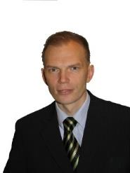
Address | 82-37 J.Pliekšāna  LV-2015 Jurmala (Latvia)
Mobile | +371 29218560
E-mail(s) | armands@hostellinglatvia.com
Nationality | Latvian
Date of birth | 12/05/1964
Gender | male
Desired employment / Occupational field | Chief of the Board
Work experience
Dates | 01/01/2009 →
Occupation or position held | EDEN project manager
Main activities and responsibilities | to manage and organize work within the EC project “European Destinations of Excellence”
Name and address of employer | Latvian Tourism Development Agency  55 Brīvības Street, LV-1519 Riga (Latvia)
Type of business or sector | State agency
Dates | 10/2004 - 06/2009
Title of qualification awarded | councillor
Principal subjects / occupational skills covered | to promote inter-institutional cooperation in particular with regional tourism organizations
Latvian Tourism Development Agency (state agency)
4 Pils Square, LV -1050 Riga (Latvia)
Dates | 03/2001 - 09/2005
Title of qualification awarded | head of department
Principal subjects / occupational skills covered | to manage the Council Tourism and External Relations Department
Name and type of organisation providing education and training | Jurmala City Council (municipal institutiuon)  5 Jomas Street, LV-2015 Jurmala (Latvia)
Dates | 08/1999 →
 | Chairman of the Board
Principal subjects / occupational skills covered | To direct activities of the association
Name and type of organisation providing education and training | Association "Apceļo Latviju" (association)  Čiekurkalna 1st line, 1 - 7, LV-1026 Riga (Latvia)
Education and Training
Dates | 2008-
Title of qualification awarded | PhD, Medical Sciences
Name and type of organisation providing education and training | Riga Stradiņš University
Level in national or international
classification
Dates | 2004-2007
Title of qualification awarded | MBA, Tourism strategic management
Name and type of organisation providing education and training | School of Business Administration Turība
Level in national or international
classification
Dates | 1982-1989
Title of qualification awarded | Mag.biol., biologist, professor of biology and chemistry
Name and type of organisation providing education and training | University of Latvia
Level in national or international
classification
Personal skills and competences
Native language | Latvian
Other language(s)
Self-assessment |  | Understanding |  |  |  | Speaking |  |  |  |  | Writing
European level (*) |  | Listening |  | Reading |  | Spoken interaction |  |  | Spoken production
English |  | C1 | Proficient user | C1 | Proficient user | C1 | Proficient user |  | - | - | B2 | Independent user
Russian |  | C2 | Proficient user | C2 | Proficient user | C2 | Proficient user |  | C2 | Proficient user | B2 | Independent user
 | (*) Common European Framework of Reference (CEF) level
Social skills and competences
Organisational skills and competences | Team man, but operates independently. Good communication skills  The ability to captivate, demanding to subordinates.
Technical skills and competences | Work with the technique at the average level
Computer skills and competences | good
Artistic skills and competences | sometimes
Driving licence(s) | B

10.06.2015.

PERSONAL INFORMATION | SANTA OGRIŅA
 | 90-2 Brīvības Street, Riga, LV1001, Latvia
 | +371 26986864; +371 29970996
 | santa.ogrina@gmail.com
 | santa@milagrotravel.lv
 | Gender: female | Date of birth: 09/05/1984 | Nationality: Latvian
WORK EXPERIENCE
2009 up to date | Marketing and Sales Manager / Co-owner  Tourism agency MILAGRO TRAVEL www.MilagroTravel.lv,  44- 23 Kr.Barona, Riga LV1011  - Product development (travel programs, routes, their descriptions);  - Website administration and optimization  - Identification of target markets  - Advertising campaigns creation  - Communication with customers  - Agreement and contract conclusion with direct service providers  - Financial flow control  - Recruiting and personnel training  - Task assignment to employees  - Customer service standards determination and control  - Independent client database creation and independent communication  - Monthly and annual reports making up  - Communication with tourism industry institutions – associations, foundations  - Everyday management of the office work  Branch: Tourism
2006 – 2009 | Store manager  Designer accessories store CHIC in the shopping center Galerija Centrs  - Recruiting and personnel training  - Task assignment to employees  - Store goods and show- window arrangement  - Incoming/ outgoing goods and stock control  - Goods ordering  - Work with customers  - Independent client database creation  - Finanical indicators reports making up  Branch: Clothing and accessory retail
2006  (January – March) | Client manager  Apartments and holiday house renting company RENTXPRESS www.rentxpress.com  Rome, Italy  - Correspondence and communication with customers and management (in English)  - Welcoming of guests and apartment exhibition, the transfer to use  - Apartments quality control  - Cleanliness assurance and control  - Repairs assignment and work performance control  Branch: Tourism
2005  (June – October) | Waitress  The hotel restaurant „Schiff”  Einsiedeln , Switzerland  - Accept and process customer orders (German)  - Warehouse goods control and ordering  - Work with cash  - Cleanliness and order assurance in the restaurant  Branch: Tourism & Hospitality
2005- 2004  (October – May) | Waitress  Restaurant and bar „PUPU Lounge”  8 Mārstaļu Street, Riga LV1050  - Accept and process customer orders  - Work with cash  - Cleanliness and order assurance in the restaurant  Branch: Tourism & Hospitality
2004  (May – October) | Waitress  The hotel sani Beach Hotel 4* restaurant and bar „Dolphins` Bar”  Halkidiki / Greece  - Accept and process customer orders  - Work with cash  - Cleanliness and order assurance in the restaurant  Branch: Tourism & Hospitality
EDUCATION
2009 - 2010 | Master's Degree in Business Administration and Enterprise and Establishment Manager Qualification
2009 - 2010 | School of Business Administration Turība  68 Graudu Street 68, Riga LV1058, Latvia
2009 - 2010 | - International business environment  - Sustainable development and innovations  - Project management  - Financial management  - Strategic and change management  - Forecasting in business  - Marketing management  - Human resource management  - Psychnology of organizations
2003 - 2007 | Professional Bachelor’s Degree in Business Administration,  Qualification of Enterprise and Establishment Manager with Specialization in Hotel Administration  School of Business Administration Turība  68 Graudu Street, Riga LV1058, Latvia
2003 - 2007 | - Business in tourism  - Tourism planning and management  - Active tourism basics  - Commercial activities in tourism  - Travel organizing  - International hotel business  - International tourism marketing  - World and Latvian tourism geography  - Hotel marketing and management  - Organization of events and conferences  - Hotel economic operations organization  - Tourism project management  - Communication and hospitality in tourism  - Rural tourism  - Business mathematics  - Financial accounting  - Menedžments, komerctiesības, mikroekonomika u.c. Management, commercial law, microeconomics, etc.
1998 - 2003 | Certificate of General Secondary Education
1998 - 2003 | Friendly Appeal Cesis State Gymnasium  2 Pūces Street, Cesis LV4101, Latvia
1997 - 1998 | Basic education
1997 - 1998 | Cesis Primary School No. 2  4 Bērzaines Street, Cēsis LV4101, Latvia
SKILLS
Native language | Latvian
Other language (s) | UNDERSTANDING |  | SPEAKING |  | WRITING
Other language (s) | Listening | Reading | Dialogue | Monologue
English | C1/2 | C1/2 | C1/2 | C1/2 | C1/2
German | B1/2 | B1/2 | B1/2 | B1/2 | B1/2
Levels: A1/2: Basic level - B1/2: Average level - C1/2 Higher level

Common European Framework of Reference for Languages

Russian | B1/2 | B1/2 | B1/2 | B1/2 | A1/2
Communication skills | Good communication skills gained through experience as a sales and marketing manager, creating different levels of communication with subordinates, customers, senior management.
Organizational / managerial skills | Currently I lead an independent team of 3 people and organize service rendering/ reception of many external services providers at local and international levels - hotels, transport companies, tour guides, restaurants and the staff - website designers, website programmers.
Computer skills | Microsoft Office, Internet, Goolge Advertising, SEO
Other skills  1997 - 2002 | Clothing design and sewing  Master Diploma  CBJC, Cesis LV4100, Latvia
Driving licence (s) | B category
ADDITIONAL INFORMATION
Seminars  Certificates | 2013 Bizness publishers practical workshop: Internet Marketing Search Engine Optimization  2013 Dienas Bizness publishers practical workshop: Internet Marketing – For Online Marketers  2012 Self-learning – Goolge Advertising  2007 Mercuri International seminar – Staff Training in Services  2013 Tour Guide Certificate – Old Riga  2005 Swiss School of Tourism & Hospitality (Kure/ Switzerland) – Hotel service

12.06.2015.
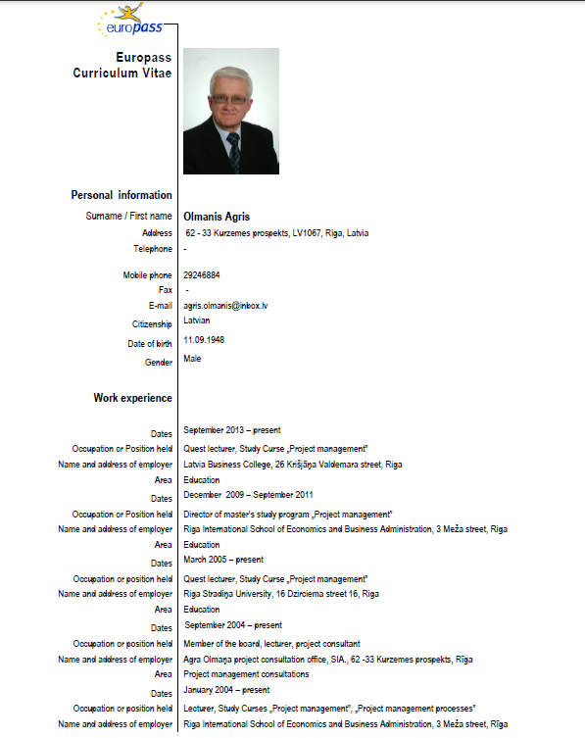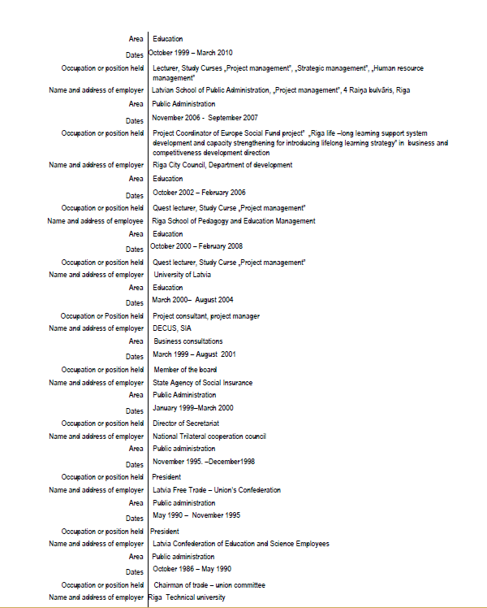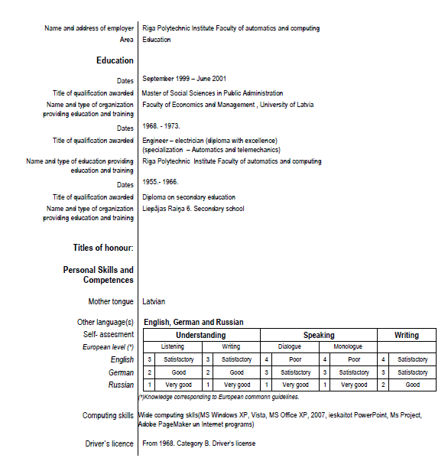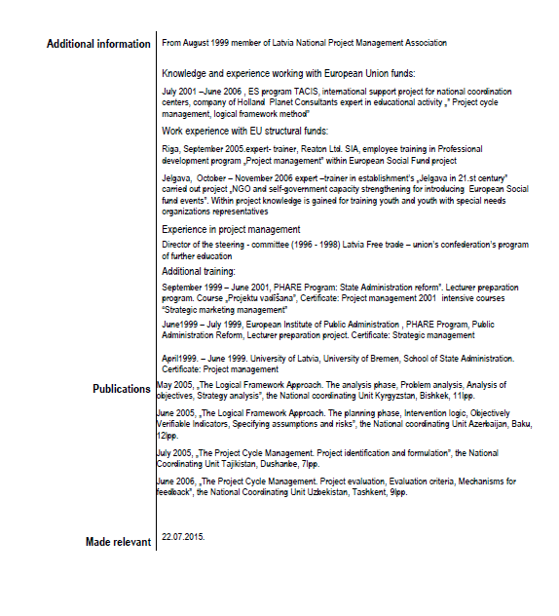

CURRICULUM VITAE

First Name, Last Name | Ināra Parādniece
Birth Place | Riga
Birth date: | January 26th, 1946
Nationality: | Latvian
Address: | 2-77 Kurzemes prospekts 2-77, Riga, LV- 1067, Latvia
Phone: | Home: +371 67414677; Cell: +371 29141834
Education:  1997 –06.2004  2002  1981 | Higher  University of Latvia, Faculty of Legal Affairs, legal science, 5,5.semesters (Defended diploma paper in 2004 “Corruption and prevention problems in state and municipality procurement field);  University of Latvia, Faculty of Economics and Management, Chair of Public Administration, Social Science master’s degree in Public Management  University of Latvia, Faculty of Foreign Languages, Philologist, German language teacher
Languages | Latvian – birth, German – fluently, Russian – fluently, English – with dictionary
Work Experience:  Since Feb’11  June’12 – Nov' 13  Since Mar’11  Since Apr’06  Jan’01. – Mar’03  Sep’97 – Jun’04  1995 - 1997 | Latvian Business College, European distance-learning college, professor  (Personnel management, Political science, Politics)  Latvian Ministry of Culture, Minister’s office manager  LLC „RODES pakalpojumi”, Director  SIA „AGNI”, Manager of Personnel  Ministry of Welfare, State employment agency, Director of Administrative department (Personnel Division, public procurement and economic security division, Documentation management division, the ESF funded projects, the ERDF project monitoring Board Vice President)  Ministry of Economics, Central privatization commission of residential houses, Manager of personnel  State’s Civil Service Administration - Civil service introduction’s manager, Personnel management’s development manager
Additional qualification  Various certified courses, information and expertise seminars  Regulatory documents prepared:  Developed concept projects and instructions:  Opinions, proposal preparations:  Organizational work | Acquired main scope of study for qualification: Public administration, Management, Economics – foundation of society’s management, public administration and municipality’s organization, public rights, political analysis, personnel management, project management, budget and finance etc.  Legal studies – civil law, criminal law, international law and public law, employment law, and theory of law etc.  “Staff assessment types and methods”; “Quality management system implementation and necessity”; “New Labor Law”; “Public speech and presentation”; “Public and local authority structural reform, organization and finances”; “Ethics, Psychology and informatics”; “Fundaments of Market Economy”; “Work descriptions and employee assessment”; “Staff management”; “interviewer training program, structured discussion about objectives and strategy for human resources management issues”; “Basics of management”; English language courses, German language course in Switzerland etc.  “Provisions of job descriptions for civil servants”; Provisions for civil servant’s job list”; Instructions for job description’s development and preparation” etc.  “Development of Civil service’s control system”; “personnel management’s development concept in state’s institutions”; “Methodology and criteria for civil servants”; “Recommendations on the competition for a vacant civil service position ”; “Officials and employee assessment”.  Given the findings, proposals and objections to the draft regulatory enactments prepared by national authorities  Organization of various seminars, management, preparation of methodological materials: “About state’s civil service official’s position evaluation and qualification category granting methodology”; 5 informative seminars “About civil service and application at municipalities”;”EU PHARE un VAS seminar “About qualification examinations of potential civil service official’s”.
Additional skills | Ability to organize, manage and plan the work. Ability to work with an audience and creative approach to work. Good implementation of theoretical knowledge in real life situations. Ability to persuade and find solutions in difficult conflict situations.  Experience in administrative and personnel management issues, regulatory and normative document preparation.  Computer skills, Windows, Excel, Internet and other office equipment.  “B” category’s driver’s license.

11.06.2015.

Europass
Curriculum Vitae
 | Personal data
 | Name/Surname | Alla Plaude
 | Identity Code | 180568-12215
 | Place of birth | Minsk
 | Address | J. Alunāna Street 8, Jūrmala, Latvia, LV 2008
 | Telephone | 2 96 275 96
 | Fax | -
 | E-mail | aplaude@inbox.lv
 | Nationality | Latvian
 | Gender | woman
 | Academic and Scientific grades | Dr.psych.
 | Work Experience
 | Dates | From 04.09.2013.
 | Occupation or position held | lecturer
 | Name of employer | The European Distance University College
 | Dates | from 11.2011.
 | Occupation or position held | lecturer
 | Name of employer  Dates  Occupation or position held  Name of employer | Riga Teacher Training and Educational Management Academy  From 2010  lecturer  Riga International School of Economics and Business Administration
 | Occupation or position held | From 2010
 | Name of employer | lecturer
 | Name of employer | at the State Employment Agency (NVA)
 | Dates | From 2006
 | Occupation or position held | lecturer
 | Name of employer | Master Class Style Ltd. – competitiveness improvement training
 | Dates | From 2005
 | Occupation or position held | private practice
 | Name of employer | Psychology / psychotherapy
 | Dates | From 2007–up to this day
 | Occupation or position held | editor at the magazine
 | Name of employer | „ Psychology for Family and Schools”
 | Dates | From 2004–2009
 | Occupation or position held | lecturer
 | Name of employer | Riga Teacher Training and Educational Management Academy
 | Dates  Occupation or position held  Name of employer  Dates  Occupation or position held  Name of employer  Dates  Occupation or position held  Name of employer  Education and Training | 2004–2006  Head of the Organisational Psychology Department at RTTEMA  Riga Teacher Training and Educational Management AcademyFrom 2004-2007  2004-2008  lecturer  BSA (BKA)  2002–2004  lecturer/assistant  Riga Teacher Training and Educational Management Academy
 | Dates | 10. 2006 – 10.2012.
 | Title of qualification awarded | Doctor of Psychology in Personality Psychology (NR. 0492)
 | Name and type of organization providing education and training | University of Latvia
 | Dates | 09. 2010 – 12. 2012
 | Title of qualification awarded | Bachelor’s Degree in Pedagogy
 | Name and type of organization providing education and training | Riga Teacher Training and Educational Management Academy
 | Dates | 2010
 | Title of qualification awarded | Qualification of psychotherapist „Individual Psychodynamic Psychotherapy”  Psychiatry clinic of Vilnius University, Faculty of Medicine
 | Name and type of organization providing education and training  Dates  Title of qualification awarded  Name and type of organization providing education and training  Dates  Title of qualification awarded  Name and type of organization providing education and training | 2003  Master’s degree in psychology  Riga Teacher Training and Educational Management Academy  2001  Bachelor’s degree in psychology and the qualification of school and family psychologist  Riga Teacher Training and Educational Management Academy
Training
Dates |  | 2001-2003
Title of qualification training |  | Psychological Training Methodology
Name and type of organization |  | St. Petersburg Acmeology Academy
Dates |  | 2000 – 2001
Title of qualification training |  | Psychologist-acmeologist
Name and type of organization |  | St. Petersburg Acmeology Academy
 | Personal Skills and Competences
 | Mother tongue | Latvian
 | Other Languages
 | Self-assessment |  | Understanding |  |  | Speaking |  |  | Writing
 |  |  | very good | good |  | very good | good |  | very good | good
 | English |  |  | X |  |  | X |  |  | X
 | Russian |  | X |  |  | X |  |  | X
 | Scientific research
 | Publications in corresponding scientific field  Proceedings and abstracts  Other publication | Plaude, A. (2013). Relationship Between Creativity Style and Stress Coping Strategies in an Adult Group. Creative Personality. Collection of Scientific Papers, 11(95-103), Riga: RTTEMA.  Plaude, A., Roze, J. & Roze, J. (2012). Creativity Styles and Psychological Defence Mechanisms: Theoretical and Empirical Insights. Creative Personality, 10, 66-75. Collection of Internationally Reviewed Scientific Paper, RPIVA, Riga.  Plaude, A., & Raščevska, M. (2011). The Association of Cognitive Abilities, Emotional Intelligence, Defence Mechanisms and Coping with Employment and Unemployment. Baltic Journal of Psychology, 12 (1, 2), 83–101.  Plaude, A., & Raščevska, M. (2008). Adaptation of M. Bond’s Defence Style Questionnaire (DSQ) in Latvia. Latvijas Universitātes raksti, 729. Sējums. Psiholoģija. Rīga: LU Apgāds.Provide information for the last 6 years  Plaude, A., & Rascevska, M. (2011). Psychometric Properties of R. Plutchik’s Life Style Index (LSI) for Latvian. Individual Presentation Abstracts of the 11th European Conference on Psychological Assessment. Riga.  Plaude, A., & Rascevska, M. (2011). How Cognitive Ability, Emotional Intelligence, Defence Mechanisms and Coping Predict Unemployment. Individual Presentations Abstracts of the 12 European Congress of Psychology Istanbul.  Plaude, A., & Rascevska, M. (2008). Adaptation of Defence Style Questionnaire. In Dalbert, C. (Ed.), International Journal of Psychology (Vol.43, pp. 649). Germany: Taylor & Francis Group.  Plaude, A. (2012). Intellect, Stress Management and Psychological Defence Mechanisms for the Unemployed. University of Latvia, 70th Conference.  Plaude, A., & Rascevska, M. (2011). Psychometric Properties of R. Plutchik’s Life Style Index (LSI) for Latvian. Individual Presentation Abstracts of the 11th European Conference on Psychological Assessment. Riga.  Plaude, A., & Rascevska, M. (2011). How Cognitive Ability, Emotional Intelligence, Defence Mechanisms and Coping Predict Unemployment. The 12 European Congress of Psychology Istanbul.  Raščevska, M., & Plaude, A. (2009). Gifted Students Profiles of Analytical, Practical and Emotional Intelligence and everyday Creativity. 2nd International conference: Gifted Children: Challenges and Possibilities.  Plaude, A. (2009). Emotional and Analytical Intellect of the Unemployed and Workers. University of Latvia, 67 th Conference.  Plaude, A., & Rascevska, M. (2008). Adaptation of Defence Style Questionnaire in Latvia. XXIX International Congress in Psychology, Berlin.  Plaude, A. (2008). Social and Psychological Description of the Unemployed. University of Latvia, 66 th Conference.  Plaude, A., & Raščevska, M. (2007). Adaptation of Defence Style Questionnaire in the Cultural Environment of Latvia. University of Latvia, 65th Conference.  Plaude, A. (2006).Psychological Defence Mechanisms and Emotional Intelligence: theoretical report. University of Latvia, 64th Conference.  Plaude, A., Raščevska, M. (2006). Adaptation of M. Bond’s Defence Style Questionnaire in Latvia. VII International Baltic Conference in Riga.
 | Participation with a report (any kind) in International scientific conferences and congresses | - Plaude, A. & Kalis, E. (2013). XVII International Creativity Conference: Creativity and defense mechanisms. RTTEMA, Riga, 29.11.2013.-30.11.2013.  - Plaude, Roze & Roze (2012). XVI International Creativity Conference: Creativity Styles and Psychological Defence Mechanisms: Theoretical and Empirical Insights. RTTEMA, Riga, 22.11.2012.-24.11.2012.  - Plaude & Petrucena (2012). Biopsychological Basics of Life in Education and Health: The Conceptions about Psychologist Role in the School by different Social Groups in the region of Latgale, RTTEMA, Riga, 26.10.2012.-28.10.2012.  - Plaude, A. (2012). Intellect, Stress Management and Psychological Defence Mechanisms for the Unemployed. University of Latvia, 70th Conference.  - Plaude, A., & Rascevska, M. (2011). Psychometric Properties of R. Plutchik’s Life Style Index (LSI) for Latvian. Individual Presentation Abstracts of the 11th European Conference on Psychological Assessment. Riga.  - Plaude, A., & Rascevska, M. (2011). How Cognitive Ability, Emotional Intelligence, Defence Mechanisms and Coping Predict Unemployment. The 12 European Congress of Psychology Istanbul.  - Raščevska, M., & Plaude, A. (2009). Gifted Students Profiles of Analytical, Practical and Emotional Intelligence and everyday Creativity. 2nd International conference: Gifted Children: Challenges and Possibilities.  - Plaude, A. (2009). Emotional and Analytical Intellect of the Unemployed and Workers. University of Latvia, 67 th Conference.  - Plaude, A., & Rascevska, M. (2008). Adaptation of Defence Style Questionnaire in Latvia. XXIX International Congress in Psychology, Berlin.  - Plaude, A. (2008). Social and Psychological Description of the Unemployed. University of Latvia, 66 th Conference.  - Plaude, A., & Raščevska, M. (2007). Adaptation of Defence Style Questionnaire in the Cultural Environment of Latvia. University of Latvia, 65th Conference.  - Plaude, A. (2006).Psychological Defence Mechanisms and Emotional Intelligence: theoretical report. University of Latvia, 64th Conference.  - Plaude, A., Raščevska, M. (2006). Adaptation of M. Bond’s Defence Style Questionnaire in Latvia. VII International Baltic Conference in Riga.
01.04.2015. Alla Plaude

CURRICULUM VITAE
SVETLANA pOLOVKO
Address: Riga, Kr. Barona street 80, Latvia
Phone: Mobile: 25944741
E-mail: svetlana.polovko@inbox.lv
Date of birth: 01 July 1980
EDUCATION
November 2013. – March 2014 | Vilnius University, Doctoral studies by ERASMUS program
2013. – 2014. | ISMA, Doctoral program “Management”
2008. – 2012. | “Riga Technical University”, Faculty of Engineering economy and Management. Doctoral study program “Management”. Theoretical exams passed. Specialisation - Insurance
2004. – 2006. | “Riga Technical University”, Faculty of Engineering economy and Management. Master study program “Management”  Professional Master degree in management. Diploma PD C Nr. 0052, Riga, 2006.
1998. – 2003. | Highest School of Economy and Culture, bachelor study program “Management”  Professional Bachelor degree in business administration. Diploma Nr. 00006, Riga, 2003
1996. – 1998. | Riga 62. school, Secondary education.
EMPLOYMENT HISTORY:
January 2011. - Present | ‘European Distance University”, researcher.
January 2010. - Present | „Latvian Business Colledge”, lecturer.
September 2008. – June 2012. | “Riga Technical University”, Faculty of Engineering economy and Management, Lecturer
September 2007. – February 2011. | Highest School of social technologies, The chief of chair of economy
November 2007. – June 2008. | Insurance joint-stock company “Baltijas Apdrošināšanas Nams” – Person risk underwriter.
2005. – 2007. | Insurance joint-stock company “BALTIKUMS”, Person risk underwriter.
2001. – 2004. | Joint-stock company “ASGprim” the exclusive dealer in Baltic countries of ОАО”Агрисовгаз” (Agrisovgaz) the branch of joint stock company ОАО”Газпром” (Gazprom), which represents 5 factories ( aluminum, steel, polymers, plastics and rubber). Administrator.
1998. – 2001. | Highest School of Economy and Culture, The president of the student's organisation
SUMMARY OF QUALIFICATIONS
- Five years successful experience in direct sales of a range of products and services.
- Motivated and enthusiastic about developing good relations with clients.
- Effective working alone or as a cooperative team member.
- Professional in appearance and presentation.

LANGUAGES:
Russian Native
Latvian Proficient level
English Average level
German Beginning level with dictionary (6 month program in University)
PUBLICATIONS:
- Baranovskis N., Polovko S. LATVIAN INSURANCE MARKET DEVELOPMENT AS MembER of the European insurance and reinsurance federation // International Scientific Conference of Nicolaus Copernicus University, POLAND, Torun, December 2009.
- Polovko S. LATVIJAS APDROŠINĀŠANAS TIRGUS VEIDOŠANĀS // “Scientific Conference on Economics and Entrepreneurship” 50. Rīgas Tehniskās universitātes konference SCEE’2009, LATVIJA, Riga, 15. – 16. oktobris, 2009
- Polovko S. LATVIJAS APDROŠINĀŠANAS TIRGUS VEIDOŠANĀS // “Scientific Conference on Economics and Entrepreneurship” 50. Rīgas Tehniskās universitātes konference SCEE’2009, LATVIJA, Riga, 15. – 16. oktobris, 2009.
- Polovko S. Перспективы развития электронных услуг на страховом рынке Латвии / Prospects of development of electronic services in the latvian insurance market // International cross-industry Research journal “Perspectives of Innovations, Economics and Business” Volume 3, PIEB Research supporting project, CZECH Republic, Prague, November, 2009.
- Polovko S. Prospects of development of electronic services in insurance / Перспективы развития электронных услуг в страховании // 9th ERNESTAS GALVANAUSKAS International Scientific Conference, Siauliai University, LITHUANIA, Siauliai, November 2009
- Baranovskis N., Polovko S. LATVIAN INSURANCE MARKET DEVELOPMENT AS MembER of the European insurance and reinsurance federation // International Scientific Conference of Nicolaus Copernicus University, POLAND, Torun, December 2009
- Apdrošināšanas pakalpojumu nozīme tautsaimniecībā / the importance of services of insurance in a national economy // XI STARPTAUTISKĀ ZINĀTNISKĀ KONFERENCE "Cilvēks, sabiedrība, valsts mūsdienu mainīgajos ekonomiskajos apstākļos", Biznesa Augstskola Turība, LATVJIA, Rīga, Marts 2010
- Актуальные проблемы реализации директив Европейского союза в сфере страхования // STARPTAUTISKĀ ZINĀTNISKĀ KONFERENCE "Tiesiskā nodrošinājuma problēmas krīzes apstākļos", Sociālo Tehnoloģiju Augstskola, LATVJIA, Rīga, Aprīlis 2010
- THE IMPORTANCE OF SERVICES OF INSURANCE IN LATVIAN ECONOMY // “International Scientific Conference European Financial Systems 2010”, Faculty of Economics and Administration, Masaryk Univercity, CZECH REPUBLIC, Brno, May 2010
- LATVIJAS APDROŠINĀŠANAS NOZARES APSKATS AKTUĀLĀS PROBLĒMAS // STARPTAUTISKĀ ZINĀTNISKĀ KONFERENCE " Tautsaimniecības problēmas krīzes apstākļos II", Sociālo Tehnoloģiju Augstskola, LATVJIA, Rīga, Maijs 2010
- LATVIJAS APDROŠINĀŠANAS TIRGUS ANALĪZE // “Scientific Conference on Economics and Entrepreneurship” 51. Rīgas Tehniskās universitātes konference SCEE’2010, LATVIJA, Rīga, oktobris, 2010.
- Polovko S. „Tendencies of development of the Latvian insurance market „ Lviv Polytechnic National University “ECONOMICS AND MANAGEMENT 2010” (EM-2010), Publishing House of Lviv Polytechnic. 25-27 November 2010, L viv, Ukraine. 230.lpp ISBN 978-617-607-000-9
- С. Половко. «Правовое регулирование страхового рынка Латвии». Международная научная конференция студентов, магистрантов и аспирантов «Правовое обеспечение инновационного развития общества и государства» (29-30 октября 2010 г., г. Минск) krājumi tiks publicēti 2011.g.
- С. Половко. «Проблемы страхового рынка Латвии в период экономического кризиса» X Международная научно-практическая конференция "Менеджмент XXI века: эффективность, качество, устойчивое развитие" РГПУ им. А.И. Герцена с 24.11.2010 по 25.11.2010 Санкт-Петербург, Россия 378.стр. ISBN 978-5-8064-1613-2
- S.Polovko. „Economic-socially role of insurance branch in Latvian economy” "Economics and Management-2011 (ICEM-2011)". The Conference will take place from 27th to 29th April, 2011 in Brno, Czech Republic. Faculty of Economics and Management of Kaunas University of Technology (Lithuania), Faculty of Engineering Economics and Management of Riga Technical University (Latvia) and others.
- Polovko S. Creating structural model of the insurance market of Latvia // World Academy of Science, Engeneering and Technology, France, Paris, 24.-26. June, 2011 (citēts zinātn. žurn. International Refereed Conference Proceedings, ISSN 2010-3778 - EBSCO, Google Scholar, Scopus, Thomson Reuters datubāzēs)
- Polovko S. , Zvanītājs J., Baranovskis N. SOCIALLY ECONOMIC ROLE OF INSURANCE IN NATIONAL ECONOMY DURING THE CRISIS // The Ninth International Conference «Challenges of Europe: Growth and Competitiveness – Reversing the Trends» Under the auspices of The President of the Republic of Croatia Mr. Ivo Josipović and Croatian Chamber of Commerce, University of Split , CROATIA, Bol, May 24.-28. 2011 (citēts zinātn. žurn. Management ISSN 1846-3363 EBSCO Publishing bibliographic and research un SciVerse SCOPUS datubāzē).
- Polovko S. MEASURED CONTRIBUTION OF INSURANCE TO ESONOMIC GROWTH // “International Scientific Conference European Financial Systems 2011”, Faculty of Economics and Administration, Masaryk Univercity, CZECH REPUBLIC, Brno, June 2.-3. 2011, ISBN 978-80-210-5509-4, p.215-218
- S. Polovko „Latvijas apdrošināšanas tirgus darbības prognozēšana” // Starptautiskā zinātniskā konference „Eiropas integrācijas sociālā un ekonomiskā dimensija: problēmas, risinājumi, perspektīvas”, Daugavpils Universitāte, LATVIJA, 3.-5. Novembrī 2011

Skills and competences:
Perfect command of Windows 3.xx/98/2000/XP, MS-DOS, , MS Office Word, Excel, FrontPage, presentation program MS PowerPoint, Access, Internet, computer graphic Photo Shop, Paint Shop Pro
Personal characteristic and competences
Responsible, executive, strategist, sociable, bright personality, flexible to adapt to multicultural environments

11.06.2015. Svetlana Polovko

Europass
Curriculum Vitae
Personal data
Name/Surname |  | Pumpure Inga
Identity Code |  | 100870-11852
Place of birth |  | Aizkraukle
Address |  | Ķeguma prospekts 3, Baldone, LV-2125
Telephone |  |  | Mobile | 26434123
Fax
E-mail |  | Inga.pumpure@gmail.com
Nationality |  | Latvian
Gender |  | Femail
Academic and Scientific grades |  | Master's Degree in Financial Management
Work Experience
Dates  Occupation or position held  Name of employer  Dates |  | From 08.2014  Lecturer of Seminars  Lietišķās informācijas dienests  From 12.2011
Occupation or position held |  | Lecturer of Seminars and refresher courses
Name of employer |  | Nodokļu likumdošanas izglītības centrs
Dates |  | 10.2011 – 12.2013
Occupation or position held |  | Lecturer of courses
Name of employer |  | Mācību un konsultāciju centrs ABC
Dates |  | From 10.2010
Occupation or position held |  | Lecturer
Name of employer |  | Latvijas biznesa koledža un Augstskola EIHSEBA
Dates |  | From 05.2010
Occupation or position held |  | Chief Accountant in 30 enterprises
Name of employer |  | Self-employed
Dates |  | 10.2010. – 12.2012
Occupation or position held |  | Lecturer of courses , Vice exam
Name of employer |  | training Centre BUTS
Dates |  | 05.2010 – 04.2013
Occupation or position held |  | financial Consultant
Name of employer |  | MetLife filiāle Latvijā
Dates |  | 08.2008 – 03.2010
Occupation or position held |  | Chief Accountant in 28 enterprises
Name of employer |  | Accounting outsourcing provider GBC, SIA
Education and Training
Dates |  | 09.2007 – 06.2009
Title of qualification awarded |  | Professional master's degree in finance and Financier, diploma PD E Nr. 0591, issued RA 2009.gada 26.jūnijā
Name and type of organization providing education and training |  | Rēzeknes Augstskola
Dates |  | 08.2003 – 07.2007
Title of qualification awarded |  | The second level professional higher education diploma PD C Nr. 3411, issued BSA 2007.gada 13.jūlijā
Name and type of organization providing education and training |  | Baltijas Starptautiskā akadēmija

Training
Dates | From 09.2012
Title of qualification training | Pārdošana 24/7 seminar cycle
Name and type of organization | Latvijas Tirdzniecības un rūpniecības kamera
Dates | 2008
Title of qualification training | practical accounting
Name and type of organization  Dates  Title of qualification training  Name and type of organization | International Correspondence Course  10.2006.-02.2007  Accounting trade and catering enterprises  Latvikon SIA

Personal Skills and Competences
Mother tongue | Latvian
Other Languages
Self-assessment |  | Understanding |  | Speaking |  | Writing
 |  | very good | good | very good | good | very good | good
English |  |  | X
Russian |  | X |  | X |  | X
Other member-associations
Dates | From 10.2012
Association, foundation | Latvijas Tirdzniecības un rūpniecības kamera
Dates | From 08.2012
Association, foundation | President of BPW Latvia Riga( Business Professional Women)

12.06.2015.

Europass
Curriculum Vitae
Personal data
Name/Surname | Sandra Ratniece
Identity Code | 200469 - 12979
Place of birth | Riga
Address | 6 – 10, Palmu Street, Riga, LV - 1006
Telephone | 26307672
Fax | -
E-mail | sandra_rat@inbox.lv
Nationality | Latvian
Gender | Female
Academic and Scientific grades | Dr. philol, docent
Work Experience
Dates | From 01.02.2012 to present time
Occupation or position held | Docent, chairperson of the senate
Name of employer | Eihseba University
Dates | from 01.11. 2011 to 01.11.2017
Occupation or position held | researcher
Name of employer | Rēzekne University (Rēzekne Higher Education Institution), Institute for Regional  Studies
Dates | from 22.06.2007 to 01.12. 2011
Occupation or position held | research assistent
Name of employer | Latvia University, Faculty of Philology (at present Faculty of Humanities)
Dates | from 03.01. 2005 to 31.12. 2006
Occupation or position held | asistent
Name of employer | Latvia University, Institute of Literature, Folklore and Art, department of Literary Theory
Education and Training | 01.09.2014  student at the Art Academy of Latvia doctoral study program "Art"
Dates | 01.03.2011
Title of qualification awarded | Dr. philol. Degree in Literary Theory; Diploma: D Nr. 0386
Name and type of organization providing education and training | Latvia University, Promotion Board
Dates | 05.07.2004
Title of qualification awarded | Mg.philol. degree in Philology; Diploma MDA Nr. 1251
Name and type of organization providing education and training | Latvia University, Faculty of Philology
Dates | 21.06. 2002
Title of qualification awarded | BA degree in Philology, Diploma: Nr. 020370
Name and type of organization providing education and training | Latvia University, Faculty of Philology
Training
Dates |  |  | From 01.02.2004 to 30.04.2004; from 01.04.2003 to 15.07.2003
Title of qualification training |  |  | Erasmus / Socrates program
Name and type of organization |  |  | Ernst-Moritz-Arndt-Universität Greifswald, Germany
Dates |  |  | 03.07.2003
Title of qualification training |  |  | Certificate of a course in German
Name and type of organization |  |  | Ernst-Moritz-Arndt-Universität Greifswald, Institute of German Philology
Personal Skills and Competences
Mother tongue | Latvian
Other Languages | German, Russian
Self-assessment |  | Understanding |  |  |  | Speaking |  |  | Writing
 |  | very good |  | good |  | very good | good |  | very good | good
German |  |  |  | X |  |  | X |  |  | X
Russian |  | X |  |  |  | X |  |  | X
Scientific research | 2009 - 2010 – ESF scholarship  29.09.2004 – Munster award for a deep and analytical research of Latvian and German Modern style in Master’s thesis Features of Modern style in the Latvian Literature of Early XX Century;  25.09.2004 – Veronikas Strēlerte’s memorial scholarship for the Bachelor’s paper Traditional and Inovative in Edvarts Virza’s Collection of Sketches „Zaļā Zemgale” in the Aspect of Literary Schools;  July, 2004 – Certificate of Recognition of Latvia University for work in the branch of Literary Science, the sub-branch of Literary Theory (for the Master’s thesis Features of Modern style in the Latvian Literature of Early XX Century).  A member of Latvian Writerrs’ Union from 2011.
Organization of conferences and compilation of collected papers of conferences:
Rēzekne University (Rēzekne Higher Education Institution), International scientific conference ” Author. Text. Age.” (27.04.2012).
The 70th conference of Latvia University: A seminar dedicated to Zigmunds Skujiņš A Visit to Zigmunds Skujiņš in LU, Faculty of Humanities, 10.02.2012;

2011: ”The Purple Time of Heather”, a seminar dedicated to Elza Ķezbere’s 100th anniversary, LU, Faculty of Humanities, 11.05.2011;

The 69th conference of Latvia University: a seminar dedicated to Mirdza Bendrupe’s 100th anniversary My World Far Away. My Heaven Here, LU, Faculty of Humanities, 18.02.2011;

Compiler and a member of editorial board of collected articles Latvian and Foreign Literature: from Romanticism to Modernism No. 1.(2010), 2. (2011.), 3. (2012.), 4. (2013.);

2009 – 2014: Latvian and Foreign Literature: from Romanticism to Modernism „I – IV (LU, Faculty of Humanities).

Scientific review of:
1) Tatjana Lvrecka’s dissertation
2) Inese Valtere’s dissertation

Supervision of course papers:
Rēzekne University (Rēzekne Higher Education Institution):
2011. / 2012. – 1 paper
2012. / 2013. – 1 paper

Publications in corresponding scientific field  Proceedings and abstracts  Other publications | 2014.  To Paint Words, to Write a Painting. The Interaction of Fine Arts and Literature, the Example of Ruta Štelmahere.// Collected papers „Topical Issues of Literary Theory”. ISSN1407-4729, No. 19, Liepāja: LiePA, 2014, pp.128. – 137. Organizer of the conference and editor in chief.  2013.  Literary Modern Style in Modern Latvian Poetry or Creative Experiment in Poetry Days 2011 – Collected papers „Topical Issues of Literary Theory”: ISSN 1407-4729, Liepāja: LU HMZF, No. 18, pp.238. – 248.  The Modern Style in XXth Century Riga: Modern Style and National Identity – The United edition of scientific papers of the 3rd World congress of Latvian Scientists and the 4th Letonika (Latvian Studies) Congress, Selected papers ”Riga Texts. The 100th Anniversary of Augusts Deglavs’ novel „Rīga””. Rīga: Zinātne, pp. 177. – 186.  2012.  Fricis Bārda’s „Zemes dēls” from the perspective of the Typology of Modern Style. The 68th conference of Latvia University. Latvian and Foreign Literature: from Romanticism to Modernism. Selected articles. No.3., Rīga: Jaunā Daugava, 2011, pp.22. – 31.  2011.  Cultural Parallels of Literary Modern Style in Latvian and Russian Literature of the early XXth Century. Issues of Modernity and Postmodernity: Selected articles of XL International Conference of Philology, March 14 – 19, 2011, Санкт-Петербург: Петербург - век, pp.32. – 37.  Latvian Culture Environment in Early XXth Century and the Modern Style. // The 68th conference of Latvia University. Latvian and Foreign Literature: from Romanticism to Modernism. Selected articles. No.2., Rīga: Jaunā Daugava, 2011, pp.71. – 78.  2010.  The Creative Work of Kārlis Skalbe and Edvarts Virza: Pantheism as a Code of National Identity. // The 67th conference of Latvia University. Latvian and Foreign Literature: from Romanticism to Modernism. Selected articles. No. 1., Rīga: Jaunā Daugava, 2010, pp.92. – 98.  2009.  Synthesis of Modern Style and Symbolist Poetics in the Texts of Early XXth Century Latvian Literature // Collected papers „Topical Issues of Literary Theory”. No. 14, Liepāja: LiePA, 2009, pp.11. – 16.  2008.  Neo-Romanticism and Modern Style in Latvian Literature of Early XXth Century (94 – 101), Panheism in Latvian Literature of Early XXth Century (102 – 110) // European Culture as a System. – Daugavpils: Saule, 2008.
Participation with a report (any kind) in International scientific conferences and congresses | 2013.  Literary Modern Style in Modern Latvian Poetry or Creative Experiment in Poetry Days 2011 – Collected papers „Topical Issues of Literary Theory”: ISSN 1407-4729, Liepāja: LU HMZF, No. 18, pp.238. – 248.  The Modern Style in XXth Century Riga: Modern Style and National Identity – The United edition of scientific papers of the 3rd World congress of Latvian Scientists and the 4th Letonika (Latvian Studies) Congress. Selected papers ”Riga Texts. The 100th Anniversary of Augusts Deglavs’ novel „Rīga””. Rīga: Zinātne, pp. 177. – 186.  2012.  Fricis Bārda’s „Zemes dēls” from the perspective of the Typology of Modern Style. The 68th conference of Latvia University. Latvian and Foreign Literature: from Romanticism to Modernism. Selected articles. No.3., Rīga: Jaunā Daugava, 2011, pp.22. – 31.  Cultural Parallels of Literary Modern Style in Latvian and Russian Literature of the early XXth Century. Issues of Modernity and Postmodernity: Selected articles of XL International Conference of Philology, March 14 – 19, 2011, Санкт-Петербург: Петербург - век, pp.32. – 37.  Latvian Culture Environment in Early XXth Century and the Modern Style. // The 68th conference of Latvia University. Latvian and Foreign Literature: from Romanticism to Modernism. Selected articles. No.2., Rīga: Jaunā Daugava, 2011, pp.71. – 78.  The Creative Work of Kārlis Skalbe and Edvarts Virza: Pantheism as a Code of National Identity. // The 67th conference of Latvia University. Latvian and Foreign Literature: from Romanticism to Modernism. Selected articles. No. 1., Rīga: Jaunā Daugava, 2010, pp.92. – 98.  2009.  Synthesis of Modern Style and Symbolist Poetics in the Texts of Early XXth Century Latvian Literature // Collected papers „Topical Issues of Literary Theory”. No. 14, Liepāja: LiePA, 2009, pp.11. – 16.  2008.  Neo-Romanticism and Modern Style in Latvian Literature of Early XXth Century (94 – 101), Panheism in Latvian Literature of Early XXth Century (102 – 110) // European Culture as a System. – Daugavpils: Saule, 2008.  2013.  International scientific conference ”Topical Issues of Literary Theory. Quest for national Identity in Baltic Literature and Culture: the Lasting, the Variable, the Missing”. No.17. Liepāja University, 04.03.2011;  3rd International scientific conference ”Latvian and Foreign Literature: from Romanticism to Modernism” – ”Romantic Perception of the World in Latvian and Foreign Literature of the Early XXth Century. The 69th conference of Latvia University Faculty of Humanities, 17.02.2011.  2012.  Poetry in 2011. International scientific conference ”Author. Text. Age.” Rēzekne University (Rēzekne Higher Education Institution), 27.04.2012.  Epistolary Poetics in Latvian Poetry During the first Decade of XXIst Century. International Scientific conference ”XXII Scientific Readings”, Daugavpils University, 26-27.01.2012.  2011.  The Modern Style in XXth Century Riga: Modern Style and National Identity – The United edition of scientific papers of the 3rd World congress of Latvian Scientists and the 4th Letonika (Latvian Studies) Congress, section ”National Identity and Latvian Literature: the fundamental Texts and their meaning”, Rīga, 24.10. – 27.10.2011, date of presentation – 25.10.2011;  Vectors of Feminine Poetry. The First Decade of XXI Century – International scientific conference ”Gender, Literary Convention and Creativity”. Latvian Council of Science, project ”Gender in Philosophy and Literature: Female Contribution to the Tradition and Creation”, Latvia University, Faculty of Humanities, 29.09.2011;  Poetry of Flowers in Literature. – The Latvian National Museum of Art, scientific conference ”Flower. Symbol, Image, Motif”, 09.06.2011;  Elzas Ķezbere’s Poetry – Latvian Time. - „The Purple Time of Heather” A seminar dedicated to Elza Ķezbere’s 100th anniversary, LU, Faculty of Humanities, 11.05.2011;  Творческие параллели литературного югендстиля (стиля модерн) в латышской и русской литературе начала 20 века – XL Международная филологическая конференция. Санкт-Петербург, 15.03.2011;  Nacionālās identitātes aspekts pēdējās desmitgades debitantu dzejā - Starptautiska zinātniska konference „Aktuālas problēmas literatūras zinātnē. Nacionālās identitātes meklējumi Baltijas literatūrā un kultūrā: stabilais, mainīgais, zaudētais”. Nr. 17. Liepājas Universitātē 2011. gada 4. martā;  Friča Bārdas „Zemes dēls” literārā jūgendstila tipoloģiskās līdzībās. - 3. starptautiska zinātniska konference „Latviešu un cittautu literatūra no romantisma līdz modernismam” - „Romantiskā pasaules izjūta 20. gs. sākuma latviešu un cittautu literatūrā”, Latvijas Universitātes 69. konference Humanitāro zinātņu fakultātē 2011. gada 17. februārī.  2010. Skaistā un neglītā koncepts jūgendstilā - Starptautiska zinātniska konference „Aktuālas problēmas literatūras zinātnē: vēsturiskā pieredze un aktuālie kultūrprocesi Baltijā”. Nr. 16. Liepājas Universitātē 2010. gada 5. martā;  Latvijas kultūrvide 20. gs. sākumā un jūgendstils. - 2. starptautiska zinātniska konference „Latviešu un cittautu literatūra no romantisma līdz modernismam” - „Romantisms, neoromantisms un dekadence latviešu un cittautu literatūras kontekstā” Latvijas Universitātes 68. konference Humanitāro zinātņu fakultātē 2010. gada 26. februārī;  Priekšmetu pasaule jaunākajos debitantu dzejas krājumos. - nolasīts starptautiskajā zinātniskajā konferencē „XX zinātniskie lasījumi”(2010. gada 28. – 29. janv.) 2010. gada 29. janvārī Daugavpils Universitātē.  2009. Literatūras kritika literatūras un kultūras periodikā– Piebalgas teksts un jaunākā latviešu literatūra (LU);  Panteisms Edvarta Virzas prozā – Edvards Virza. Zem lupas (E. Smiļģa Teātra muzejs, 2009. g. 26. febr.);  Kārļa Skalbes daiļrade: panteisms kā nacionālās identitātes kods – Aktuālas problēmas romantisma un neoromantisma pētniecībā (LU, 2009. g. 10. febr.).  2008. LU 66. konferences ietvaros sekcijā „“Letonika un baltistika” Literārais mantojums un tā interpretācija mūsdienās” nolasīts referāts „Jūgendstila ģenēze latviešu literatūrā” (12. - 13. 02. 2008.);  LU 66. konferences ietvaros sadaļā “Valoda, literatūra un kultūras studijas” apakšsekcija “Letonika un Baltistika” Andreja Upīša konference “Jaunākā latviešu literatūra” nolasīts referāts „Literatūras kritika literatūras un kultūras periodikā” (11.03.2008.);  LPA 14. starptautiskās zinātniskās konferences „Aktuālas problēmas literatūras zinātnē” ietvaros plānots nolasīt referātu „Jūgendstila un simbolisma poētikas sintēze 20. gadsimta sākuma latviešu literatūras tekstos“ (06. – 08. 03. 2008.).
Creative Parallels of Literary Modern Style in Latvian and Russian Literature of Early XX Century – XL International Conference of Philology. Санкт-Петербург, 15.03.2011;
The Aspect of National Identity in the Debut Poetry of the Recent Decade – International Scientific conference „Topical Issues of Literary Theory. Quest for National Identity in Baltic Literature and Culture: the Lasting, the Variable, the Missing”. No. 17. Liepāja University, 04.03.2011;
Fricis Bārda’s „Zemes dēls” from the perspective of the Typology of Modern Style. – 3rd International scientific conference ”Latvian and Foreign Literature: from Romanticism to Modernism” – ”Romantic Perception of the World in Early XXth Century Latvian and Foreign Literature” The 69th conference of Latvia University, Faculty of Humanities, 17.02.2011.

2010.
The Concept of the Beautiful and the Ugly in the Modern Style – International scientific conference ”Topical Issues of Literary Theory: Historical Experience and Topical Processes in the Baltics”. No.16, Liepāja University, 05.03.2010;
Latvian Culture Environment in Early XXth Century and the Modern Style.- 2nd International scientific conference ” Latvian and Foreign Literature: from Romanticism to Modernism” – ”Romanticism and Neo-Romanticism and Decadence in Latvian and Foreign Literature”. The 68th conference of Latvia University, Faculty of Humanities, 26.02.2010;
The Realm of Objects in the Recent Poetic Debuts. – International scientific conference ”XX Scientific Readings”, 28-29.01.2010, Daugavpils University, date of presentation 29.01.2010.

2009.
Literary Criticism in Literary and Culture Periodicals – The text of Piebalga and the current Latvian literature (LU);
Pantheism in Edvarts Virza’s Prose - Edvards Virza. Under a magnifying glass. (E.Smiļģis’ Theatre museum), 26.02.2009;
The Creative Work of Kārlis Skalbe: Pantheism as a Code of National Identity – Topical issues in the research of Romanticism and Neo-Romanticism, LU, 10.02.2009.

2008.
Genesiss of Modern Style in Latvian Literature - The 66th conference of Latvia University, section ”Baltic and Latvian Studies”. Literary heritage and its interpretation nowadays, 12-13.02.2008, date of presentation 13.02.2008;
Literary Criticism in Literary and Culture Periodicals - The 66th conference of Latvia University, section ”Language, Literature and Cultural Studies”, sub-section ”Letonic and Baltic Studies”, Andrejs Upīts’ conference ”Recent Latvian Literature”, 11.03.2008.;
Synthesis of Modern Style and Symbolist Poetics in the Early XXth Century Latvian Literature – LPA 14th International scientific conference ”Topical Issues of Literary Theory”, 06. – 08. 03. 2008.

13.06.2014.

CURRICULUM VITAE
Personal information | Lilita Reķe
 | Kuldīgas Street 13a – 29, Riga, LV – 1007, Latvia
 | 29266946
 | lilitare@e-apollo.lv
Gender Female
Date of birth 13.02.1957.
Citizenship Latvian
Work experience

Septmber 2011 - Present | Psychologist
Septmber 2011 - Present | European Distance University College
Septmber 2011 - Present | Lecturer. Course title: Communication and Presentation Skills; Professional Ethics and Etiquette; Communication and Professional Ethics; Psychology
Septmber 2011 - Present | Branch Education

September 2011 – April 2012 |  | Psychologist
 |  | Hotel business school of organization. Smilšu Street 3, Riga
 |  | Lecturer. Course title: Business Communication
 |  | Branch Education
September 2008 |  | Psychologist
 |  | Business College of Latvia. Kr.Valdemāra Street 26, Riga
 |  | Lecturer. Course title: Business Communication, Presentation and Ethics; Presentation Skills; Psychology; Communication and Professional Ethics
 |  | Branch Education
September 2008 – February 2009 |  | Psychologist
 |  | Higher School of Psychology. Lomonosova Street 4, Riga
 |  | Lecturer. Course title: Personal Growth Training
 |  | Branch Education
March 2007 - August 2008 |  | Psychologist
 |  | 85 Riga Secondary School. Nīcgales Street 22, Riga
 |  | Pupils, parents and teachers management consultancy; lectures; group lessons; workshops; social-psychological trainings; Management of Scientific research thesis in psychology
 |  | Branch Psychology
 | May 2007 – May 2009 |  | Psychologist
 |  |  | The Association "Children and Youth Trust Phone". Tērbatas Street 5, Riga
 |  |  | Consultant. Socio-psychological training management; lectures; workshops; psychological counseling
 |  |  | Branch Psychology
 | November 2004 – January 2006 |  | Psychologist
 |  |  | Riga Estonian Secondary School. Atgāzenes Street 26, Riga
 |  |  | Pupils, parents and teachers management consultancy; workshops; social-psychological trainings
 |  |  | Branch Psychology
EDUCATION
September 2007 |  |  |  | Doctoral student
 |  |  |  | Daugavpils University
Formation of structure of the Scientific work and preparation for onward publication
The Art of Management in organizations and groups
Psychological aspects of communication in the information society
Personality paradigm in the context of social psychology

September 2005 - June 2007 | Master of Psychology
September 2005 - June 2007 | Daugavpils University
September 2005 - June 2007 | - Scientific thesis  - Group Relations Processes  - Interpersonal relations processes  - Contemporary personality problems  - Organizational Psychology  - Professional stress management in organization  - Cross-cultural psychology  - Speaking Master scientific readings  - Lecturer practice
September 2000 – June 2005 | Practical psychologist qualification  Professional Bachelor`s Degree of Psychology
September 2000 – June 2005 | International Higher School of Practical Psychology
September 2000 – June 2005 | - Social Psychology  - General Psychology  - Personality Psychology  - Communication Psychology  - Methodology of Scientific Research  - Personality Research Methods  - Psychological counseling

PERSONAL SKILLS AND COMPETENCES

Mother tongue | Latvian
 | Understanding |  | Speaking |  | Writing
 | Listening | Reading | Spoken interaction | Spoken production
English | B1/2 | B1/2 | B1/2 | B1/2 | B1/2
Russian | C1/2 | C1/2 | C1/2 | C1/2 | C1/2
Levels: A1 / 2: Basic - B1 / 2: Intermediate Level - C1 / 2 Highest Level
Common European Framework of Reference for Languages
Communication skills | Good communication skills gained by learning the professional scope of institutions of higher education, seminars, courses, group psychotherapy, workshops, in customer service of book store company.
Organizational / management skills | - Management – managing the socio-psychologic training of driving a working group seminars in the professional area.
Work-related skills | - A good knowledge of public speaking skill (currently conduct studies)
Computer skills | - Good knowledge of Microsoft Office ™
Other skills | - Stress control methods
Driver`s license | Valid B category driver`s license

ADDITIONAL INFORMATION
Congress  Publications  Projects  Conferences  Seminars  Membership in associations, organizations  Acknowledgment | - 2. The Joint Latvian Psychologists Congress, Daugavpils, 05.18. - 19.05.2012.  - Leader psychology. Within Business College of Latvia and European Distance University College. Riga, 28 April 2012.  - European project "Children and Youth Trust Centre Development in Latvia." Communication psychology course program author and manager. Project consultant for support group "Children, adolescents and young people with communication problems" (May 2007 - May 2009).  - Scientific - Practical Conference ''Economic, legal and technological aspects in Entrepreneurship””. "The Leader psychology Business College of Latvia and European Distance University College , Riga, 28 April 2012 .  - International conference "Language, communication, cultural semantics ''. "Youth career choices in relation to self-esteem '', International Higher School of Practical Psychology , Riga, 9 April 2002.  - Personal and Professional Development School (290 hours) (Latvia)  - Anger Management Program (Riga City Council municipal authorities Riga Addiction Prevention Centre).  - Personality as a general psychology and psychological practice subject (B.Bratuss, Moscow).  - Family psychotherapy (I.Pļaviņa, Latvia).  - Emotional state of occurrence of Self-Directed Search: past, present and future experiences (N.Ivanova, Latvia).  - Self-confidence developmental psychology (A.Sloka, Latvia).  - Individual psychotherapy theory and technique (F.Vasiļuks, Russia).  - Personality and personal growth (V.Kozlovs, Russia).  - Cross-Cultural Psychology (M.Lalū, France).  - Correction work with the emotional state (N.Ivanova, Latvia).  - Neuro-linguistic programming and basic techniques (N.Ščerbakovs, Latvia).  - Clinical Psychology (H.Židuārs (France).  - Color Psychology (Ē.Zalcmane, Latvia).  - Leader Psychology (A.Plotniece, Latvia).  - The Association of Baltic Practice Psychology  - Council of program. Business College of Latvia  - The active participation in the development of Higher School ( International Higher School of Practical Psychology , 2005).

11.06.2015.

Curriculum Vitae
Personal information
Name, surname: |  | Nils Sautiņš
Phone number: |  | 28460114
E-mail: |  | sautins.nils13@inbox.lv
Birth date: |  | 20.11.1969.
Work experience
Work place
From: |  | April 4, 2014
Until: |  | Now
Position: |  | Vice-rector
Name of work place: |  | European Distance University
Address of work place: |  | 26 Kr.Valdemāra street, Riga, LV-1010
Sphere: |  | Education
Work place
From: |  | June 17, 2013
Until: |  | Now
Position: |  | Alternate of college director (study process, human resource management)
Name of work place: |  | Latvia Business College
Address of work place: |  | 26 Kr.Valdemāra street, Riga, LV-1010
Sphere: |  | Education
Work place
From: |  | June 1, 2012
Until: |  | May 24, 2013
Position: |  | Acting rector
Name of work place: |  | Management and social work university "Attīstība" SIA
Address of work place: |  | 1 Eizenijas street, Riga
Sphere: |  | Education
Work place
From: |  | 2011
Until: |  | 2012
Position: |  | Researcher
Name of work place: |  | Riga Teacher Training and Educational Management Academy
Address of work place: |  | 1 Imantas 7th lane, Riga
Sphere: |  | Education
Work place
From: |  | 2009
Until: |  | 2012
Position: |  | Assistant professor
Name of work place: |  | Riga Teacher Training and Educational Management Academy
Address of work place: |  | 1 Imantas 7th lane, Riga
Sphere: |  | Education
Work place
From: |  | 2008
Until: |  | 2011
Position: |  | Researcher
Name of work place: |  | Riga Teacher Training and Educational Management Academy
Address of work place: |  | 1 Imantas 7th lane, Riga
Sphere: |  | Education
Work place
From: |  | 2007
Until: |  | 2008
Position: |  | Reasearcher
Name of work place: |  | University of Latvia, Institute of pedagogy
Address of work place: |  | 74/76 Jurmalas avenue, Riga
Sphere: |  | Education
Work place
From: |  | 2006
Until: |  | 2008
Position: |  | Lecturer
Name of work place: |  | SIA Educational center „Buts”
Address of work place: |  | 125 Lacplesa street, Riga
Sphere: |  | Education
Work place
From: |  | 2006
Until: |  | 2009
Position: |  | Assistant professor
Name of work place: |  | Riga Teacher Training and Educational Management Academy
Address of work place: |  | 1 Imantas 7th lane, Riga
Sphere: |  | Education
Work place
From: |  | 2005
Until: |  | 2006
Position: |  | Study department manager, Assistant professor
Name of work place: |  | Riga Teacher Training and Educational Management Academy
Address of work place: |  | 1 Imantas 7th lane, Riga
Sphere: |  | Education
Work place
From: |  | 2003
Until: |  | 2005
Position: |  | Alternate of Study process vice-rector
Name of work place: |  | Riga Teacher Training and Educational Management Academy
Address of work place: |  | 1 Imantas 7th lane, Riga
Sphere: |  | Education
Work place
From: |  | 2002
Until: |  | 2003
Position: |  | Human resource manager, Assistant professor
Name of work place: |  | Riga Teacher Training and Educational Management Academy
Address of work place: |  | 1 Imantas 7th lane, Riga
Sphere: |  | Education
Work place
From: |  | 2001
Until: |  | 2002
Position: |  | Human resource manager, Vice Dean, Assistant professor
Name of work place: |  | Riga Teacher Training and Educational Management Academy
Address of work place: |  | 1 Imantas 7th lane, Riga
Sphere: |  | Education
Work place
From: |  | 1995
Until: |  | 2001
Position: |  | Human resource manager, Vice Dean, Lecturer
Name of work place: |  | Riga Teacher Training and Educational Management Academy
Address of work place: |  | 1 Imantas 7th lane, Riga
Sphere: |  | Education
Work place
From: |  | 1994
Until: |  | 1995
Position: |  | Human resource manager, Lecturer
Name of work place: |  | Riga Teacher Training and Educational Management Academy
Address of work place: |  | 1 Imantas 7th lane, Riga
Sphere: |  | Education
Work place
From: |  | 1993
Until: |  | 1994
Position: |  | Alternate of director in educational work, biology teacher
Name of work place: |  | Riga 1st Christian school
Address of work place: |  | 3 A.Deglava street, Riga
Sphere: |  | Education
Work place
From: |  | 1991
Until: |  | 1991
Position: |  | Senior laboratory assistant of Microbiology
Name of work place: |  | Faculty of Biology, University of Latvia
Address of work place: |  | 4 Kronvalda Bulevard, Riga
Sphere: |  | Other services
Work place
From: |  | 1990
Until: |  | 1991
Position: |  | Economist
Name of work place: |  | Latvia Statistics Commitee
Address of work place: |  | 1 Lacplesa street, Riga
Sphere: |  | Other services
Education
Educational institution
From: |  | 1998
Until: |  | 1999
Name of educational institution: |  | Riga Teacher Training and Educational Management Academy
Name of qualification of/and degree: |  | Manager of education
Study direction (main subjects)/professional skills: |  | Education management
Educational institution
No: |  | 1995
Līdz: |  | 2003
Izglītības iestādes nosaukums: |  | University of Latvia
Piešķirtā kvalifikācija un/vai grāds: |  | Pedagogy doctorate degree
Studiju virziens  (vadošie priekšmeti)/  iegūtās profesionālās iemaņas: |  | Pedagogy
Educational institution
No: |  | 1993
Līdz: |  | 1994
Izglītības iestādes nosaukums: |  | University of Latvia
Piešķirtā kvalifikācija un/vai grāds: |  | Pedagogy masters degree
Studiju virziens  (vadošie priekšmeti)/  iegūtās profesionālās iemaņas: |  | Pedagogy
Educational institution
No: |  | 1988
Līdz: |  | 1993
Izglītības iestādes nosaukums: |  | Faculty of Biology, University of Latvia
Piešķirtā kvalifikācija un/vai grāds: |  | Biologist, teacher of biology and chemistry
Studiju virziens  (vadošie priekšmeti)/  iegūtās profesionālās iemaņas: |  | Biology, Chemistry
Skills
Language skills
Mother tongue: |  | Latvian
Foreign language
Language: |  | Russian
Listening: |  | Advanced (C1)
Reading: |  | Advanced (C1)
Diologue: |  | Advanced (C1)
Monologue: |  | Advanced (C1)
Writing: |  | Advanced (C1)
Foreign language
Language: |  | German
Listening: |  | Intermidiate (B1)
Reading: |  | Intermidiate (B1)
Diologue: |  | Intermidiate (B1)
Monologue: |  | Intermidiate (B1)
Writing: |  | Intermidiate (B1)
Computer skills
MS Word: |  | Yes
MS Excel: |  | Yes
MS PowerPoint: |  | Yes
Social skills
Team work: |  | Yes
Crosscultural communication: |  | Yes
Diologue with business partners: |  | Yes
Social empathy: |  | Yes
Social intelect: |  | Yes
Conflict resolving: |  | Yes
Adjustment to different situations: |  | Yes
Defending group interests: |  | Yes
Organizational skills
Coordinate and lead: |  | Yes
Organize task force: |  | Yes
Self-management: |  | Yes
Generate and carry out ideas: |  | Yes
Scientific research
Publications
Original article in international, anonymously reviewed scientific issue
Author: |  | Sautiņš N.
Year of submission: |  | 2002
Year of publication: |  | 2002
Name of article: |  | Kristīgās pedagoģijas loma vidējās izglītības sistēmā
Name of issue: |  | Starptautiskās konferences materiāli
Place of issue: |  | Rīga
Publishing house: |  | UNESCO LNK
Pages: |  | 68-71
Original article in international, anonymously reviewed scientific issue
Author: |  | Sautiņš N.
Year of submission: |  | 2002
Year of publication: |  | 2002
Name of article: |  | Kristīgās vērtības- kā skolas pedagoģiskā procesa komponents
Name of issue: |  | ATEE starptautiskā konference.
Place of issue: |  | Rīga
Publishing house: |  | Izglītības soļi
Pages: |  | 294-305
Original article in international, anonymously reviewed scientific issue
Author: |  | Sautiņš N.
Year of submission: |  | 2002
Year of publication: |  | 2002
Name of article: |  | The role of Cristian pedagogy in the system of Latvia secondary education
Name of issue: |  | Toward Civic Culture in Central and East Europen contries- Materials of the international conference
Place of issue: |  | Rīga
Publishing house: |  | UNESCO LNK
Pages: |  | 73-77
Original article in international, anonymously reviewed scientific issue
Author: |  | Sautiņš N.
Year of submission: |  | 2001
Year of publication: |  | 2001
Name of article: |  | The role of Christian pedagogy in the system of Latvia secondary education
Name of issue: |  | Towards Civic Culture in Central and East Europen countries
Place of issue: |  | Rīga
Publishing house: |  | UNESCO LNK
Pages: |  | 5-9
Original article in international, anonymously reviewed scientific issue
Author: |  | Rone S.,Sautiņš N.
Year of submission: |  | 2011
Year of publication: |  | 2012
Name of article: |  | Radošs līderis izglītības kvalitātei
Name of issue: |  | 6.starptautiskā zinātniskā konference, Rīgas Pedagoģijas un izglītības vadības akdēmija, Zinātniskie raksti.
Place of issue: |  | Latvija
Publishing house: |  | Rīgas Pedagoģijas in izglītības vadības akadēmija.
Pages: |  | 285-290
ISBN or ISSN: |  | ISBN 978-9934-8215-9-2
Original article in Latvia scientific issue
Author: |  | Sautiņš N., Lasmane A., Kāposta I.
Year of publication: |  | 2010
Name of article: |  | Organisational Culture, Organisational Image and Link with its Reputation
Name of issue: |  | RPIVA jaunizveidojamajā rakstu krājumā Vadībzinātnēs iesniegts publicēšanai
Place of issue: |  | Rīga
Original article in Latvia scientific issue
Author: |  | Sautiņš N., Lasmane A., Kāposta I.
Year of submission: |  | 2009
Year of publication: |  | 2009
Name of article: |  | Work Motivation Peculiarities of Employees from Various Industries in Latvia
Name of issue: |  | Signum Temporis, Volume 2, Number 1
Place of issue: |  | Rīga
Publishing house: |  | SIA MaxMor
Pages: |  | 34-45
ISBN or ISSN: |  | ISSN 1691- 4929
Original article in Latvia scientific issue
Author: |  | Sautiņš N.
Year of submission: |  | 2002
Year of publication: |  | 2002
Name of article: |  | Skolotāju un skolēnu saskarsmes īpatnības skolas pedagoģiskā procesā
Name of issue: |  | Starptautiskās zinātniskās konferences " Komunikācija un kopība"raksti
Place of issue: |  | Jelgava
Publishing house: |  | LLU
Pages: |  | 297-300
Original article in Latvia scientific issue
Author: |  | Sautiņš N.
Year of submission: |  | 2001
Year of publication: |  | 2001
Name of article: |  | Kristīgā audzināšana un personības attīstība 21.gasimta sākumā
Name of issue: |  | Startautiskas konferences rakstu krājums
Place of issue: |  | Rīga
Publishing house: |  | SO "Izglītībai un attīstībai"
Pages: |  | 99-104
Original article in Latvia scientific issue
Author: |  | Sautiņš N.
Year of submission: |  | 2001
Year of publication: |  | 2001
Name of article: |  | Harmoniskas personības audzināšana kristīgajā pedagoģijā
Name of issue: |  | Zinātniskie raksti pedagoģijā 641.sējums
Place of issue: |  | Rīga
Publishing house: |  | LU PPI
Pages: |  | 253- 261
Original article in Latvia scientific issue
Author: |  | Sautiņš N.
Year of submission: |  | 2000
Year of publication: |  | 2000
Name of article: |  | Personības un audzināšanas problēmas kristīgā skatījumā
Name of issue: |  | RPIVA starptautiskās conferences Sociālā pedagoģija un personības psiholoģiskadaptācija mainīgā sociālajā vidē materiāli
Place of issue: |  | Rīga
Publishing house: |  | Vārti
Pages: |  | 108- 111
Original article in popular scientific issue
Author: |  | Sautiņš N.
Year of submission: |  | 2007
Year of publication: |  | 2007
Name of article: |  | Lietvedība kā pārvaldes instruments
Name of issue: |  | Office Manager
Pages: |  | 12-14
Scientific projects and programs
RPIVA research project
Project registration number: |  | 01/2011 -3
Project name: |  | Izglītības vadība:vispārizglītojošās skolas direktoru vietnieku motivācija pilnveidot kompetenci
Statuss in project: |  | Dalībnieks
From: |  | 15.04.2011.
Until: |  | 30.12.2011.
ESF project
Project registration number: |  | VPD1/ESF/NVA/06/GS/3.3.3./00001/0089/38
Project name: |  | Apmācības programma uzņēmējdarbības uzsākšanai Bauskas pilsētā
Organizing institution: |  | Bauskas pilsētas Dome
Statuss in project: |  | Dalībnieks
From: |  | 08.03.2007.
Until: |  | 12.03.2007.
ESF project
Project registration number: |  | VDP 1/ESF/NVA/05/GS.5.3.1./0001/0045/15
Project name: |  | Allažu pagasts mācās izmantot ES Sociālā fonda iespējas
Organizing institution: |  | SIA Mācību centrs "ABC"
Statuss in project: |  | Dalībnieks
From: |  | 19.09.2006.
Until: |  | 19.09.2006.
Pedagogic work
Master thesis supervising/reviewing
Amount: |  | 5
Bachelor thesis supervising/reviewing
Amount: |  | 10
Qualification thesis supervising/reviewing
Amount: |  | 35
Lecturing and seminars
Study course: |  | Record-keeping in human resource management
Credits: |  | 3
Lecturing and seminars
Study course: |  | Record-keeping
Credits: |  | 2
Lecturing and seminars
Study course: |  | Record-keeping in budgetary institutions
Credits: |  | 2
Study course development
Study course: |  | Record-keeping in human resource management
Credits: |  | 2
Study course development
Study course: |  | Record-keeping in human resource management
Credits: |  | 4
Study course development
Study course: |  | Record-keeping in labour protections
Credits: |  | 2
Reporting in academic conferences
Report: |  | Skolotāju un skolēnu saskarsmes īpatnības skolas pedagoģiskajā procesā
Conference: |  | Komunikācija un kopība
Organizing institution: |  | LLU
City: |  | Jelgava
Reporting in academic conferences
Report: |  | Kristīgās vērtības- kā skolas pedagoģiskā procesa komponents
Conference: |  | ATEE
Organizing institution: |  | LU
City: |  | Rīga
Date: |  | 02.05.2002.
Reporting in academic conferences
Report: |  | Kristīgā audzināšana un personības attīstība 21.gadsimta sākumā
Conference: |  | Konflikta teorija un prakse multikulturālā sabiedrībā
Organizing institution: |  | RPIVA, LU
City: |  | Rīga
Date: |  | 11.04.2001.
Reporting in academic conferences
Report: |  | Personības un audzināšanas problēmas kristīgā skatījumā
Conference: |  | Sociālā pedagoģija un personības psiholoģiskā adaptācija mainīgā sociālajā vidē
Organizing institution: |  | RPIVA, Vroclavas universitāte, Viļņas Pedagoģijas universitāte, Humanitārā izglītības akadēmija
City: |  | Rīga
Date: |  | 09.03.2000.
Organizational activities
Managing a collegial body or participation in its activities
Institution: |  | RPIVA Council of Faculty of Social sciences
Statuss: |  | Councilor
From: |  | 2010
Until: |  | 2012
Managing a collegial body or participation in its activities
Institution: |  | RPIVA Senāts
Statuss: |  | Senators, Senāta sekretārs, Personāliju un struktūras komisijas vadītājs
From: |  | 2008
Until: |  | 2012
Managing a collegial body or participation in its activities
Institution: |  | Academic programme agency
Statuss: |  | Expert
From: |  | 2007
Until: |  | 2009
Managing a collegial body or participation in its activities
Institution: |  | RPIVATrade Union organization
Statuss: |  | Member,
From: |  | 1994
Until: |  | 2012
Institution: |  | Latvia Business College Council
Statuss: |  | Council secretary
From: |  | 2013
Until:
 |  | (signature)

Riga, 10.06.2015.

Europass
Curriculum Vitae
Personal data
Name/Surname | Konstantins Savenkovs
Identity Code | 040785-10405
Place of birth | Riga, Latvia
Address | Maskavas street 323-7, Riga, Latvia, LV-1069
Telephone | (+371) 26849847
Fax | no
E-mail | savenkovs@inbox.lv
Nationality | Latvian
Gender | Male
Academic and Scientific grades | MA. re. soc.
Work Experience
Dates | 09.2012 - …
Occupation or position held | Lecturer: Course program for teaching the subject of economics (Macroeconomics / Microeconomics / Economic Basics) Management.
Name of employer | Ltd „EDU”
Dates | 05.2009 - 09.2010
Occupation or position held | HR Manager: Work with staff.
Name of employer | Ltd „Gefests-auto”
Dates | 02.2008 - ...
Occupation or position held | Lecturer: Course program for teaching the subject of economics (Macroeconomics / Microeconomics / Economic Basics) Management.
Name of employer | Ltd „Latvijas Biznesa Koledža”
Dates | 01.2007 - 06.2007
Occupation or position held | transport Manager
Name of employer | Ltd „Hic Group”
Dates | 01.2006 - 03.2007
Occupation or position held | Transport worker / manager
Name of employer | Ltd „SLT Rīga”
Education and Training
Dates | 09.2013 – ...
Title of qualification awarded | Doctoral Degree Programme "Regional economics and economic policy"
Name and type of organization providing education and training | Baltic Internaytional Academy
Dates | 2008 - 2009
Title of qualification awarded | Master of Social Sciences in Management Science
Name and type of organization providing education and training | Transport and Telecommunication Institute
Dates | 2004 - 2008
Title of qualification awarded | Higher Professional Bachelor Study Programme "Transport and Business Logistics"
Name and type of organization providing education and training | Transport and Telecommunication Institute

Dates  Title of qualification awarded  Name and type of organization providing education and training  Training | 1992 – 2004  The Certificate of Secondary Education  Riga Secondary School Nr44
Dates | 15.04.2014 - 19.04.2014
Title of qualification training | User's electrical technical operating rules and safety regulations technical skills courses. Qualification Group 5C
Name and type of organization | Ltd «Rīgas zinātnes un tehnikas nams – RZTN»
Dates | 15.04.2013 - 19.04.2013
Title of qualification training | User's electrical technical operating rules and safety regulations technical skills courses. Qualification Group 5C
Name and type of organization | Ltd «Rīgas zinātnes un tehnikas nams – RZTN»
Dates | 02.04.2012 - 07.04.2012
Title of qualification training | User's electrical technical operating rules and safety regulations technical skills courses. Qualification Group 5C
Name and type of organization  Dates  Title of qualification training  Name and type of organization  Dates  Title of qualification training  Name and type of organization  Dates  Title of qualification training  Name and type of organization  Dates  Title of qualification training  Name and type of organization | Ltd «Rīgas zinātnes un tehnikas nams – RZTN»  02.04.2010 - 07.04.2010  User's electrical technical operating rules and safety regulations technical skills courses. Qualification Group 4C  Ltd «Rīgas zinātnes un tehnikas nams – RZTN»  02.04.2009 - 07.04.2009  User's electrical technical operating rules and safety regulations technical skills courses. Qualification Group 3B  Ltd «Rīgas zinātnes un tehnikas nams – RZTN»  01.12.2007 - 08.02.2008  Certificate of Professional Competence for International Road Transport in accordance with European training, testing and diploma standards in international road haulage.  Research and Training Advisory transport and logistics center  2004 – 2008  English language courses  Language Centre IH Riga-Satva

Personal Skills and Competences
Mother tongue | Russian
Other Languages
Self-assessment |  | Understanding |  | Speaking |  | Writing
 |  | very good | good | very good | good | very good | good
English |  |  | X |  | X |  | X
Latvian |  | X |  |  | X |  | X
Scientific research  Publications in corresponding scientific field  Proceedings and abstracts | 20.05.2011 - ...  “Efficient management of the College”. Graduates Association the Department of Management Science TTI.  30.05.2014. Transformational Processes in Law, Regional Economics and Economic Policies: Topical Economic, Political and Legal Issues”. V International Scientific Conference. «The influence of European innovation policy for the economic development of Latvia, Lithuania and Estonia». Natural and Humanities University in Siedlce (Poland).  25.04.2014. First International Scientific Conference. Topical: Company. Creativity. Work. "The impact of European innovation policy on economic development in the region of the Baltic countries". LBK College and Ltd „EDU”  2013 .g. „Transformational Processes in Law, Regional Economics and Economic Policies: Topical Economic, Political and Legal Issues”. II International Scientific Conference . Baltic Internaytional Academy.  2012 “Evaluation of the leadership based on company’s value management”.  Research and Technology – Step into the Future.  2011 “The nature of the servant-leader from the point of view of Christianity in systems management”. Research and Technology – Step into the Future.  2010 “Mechanisms of collective leadership in systems management”. Research and Technology – Step into the Future.
Participation with a report (any kind) in International scientific conferences and congresses | 2009 “Leadership in the organization: the distinction between theory and practice”. Technology – Step into the Future.  Title of the research paper: Leadership in the organization: the distinction between theory and practice  Moscow State Open University

10.06.2015.

CV

Personal information
Name |  | Jelena Stepanova
Address |  | Zhagatu street 13-12, LV-1084, Riga, Latvia
Telephone |  | (+371) 26 44 55 35, 67 56 02 64
Fax
E-mail |  | helen_stepanova@inbox.lv

Date of birth |  | 17.03.1976

Work experience
Dates (from – to) | September 2013 – Present
Name and address of employer | Riga 1st Secondary School, Kr. Valdemara 26, Riga, Latvia
Type of business or sector | Education
Occupation or position held | English Language Teacher
Main activities and responsibilities | Create the program for 7th, 8th, 9th forms, conduct different levels lessons for distant pupils at http://distance-learning.com , create the tests, exams, correct written homework

Dates (from – to) |  | February 2012 – Present
Name and address of employer |  | The European Distance University, Kr. Valdemara 26, Riga, Latvia
Type of business or sector |  | Education
Occupation or position held |  | Business English Lecturer
Main activities and responsibilities |  | Create the program for Business Administration, Jurisprudence, Computer Science, Tourism Management faculties, conduct different levels lessons and seminars for day, night departments, for distant students off-line and online at http://distance-learning.com , create the tests, exams, correct written homework
Dates (from – to) |  | September 2013 – Present
Name and address of employer |  | Latvian Business College, Kr. Valdemara 26, Riga, Latvia
Type of business or sector |  | Education
Occupation or position held |  | Business English Lecturer
Main activities and responsibilities |  | Create the program for Business Administration, Law, Computer Science, Tourism and Hotel Management Faculties, conduct different levels lessons and seminars for day, night departments, for distant students off-line and online at http://distance-learning.com , create the tests, exams, correct written homework
Dates (from – to) |  | October 2008 – Present
Name and address of employer |  | ’’Bright World’’, Kr. Barona 134, Riga, Latvia
Type of business or sector |  | Education
Occupation or position held |  | English Language Teacher, Project Originator
Main activities and responsibilities |  | Organize English language courses, create the program, conduct different levels lessons, arrange English Books Club and English Speaking Club, copywriting, informational support of the project

Dates (from – to) |  | July 2002 – September 2008
Name and address of employer |  | SIA SIRIUS Satellite Services Latvija, Zakusalas krastmala 3-204, Riga, Latvia
Type of business or sector |  | IT/Telecommunication
Occupation or position held |  | General Manager, Sales&Admin.
Main activities and responsibilities |  | Company general administration, HR management, manage sales activities, including budgets, planning, reporting, marketing events arrangement

Dates (from – to) |  | September 1998 – October 2002
Name and address of employer |  | The School of Business Administration Turiba, Graudu street 68, Riga, Latvia
Type of business or sector |  | Education
Occupation or position held |  | English Language Teacher
Main activities and responsibilities |  | Plan scheme of lectures, conduct lectures and seminars, correct written homework

Dates (from – to) |  | September 1998 – September 1999
Name and address of employer |  | Riga Secondary School Nr.20, Stamerienas 8, Riga, Latvia
Type of business or sector |  | Education
Occupation or position held |  | English Language Teacher
Main activities and responsibilities |  | Plan scheme of lectures, conduct lectures and seminars, correct written homework

Dates (from – to) |  | September 1998 – January 1999
Name and address of employer |  | Association of Latvian Commercial Banks, Perses street 9/11, Riga, Latvia
Type of business or sector |  | Administration
Occupation or position held |  | English-Russian translator
Main activities and responsibilities |  | Translation of internal documents

Dates (from – to) |  | June 1996 – October 1996
Name and address of employer |  | Acacia Tour Inc, 2001 Beverly Blvd. , Los Angeles, USA
Type of business or sector |  | Tourism
Occupation or position held |  | Marketing manager assistant
Main activities and responsibilities |  | Travel tour promotion, tickets for a group tour registration, estimation of the tour

Dates (from – to) |  | June 2000 – September 2000
Name and address of employer |  | Restaurant ‘Lucky Nugget Saloon’, Disneyland Resort Paris, Paris, France
Type of business or sector |  | Entertainment
Occupation or position held |  | Hostess
Main activities and responsibilities |  | Greet arriving guests, show guests their table, offer menu and other information as necessary

Dates (from – to) |  | June 1999 – September 1999
Name and address of employer |  | Raising Sun Motor Inn, Glacier National Park, Montana, USA
Type of business or sector |  | Tourism, Entertainment
Occupation or position held |  | Receptionist
Main activities and responsibilities |  | Check in, check out of the guests

Education

Dates (from – to) |  | 1997 - 1999
Name and type of organisation providing education and training |  | Faculty of Management, Latvian University
Principal subjects/occupational  skills covered |  | Organizing and Management for Performance, Strategic Management, HR Management, Marketing, Business Accounting, Executive skills: thinking an acting for effective practice
Title of qualification awarded |  | Master of Social Science (Management)

Dates (from – to) |  | 1995 - 2000
Name and type of organisation providing education and training |  | Faculty of Foreign Languages, Latvian University
Principal subjects/occupational  skills covered |  | Two foreign languages, linguistics, literary studies, pedagogy, translation’s theory and practice, psychology, methods of teaching the language
Title of qualification awarded |  | Bachelor of Arts (BA)

Dates (from – to) |  | 1997 - 1997
Name and type of organisation providing education and training |  | Faculty of Economics, Riga Aviation University
Principal subjects/occupational  skills covered |  | Business law: Latvian Labour Law, Administrative Breaches Law, Criminal Law, Civil Law, psychology
Title of qualification awarded |  | Qualification in Business Activity Legal Security

Dates (from – to) |  | 1993 - 1997
Name and type of organisation providing education and training |  | Faculty of Economics, Riga Aviation University
Principal subjects/occupational  skills covered |  | Business Administration, research methods, management, business law, finance and accounting, communication, HR Management
Title of qualification awarded |  | Bachelor of Science in Economics

Dates (from – to) |  | 1982 - 1993
Name and type of organisation providing education and training |  | 1ST Riga Technical Lyceum
Principal subjects/occupational  skills covered |  | Deep study of English and math
Title of qualification awarded |  | Primary and secondary education

Dates (from – to |  | 1984 - 1991
Name and type of organisation providing education and training |  | Riga Music school

Trainings

Dates (from – to) |  |  |  | 11.05.2014 - 18.05.2014
Name and type of organisation providing education and training |  |  |  | Nowa Huta Cultural Centre., Grundtvig Workshop ‘FluenC-fluent and creative’, Cracow, Poland
Dates (from – to) | 01.03.2014 - 08.03.2014
Name and type of organisation providing education and training | LEAP Ltd., Grundtvig Workshop ‘Creative thinking in literacy learning’, Birmingham,  United Kingdom
Dates (from – to) |  |  |  | January 2012-April 2013
Name and type of organisation providing education and training |  |  |  | Oxford University Press, Oxford Professional Development seminars, 40 hours
Dates (from – to) |  |  |  | October 2011-April 2013
Name and type of organisation providing education and training |  |  |  | Cambridge University Press, Cambridge Professional Development seminars, 15 hours
Dates (from – to) |  |  |  | November 2011-April 2013
Name and type of organisation providing education and training |  |  |  | Pearson Longman Training Department, Great Teachers Development Program, 25 hours
Dates (from – to) |  |  |  | January 2011-April 2013
Name and type of organisation providing education and training |  |  |  | French Language courses, Institut Francais and IH Riga, 250 hours, Level: B2
Dates (from – to) |  |  |  | 30.09.2012 - 01.12.2012
Name and type of organisation providing education and training |  |  |  | Stanford University, PhD. Kristin Sainani, Course ‘’Writing in the Sciences’’ at Coursera
Dates (from – to) |  |  |  | 09.06.2011 - 19.06.2011
Name and type of organisation providing education and training |  |  |  | Centro Creative ‘’Danilo Dolci’’, Grundtvig Workshop ‘Culturitalian: The Art of Learning Italian through the cultural diversity’, Palermo, Italy
Dates (from – to) |  |  |  | December 2009
Name and type of organisation providing education and training |  |  |  | Profesionālās izglītības, tālākizglītības un eksaminācijas centrs, ‘’Professional Education Program for Teachers’’, 40 hours
Personal Skills and Competences  Mother tongue |  | Russian
Other Languages
Self-assessment |  |  | Understanding |  |  | Speaking |  | Writing
 |  |  | very good |  | good | very good | good | very good | good
English |  |  | X |  |  | X |  | X
French |  |  | X |  |  | X |  | X
Latvian |  |  | X |  |  | X |  | X
Other skills
Scientific research and publications in corresponding scientific field  Participation with a report (any kind) in International scientific conferences and congresses |  | July, 2013, ‘Vocabulary for all’, English Teaching Professional’’, Nr.87, Pavilion Publishing and Media Ltd, OLM Group, United Kindgom  21st of May 2013, Oxford University Press, ELT ‘Receptive skills: Resources for independent learning’, http://oupeltglobalblog.com/2013/05/21/receptive-skills-resources-for-independent-learning/  25th of June, 2013, Oxford University Press, ELT, ‘Productive skills: Resources for independent learning’,  http://oupeltglobalblog.com/2013/06/25/productive-skills-resources-for-independent-learning/  1st of May, 2012, - Oxford University Press, ELT Oxford University Press, ‘Teaching vocabulary through different learning styles’ http://oupeltglobalblog.com/2012/05/01/teaching-vocabulary-through-different-learning-styles/  March 2014–Creative thinking in literacy learning (Birmingham, United Kingdom).  February 2013 – Certificate ‘’Informal English Language Education for Adults’’ valid till 2016.  June 2011– CulturItalian: The Art of Learning Italian through Cultural Diversity (Palermo, Sicilia).  January 2009. – Certificate ‘’Informal English Language Education for Adults’’ valid till 2013.  International Scientific Conference "Significance of Context in Contemporary Humanities". University Of Latvia, Faculty Of Humanities, 10th May, 2013. Report: ‘’Teaching vocabulary through different learning styles and the Internet resources’’
11.06.2015.

PERSONAL INFORMATION | Inese Tomase
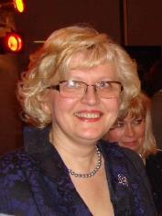 | 53 Raunas street, Riga, LV1084, Latvia
 | +371 67701414 +371 26116643
 | inesetomase@inbox.lv
 | Sex Eemale sex | Date of birth 26/01/1958 | Nationality Latvia
JOB APPLIED FOR  POSITION | Lecturer of hospitality related subjects
WORK EXPERIENCE
10/09/2001 – until now  01/06/2012 - 19/06/2013 | Lecturer, Hotel manager since 2013
10/09/2001 – until now  01/06/2012 - 19/06/2013 | VSIA Riga Technical school of Tourism and creative industries , www.rtrit.lv  26 Nicgales street, LV1035 Riga (Latvia)  Business university TURIBA www.turiba.lv  68 Graudu street, LV1058, Riga, Latvia
10/09/2001 – until now  01/06/2012 - 19/06/2013 | Management of a hotel, procurement, budgeting, HR, lecturing and training in revenue management, crisis management, hospitality related subjects, event management etc.
10/09/2001 – until now  01/06/2012 - 19/06/2013 | Marketing manager at Hertz International
Hertz International Latvia office, www.hertz.com www.hertz.lv
24 Aspazijas bulv., LV1050 Riga (Latvia)
Management of sales and marketing activities, PR, budgeting, procurement, development of procedures, customer service quality management

19/06/2006 - 13/07/2011  17/05/2002 - 19/06/2006 | International company Domina Inn Hotel General Manager, regional manager covering the Baltic States  International Hotel chain Domina Hotel Group www.dominahotels.com  1 Via Maffei, 20135 Milan (Italy)  Hotel management, budgeting and finance management, revenue and profit management, sales, procurement, HR, quality management, customer relations, property management, maintenance.  Hotel Riga General Manager
Hotel Riga – currently under renovation
22 Aspazijas bulv, LV1050 Riga (Latvia)

Hotel management, finance, cash-flow and profit management, sales, PR, quality management, customer relations, property management.

01/09/2000 – 17/05/2002  30/08/1991 - 01/09/2013 | Head of department  Riga City Council Agency Riga 800  6 Ratslaukums, LV1050 Riga (Latvia)  Foundation and development of Riga First Tourist Information centre. Marketing activities related to the Anniversary of Riga 800. Project management and office administration.
President
United Latvian Friendship societies (NGO)
3 Vecpilsetas street, LV1050 Riga (Latvia)

01/09/1981 – 30/08/1991 | Events manager, teacher  Riga Secondary school Nr. 50  97 Kr.Barona street, Riga (Latvia)
EDUCATION AND TRAINING
2013 -2014 | Project manager
2013 -2014 | Latvia University , Faculty of Economics and Management  5 Aspazijas bulv. Riga LV1050, Latvia
2013 -2014 | - Project management, financial and resources planning
01/09/1976 - 20/06/1981) |  | Foreign languages specialist, Masters’ degree  Latvia University , Faculty of Foreign languages  19 Raina bulv. Riga LV1050, Latvia
 |  | Languages, translation, psychology
Personal skills and competences | Native language - Latvian
Other language(s) | UNDERSTANDING |  |  | SPEAKING |  | WRITING
Other language(s) | Listening |  | Reading | Spoken interaction | Spoken production
English | Proficient user |  | Proficient user | Proficient user | Proficient user | Proficient user
Russian | Proficient user |  | Proficient user | Proficient user | Proficient user | Proficient user
Levels: A1/2: Basic user - B1/2: Independent user - C1/2 Proficient user
Common European Framework of Reference for Languages
Communication skills | Good communication and presentation skills, good negotiation skills, Reporting, feedback and control management practice.
Organisational / managerial skills | Experienced manager and leader, active, positive, optimistic, hard-working, responsible and reliable  Good at time and resources planning. Excellent team-builder and organiser, quality control and customer care long-term experience..
Job-related skills | Good at planning, customer oriented, knowledge of the local laws and requirements, of the basic accountancy requirements. Analytical and able to find the most suitable/appropriate decision.
Computer skills | Computer daily usage since early 90-ies,  MS Office programs and Trados, Libica, Fidelio, 4hotels
Other skills | Travelling, theatre, performing arts, gardening.

Europass
Curriculum Vitae
PERSONAL INFORMATION
First name(s) / Surname(s) | Sanita Vāne
Personal number | 290968-11800
Place of birth | Riga
Address (recorded and place of residence) | 14/11-273 Pāles Street, LV-1024
Phone | 67532461 |  |  | Mobile phone |  |  | 29683318
Fax
E-mail | svane@inbox.lv
Nationality | Latvian
Gender | Female
Academic titles and scientific degrees | Master in Pedagogogy (Mg. paed.), lecturer
Work Experience
Time period | from 09/ 2013 up to date
Occupation or position held | lecturer
Name of employer | Latvia Business College
Time period | from 2012 up to date
Occupation or position held | lecturer
Name of employer | ETA (European International High School of Economics and Business Administration - EIHSEBA)
Time period | from 2002 to 07.2013
Occupation or position held | lecturer
Name of employer | Baltic International Academy (formerly: The Baltic Russian Institute)
Time period | from 2005 to 2008
Occupation or position held | lecturer
Name of employer | Latvia Business College
Time period | 08. 1996 – 07. 2003
Occupation or position held | Economics and Business Department, lecturer
Name of employer | Riga Teacher Training and Education Management Academy
Education
Time period | from 09.2011 to 05.2013
Title of education document/ Title of qualification awarded | Studies in Master’s Program „Large and Medium-Sized Enterprises Management”  interrupted studies
Name and type of educational institution | Higher School EIHSEBA
Time period | 10. 1997 – 06.1999
Title of education document / Title of qualification awarded | Pedagogy Master's degree in school management industry  (Mg. paed.), Diploma MD No. 000170, issued by RPIVA on 12th June 1999  Education Supervisor Qualification, Diploma VD No. 000502, issued by RPIVA on 12 June 1999
Name and type of educational institution | Riga Teacher Training and Educational Management Academy, Master's program studies
Time period | 09.1986 – 06. 1993
Title of education document / Title of qualification awarded | Diploma of Higher Education  УВ No. 102944, issued by LU on 17th June 1993, specialty - Applied Mathematics, Mathematician‘s Qualification
Name and type of educational institution | University of Latvia, Faculty of Physics and Mathematics
Advanced training
Time period | 10.2001
Seminar\training title
Name of educational institution | Pedagogical Mastery Workshop  Riga Teacher Training and Education Management Academy
Skills
Native language | Latvian
Self- assessment |  | Understanding |  |  | Speaking |  |  | Writing
 |  | very good | good |  | very good | good |  | very good | good
English |  |  | X
French |  |  | X
Russian |  | X |  |  | X |  |  | X
Scientific Activities
Publications in corresponding scientific field

- Characteristiscs of fatal patient cases out of Riga hospitals S. Vāne, R.Kleina, A.Šmits Published and report: 3rd International interdisciplinary scientific conference „Society. Health. Welfare”. 2012.
- Theoretical Aspects of Customer Satisfaction Research S.Vāne, E.Liepa. Zinātniski – practical conferences "Economic, Legal and Technological Aspects of Business” symposium. Riga: Latvia Business College, Higher School EIHSEBA, 2012
- Analysis of deceased cases out of hospitals without medical aid. S. Vāne, R.Kleina, A.Šmits Published and report 3rd International interdisciplinary scientific conference „Society. Health. Welfare”. Abstracts. November 11-12, 2010.
- VSIA „Strenci Mental Hospital” development project Sanita Vāne Vitālijs Rodins, RSEBA, 2008.
- Latvia`s Employed Business Management Students` Readiness for Life and Work in Circumstances of Sustainable Development. I.Kalve, Co-author S.Vāne. Published in internationally reviewed scientific symposium “Education and Sustainable Development: First Steps Toward Changes” Volume 2, Daugavpils: Daugavpils Pedagogical University, The Institute of Sustainable Education; 2007, pp.114-123.
Pedagogical Activities
Courses  taught (course title,  the volume of credits) | Latvia Business College Computer Science (2CP)  ETA (EIHSEBA): Computer Science (3CP)  Applications (2CP)  BSA: Higher Mathematics (2CP)  Introduction to Higher Mathematics (2 CP)  Statistical Data Mathematical Processing (1CP)  Firm and Commercial Activity Statistics (2 CP)  Mathematical Economics (2CP)  Economic Calculations in Spreadsheets (2 CP)  Informatics (3CP)  Informatics and Programming Language (3CP)
Developed courses (indicate if it is implemented in the program, in which) | ETA: Computer Science - for study programs “ Business Administration”, “Tourism Management ” and “Jurisprudence”  ETA: Applications - in study program “Computer Science”  Latvia Business College: Computer Science in study program “Business Activities”
Advised Bachelor’s and Qualification Papers | more than 35.
Participation with a report (of any kind) in international scientific conferences and congresses | - Theoretical Aspects of Customer Satisfaction Research S.Vāne, E.Liepa. Scientific practical conferences "Economic, Legal and Technological Aspects of Business” symposium. Riga: Latvia Business College, Higher School EIHSEBA, 2012  - Analysis of deceased cases out of hospitals without medical aid. S. Vāne, R.Kleina, A.Šmits Published and report 3rd International interdisciplinary scientific conference „Society. Health. Welfare”. Abstracts. November 11-12, 2010.

10.06.2015.
Curriculum Vitae
Dr. psych., Mg.math. Mārtiņš Veide
DATE OF BIRTH
12.12.1971.
EDUCATION
1998 Dr. psych., Inst. of psychology and pedagogy, University of Latvia
1994 Mg. math, Faculty of physics and mathematics, University of Latvia
1989 Secondary school #1, Riga
EMPLOYMENT
2002 - present University of Latvia
2012 - present LBK College
2008 - 2011 Riga International School of Economics and Business Administration
2002 - 2008 International Higher School of Practical Psychology
1998 - 2002 Media agency VIA Media Latvia
1996 - 1997 Secondary school #2, Riga
1995 - 1996 Tele Media Latvia
1994 - 1995 Boarding school Heimschule Schlössli Ins (Switzerland)
1993 - 1994 Inst. of psychology and pedagogy, University of Latvia
LENGTH OF ACADEMIC/SCIENTIFIC SERVICE
17 years
SCIENTIFIC RESEARCH AND PUBLICATIONS (FOR PAST 6 YEARS)
Participant or supervisor of projects, programs
participation in the OECD PISA 2014
Publications
- The existential meaning of personal experience in the learning process.// Teacher of the 21st century: Quality Education for Quality Teaching, 2014. Newcastle upon Tyne, Cambridge Scoolar Publishing, ISBN (13): 978-1-4438-5612-6
- The existential aspects of learning in physical education and sport activity.// LASE
Journal of Sport Science, Vol. 4, (2013) Nr. 2, pp. 110-125.
Promotion of science
- Reklāma un mūsu vērtības (Advertising and our values)// Biznesa Psiholoģija (Business Psychology) 05/06, 2011.
- Dziedinošās terapijas (Healing therapies).- R.: Jumava, 2010. 192 p. /co-author: E.Ozola/
- Computer games on the scales of Themis, 1.part.// Psiholoģija Ģimenei un Skolai (Psychology for Family and School) 07(#42), 2009. pp. 22-25. /co-author: E.Ozola/
- Computer games on the scales of Themis, 2.part.// Psiholoģija Ģimenei un Skolai (Psychology for Family and School) 08(#43), 2009. Pp. 4-11. /co-author: E.Ozola/
Participation with reports (of any kind) in scientific conferences and congresses
2013 SELL International Scientific Conference in Sports Science „Sports, Student, Lifestyle”, OSC, “The existential aspects of learning in physical education and sport activity”
2013 ATEE Spring Conference ”Teacher of the 21st Century: Quality education for quality teaching”, „The existential meaning of personal experience in the learning process”
2013 LU Scientific Conference „Pedagogy for sectoral development” „Eksistenciālie aspekti mācīšanās procesā augstskolā” (The existential aspects of learning in institutions of higher education”

PEDAGOGICAL WORK (FOR PAST 6 YEARS)
Supervised master works
4

Suppressed diploma papers, bachelors and qualification works
51

Taught study courses (name, credit value)
Psychology of advertising (3 ETCS)
Psychology of communication (3 ETCS)
Scientific research and investigation methods (practicum) (3 ETCS)
Integration of the psychology and physiology in the educational process
(master's program, 3 ETCS)
Statistical methods (resident program, 3 ETCS)
Advertising and PR management (3 ETCS)
Business communication (3 ETCS)
General psychology (6 ETCS)
ORGANIZATIONAL WORK (FOR PAST 6 YEARS)
Participation in LU collegiate institutions and other organizational duties in LU
Participation in Museum of Pedagogy within the Night of Museums
Organization of international and Latvian conferences
Organization of ATEE Spring Conference „ATEE Teacher of the 21st Century: Quality education for quality teaching”

11.06.2015.

- Descriptions of the programme of study “Business Administration
Study course | Cr.
Business Foreign Language I | 3
Business Foreign Language II | 3
Communication Psychology | 2
Business Communication, Presentation and Ethics | 2
Rhetoric | 2
Cultural History | 2
Pedagogy | 2
Environmental, Labour and Civil Protection | 1
Computer Science and Records Management | 3
Internet Technologies and their use in Commercial Activities | 3
Management Information Systems | 2
Labour Law | 2
Microeconomics | 2
Macroeconomics | 3
Entrepreneurship | 2
Marketing | 3
Mathematics for Economists | 2
General economic and company statistics | 2
Accountancy | 2
Basics of Sociology | 1
Project Management | 2
Quality Management | 2
Supply Chain Management | 2
Management Sciences | 2
Personnel Management | 2
Research methods | 2
Taxes and Fees | 2
Finance and Credit | 2
Marketing Research | 2
Personnel Management System and Specific Functions in the Sectoral Context | 2
Management Psychology | 2
Financial Management in Business | 2
Inventory Management | 2
E-commerce | 3
Production and Service Management | 3
Advertising Psychology | 2
Advertising and Public Relations Management | 2
International Marketing | 2
Management Accountancy | 3
Banking | 2
Commercial Law | 2
Corporate Social Responsibility and Social Dialogue | 2
Globalisation | 2
Strategic Management | 3
Innovation and Risk Management | 2
Sales Management | 2
Internet Marketing | 1
Web site designing | 3
World Economics | 2
World Market Conjucture | 2
Business Communication | 2
Investments | 2
Insurance | 2
Commodity Science | 4
Intercultural Communication | 2
Professional ethics and etiquette | 2
Politology | 2

Study course title | Cr. | Study course brief description
Business Foreign Language I | 3 | The aim of the study course – to acquire a mastery of in-depth terminology of industry and to promote the use of foreign language knowledge and skills in the field of business management, thereby developing students' professional competence.  Intended learning outcomes:  Knowledge – professional terms in English, history, political science.  Skills:  - to have a good command of English at the communication level;  - to use professional terminology in English;  - to improve speaking and writing skills;  - to be able to improve personal knowledge on an on-going basis, acquire new information and skills;  - to carry out the work independently or collectively with other colleagues.  Competences:  - ability to work with legal texts;  - ability to hold a discussion in English on the mentioned topics;  - ability to select the necessary information;  - be able to improve personal competence and specialization independently;  - be able to use the acquired knowledge in working with documents and legislation.
Business Foreign Language II (German) | 3 | The aim of the study course – encourage and promote the use of the German language knowledge and skills in scope of tourism, in such a way developing the students' professional competence.  Intended learning outcomes:  Knowledge – profesionālie termini svešvalodā.  Skills:  - to have a good command of German at the communication level;  - to use professional terminology in a foreing language;  - to improve speaking and writing skills;  - to be able to improve personal knowledge on an on-going basis, acquire new information and skills;  - to carry out the work independently or collectively with other colleagues.  Competences:  - ability to work with logistics texts;  - ability to hold a discussion in a foreing language on the mentioned topics;  - ability to select the necessary information in a foreing language ;  - be able to improve personal competence and specialization independently;  - be able to use the acquired knowledge in working with documents, diagrams and schemes.
Professional Foreign Language II (Russian) | 3 | The aim of the study course - encourage and promote the use of the Russian language knowledge and skills in scope of tourism, in such a way developing the students' professional competence, as well as provide knowledge of the terminology used in the field of tourism.  Intended learning outcomes:  Knowledge:  - knowledge of the specifics of the Russian language use in the field of tourism;  - to be conversant with modern tourist terminology.  Skills:  - to be conversant with industry terminology in Russian;  - to create and translate written texts (abstracts, letters, CVs, contracts);  - to read authentic texts in the Russian print media and Internet;  - to apply the acquired grammatical structures in colloquial language.  Competences:  - the successful acquisition of the course makes it possible to master in deep the specific ability to apply in practice the skills acquired during the course to translate various texts from and into Russian;  - ability to express one’s opinion (verbally and in writing) by selecting grammatical structures that are appropriate to the situation;  - ability to read and understand authentic texts on the industry's problems;  - ability to use the industry terminology.
Communication Psychology | 2 | The aim of the study course – to improve students' knowledge in the field of psychology, and develop skills to use the acquired knowledge in professional activity and everyday life situations.  Intended learning outcomes:  Knowledge –students are familiar with the main guidelines in the field of psychology.  Skills – students are able to analyze a specific situation, are aware of their emotional state and behavior in a given situation.  Competences – students are able to develop constructive interpersonal relationships, control their emotional state and expressions, and choose the appropriate behavior according to the specific situation.
Business Communication, Presentation and Ethics | 2 | The aim of the study course – to provide knowledge, raise awareness and build practical skills in business communication culture in the professional environment.  Intended learning outcomes:  Knowledge – to provide general knowledge about the professional ethics and etiquette role and place in contemporary society.  Skills:  - to build business skills in ethics and etiquette in their observance with business partners, competitors, subordinates, colleagues and in everyday life;  - to teach students to analyze their own and others' behavior, observance of ethics and etiquette norms.  Competences:  - improved knowledge of professional ethics and etiquette role and place in modern society;  - acquired skills in ethics and etiquette in their observance with business partners, competitors, subordinates, colleagues and in everyday life;  - improved ability to analyze their own and others' behavior, observance of ethics and labeling norms.
Rhetoric | 2 | The aim of the study course – to assist in the understanding of rhetoric as general personality and social culture characteristics.  Intended learning outcomes:  Knowledge – to give an opportunity to learn the nature of communication and its functions.  Skills – to improve personal public speaking skills.  Competences –developed expressive speaking skills that are useful to man as a person and the company's manager.
Cultural History | 2 | The aim of the study course – to improve students' knowledge of European and Latvian cultural history and contemporary culture; to develop the skills to investigate and compare the culture of different periods and eras, to express and justify personal views; to stimulate students' interest and build their skills of in-depth exploration of certain themes.  Intended learning outcomes:  Knowledge – students are competent in European and Latvian cultural history, style history, Latvian folklore, costumes and theater history and current events of contemporary culture.  Skills– students are able to compare the culture of different periods and countries, to see the most important things in every culture, to express their opinion and substantiate it with cultural facts.  Competences – students understand the relationship between cultural processes, their causation, and see the impact of different cultures in today's society and the perception of the world.
Pedagogics | 2 | The aim of the study course – promote the formation of the students' pedagogical thinking, pedagogical process and its regularities acquisition, understanding of the importance of training and upbringing for personal self-fulfillment and self-perfection process.  Intended learning outcomes:  Knowledge – students will gain knowledge about the pedagogical concepts, teaching science system and regularities of the subject, research methods, personal development opportunities and educator’s mission in today's society, acquire an understanding of the essence of the educational process, pedagogical science structure, its relationship with other sciences.  Skills – students are able to solve pedagogical problems, are able to see, weigh up problems in pedagogy and in the teacher’s action.  Competences – students know how, in accordance with the perceived problems of teaching, to create a package of measures to address them.
Environmental, Labour and Civil Protection | 1 | The aim of the study course – to provide knowledge of the Latvian law requirements, the EU environmental directives and occupational health and safety matters, fundamental principles of civil protection and fire safety.  Intended learning outcomes:  Knowledge – knowledge of the working environment risk factors, as well as understanding of risk management and evaluation methods.  Skills – the ability to develop measures for risk factor prevention or reduction.  Competences –knowledge and practical skills of the labor protection system implementation in enterprises, with particular emphasis on occupational risk factors and the elaboration of the measures for risk factor prevention or reduction, the employer and employee’s rights and obligations in scope of occupational health and safety issues.
Computer Science and Records Management | 3 | The aim of the study course – to develop a deeper level of competence, knowledge and skills to use a computer for processing of information necessary for the study process and professional work. To provide knowledge of a computerized record-keeping role in the management process and of the requirements for document development and drawing up, the preparation of documents for further keeping, to develop the skills of independent preparation of various documents, to provide insight into the electronic documents and electronic signatures, as well as to advise students how to work with the developed or received documents and how to develop and draw up the documents in order to have legal effect.  Intended learning outcomes:  Knowledge – knowledge of information technology and computer use, understanding of a variety of documents, the requirements for drawing up.  Skills:  - to be conversant in computer science terminology and information technology terms, literature, etc. sources;  - to be able to perform tasks accurately and independently;  - to find, select and process the information of the world wide web that is necessary for performance of work tasks, using the appropriate information technologies;  - ability to use the appropriate applications for performance of various tasks;  - to be able to use the applications in the study process and its results presentation;  - to be able to improve personal knowledge on an on-going basis, to acquire new information and skills;  - to carry out the work independently and in collaboration with the teaching staff;  - to knows how to deal with the business correspondence forms and particular characteristics of writing;  - to be able to make up the most common business documents.  Competences:  - the ability to use information technologies in the study process and business;  - the ability to apply the theoretical and practical computer science knowledge and skills for the company's efficient operation;  - the ability to select the necessary information on information technology applications;  - the ability to choose and apply the appropriate applications for performance of each task;  - to be able to get oriented accurately and correctly in the fixed document forms and types of the Republic of Latvia;  - to write properly business letters and other documents.
Internet Technologies and their Use in Commercial Activities | 3 | The aim of the study course – to build competencies, knowledge and skills in Internet technologies and their commercial applications.  Intended learning outcomes:  Knowledge:  - on Internet technology capabilities;  - on Internet technology organization;  - on the use of Internet technology and its efficiency in commercial activities.  Skills:  - to be conversant in the Internet technology terminology;  - to be conversant in the different Internet technologies used by companies;  - to be able to select and use the appropriate Internet technologies for various business objectives realization;  - to carry out the work independently and in collaboration with the teaching staff.  Competences:  - ability to choose and use the Internet technologies in business;  - ability to apply theoretical and practical knowledge and skills in the use of the Internet technology for the effectiveness of the company’ commercial activities;  - ability to select the necessary information on the Internet technology applications in commercial activities.
Management Information Systems | 2 | The aim of the study course – to build competencies, knowledge and skills in the essence of the management information system and their management methods, as well as the organizational, security and legal aspects of information systems.  Intended learning outcomes:  Knowledge:  - in the use of information technology and management information systems.  about the nature of the management information systems;  - about the basics of management information system creation, information system organizational aspects, information system development organization;  - about the information system management methodology;  - about quality and efficiency of management information systems, information system security management;  - about the control software of management information systems and information legal environment.  Skills:  - to be competent in the management information system terminology;  - to be conversant in the different information systems meant for companies;  - to be able to select and use the appropriate information technologies for performance of various tasks;  - to carry out the work independently and in collaboration with the teaching staff.  Competences:  - ability to use information technology and management information systems in business;  - ability to apply theoretical and practical knowledge and skills for the efficient operation of the company's personnel management;  - to be able to select the necessary information on the management information system applications.
Labour Law | 2 | The aim of the study course – to develop skills to apply theoretical knowledge in solving the issues of legal employment relationship, to be able to analyze the issues of legal nature in the relationship between employees and employers, to follow the Labor Law to calculate the employees’ remuneration.  Intended learning outcomes:  Knowledge – students gain understanding of the essence of Labor Law and its fundamental principles.  Skills – to build skills to develop the local standard employment regulations in the company.  Competences – the knowledge and practical skills in scope of the Labour Law system of Latvia, in solving problems of legal nature, with particular emphasis on the employer-employee relationship, promoting social dialogue and procedure of dispute resolution.
Microeconomics | 2 | The aim of the study course – learn the basics of microeconomic theory and its practical application in assessment of different alternatives as well as in economic decision-making in the best possible way.  Intended learning outcomes:  Knowledge – students are familiar with basic concepts of microeconomic theory, concepts and indicators.  Skills – the ability to analyze and explain the supply and demand formation principles, the cost of production alternatives and pricing characteristics.  Competences – the ability to evaluate the company's profit-making opportunities based on the company cost data analysis as well as the company's performance, and forecast its development directions.
Macroeconomics | 3 | The aim of the study course – to build professional skills at the level of the country market economy, to provide knowledge of the main contemporary economic theories, showing their role in decision-making and solving economic problems.  Intended learning outcomes:  Knowledge – students are familiar with the functioning of the market economy regularities at the macro level.  Skills – the ability to analyze and interpret statistical data that characterize the main macroeconomic indicators.  Competences – students know how to assess the national economy development results based on the statistical data analysis and forecast its development directions.
Business Activities | 2 | The aim of the study course – to provide students with theoretical and practical knowledge of the economic aspects of commercial activity.  Intended learning outcomes:  Knowledge – to understand the essence and role of small business in economic development and social problem solving. To understand the need for the state participation in small business activities. To understand the impact of the state influence forms and methods in business. Based on the statistical material analysis, to reveal the key trends and to assess the development of Latvian business in some economic sectors.  Skills:  - to be able to assess the necessary resources and sources of information;  - to be able to assess the conditions for starting a business based on personal entrepreneurial self-assessment and draw conclusions about the opportunities to start their own business;  - to understand the business plan significance and its role in the implementation of business ideas and be able to draw up a simple business plan, i.e. "theoretically" open their own business;  - to be able to present information reports independently or within the work groups;  - to select and process information that is necessary for performance of the work tasks, using information technology;  - to be able to improve personal knowledge on an on-going basis, to acquire new information and skills;  - to organize, plan and control their own work and the work of subordinates;  - to carry out the work independently or collectively;  - to be able to determine the priorities of the work tasks;  - to make decisions and show initiative;  - to use software and other information technology.  Competences:  - the ability to systematize the information gathered, to use the obtained information in the preparation of decisions as well as adoption and implementation;  - the ability to conduct professional and / or scientific research;  - the ability to build skills to work with the latest information technology on an on-going basis;  - the ability to present projects.
Marketing | 3 | The aim of the study course – to provide knowledge on the role of marketing within the framework of modern management paradigm, to develop skills to analyze the company's marketing activities and to present proposals for the improvement of marketing management.  Intended learning outcomes:  Knowledge – acquisition of knowledge about the trends of marketing complex and types of change, and its role in the modern communication and competition system, in enhancing production efficiency.  Skills – to develop skills to analyze the company's marketing activities, selecting appropriate methods.  Competences – to build rational criticism in decision-making, the ability to evaluate the factors influencing the development of the communication systems, and to decide on the future development of the market-orientated activities.
Mathematics for Economists | 2 | The aim of the study course –. to provide basic knowledge in various sections of higher mathematics that are necessary for the successful acquisition of the specialty subjects. To develop students' logical and abstract thinking, the skills of the concept use in connection with the specialty subjects and their main objects to develop the students‘ ability to identify the economic situation and the capabilities of the process mathematical modeling and analysis, by analyzing more complex task solutions to be solved in future.  Intended learning outcomes:  Knowledge – to recognize and be able to characterize the major study subjects of linear algebra, mathematical analysis and financial mathematics, basic techniques and possibilities for their uses for simple economic case studies.  Skills:  - to able to perform operations with determinants, matrices, to solve systems of linear equations;  - to able to perform the function of limit calculation, to find simple and compound function derivatives, use their function extreme for monotone interval determination;  - to able to perform simple financial mathematics calculations.  Competences:  - students understand and are able to use basic financial mathematics relations; are able to formalize simple economic problems, solve them using a linear system of equations or analytical function models.
General Economic and Company Statistics | 2 | The aim of the study course – to develop students' understanding of the role of statistics in business To provide knowledge of statistical methods and their use in the analysis of economic phenomena and processes, as well as to develop skills to use them in the economic, demographic and social phenomena analysis. To provide theoretical knowledge about specific statistical methods. To raise awareness of the content of statistical indicators, calculation methods, interpretation of the results obtained.  Intended learning outcomes:  Knowledge:  - students are conversant in the statistical information, understand the essence and importance of statistical observation and statistical indicators for economic phenomena characterization;  - are able to classify the forms of acquisition of statistical information and statistical data processing methods.  Skills:  - students are able to apply statistical research methods, summarize and organize statistical data, calculate and interpret absolute and relative values;  - know how to calculate and interpret statistical series characteristics, forecast future values of time series, to assess their validity;  - know how to calculate and interpret the absolute difference of individual and joint index numbers that are broadly used in economics.  Competences:  - students are able to carry out little research on their own, choosing the most suitable methods of data acquisition and processing;  - are able to demonstrate their understanding of the obtained results and the practical solutions, to explain, argue and justify them.
Accountancy | 2 | The aim of the study course – to acquire the necessary amount of knowledge of the financial accounting course that allows, to understand the accounting procedures and recording workflow in the enterprise, based on business, accounting, tax and other regulatory legislation and regulations.  Intended learning outcomes:  Knowledge – theoretical knowledge of accounting processes in the company.  Skills – students are able to classify accounting items, based on the theoretical knowledge, understand the company's revenues and expenses accounts, are able to perform a variety of accounting estimates within the scope of the acquired program, draw up a simplified balance sheet.  Competences – the ability to apply theoretical knowledge and practical skills in the company's operational processes.
Basics of Sociology | 1 | The aim of the study course – to introduce sociology as a science, its role in society and the life of every person; to teach students to evaluate correctly public phenomena, to be able to analyze them objectively.  Intended learning outcomes:  Knowledge:  - to show the importance of sociology in the life of society and every human;  - to present the peculiarities of the society development;  - to provide insight into the role of information in work, everyday life, research.  Skills:  - to learn how to use sociological research in personal activities;  - to learn how to draw up a research program, to choose the correct research methods;  - to learn how properly to carry out survey, interviews, observation, document analysis.  Competences – students are able to carry out sociological research, choosing the most appropriate research methods, and to analyze the results.
Project Management | 2 | The aim of the study course - to provide students with knowledge of the creation principles of modern society's economic and social development projects, to develop skills to write up projects and determine the economic efficiency of the project implementation.  Intended learning outcomes:  Knowledge - knowledge about the company's strategic development determination methods, understanding of the project development environment, goals, objectives, stages and strategies.  Skills – to be able to assess the investment project implementation capabilities, to make commercial calculations and determine the methods of their application for the project development, to be able to determine the options and opportunities of the project implementation economic efficiency.  Competences – to have understanding of the project life cycle and its structure, to be able to make up their projects and determine the economic efficiency of the project implementation.
Quality Management | 2 | The aim of the study course – to acquaint students with quality management systems, to create awareness of the application and implementation of the requirements, the basic principles of the quality management system, the process approach and its benefits, the quality management system integration capabilities, the continuous improvement of quality management.  Intended learning outcomes:  Knowledge – students acquire knowledge of the certification procedures of various quality systems and implementation methodology.  Skills - students have knowledge of the quality management system integration possibilities and requirements, its administration and the need for continuous improvement.  Competences:  - students understand the basic principles of quality management systems, process, approaches and their benefits;  - are able to carry out self-evaluation - internal audit, understand its importance and actions.
Supply Chain Management | 2 | The aim of the study course – to provide knowledge on the operation of logistic systems, to develop skills in analysis of logistics core activities and the type of supporting operations and to use them in business, logistics systems management.  Intended learning outcomes:  Knowledge- knowledge of logistics fundamental principles and its role in organization of activities, skills to choose the most optimal route.  Skills – to understand the significance and creation principles of the goods movement, information and financial flows.  Competences:  - students understand the nature of logistics and its role in business;  - are able to apply theoretical knowledge in procurement, production, transport and other logistics processes.
Management Sciences | 2 | The aim of the study course – to provide the necessary amount of knowledge about management as an objective process in human task-oriented joint activities in any sphere of public life.  Intended learning outcomes:  Knowledge:  - to be aware of management theory evolution; management process nature, management functions and decision-making methods, the organization's internal and external environment interaction, targeted operational guidelines;  - to know the basic principles of modern management theory;  - to know the components of the company's management functional process and their interrelationship.  Skills:  - to be able to define the company's activity goals and main lines of business as consistent with the owners’ and the public interest;  - to be able to make up, approve, correct and improve the company's business plans;  be able to apply the newest forms of work organization;  - to understand and create an organization internal environment model;  - to modify the organizational structure in accordance with the organization's activity current events;  - to identify the intensity of external environmental impact factors;  to determine the peculiarities of the organization's activities in accordance with its development;  - to summarize information about the organization's internal strengths and weaknesses;  - to be able to identify the opportunities, which the external environment offers, and threats.  Competences:  - to be competent in the assessment of the organization’s targeted actions;  - to be able to propose solutions with reason for modification of the internal environment of the organization in accordance with the organization's development current issues.
Human Resource Management | 2 | The aim of the study course –to raise awareness of the personnel management policy, as well as human resource management organizational methods and influencing factors that are necessary to work with the staff in organizations and to contribute the best practice of the manager.  Intended learning outcomes:  Knowledge - knowledge of the nature of personnel management, the necessity of personnel planning.  Skills:  - to learn the methods of work analysis;  - to learn the methods of recruitment;  - to come to terms with the management strategy and personnel policy interrelation;  - to learn the organizational principles of meetings.  Competences – students gained knowledge about personnel management functions and methods, they are able to create a requirement profile and carry out recruitment.
Research Methods | 2 | The aim of the study course –to promote understanding of the nature of the research, to be able to carry out science-based research, with particular emphasis on labour market studies.  Intended learning outcomes:  Knowledge:  - to be conversant in the essence of modern research;  - to demonstrate critical understanding of the research subject and provide a summary of the problem;  - be able to demonstrate knowledge of labour market research in the theory and practice.  Skills:  - to be conversant scientific research specifics;  - to show research skills, demonstrating analytical approach to the study subject analysis, the ability to apply theoretical knowledge to solving practical tasks for the company’s or institution personnel management improvement;  - are able to find, systematize and use information data bases as well as to use of the appropriate statistics, econometrics and other analysis methods and techniques.  Competences:  - the successful acquisition of the course provides an opportunity to develop academic papers to the best advantage;  - to able to conduct scientifically-grounded labour market research.  - to promote students' ability to carry out the company's strategy audit and to develop the company's further development plan, as well as to create a business plan.
Taxes and Fees | 2 | The aim of the study course – to provide knowledge on the theoretical guidelines of tax policy- making, the tax and fee system of the Republic of Latvia, to build awareness of the tax as a financial and economic impact factor, influencing the efficient planning and analysis, to present the basic principles of international tax law and the costs of tax structuring as well as planning opportunities in international transactions.  Intended learning outcomes:  Knowledge:  - to provide knowledge on the basic principles of tax policy-making, the methods and their selection-related problems;  - to form an idea of international taxation and its impact on the tax policy of the Republic of Latvia;  - to raise awareness of the tax and fee system of the Republic of Latvia and its regulatory legal base.  Skills:  - to develop the skill to interpret the tax regulations and rules of the Republic of Latvia and apply them in practical situations;  - to understand the role of tax administration in the implementation of tax policy.  Competences – students gain understanding of the tax and fee system of the Republic of Latvia and its regulatory legal base.
Finance and Credit | 2 | The aim of the study course – to educate students in the money and financial relations processes, giving basic financial concepts and understanding of the financial and monetary systems, to show the ways of commercial projects financing.  Intended learning outcomes:  Knowledge – students are familiar with the monetary and financial relations processes, financial concepts and have understanding of the financial and monetary systems, the ways of commercial projects financing.  Skills – students are able to solve practical tasks in the field of finance and credit, to choose the most appropriate scientific methods.  Competences – students are able to find the ways of financing commercial projects as consistent with the perceived problems and a package of measures to address them, predict and evaluate the results.
Marketing Research | 2 | The aim of the study course – to provide students with knowledge and skills in the marketing research theoretical and practical aspects in modern organizations.  Intended learning outcomes:  Knowledge:  - to develop understanding of marketing research types, forms and methods;  - to provide students with knowledge of the use of mathematical statistics methods in data processing;  - to form an idea of the software application for data acquisition, processing and evaluation of the results.  Skills:  - to identify the required number of respondents;  - to define and select target audience;  - to apply the applications for the necessary data acquisition.  Competences:  - to select the required data acquisition applications;  - to choose the most appropriate mathematical statistical methods for data processing and interpretation;  - to draw scientifically valid conclusions and put forward proposals for improving the operation of the company.
Personnel Management System and Function Specifics in the Context of Sector | 2 | The aim of the study course - to provide students with the knowledge of the most characteristic and the most important functions and specifics of the sectors of national economy regarding the theoretical and practical issues of the personnel management system, to develop analytical abilities and skills to solve problems independently, preparing students to continue the studies of higher level and to carry out scientific work, emphasizing current events of the personnel management process in the context of industries.  Intended learning outcomes:  Knowledge - to provide students with the knowledge of the most characteristic and the most important functions and specifics of the sectors of national economy regarding the theoretical and practical issues of the personnel management system, to develop analytical abilities and skills to solve problems independently, preparing students to continue the studies of higher level and to carry out scientific work, emphasizing current events of the personnel management process in the context of industries.  Skills – students are able to apply their theoretical knowledge and practical skills for the personnel management system implementation in the public administration and business structures, providing targeted and effective functioning in a team, to find solutions for problematic situations.  Competences –the capacity and ability to organize their professional work, taking advantage of effective techniques and methods, in practice, to organize personnel management administrative measures, personnel management strategy and policy making, personnel documentation records management.
Management Psychology | 2 | The aim of the study course – to develop the idea of management psychology as a social psychology focus area, its formation, the major research problems and interdependence of these problems, to improve communication skills, to develop creative initiative, reflection, empathy, conflict resolution skills, to master the organization and practical aspects of management psychology.  Intended learning outcomes:  Knowledge of psychological constitutive theories about awareness of human self and others, human psychological types, behavior regulators, interaction within different groups.  Skills – to understand personal and other people's motives, the possibilities of people's individual behavior and collective behavior analysis, control and management, to use these skills in people management.  Competences – students completemented their knowledge of psychology, improved skills to understand their own and other people's motives and ability to manage a collective body.
Business and Financial Management | 2 | The aim of the study course – to improve students' knowledge and skills in financial management, to familiarize them with the main company’s financial indicators related to the commercial activities in a market economy, to give an idea of the balance sheet analysis, profit and loss characteristics analysis, to build understanding of the company's financial resources.  Intended learning outcomes:  Knowledge – students have the knowledge about the calculation of the company's financial results and the analysis of the results.  Skills:  - students know how to make calculations in the form of test and problem-solving manner;  - are able to select and process the necessary information for performance of the work tasks, using information technology;  are able to improve their knowledge on an on-going basis, to acquire new information and skills;  - are able to organize, plan and control their own work and the work of their subordinates;  - can perform work individually or collectively;  - are able to determine the priorities of the tasks;  - can make decisions and show initiative;  - can use software and other information technologies.  Competences:  -students are able according to the perceived problems to create a package of measures to address them, to evaluate the company's liquidity and profitability indicators.-
Inventory Management | 2 | The aim of the study course - to develop students' understanding of the role of warehousing and inventory management in the organization of business logistics processes, to provide knowledge of inventory management models, as well as to build the skills to apply the methods for economic activity optimization. To provide theoretical knowledge on the warehouse type selection principles and the numerical indicators that are used for their assessment. To create understanding of techniques for an optimal solution, the use of outcomes.  Intended learning outcomes:  Knowledge:  - students have knowledge of the warehousing characteristic principles, criteria and indicators, understand the nature of their research and their role in the business analysis;  - are able to classify the applied models of the optimal inventory management strategy selection;  - are familiar with computerized models solving capabilities (WinQSB, QM).  Skills:  - students are able to make the choice the inventory management model, which suits the situation;  - can determine the optimal warehousing and inventory management strategy parameters for the appropriate situation;  - students are able to calculate warehousing characterizing figures;  - knows how to use separate applications (WinQSB, QM) to obtain a solution.  Competences:  - Spēj patstāvīgi identificēt problēmu, veikt datu atlasi, analizēt to izvēloties atbilstošas metodes  - Spēj parādīt izpratni par iegūtajiem rezultātiem, praktiskajiem risinājumiem, tos izskaidrot, argumentēt un pamatot.
E-commerce | 3 | The aim of the study course – to provide students with theoretical and practical knowledge of electronic commerce and payment systems. To build practical skills to design an electronic trading system and the ability to use electronic payment systems.  Intended learning outcomes:  Knowledge – students are familiar with the basic issues of electronic commerce.  Skills – students are able to apply the acquired knowledge in websites design.  Competences:  - understanding of electronic commerce and payment systems;  - the ability to use electronic payment systems;  - the skills to design an electronic trading system.
Production and Service Management | 3 | The aim of the study course – to develop skills to apply the theoretical knowledge in the company's production processes and service promotion; to be able to analyze management functions; to understand and be able to apply the value-added service development and staff refresher opportunities in practice .  Intended learning outcomes:  Knowledge - students are familiar with and are able to explain the main production process and service management principles, know scientific publications, literature, law and Internet resources.  Skills – students are able to explain and analyze a variety of manufacturing and service lifecycle phases and stages.  Competences – students can independently analyze the workplace description, are able to evaluate the procurement process and develop the staff knowledge improvement measures in the production plant. They are able to see the problems that can arise in the production process management, draw conclusions, make suggestions, and formulate proposals to improve the operation of the company.
Psychology of Advertising | 2 | The aim of the study course – to provide knowledge on the basic principles of advertising psychology, using theoretical knowledge, to develop skills and abilities to identify, select and use the effective communication tools for advertising creation.  Intended learning outcomes:  Knowledge - knowledge of advertising psychology basic principles.  Skills – to analyze advertising communication and its basic elements; to use modern information acquisition, processing and systematization technologies; to communicate and interact with the staff, partners, owners, media, government and non-governmental institutions.  Competences – to be able to think critically and to apply self-analysis capabilities for choosing the distribution channels for advertising.
Advertising and Public Relations Management | 2 | The aim of the study course – to introduce students to advertising and public relations-building conditions, to develop the skill to evaluate the effectiveness of campaigns.  Intended learning outcomes:  Knowledge – to provide theoretical knowledge in the creation of independent advertising and in the organization and management of public relations campaigns.  Skills:  - to develop skills to analyze the advertising communication and its basic elements;  - develop critical thinking when making a selection of advertising distribution channels.  Competences – students are able to choose the most appropriate forms of advertising and distribution channels, are able to organize and conduct public relations campaigns.
International Marketing | 2 | The aim of the study course - to provide students with theoretical and practical knowledge about marketing decision-making for problem- solving, its implementation and control in the global environment, to identify and assess the environmental characteristics of the global market.  Intended learning outcomes:  Knowledge - students gain knowledge of the international market characteristics and corporate marketing business principles in a multicultural environment.  Skills – to apply the international marketing technologies and international marketing theory under the conditions of market internationalization and globalization  Competences – students will be able to evaluate the company's current marketing strategies suitability under the conditions of global market and to develop international marketing strategies for new products.
Management Accountancy | 3 | The aim of the study course – to develop skills to analyze the information taken from the operating data on economic activity, which focuses on the management decision-making, as well as to provide knowledge of management accounting methods and techniques, and to develop skills to calculate the prime cost estimates of management accounting systems, in order to help to plan and control the company's costs.  Intended learning outcomes:  Knowledge - knowledge and understanding of the management accounting role and functions in the company, its necessity for business success, understanding of the business organization and planning.  Skills:  - students are able to classify the company's costs, based on the theoretical knowledge;  - understand the necessity of prime cost calculation and are able to apply skills in the calculation;  - students are able to carry out analysis of the obtained data within the acquired program, and are able to present the results.  Competences – the ability to apply theoretical knowledge and practical skills in the company’s business management, planning and control processes, i.e., the ability to ensure cost accounting for the calculation of prime costs and pricing, the ability to prepare the basic information for the company’s management in short-term and long-term decision-making.
Banking | 2 | The aim of the study course - to develop skills to apply theoretical knowledge in financial products and services, the literacy in both personal and corporate financial issues solving; to be able to analyze the proposed banking products and services, if necessary, to use them for the personnel management; to understand and be able to apply in practice the most appropriate financial products and attraction instruments.  Intended learning outcomes:  Knowledge - students are familiar with and are able to explain the main concepts related to the activities of the bank, the financial instruments applicable in business, know scientific literature, law, and the Internet resources.  Skills – students are able to explain and distinguish between different financial products and services.  Competences – students are able to understand independently the offered banking services. Students are able to see and assess the difference and the necessity of lending and investing, to draw conclusions, to make suggestions, to formulate proposals for attraction of a variety of financial products.
Commercial Law | 2 | The aim of the study course – to develop skills to apply theoretical knowledge in solving employment relationship, to be able to analyze issues of legal nature in the relations between merchants and other civil entities.  Intended learning outcomes:  Knowledge – knowledge of economics, history, political science.  Skills:  - to be conversant in terminology, literature and other sources;  - to be familiar with the Latvian law, the European Union (Community) law and international law;  - to use legal sources and apply the rules of law relating to commercial law;  - to be conversant in the public administration institutional system;  - to identify legal problems and facts that are important for solving these problems;  - to use legal techniques for resolution of legal problems and conflicts;  - to prepare, organize and carry out legal actions that are necessary for problem solving in the field of commercial law;  - to produce legal documents;  - to be able to present information reports independently or within working groups, as well as drafts of legislative acts;  - to select and process legal information that is necessary for performance of work tasks, applying appropriate legal research methods and information technologies;  - to be able to improve personal knowledge on an on-going basis, to acquire new information and skills;  to perform work independently or jointly with other colleagues.  Competences:  - the ability to study legal information;  - the ability to select the necessary legal information;  - the ability to use legal sources independently;  - the ability to systematize the acquired legal information, to use the obtained information for the decisions preparation, adoption and implementation;  - the ability to follow constantly the changes in the policy planning documents and legislation;  - the ability to follow the case – law of courts and legal literature in commercial law;  - the ability to argue legal opinions.
Corporate Social Responsibility and Social Dialogue | 2 | The aim of the study course - to promote students' understanding of the theoretical and practical operational aspects of corporate social responsibility and social dialogue.  Intended learning outcomes:  Knowledge - knowledge about the essence of corporate social responsibility and the experience of various states in social corporate responsibility and social dialogue ensuring.  Skills – the ability to understand the company's business interconnection; the ability to work in psychologically difficult situations; the ability to express their views and to argue it, and to be conversant in regulatory documents of the social partnership.  Competences – the improvement of skills of problem-solving and collective agreement development, students are able to manage and organize the collective negotiations and reach an agreement.
Globalisation | 2 | The aim of the study course - to provide knowledge about the globalization processes Latvia and all over the world.  Intended learning outcomes:  Knowledge - students will gain knowledge about the process of globalization that happens at the local and global levels.  Skills – to broaden students’ horizons in respect of time challenges and adequate responses to the opportunities all over the world because of occurring deep system crisis and under the conditions of the revolutionary transformation process.  Competences – students are able to debate on globalization issues with reason.
Strategic Management | 3 | The aim of the study course – to give an idea of the ideological foundations of the strategic management process as well as to build students’, future leaders and managers, practical skills and creative thinking.  Intended learning outcomes:  Knowledge - students will gain knowledge of contemporary trends of international marketing in the company and international marketing management processes.  Skills:  - to determine the company's mission and goals, perform a strategic analysis, formulate the strategy development stages and to develop action plans for its implementation;  - to perform a competitor analysis and the external and internal analysis, to have knowledge of the product life cycle stages, business competitiveness;  - to use a variety of methods for assessing the strategy;  - to use different types of strategies in their own companies;  - to use the theoretical knowledge for the personnel management in a highly competitive environment;  - to determine the quality of the strategies.  Competences – students have the opportunity to clarify the role of entrepreneurs in strategic management, in forecasting future issues, in the stages of strategic business planning cycle and reasonably to debate on issues of strategic management in the decision-making process.
Innovation and Risk Management | 2 | The aim of the study course – to develop the ability to see opportunities and innovative solutions, taking into account time, probability and risk factors in commercial activities, to provide knowledge about risk identification, evaluation, sharing, control, and risk-pooling concepts.  Intended learning outcomes:  Knowledge – to develop understanding of the risk functions in business and innovation risks.  Skills:  - to develop the ability to apply risk analysis methods;  - to develop skills to assess the investment risk.  Competences – to link the theoretical knowledge about the risk management methods to the practical application in risk minimization.
Sales Management | 2 | The aim of the study course – to provide students with knowledge of the sales management role and opportunities, sales management principles and their impact on the turnover and profit of the company.  Intended learning outcomes:  Knowledge – knowledge of basic issues of the sales process.  Skills:  - to apply the acquired knowledge for the sales process implementation;  - to prepare for negotiations with a client , how to handle different negotiating situations;  - to know how to hold product or service presentations to the best advantage;  - to know what communication methods to use to find a proper solution in the negotiations with a client.  Competences – students have understanding of the essence of sales, knowledge about the sales business models, the ability to analyze and evaluate, individually and independently, the situation in a particular company.
Internet Marketing | 2 | The aim of the study course – to introduce students to the basics of e-marketing and provide insight into the components of e-sales.  Intended learning outcomes:  Knowledge:  - to build undestanding of the E-commerce underlying theories and concepts;  - to improve the knowledge of contemporary issues and current events of e-commerce;  - to assess the importance of technologies for e-commerce.  Skills:  - to determine the economic effectiveness, to assess the customer satisfaction with products and services that are offered through e-commerce tools;  - to assess the necessity for rapid and qualitative information, when making financial decisions that are necessary for e-commerce.  Competences:  - to assess the quality of e-commerce WWW resources from an independent visitor's point of view;  - to compare e-commerce with traditional communication models.
Web Site Designing | 3 | The aim of the study course – Sniegt studentiem teorētiskās un praktiskās zināšanas par tīmekļa vietnes projektēšanu. Attīstīt iemaņas veidot un lietot projektēšanas metodes un modeļus praktiski elektroniskās komercijas projektu veidošanā, izmantojot datorprogrammas apgūšanu ar tālāku iespēju pilnveidot šīs zināšanas un pielietot tās savā darbā  Intended learning outcomes:  Knowledge - to provide students with the knowledge and practical skills in website design.  Skills - students are familiar with the website design terms, literature, etc. sources, are able to use appropriate applications for various tasks, are able to continuously improve their knowledge, acquire new information and skills.  Competences – students are able to carry out a website design in business, are able to select the necessary information about the web site designing.
World Economy | 2 | The aim of the study course – to build professional skills in shaping the global economic relations, to provide knowledge on the main contemporary theories of international economics, demonstrating their role in the decision-making process, and tackling the economic problems.  Intended learning outcomes:  Knowledge - students are familiar with the world economy functioning regularities at the macro level.  Skills – students are able to analyze and interpret statistical data that characterize the main macroeconomic indicators.  Competences – students know how to assess the national economy development results, based on the analysis of statistical database, and forecast its lines of development.
World Market Conjucture | 2 | The aim of the study course – to give knowledge of the international conjucture and the understanding of the regulation of trade and world commodity markets.  Intended learning outcomes:  Knowledge:  - to provide general knowledge about the market conjuncture aspects in modern society;  - to provide the knowledge of international trade regulation;  - to deepen the understanding of the Republic of Latvia place in the global market.  Skills – develop the ability to use information on the international economic relations for the company's management decisions and their effectiveness analysis.  Competences – the obtained knowledge of international market conjucture and the ability to understand the regulation of trade and knowledge of the global commodity markets.
Business Communication | 2 | The aim of the study course – to improve students 'knowledge and practical skills in business communication, to raise the students' competence in oral and written communication. To supplement the students 'knowledge through effective business communication techniques and to develop students' ability to apply effective business communication skills in practice. To develop students 'overall understanding of the nature of the communication process, the role and importance of the ability to recognize and evaluate the media mechanisms, to improve students' ability to identify and overcome cultural and communication barriers.  Intended learning outcomes:  Knowledge – students are familiar with oral and written business communication types, their meaning and importance, can describe the communication process. Students are able to recognize the types of business communication, to assess the quality and efficiency of their use, as well as are able to offer methods of communication that raise the business communication type efficiency or improve its quality.  Skills – students are able to identify correctly the situation and choose the appropriate type of communication, are able to determine independently and apply effective application techniques. They actively participate in practical training and perform independent tasks, students are able apply knowledge in practice that is acquired during the classes about oral and written business communication techniques.  Competences – students are competent in oral and written forms of business communication and their practical application and recognition. Students are able to apply the acquired theoretical knowledge in practice, and on the basis of practical skills, know how to identify the business communication gaps and provide advice for business communication efficiency improvement.
Investments | 2 | The aim of the study course – to provide knowledge on the basic principles of investing, introducing students to the most important aspects of investment theory. The course will address issues of investment processes, strategy and management, as well as the diversity of alternative investment opportunities and the basic principles of management and portfolio investment.  Intended learning outcomes:  Knowledge:  - to provide knowledge about the main types of investment, their classification;  - to present modern methods of the investment project efficiency analysis;  - to deepen the understanding of the place of the Latvian Republic in the global market.  Skills:  - to learn to create the basic parameters of the project evaluation (cash flow, required investment, rate of return, risk parameters);  - to develop the necessary knowledge to perform the investment system analysis: the real investment projects, comparative assessment of projects, taking into account various constraints, the choice between alternative projects;  - to build the skills of securities valuation, financial investment portfolio formation (creation and management).  Competences – the acquired knowledge about the principles of financial investment efficiency evaluation and methods, students have the skills in the real investment project management.
Insurance | 2 | The aim of the study course – to acquaint students with insurance as one of the lines of business and risk management methods. The course introduces students to insurance science, specifies the nature and the basic functions of insurance, introduces insurance terminology and provides an insight into the insurance sectors, sub-sectors and forms of insurance, insurance market participants and its basic operational principles, the basics of the insurance company's financial management and capabilities of fraud prevention and combat.  Intended learning outcomes:  Knowledge knowledge on insurance law, the economic nature, the operational principles and basic techniques.  Skills – to decide on the protection of interests and understand the peculiarities of insurance sales in the field of tourism and hotels.  Competences – the ability to assess risk situations and make well- grounded decisions.
Commodity Science | 4 | The aim of the study course – to provide knowledge on food and non-food products, their use specifics, changes in the processing, storage and transportation, production technology, quality levels.  Intended learning outcomes:  Knowledge - knowledge about the main categories of commodity science and understanding of food and non-food products classification, operational characteristics.  Skills – to take decisions on the packing of goods, transportation, to be able to detect defects and assess damage, to know the quality requirements for various categories of goods.  Competences – the ability to assess the conformity of the goods with the quality requirements and to take reasonable decisions in case of changes of food and non-food products, during processing, storage and transportation.
Intercultural Communication | 2 | The aim of the study course – to give students an insight into the field of intercultural communication, and develop skills to use the acquired knowledge in professional activity and everyday life situations.  Intended learning outcomes:  Knowledge students are familiar with the main approaches in different peoples culture and factors influencing intercultural communication.  Skills:  - students are able to analyze a specific situation, to understand their behavior within the accepted code of conduct of the specific folk culture;  - know how to respect ethical and moral standards of the specific culture.  Competences:  - students are able to create constructive interpersonal relationships with different cultures;  - students are able to choose and apply the appropriate behavior and actions to a particular culture and environment, taking into account social interaction principles and norms of the specific culture.
Professional Ethics and Etiquette | 2 | The aim of the study course – to provide knowledge, raise awareness and build practical skills in business communication culture in the professional environment.  Intended learning outcomes:  Knowledge –to improve knowledge about the professional ethics and etiquette role and place in contemporary society.  Skills - skills in ethics and etiquette in their observance with business partners, competitors, subordinates, colleagues and in everyday life;  Competences – improved ability to analyze their own and others' behavior, observance of ethics and etiquette norms.
Politology | 2 | The aim of the study course – to give students an idea of the political process regularities, to build a systematic picture of society's socio-economic and political structures and processes in the country, to improve the ability to analyze, understand and evaluate the processes taking place in society.  Intended learning outcomes:  Knowledge – understanding of the political process regularities, the notion of the society’s socio-economic and political structures and processes in the country.  Skills:  - to develop the skills to analyze national and international policy formulation and implementation;  - to improve students' self-sufficiency and willingness to follow the political processes in Latvia and in the world, as well as openness to a dialogue with the public and the political elite.  Competences – students have got an idea of the political process regularities, the society's socio-economic and political structures and processes in the country, have improved their ability to analyze, understand and evaluate the processes taking place in society.

- Descriptions of the programme of study “Personnel Managementi
Study course | Cr.
Business Foreign Language I | 3
Business Foreign Language II | 3
Business Communication, Presentation and Ethics | 2
Official Business Language and Record Keeping | 2
Rhetoric | 2
Cultural History | 2
Pedagogy | 2
Environmental, Labour and Civil Protection | 1
Marketing | 3
Computer Science | 2
Microeconomics | 2
Macroeconomics | 3
Personality Psychology | 2
Conflictology | 1
Mathematics for Economists | 2
General economic and company statistics | 2
World Economics | 2
Globalisation | 2
Management Sciences | 2
Business Activities | 2
Business Communication | 2
Advertising and Public Relations Management | 2
Advertising Psychology | 2
Banking | 2
Sociology | 2
Personnel Management | 2
Research Methods and Labour Market Research | 2
Personnel Record Keeping | 2
Management Psychology and Team Building | 3
Internal Communication | 1
Management Information Systems | 2
Personnel Management System and Specific Functions in the Sectoral Context | 2
Personnel Strategic Planning and Recruitment | 2
Project Management | 2
Project Personnel Management | 2
Strategic Management | 2
Innovation and Risk Management | 2
Quality Management | 2
International Marketing | 2
Internet Marketing | 1
Production and Service Management | 4
Marketing Research | 2
Taxes and Fees | 2
Accountancy | 2
Finance and Credit | 2
Management Accountancy | 3
Financial Management in Business | 2
Commercial Law | 2
Labour Law | 2
Social Rights | 2
Corporate Social Responsibility and Social Dialogue | 2
Intercultural Communication | 2
Personnel Marketing | 2
Insurance | 2
Logistics | 2

Study course title | Cr. | Study course brief description
Business Foreign Language I | 3 | The aim of the study course – to acquire a mastery of in-depth terminology of industry and to promote the use of foreign language knowledge and skills in the field of business management, thereby developing students' professional competence.  Intended learning outcomes:  Knowledge – professional terms in English, history, political science.  Skills:  - to have a good command of English at the communication level;  - to use professional terminology in English;  - to improve speaking and writing skills;  - to be able to improve personal knowledge on an on-going basis, acquire new information and skills;  - to carry out the work independently or collectively with other colleagues.  Competences:  - ability to work with legal texts;  - ability to hold a discussion in English on the mentioned topics;  - ability to select the necessary information;  - be able to improve personal competence and specialization independently;  - be able to use the acquired knowledge in working with documents and legislation.
Business Foreign Language II (German) | 3 | The aim of the study course – encourage and promote the use of the German language knowledge and skills in scope of tourism, in such a way developing the students' professional competence.  Intended learning outcomes:  Knowledge – profesionālie termini svešvalodā.  Skills:  - to have a good command of German at the communication level;  - to use professional terminology in a foreing language;  - to improve speaking and writing skills;  - to be able to improve personal knowledge on an on-going basis, acquire new information and skills;  - to carry out the work independently or collectively with other colleagues.  Competences:  - ability to work with logistics texts;  - ability to hold a discussion in a foreing language on the mentioned topics;  - ability to select the necessary information in a foreing language ;  - be able to improve personal competence and specialization independently;  - be able to use the acquired knowledge in working with documents, diagrams and schemes.
Professional Foreign Language II (Russian) | 3 | The aim of the study course - encourage and promote the use of the Russian language knowledge and skills in scope of tourism, in such a way developing the students' professional competence, as well as provide knowledge of the terminology used in the field of tourism.  Intended learning outcomes:  Knowledge:  - knowledge of the specifics of the Russian language use in the field of tourism;  - to be conversant with modern tourist terminology.  Skills:  - to be conversant with industry terminology in Russian;  - to create and translate written texts (abstracts, letters, CVs, contracts);  - to read authentic texts in the Russian print media and Internet;  - to apply the acquired grammatical structures in colloquial language.  Competences:  - the successful acquisition of the course makes it possible to master in deep the specific ability to apply in practice the skills acquired during the course to translate various texts from and into Russian;  - ability to express one’s opinion (verbally and in writing) by selecting grammatical structures that are appropriate to the situation;  - ability to read and understand authentic texts on the industry's problems;  - ability to use the industry terminology.
Business Communication, Presentation and Ethics | 2 | The aim of the study course – to provide knowledge, raise awareness and build practical skills in business communication culture in the professional environment.  Intended learning outcomes:  Knowledge – to provide general knowledge about the professional ethics and etiquette role and place in contemporary society.  Skills:  - to build business skills in ethics and etiquette in their observance with business partners, competitors, subordinates, colleagues and in everyday life;  - to teach students to analyze their own and others' behavior, observance of ethics and etiquette norms.  Competences:  - improved knowledge of professional ethics and etiquette role and place in modern society;  - acquired skills in ethics and etiquette in their observance with business partners, competitors, subordinates, colleagues and in everyday life;  - improved ability to analyze their own and others' behavior, observance of ethics and labeling norms.
Official Business Language and Record Keeping | 2 | The aim of the study course - to improve knowledge of the office work organization and record-keeping, to get acquainted with innovations in these areas, as well as the correct use of the state language, and understanding of business correspondence; to develop skills to use the acquired knowledge in professional activity and everyday life situations. To provide knowledge on the computerized record-keeping role in the management process, business letters, e-mail, etc. business document circulation, presentation and specifics of the e-environment, as well as requirements for document processing and formatting, the preparation of documents for further storage, to develop the skills of independent preparation of various documents.  Intended learning outcomes:  Knowledge – to know the office work organization, the key issues of the state language and business correspondence.  Skills –  to be able accurately, systematically and purposefully to organize work in the office, using the Internet environment; to communicate in the state language both in written and oral form, as well as to be conversant in the computerized record-keeping forms and writing specifics.  Competences – to be conversant in the forms and types of the documents specified by the Republic of Latvia.
Rhetoric | 2 | The aim of the study course – to assist in the understanding of rhetoric as general personality and social culture characteristics.  Intended learning outcomes:  Knowledge – to give an opportunity to learn the nature of communication and its functions.  Skills – to improve personal public speaking skills.  Competences –developed expressive speaking skills that are useful to man as a person and the company's manager.
Cultural History | 2 | The aim of the study course – to improve students' knowledge of European and Latvian cultural history and contemporary culture; to develop the skills to investigate and compare the culture of different periods and eras, to express and justify personal views; to stimulate students' interest and build their skills of in-depth exploration of certain themes.  Intended learning outcomes:  Knowledge – students are competent in European and Latvian cultural history, style history, Latvian folklore, costumes and theater history and current events of contemporary culture.  Skills– students are able to compare the culture of different periods and countries, to see the most important things in every culture, to express their opinion and substantiate it with cultural facts.  Competences – students understand the relationship between cultural processes, their causation, and see the impact of different cultures in today's society and the perception of the world.
Pedagogics | 2 | The aim of the study course – promote the formation of the students' pedagogical thinking, pedagogical process and its regularities acquisition, understanding of the importance of training and upbringing for personal self-fulfillment and self-perfection process.  Intended learning outcomes:  Knowledge – students will gain knowledge about the pedagogical concepts, teaching science system and regularities of the subject, research methods, personal development opportunities and educator’s mission in today's society, acquire an understanding of the essence of the educational process, pedagogical science structure, its relationship with other sciences.  Skills – students are able to solve pedagogical problems, are able to see, weigh up problems in pedagogy and in the teacher’s action.  Competences – students know how, in accordance with the perceived problems of teaching, to create a package of measures to address them.
Environmental, Labour and Civil Protection | 1 | The aim of the study course – to provide knowledge of the Latvian law requirements, the EU environmental directives and occupational health and safety matters, fundamental principles of civil protection and fire safety.  Intended learning outcomes:  Knowledge – knowledge of the working environment risk factors, as well as understanding of risk management and evaluation methods.  Skills – the ability to develop measures for risk factor prevention or reduction.  Competences –knowledge and practical skills of the labor protection system implementation in enterprises, with particular emphasis on occupational risk factors and the elaboration of the measures for risk factor prevention or reduction, the employer and employee’s rights and obligations in scope of occupational health and safety issues.
Marketing | 3 | The aim of the study course – to provide knowledge on the role of marketing within the framework of modern management paradigm, to develop skills to analyze the company's marketing activities and to present proposals for the improvement of marketing management.  Intended learning outcomes:  Knowledge – acquisition of knowledge about the trends of marketing complex and types of change, and its role in the modern communication and competition system, in enhancing production efficiency.  Skills – to develop skills to analyze the company's marketing activities, selecting appropriate methods.  Competences – to build rational criticism in decision-making, the ability to evaluate the factors influencing the development of the communication systems, and to decide on the future development of the market-orientated activities.
Computer Science | 2 | The aim of the study course – to develop a deeper level of competence, knowledge and skills to use computer for processing of information necessary for the study process and professional work.  Intended learning outcomes:  Knowledge - knowledge of information technology and computer use.  Skills:  - to be conversant in computer science terminology and information technology terms, literature, etc. sources;  - to be able to perform tasks accurately and independently;  - to find, select and process the information of the world wide web that is necessary for performance of work tasks, using the appropriate information technologies;  - ability to use the appropriate applications for performance of various tasks;  - to be able to use the applications in the study process and its results presentation;  - to be able to improve personal knowledge on an on-going basis, to acquire new information and skills;  - to carry out the work independently and in collaboration with the teaching staff;  Competences:  - the ability to use information technologies in the study process and business;  - the ability to apply the theoretical and practical computer science knowledge and skills for the company's efficient operation;  - the ability to select the necessary information on information technology applications;  - the ability to choose and apply the appropriate applications for performance of each task.
Microeconomics | 2 | The aim of the study course – learn the basics of microeconomic theory and its practical application in assessment of different alternatives as well as in economic decision-making in the best possible way.  Intended learning outcomes:  Knowledge – students are familiar with basic concepts of microeconomic theory, concepts and indicators.  Skills – the ability to analyze and explain the supply and demand formation principles, the cost of production alternatives and pricing characteristics.  Competences – the ability to evaluate the company's profit-making opportunities based on the company cost data analysis as well as the company's performance, and forecast its development directions.
Macroeconomics | 3 | The aim of the study course – to build professional skills at the level of the country market economy, to provide knowledge of the main contemporary economic theories, showing their role in decision-making and solving economic problems.  Intended learning outcomes:  Knowledge – students are familiar with the functioning of the market economy regularities at the macro level.  Skills – the ability to analyze and interpret statistical data that characterize the main macroeconomic indicators.  Competences – students know how to assess the national economy development results based on the statistical data analysis and forecast its development directions.
Personality Psychology | 2 | The aim of the study course – to improve students' knowledge in the field of psychology, personality psychology, and develop skills to use the acquired knowledge in professional activity and everyday life situations.  Intended learning outcomes :  Knowledge - are familiar with the main guidelines in the field of personality psychology.  Skills:  - are able to analyze a specific situation, to be aware of personal emotional state and behavior in a given situation;  - are able to work in a team / group, to delegate and coordinate tasks;  - students communicate and interact with the staff;  - are able to acquire new knowledge independently  Competences:  - students are able to understand themselves;  - are able to understand better other people and their actions;  - students are able to create constructive interpersonal relationships, to control their emotional state expression and to choose the appropriate behavior according to the specific situation;  - are able to work individually and in groups, using their knowledge and skills, are able to take responsibility for their work results.
Conflictology | 1 | The aim of the study course – to provide knowledge about the conflict from the perspective of psychological theory, look at the causes and possible solutions, to develop skills and abilities to perform conflict analysis through the theoretical knowledge, choosing the most effective methods of conflict resolution.  Intended learning outcomes:  Knowledge – knowledge on the recent theoretical aspects of conflict resolution, the causes of conflict and ways to tackle them, on the use of methods and techniques in conflict resolution.  Skills – the ability to use / integrate theoretical knowledge into the understanding of conflict situations and conflict solving.  Competences - the developed skills to solve complex problem situations, integrating effective psychological conflict resolution strategies into them.
Mathematics for Economists | 2 | The aim of the study course –. to provide basic knowledge in various sections of higher mathematics that are necessary for the successful acquisition of the specialty subjects. To develop students' logical and abstract thinking, the skills of the concept use in connection with the specialty subjects and their main objects to develop the students‘ ability to identify the economic situation and the capabilities of the process mathematical modeling and analysis, by analyzing more complex task solutions to be solved in future.  Intended learning outcomes:  Knowledge – to recognize and be able to characterize the major study subjects of linear algebra, mathematical analysis and financial mathematics, basic techniques and possibilities for their uses for simple economic case studies.  Skills:  - to able to perform operations with determinants, matrices, to solve systems of linear equations;  - to able to perform the function of limit calculation, to find simple and compound function derivatives, use their function extreme for monotone interval determination;  - to able to perform simple financial mathematics calculations.  Competences:  - students understand and are able to use basic financial mathematics relations; are able to formalize simple economic problems, solve them using a linear system of equations or analytical function models.
General Economic and Company Statistics | 2 | The aim of the study course – to develop students' understanding of the role of statistics in business To provide knowledge of statistical methods and their use in the analysis of economic phenomena and processes, as well as to develop skills to use them in the economic, demographic and social phenomena analysis. To provide theoretical knowledge about specific statistical methods. To raise awareness of the content of statistical indicators, calculation methods, interpretation of the results obtained.  Intended learning outcomes:  Knowledge:  - students are conversant in the statistical information, understand the essence and importance of statistical observation and statistical indicators for economic phenomena characterization;  - are able to classify the forms of acquisition of statistical information and statistical data processing methods.  Skills:  - students are able to apply statistical research methods, summarize and organize statistical data, calculate and interpret absolute and relative values;  - know how to calculate and interpret statistical series characteristics, forecast future values of time series, to assess their validity;  - know how to calculate and interpret the absolute difference of individual and joint index numbers that are broadly used in economics.  Competences:  - students are able to carry out little research on their own, choosing the most suitable methods of data acquisition and processing;  - are able to demonstrate their understanding of the obtained results and the practical solutions, to explain, argue and justify them.
World Economy | 2 | The aim of the study course – to build professional skills in shaping the global economic relations, to provide knowledge on the main contemporary theories of international economics, demonstrating their role in the decision-making process, and tackling the economic problems.  Intended learning outcomes:  Knowledge - students are familiar with the world economy functioning regularities at the macro level.  Skills – students are able to analyze and interpret statistical data that characterize the main macroeconomic indicators.  Competences – students know how to assess the national economy development results, based on the analysis of statistical database, and forecast its lines of development.
Globalisation | 2 | The aim of the study course - to provide knowledge about the globalization processes Latvia and all over the world.  Intended learning outcomes:  Knowledge - students will gain knowledge about the process of globalization that happens at the local and global levels.  Skills – to broaden students’ horizons in respect of time challenges and adequate responses to the opportunities all over the world because of occurring deep system crisis and under the conditions of the revolutionary transformation process.  Competences – students are able to debate on globalization issues with reason.
Management Sciences | 2 | The aim of the study course – to provide the necessary amount of knowledge about management as an objective process in human task-oriented joint activities in any sphere of public life.  Intended learning outcomes:  Knowledge:  - to be aware of management theory evolution; management process nature, management functions and decision-making methods, the organization's internal and external environment interaction, targeted operational guidelines;  - to know the basic principles of modern management theory;  - to know the components of the company's management functional process and their interrelationship.  Skills:  - to be able to define the company's activity goals and main lines of business as consistent with the owners’ and the public interest;  - to be able to make up, approve, correct and improve the company's business plans;  be able to apply the newest forms of work organization;  - to understand and create an organization internal environment model;  - to modify the organizational structure in accordance with the organization's activity current events;  - to identify the intensity of external environmental impact factors;  to determine the peculiarities of the organization's activities in accordance with its development;  - to summarize information about the organization's internal strengths and weaknesses;  - to be able to identify the opportunities, which the external environment offers, and threats.  Competences:  - to be competent in the assessment of the organization’s targeted actions;  - to be able to propose solutions with reason for modification of the internal environment of the organization in accordance with the organization's development current issues.
Business Activities | 2 | The aim of the study course – to provide students with theoretical and practical knowledge of the economic aspects of commercial activity.  Intended learning outcomes:  Knowledge – to understand the essence and role of small business in economic development and social problem solving. To understand the need for the state participation in small business activities. To understand the impact of the state influence forms and methods in business. Based on the statistical material analysis, to reveal the key trends and to assess the development of Latvian business in some economic sectors.  Skills:  - to be able to assess the necessary resources and sources of information;  - to be able to assess the conditions for starting a business based on personal entrepreneurial self-assessment and draw conclusions about the opportunities to start their own business;  - to understand the business plan significance and its role in the implementation of business ideas and be able to draw up a simple business plan, i.e. "theoretically" open their own business;  - to be able to present information reports independently or within the work groups;  - to select and process information that is necessary for performance of the work tasks, using information technology;  - to be able to improve personal knowledge on an on-going basis, to acquire new information and skills;  - to organize, plan and control their own work and the work of subordinates;  - to carry out the work independently or collectively;  - to be able to determine the priorities of the work tasks;  - to make decisions and show initiative;  - to use software and other information technology.  Competences:  - the ability to systematize the information gathered, to use the obtained information in the preparation of decisions as well as adoption and implementation;  - the ability to conduct professional and / or scientific research;  - the ability to build skills to work with the latest information technology on an on-going basis;  - the ability to present projects.
Business Communication | 2 | The aim of the study course – to improve students 'knowledge and practical skills in business communication, to raise the students' competence in oral and written communication. To supplement the students 'knowledge through effective business communication techniques and to develop students' ability to apply effective business communication skills in practice. To develop students 'overall understanding of the nature of the communication process, the role and importance of the ability to recognize and evaluate the media mechanisms, to improve students' ability to identify and overcome cultural and communication barriers.  Intended learning outcomes:  Knowledge – students are familiar with oral and written business communication types, their meaning and importance, can describe the communication process. Students are able to recognize the types of business communication, to assess the quality and efficiency of their use, as well as are able to offer methods of communication that raise the business communication type efficiency or improve its quality.  Skills – students are able to identify correctly the situation and choose the appropriate type of communication, are able to determine independently and apply effective application techniques. They actively participate in practical training and perform independent tasks, students are able apply knowledge in practice that is acquired during the classes about oral and written business communication techniques.  Competences – students are competent in oral and written forms of business communication and their practical application and recognition. Students are able to apply the acquired theoretical knowledge in practice, and on the basis of practical skills, know how to identify the business communication gaps and provide advice for business communication efficiency improvement.
Advertising and Public Relations Management | 2 | The aim of the study course – to introduce students to advertising and public relations-building conditions, to develop the skill to evaluate the effectiveness of campaigns.  Intended learning outcomes:  Knowledge – to provide theoretical knowledge in the creation of independent advertising and in the organization and management of public relations campaigns.  Skills:  - to develop skills to analyze the advertising communication and its basic elements;  - develop critical thinking when making a selection of advertising distribution channels.  Competences – students are able to choose the most appropriate forms of advertising and distribution channels, are able to organize and conduct public relations campaigns.
Advertising Psychology | 2 | The aim of the study course – to provide knowledge on the basic principles of advertising psychology, using theoretical knowledge, to develop skills and abilities to identify, select and use the effective communication tools for advertising creation.  Intended learning outcomes:  Knowledge - knowledge of advertising psychology basic principles.  Skills - to analyze the advertising communication and its basic elements; to use of modern information acquisition , processing and systematization technologies; to communicate and interact with the staff, partners, owners, media, government and non-governmental institutions.  Competences – to be able to think critically and to apply self-analysis capabilities for the choice of advertising distribution channels
Banking | 2 | The aim of the study course - to develop skills to apply theoretical knowledge in financial products and services, the literacy in both personal and corporate financial issues solving; to be able to analyze the proposed banking products and services, if necessary, to use them for the personnel management; to understand and be able to apply in practice the most appropriate financial products and attraction instruments.  Intended learning outcomes:  Knowledge - students are familiar with and are able to explain the main concepts related to the activities of the bank, the financial instruments applicable in business, know scientific literature, law, and the Internet resources.  Skills – students are able to explain and distinguish between different financial products and services.  Competences – students are able to understand independently the offered banking services. Students are able to see and assess the difference and the necessity of lending and investing, to draw conclusions, to make suggestions, to formulate proposals for attraction of a variety of financial products.
Sociology | 2 | The aim of the study course – to introduce sociology as a science, its role in society and the life of every person; to teach students to evaluate correctly public phenomena, to be able to analyze them objectively.  Intended learning outcomes:  Knowledge:  - to show the importance of sociology in the life of society and every human;  - to present the peculiarities of the society development;  - to provide insight into the role of information in work, everyday life, research.  Skills:  - to learn how to use sociological research in personal activities;  - to learn how to draw up a research program, to choose the correct research methods;  - to learn how properly to carry out survey, interviews, observation, document analysis.  Competences – students are able to carry out sociological research, choosing the most appropriate research methods, and to analyze the results.
Personnel Management | 2 | The aim of the study course –to raise awareness of the personnel management policy, as well as human resource management organizational methods and influencing factors that are necessary to work with the staff in organizations and to contribute the best practice of the manager.  Intended learning outcomes:  Knowledge - knowledge of the nature of personnel management, the necessity of personnel planning.  Skills:  - to learn the methods of work analysis;  - to learn the methods of recruitment;  - to come to terms with the management strategy and personnel policy interrelation;  - to learn the organizational principles of meetings.  Competences – students gained knowledge about personnel management functions and methods, they are able to create a requirement profile and carry out recruitment.
Research Methods and Labour Market Studies | 2 | The aim of the study course – to promote understanding of the nature of the research, to be able to carry out science-based research, with particular emphasis on labour market studies.  Intended learning outcomes:  Knowledge:  - students are conversant in the essence of modern research;  - demonstrate critical understanding of the research subject t and provide a summary of the problem;  - are able to demonstrate knowledge of labour market research in the theory and practice.  Skills:  - to be conversant scientific research specifics;  - to show research skills, demonstrating analytical approach to the study subject analysis, the ability to apply theoretical knowledge to solving practical tasks for the company’s or institution personnel management improvement;  - are able to find, systematize and use information data bases as well as to use of the appropriate statistics, econometrics and other analysis methods and techniques.  Competences:  - the successful acquisition of the course provides an opportunity to develop academic papers to the best advantage;  - to able to conduct scientifically-grounded labour market research.
Personnel Records Management | 2 | The aim of the study course –  to encourage the development of organizational and communicative competences of the specialist of personnel records management.  Intended learning outcomes:  Knowledge - knowledge of personnel records keeping and its regulatory laws and regulations.  Skills – to prepare documents and the drafts of the company's internal regulations in personnel matters.  Competences – the ability to execute the personnel records in accordance with the applicable laws and regulations, the ability to prepare the transfer of personnel documents to the archives, according to the organization's records nomenclature.
Management Psychology and Team Building | 3 | The aim of the study course – The course aims to present the knowledge of psychology of management, management process and the influence of interpersonal relationships that appeared in the management process; to be able, using the methodological basis and in line with research subject, to analyze productive cooperation forms of the staff and manager, to develop the creative initiative, characteristic for management processes, in the analysis and resolution of contradictions and paradoxes.  Intended learning outcomes:  Knowledge - knowledge of the theories psychology of management, cognition and knowledge of management processes.  Skills:  -skills in planning, organization, motivation and control functions of management;  -to be able to analyze the company's operations, to identify problems and develop solutions;  -to be able to analyze, systematize and integrate the information necessary for company's operation;  -to be able to use modern information acquisition, processing and systematization technologies;  -to be able to organize and manage the work of staff, to be able to deal with conflict situations;  -to be able to manage the team / group work;  -to be able to work in a team / group, and coordinate fulfillment of duties;  -to be able to select, evaluate and motivate staff;  -to be able to implement progressive solutions and methods to the company's work, production and management organization;  -to be able to use the latest forms of work organization and the management information system for the enterprise management process  -to be able to understand the owners 'and other stakeholders' interests and integrate them into the company's strategic development plan;  -to be able to communicate and interact with the staff, partners, owners, media, government and non-governmental institutions;  -to be able to acquire new knowledge independently;  -to be able to plan and organize their work effectively;  -to be able to prepare and deliver presentations.  Competences:  -the acquired competence to reveal, advance and stimulate own manager’s capacities in the organization’s development;  -the ability to use theoretical and practical knowledge and skills for -the company’s and its bodies effective management;  -the ability to develop the company's business strategy, mission and goals in the state’s, the owners and the public interest;  -the ability to plan and predict the effective operation of the company in accordance with the objectives, the economic environment and the labour market situation;  -the ability to manage the national and international staff;  -the ability to work individually and in groups, using their knowledge and leadership skills, the ability to take responsibility for their performance;  -the ability to represent the company in dealings with other businesses, organizations, institutions, including municipalities and public institutions;  -the ability to collaborate with other companies, owners and other concerned groups for the achievement of the company's objectives;  -the ability to communicate in the state language and at least two foreign languages.
Internal Communication | 1 | The aim of the study course –  to improve students' knowledge and practical skills of internal communication in both oral and written form. To develop students' overall understanding of the nature of the communication process, the role and importance.  Intended learning outcomes:  Knowledge - students are familiar with oral and written internal communication types, their meaning and importance, can describe the communication process. Students are conversant in the office work organization, basic issues of the state language and business correspondence.  Skills – students actively participate in practical training and perform independent tasks, students are able apply knowledge in practice that is acquired during the classes about oral and written business communication techniques. The student know how to organize work, accurately, systematically and purposefully, in the office, using the Internet environment; they can communicate both written and oral form in the state language, as well as they are familiar with the computerized record-keeping forms and writing specifics.  Competences – students are competent in oral and written forms of business communication and their practical application and recognition as well as they know how to identify internal communication failures and can give recommendations on the internal communication efficiency. Students are familiar with the forms and types of the documents fixed in the Republic of Latvia.
Management Information Systems | 2 | The aim of the study course – to build competencies, knowledge and skills in the essence of the management information system and their management methods, as well as the organizational, security and legal aspects of information systems.  Intended learning outcomes:  Knowledge:  - in the use of information technology and management information systems.  about the nature of the management information systems;  - about the basics of management information system creation, information system organizational aspects, information system development organization;  - about the information system management methodology;  - about quality and efficiency of management information systems, information system security management;  - about the control software of management information systems and information legal environment.  Skills:  - to be competent in the management information system terminology;  - to be conversant in the different information systems meant for companies;  - to be able to select and use the appropriate information technologies for performance of various tasks;  - to carry out the work independently and in collaboration with the teaching staff.  Competences:  - ability to use information technology and management information systems in business;  - ability to apply theoretical and practical knowledge and skills for the efficient operation of the company's personnel management;  - to be able to select the necessary information on the management information system applications.
Personnel Management System and Function Specifics in the Context of Sector | 2 | The aim of the study course - to provide students with the knowledge of the most characteristic and the most important functions and specifics of the sectors of national economy regarding the theoretical and practical issues of the personnel management system, to develop analytical abilities and skills to solve problems independently, preparing students to continue the studies of higher level and to carry out scientific work, emphasizing current events of the personnel management process in the context of industries.  Intended learning outcomes:  Knowledge - to provide students with the knowledge of the most characteristic and the most important functions and specifics of the sectors of national economy regarding the theoretical and practical issues of the personnel management system, to develop analytical abilities and skills to solve problems independently, preparing students to continue the studies of higher level and to carry out scientific work, emphasizing current events of the personnel management process in the context of industries.  Skills – students are able to apply their theoretical knowledge and practical skills for the personnel management system implementation in the public administration and business structures, providing targeted and effective functioning in a team, to find solutions for problematic situations.  Competences –the capacity and ability to organize their professional work, taking advantage of effective techniques and methods, in practice, to organize personnel management administrative measures, personnel management strategy and policy making, personnel documentation records management.
Personnel Strategic Planning and Recruitment | 2 | The aim of the study course – to provide knowledge on the theoretical aspects of the staff strategic planning management system and management, to raise awareness of the human involvement methods and quality assessment, the current problems in personnel selection and assessment process, improving students' skills and competencies in decision-making, creation of labour relations and the application legal framework.  Intended learning outcomes:  Knowledge - students are familiar with the theoretical aspects of the personnel planning system and management, the goals and objectives of personnel planning and selection, the basic principles for building organizational structure, a job interview and negotiation management procedures, the choice of the latest assessment methods and their practical use.  Skills - students are able to apply their theoretical knowledge and practical skills in the staff strategic planning and engagement for implementation of the personnel management system in the public administration and business structures, addressing all the personnel planning and selection issues (along with the traditional lecture classes it is planned to use discussions, case studies, group games and other active learning methods).  Competences – capacity and ability to organize their professional work, using effective ways and methods to ensure the recruitment and evaluation documentation creation principles (job description, job ad text, forms and procedures of interview organization for candidates).
Project Management | 2 | The aim of the study course – to provide knowledge and understanding of the nature of a project, the project management guidelines, to introduce students to the basics of project management and provide an idea of the project management system components - the most important principles, methods and steps in project management and their impact on the organization and staff. To develop skills in project planning and control.  Intended learning outcomes:  Knowledge:  - to build an understanding of project management concepts and underlying theories;  - to improve the knowledge about contemporary issues and current developments in project management;  - to assess the importance of technology in project management.  Skills:  - to determine the economic efficiency of the project through project management tools;  - to assess the necessity for rapid and qualitative information, when taking of financial decisions that are necessary for the development of projects.  Competences:  -to evaluate the quality of the developed projects from an independent user’s point of view;  -to compare the effectiveness of different projects.
Project Personnel Management | 2 | The aim of the study course – to develop the project preparation and implementation expertise in the field of personnel management.  Intended learning outcomes:  Knowledge:  -knowledge about the project management methods;  -about project planning;  -about the project application and the evaluation system of the obtained results;  -about project management software;  -about trends, when working with the EU funds, for various development projects.  Skills:  -to prepare the project application documentation;  -to justify and defend the project budget;  -to evaluate the efficiency of project alternatives from financial, risk prevention and planned result points of view;  -to take control of the project;  -to work in a project team.  Competences:  -the ability to analyze and evaluate the offer projects in the staff management environment;  -the ability to define the activity goals and basic lines of the company’s project personnel;  the ability to develop the company's staff development projects and participate in them;  -the ability to plan the need for improvement of the company's staff professional competencies;  -the ability to apply innovative project management techniques;  to follow the ethical principles and social responsibility principles in the project work;  to reduce the risks of project failure in the personnel management.
Strategic Management | 2 | The aim of the study course – to give an idea of the ideological foundations of the strategic management process as well as to build students’, future leaders and managers, practical skills and creative thinking.  Intended learning outcomes:  Knowledge - students will gain knowledge of contemporary trends of international marketing in the company and international marketing management processes.  Skills:  - to determine the company's mission and goals, perform a strategic analysis, formulate the strategy development stages and to develop action plans for its implementation;  - to perform a competitor analysis and the external and internal analysis, to have knowledge of the product life cycle stages, business competitiveness;  - to use a variety of methods for assessing the strategy;  - to use different types of strategies in their own companies;  - to use the theoretical knowledge for the personnel management in a highly competitive environment;  - to determine the quality of the strategies.  Competences – students have the opportunity to clarify the role of entrepreneurs in strategic management, in forecasting future issues, in the stages of strategic business planning cycle and reasonably to debate on issues of strategic management in the decision-making process.
Innovation and Risk Management | 2 | The aim of the study course – to develop the ability to see opportunities and innovative solutions, taking into account time, probability and risk factors in commercial activities, to provide knowledge about risk identification, evaluation, sharing, control, and risk-pooling concepts.  Intended learning outcomes:  Knowledge – to develop understanding of the risk functions in business and innovation risks.  Skills:  - to develop the ability to apply risk analysis methods;  - to develop skills to assess the investment risk.  Competences – to link the theoretical knowledge about the risk management methods to the practical application in risk minimization.
Quality Management | 2 | The aim of the study course – to acquaint students with quality management systems, to create awareness of the application and implementation of the requirements, the basic principles of the quality management system, the process approach and its benefits, the quality management system integration capabilities, the continuous improvement of quality management.  Intended learning outcomes:  Knowledge – students acquire knowledge of the certification procedures of various quality systems and implementation methodology.  Skills - students have knowledge of the quality management system integration possibilities and requirements, its administration and the need for continuous improvement.  Competences:  - students understand the basic principles of quality management systems, process, approaches and their benefits;  - are able to carry out self-evaluation - internal audit, understand its importance and actions.
International Marketing | 2 | The aim of the study course - to provide students with theoretical and practical knowledge about marketing decision-making for problem- solving, its implementation and control in the global environment, to identify and assess the environmental characteristics of the global market.  Intended learning outcomes:  Knowledge - students gain knowledge of the international market characteristics and corporate marketing business principles in a multicultural environment.  Skills – to apply the international marketing technologies and international marketing theory under the conditions of market internationalization and globalization  Competences – students will be able to evaluate the company's current marketing strategies suitability under the conditions of global market and to develop international marketing strategies for new products.
Internet Marketing | 1 | The aim of the study course – to introduce students to the basics of e-marketing and provide insight into the components of e-sales.  Intended learning outcomes:  Knowledge:  - to build undestanding of the E-commerce underlying theories and concepts;  - to improve the knowledge of contemporary issues and current events of e-commerce;  - to assess the importance of technologies for e-commerce.  Skills:  - to determine the economic effectiveness, to assess the customer satisfaction with products and services that are offered through e-commerce tools;  - to assess the necessity for rapid and qualitative information, when making financial decisions that are necessary for e-commerce.  Competences:  - to assess the quality of e-commerce WWW resources from an independent visitor's point of view;  - to compare e-commerce with traditional communication models.
Production and Service Management | 4 | The aim of the study course – to develop skills to apply the theoretical knowledge in the company's production processes and service promotion; to be able to analyze management functions; to understand and be able to apply the value-added service development and staff refresher opportunities in practice .  Intended learning outcomes:  Knowledge - students are familiar with and are able to explain the main production process and service management principles, know scientific publications, literature, law and Internet resources.  Skills – students are able to explain and analyze a variety of manufacturing and service lifecycle phases and stages.  Competences – students can independently analyze the workplace description, are able to evaluate the procurement process and develop the staff knowledge improvement measures in the production plant. They are able to see the problems that can arise in the production process management, draw conclusions, make suggestions, and formulate proposals to improve the operation of the company.
Marketing Research | 2 | The aim of the study course – to provide students with knowledge and skills in the marketing research theoretical and practical aspects in modern organizations.  Intended learning outcomes:  Knowledge:  - to develop understanding of marketing research types, forms and methods;  - to provide students with knowledge of the use of mathematical statistics methods in data processing;  - to form an idea of the software application for data acquisition, processing and evaluation of the results.  Skills:  - to identify the required number of respondents;  - to define and select target audience;  - to apply the applications for the necessary data acquisition.  Competences:  - to select the required data acquisition applications;  - to choose the most appropriate mathematical statistical methods for data processing and interpretation;  - to draw scientifically valid conclusions and put forward proposals for improving the operation of the company.
Taxes and Fees | 2 | The aim of the study course – to provide knowledge on the theoretical guidelines of tax policy- making, the tax and fee system of the Republic of Latvia, to build awareness of the tax as a financial and economic impact factor, influencing the efficient planning and analysis, to present the basic principles of international tax law and the costs of tax structuring as well as planning opportunities in international transactions.  Intended learning outcomes:  Knowledge:  - to provide knowledge on the basic principles of tax policy-making, the methods and their selection-related problems;  - to form an idea of international taxation and its impact on the tax policy of the Republic of Latvia;  - to raise awareness of the tax and fee system of the Republic of Latvia and its regulatory legal base.  Skills:  - to develop the skill to interpret the tax regulations and rules of the Republic of Latvia and apply them in practical situations;  - to understand the role of tax administration in the implementation of tax policy.  Competences – students gain understanding of the tax and fee system of the Republic of Latvia and its regulatory legal base.
Accountancy | 2 | The aim of the study course – to acquire the necessary amount of knowledge of the financial accounting course that allows, to understand the accounting procedures and recording workflow in the enterprise, based on business, accounting, tax and other regulatory legislation and regulations.  Intended learning outcomes:  Knowledge – theoretical knowledge of accounting processes in the company.  Skills – students are able to classify accounting items, based on the theoretical knowledge, understand the company's revenues and expenses accounts, are able to perform a variety of accounting estimates within the scope of the acquired program, draw up a simplified balance sheet.  Competences – the ability to apply theoretical knowledge and practical skills in the company's operational processes.
Finance and Credit | 2 | The aim of the study course – to educate students in the money and financial relations processes, giving basic financial concepts and understanding of the financial and monetary systems, to show the ways of commercial projects financing.  Intended learning outcomes:  Knowledge – students are familiar with the monetary and financial relations processes, financial concepts and have understanding of the financial and monetary systems, the ways of commercial projects financing.  Skills – students are able to solve practical tasks in the field of finance and credit, to choose the most appropriate scientific methods.  Competences – students are able to find the ways of financing commercial projects as consistent with the perceived problems and a package of measures to address them, predict and evaluate the results.
Management Accountancy | 3 | The aim of the study course – to develop skills to analyze the information taken from the operating data on economic activity, which focuses on the management decision-making, as well as to provide knowledge of management accounting methods and techniques, and to develop skills to calculate the prime cost estimates of management accounting systems, in order to help to plan and control the company's costs.  Intended learning outcomes:  Knowledge - knowledge and understanding of the management accounting role and functions in the company, its necessity for business success, understanding of the business organization and planning.  Skills:  - students are able to classify the company's costs, based on the theoretical knowledge;  - understand the necessity of prime cost calculation and are able to apply skills in the calculation;  - students are able to carry out analysis of the obtained data within the acquired program, and are able to present the results.  Competences – the ability to apply theoretical knowledge and practical skills in the company’s business management, planning and control processes, i.e., the ability to ensure cost accounting for the calculation of prime costs and pricing, the ability to prepare the basic information for the company’s management in short-term and long-term decision-making.
Financial Management in Business | 2 | The aim of the study course – to improve students' knowledge and skills in financial management, to familiarize them with the main company’s financial indicators related to the commercial activities in a market economy, to give an idea of the balance sheet analysis, profit and loss characteristics analysis, to build understanding of the company's financial resources.  Intended learning outcomes:  Knowledge – students have the knowledge about the calculation of the company's financial results and the analysis of the results.  Skills:  - students know how to make calculations in the form of test and problem-solving manner;  - are able to select and process the necessary information for performance of the work tasks, using information technology;  are able to improve their knowledge on an on-going basis, to acquire new information and skills;  - are able to organize, plan and control their own work and the work of their subordinates;  - can perform work individually or collectively;  - are able to determine the priorities of the tasks;  - can make decisions and show initiative;  - can use software and other information technologies.  Competences:  -students are able according to the perceived problems to create a package of measures to address them, to evaluate the company's liquidity and profitability indicators.-
Commercial Law | 2 | The aim of the study course – to develop skills to apply theoretical knowledge in solving employment relationship, to be able to analyze issues of legal nature in the relations between merchants and other civil entities.  Intended learning outcomes:  Knowledge – knowledge of economics, history, political science.  Skills:  - to be conversant in terminology, literature and other sources;  - to be familiar with the Latvian law, the European Union (Community) law and international law;  - to use legal sources and apply the rules of law relating to commercial law;  - to be conversant in the public administration institutional system;  - to identify legal problems and facts that are important for solving these problems;  - to use legal techniques for resolution of legal problems and conflicts;  - to prepare, organize and carry out legal actions that are necessary for problem solving in the field of commercial law;  - to produce legal documents;  - to be able to present information reports independently or within working groups, as well as drafts of legislative acts;  - to select and process legal information that is necessary for performance of work tasks, applying appropriate legal research methods and information technologies;  - to be able to improve personal knowledge on an on-going basis, to acquire new information and skills;  to perform work independently or jointly with other colleagues.  Competences:  - the ability to study legal information;  - the ability to select the necessary legal information;  - the ability to use legal sources independently;  - the ability to systematize the acquired legal information, to use the obtained information for the decisions preparation, adoption and implementation;  - the ability to follow constantly the changes in the policy planning documents and legislation;  - the ability to follow the case – law of courts and legal literature in commercial law;  - the ability to argue legal opinions.
Labour Law | 2 | The aim of the study course – to develop skills to apply theoretical knowledge in solving the issues of legal employment relationship, to be able to analyze the issues of legal nature in the relationship between employees and employers, to follow the Labor Law to calculate the employees’ remuneration.  Intended learning outcomes:  Knowledge – students gain understanding of the essence of Labor Law and its fundamental principles.  Skills – to build skills to develop the local standard employment regulations in the company.  Competences – the knowledge and practical skills in scope of the Labour Law system of Latvia, in solving problems of legal nature, with particular emphasis on the employer-employee relationship, promoting social dialogue and procedure of dispute resolution.
Social Rights | 2 | The aim of the study course – to raise awareness and knowledge of the nature of social rights, history, sources of law, the social security system, as well as to introduce students to its nature, goals, objectives, principles of operation, implementation mechanisms and institutions.  Intended learning outcomes:  Knowledge – students have to be familiar with the statutory enactments and laws that regulate and determine the law enforcement principles in scope of the social rights.  Skills – students must be able to apply the laws and regulations that regulate activities related to social rights sector.  Competences – students have to be able to analyze and evaluate existing laws and regulations, their operating principles, concerning the matters that regulate the social rights sector in Latvia and the EU.
Corporate Social Responsibility and Social Dialogue | 2 | The aim of the study course - to promote students' understanding of the theoretical and practical operational aspects of corporate social responsibility and social dialogue.  Intended learning outcomes:  Knowledge - knowledge about the essence of corporate social responsibility and the experience of various states in social corporate responsibility and social dialogue ensuring.  Skills – the ability to understand the company's business interconnection; the ability to work in psychologically difficult situations; the ability to express their views and to argue it, and to be conversant in regulatory documents of the social partnership.  Competences – the improvement of skills of problem-solving and collective agreement development, students are able to manage and organize the collective negotiations and reach an agreement.
Intercultural Communication | 2 | The aim of the study course – to give students an insight into the field of intercultural communication, and develop skills to use the acquired knowledge in professional activity and everyday life situations.  Intended learning outcomes:  Knowledge students are familiar with the main approaches in different peoples culture and factors influencing intercultural communication.  Skills:  - students are able to analyze a specific situation, to understand their behavior within the accepted code of conduct of the specific folk culture;  - know how to respect ethical and moral standards of the specific culture.  Competences:  - students are able to create constructive interpersonal relationships with different cultures;  - students are able to choose and apply the appropriate behavior and actions to a particular culture and environment, taking into account social interaction principles and norms of the specific culture.
Personnel Marketing | 2 | The aim of the study course – to provide knowledge on the personnel marketing awareness from the potential employee and the company's points of view, on the implementation of the staff marketing functions, based on the company's management processes and labour market research specifics: labour market segmentation, enterprise personnel planning, attraction and selection, the use of evaluation of performance results well as the awareness of the necessity for a corporate image and corporate culture.  Intended learning outcomes:  Knowledge:  -students understand the recruitment activities in their interrelationship;  -students are able to evaluate business ownership interest in the recruitment field;  -know the principles of introduction of personnel management marketing, the personnel planning goals and objectives, the recruitment process procedures and sequence;  -understand the basic principles of recruitment and the employee integration process and importance, the measures of staff development as well as the nature and implementation of related measures;  -understand the staff segmentation problems, are familiar with the theory application in practice;  -know the required specialist personnel expertise in this area.  Skills:  -students are able to integrate the company’s owners interests into the company's personnel marketing plan;  -formulate the goals of the personnel search and selection, can drawn up the personnel search plan;  -organize and manage the process;  -develop and apply the principles of the staff marketing;  -develop and organize recruitment events.  Competences:  -students are competent in the evaluation of the organization’s recruitment opportunities;  -are able to offer solutions for the organization’s personnel marketing activities in accordance with the current issues in the organization’s development.
Insurance | 2 | The aim of the study course – to acquaint students with insurance as one of the lines of business and risk management methods. The course introduces students to insurance science, specifies the nature and the basic functions of insurance, introduces insurance terminology and provides an insight into the insurance sectors, sub-sectors and forms of insurance, insurance market participants and its basic operational principles, the basics of the insurance company's financial management and capabilities of fraud prevention and combat.  Intended learning outcomes:  Knowledge knowledge on insurance law, the economic nature, the operational principles and basic techniques.  Skills – to decide on the protection of interests and understand the peculiarities of insurance sales in the field of tourism and hotels.  Competences – the ability to assess risk situations and make well- grounded decisions.
Logistics | 2 | The aim of the study course – to provide knowledge on the operation of logistic systems, to develop skills in analysis of logistics core activities and the type of supporting operations and to use them in business, logistics systems management.  Intended learning outcomes:  Knowledge- knowledge of logistics fundamental principles and its role in organization of activities, skills to choose the most optimal route.  Skills – to understand the significance and creation principles of the goods movement, information and financial flows.  Competences:  - students understand the nature of logistics and its role in business;  - are able to apply theoretical knowledge in procurement, production, transport and other logistics processes.

- Students, graduates, employers questionnaire materials
Evaluation Questionnaire for the Programme of Study Tourism Management

Dear Student,
Thank you for taking the time to complete this survey held by European Distance University College. The objective of the survey is to find out your opinion on the proficiency level of new professionals. With your help, we would like to assess the strengths and weaknesses of the study process. The obtained information will help us improve the quality of education offered by the University College, as well as the programmes of study and the study process.
Survey results will be used in aggregate form only.
We appreciate your feedback in advance.

- Your age ⁭ 18-20 ⁭ 21-25 ⁭ 26-30 ⁭ 31-35 ⁭ 36-40 ⁭ 41-45 ⁭ over 46

- What/Who encouraged you to choose the particular institution of higher education?
__________________________________________________________________________________________
__________________________________________________________________________________________

- What/Who encouraged you to choose the particular programme of study?
__________________________________________________________________________________________
__________________________________________________________________________________________

- What/Who encouraged you to choose the full-time, evening, Saturday or extramural (underline as appropriate) mode of studies?
__________________________________________________________________________________________
__________________________________________________________________________________________

- In what area and in what type of company do you work?
⁭production  construction  trade  tourism  service sector  ⁭ __________________________________ | ⁭state authority  local government authority  private company (limited liability company or joint stock company)  public organisation  own business  I do not work
- Is your job currently related to the study programme you have chosen?
⁭ yes
⁭ in part
⁭ no
- Do you use the knowledge, skills and abilities you have acquired during the studies in your job?
⁭ yes
⁭ rather yes than no
⁭ rather no than yes
⁭ no
- Does the process of studies meet your expectations as to what it should be?
⁭ yes
⁭ no, it needs to be improved ________________________________________________________________
________________________________________________________________
- Are you satisfied with the study process organisation?
⁭ yes
⁭ no, it needs to be improved ________________________________________________________________
________________________________________________________________
- Are you satisfied with the content of the study programme?
⁭ yes
⁭ no, it needs to be improved ________________________________________________________________
________________________________________________________________

- What subjects in your opinion are the most necessary and the most interesting?
_______________________________________________________________________________________
_______________________________________________________________________________________
- What subjects do you think are unnecessary?
_______________________________________________________________________________________
_______________________________________________________________________________________

- Do you manage to fulfil all requirements of your teacher provided that you attend all classes?
⁭ yes
⁭ rather yes than no
⁭ rather no than yes
⁭ no
In what subjects this is not possible?
_______________________________________________________________________________________
_______________________________________________________________________________________

- What are your suggestions to improve the quality of the study process?
_______________________________________________________________________________________
_______________________________________________________________________________________
_______________________________________________________________________________________

Thank you for your feedback!

Questionnaire for Employers of the Students Enrolled in the Programme of Study Tourism Management

Dear Employer,
Thank you for taking the time to complete this survey held by European Distance University College. The objective of the survey is to find out your opinion on the proficiency level of new professionals. With your help, we would like to assess the strengths and weaknesses of the study process. The obtained information will help us improve the quality of education offered by the University College, as well as the programmes of study and the study process.
Survey results will be used in aggregate form only.
We appreciate your feedback in advance.
Company/institution ______________________________________________________________
Line of activities ________________________________________________________________
Location of activities (mark as appropriate): Riga, Riga Region, other city, other place in Latvia _____________
- What mode of instruction, in your opinion, provides the best result of studies in terms of knowledge, skills and competences (please underline): full-time (day courses) or part-time (evening, weekend or extramural courses)?
- Do you support the studies of your employee? If yes, in what way? (please underline): by participating in funding of the studies, by allowing flexible work schedule, by showing interest in the results of the studies, _______________________________
- What additional knowledge and/or additional skills do your employees require? ___________________________________________________________________________________
- Your suggestions for improving the programme of study: __________________________________________________________________________________
__________________________________________________________________________________
- What kind of employees (occupation-wise) will your company require within the next 6 months? ___________________________________________________________________________________
- Are you ready to offer work placement to other students of our University College? ________________
- Please evaluate the competences of your employee – a student of EDU – on the following criteria:
 | excellent | good | average | poor
- Ability to apply theoretical and practical knowledge and skills in the effective management of the company and its departments. | ⁯ | ⁯ | ⁯ | ⁯
- Ability to develop the company’s business strategy, mission and objectives for the benefit of the state, the owners and the society. | ⁯ | ⁯ | ⁯ | ⁯
- Ability to plan and forecast the company’s effective operation in accordance with the set objectives, the economic environment and the labour market situation. | ⁯ | ⁯ | ⁯ | ⁯
- Ability to organise the company’s efficient operation in accordance with the set objectives, the economic environment and the labour market situation. | ⁯ | ⁯ | ⁯ | ⁯
- Ability to manage a national and international (multicultural) staff team. | ⁯ | ⁯ | ⁯ | ⁯
- Ability to work individually and in groups, using one’s knowledge and leadership skills, and ability to take responsibility for one’s performance. | ⁯ | ⁯ | ⁯ | ⁯
- Ability to represent the company in dealings with other companies, organisations and institutions, including local government and state institutions. | ⁯ | ⁯ | ⁯ | ⁯
- Ability to collaborate with other companies, owners and other groups of stakeholders to achieve the company’s objectives. | ⁯ | ⁯ | ⁯ | ⁯
- Ability to communicate in the official language and at least two foreign languages. | ⁯ | ⁯ | ⁯ | ⁯
- Ability to conduct research with scientific value in the area of management science. | ⁯ | ⁯ | ⁯ | ⁯
- The ability to use information technology in performance of one’s tasks. | ⁯ | ⁯ | ⁯ | ⁯
- Ability to ensure compliance with the laws and regulations on occupational health and safety and fire safety in the company. | ⁯ | ⁯ | ⁯ | ⁯
- Ability to ensure compliance with employment relationship standards in the company. | ⁯ | ⁯ | ⁯ | ⁯
- Ability to ensure compliance with the laws and regulations on environmental protection in the company. | ⁯ | ⁯ | ⁯ | ⁯
Thank you for your feedback!

Questionnaire for Graduates of the Programme of Study Tourism Management

Dear Student,
Thank you for taking the time to complete this survey held by European Distance University College. The objective of the survey is to find out your opinion on the proficiency level of new professionals. With your help, we would like to assess the strengths and weaknesses of the study process. The obtained information will help us improve the quality of education offered by the University College, as well as the programmes of study and the study process.
Survey results will be used in aggregate form only.
We appreciate your feedback in advance.

- Your age ⁭ 18-20 ⁭ 21-25 ⁭ 26-30 ⁭ 31-35 ⁭ 36-40 ⁭ 41-45 ⁭ over 46

- What/Who encouraged you to choose the particular institution of higher education?
__________________________________________________________________________________________

- What/Who encouraged you to choose the particular programme of study?
__________________________________________________________________________________________

- What/Who encouraged you to choose the full-time, evening, Saturday or extramural (underline as appropriate) mode of studies?
__________________________________________________________________________________________

- In what area and in what type of company do you work?
production  construction  trade  tourism  service sector  __________________________________ | state authority  local government authority  private company (limited liability company or joint stock company)  public organisation  own business  I do not work
- Is your job currently related to the study programme you have chosen?
⁭ yes
⁭ in part
⁭ no
- Do you use the knowledge, skills and abilities you have acquired during the studies in your job?
⁭ yes
⁭ rather yes than no
⁭ rather no than yes
⁭ no
- What are your plans for continuing your education?
I am going to continue my education at a university (what university? what level of studies?) ____________________________________________________________________
____________________________________________________________________
I am going to attend courses and seminars (please specify) ____________________________________________________________________
____________________________________________________________________
I am not going to continue my education
- Does the process of studies meet your expectations as to what it should be?
⁭ yes
⁭ no, it needs to be improved ____________________________________________________________________
- Are you satisfied with the study process organisation?
⁭ yes
⁭ no, it needs to be improved ____________________________________________________________________
- Are you satisfied with the content of the study programme?
⁭ yes
⁭ no, it needs to be improved ____________________________________________________________________
- What subjects in your opinion are the most necessary and the most interesting?
_____________________________________________________________________________________________________________________________________________________________________________________________________________________________________________________________________
- What subjects do you think are unnecessary?
______________________________________________________________________________________________________________________________________________________________________________
- Do you manage to fulfil all requirements of your teacher provided that you attend all classes?
⁭ yes
⁭ rather yes than no
⁭ rather no than yes
⁭ no
In what subjects this is not possible?
______________________________________________________________________________________________________________________________________________________________________________

- What are your suggestions to improve the quality of the study process?
_____________________________________________________________________________________________________________________________________________________________________________________________________________________________________________________________________

- Please rate your abilities in the following areas:
 | excellent | good | average | poor
- Ability to understand the current economic development patterns and principles. | ⁯ | ⁯ | ⁯ | ⁯
- Ability to understand the correlations of the company’s operations. | ⁯ | ⁯ | ⁯ | ⁯
- Ability to analyse the current processes in the economic environment and make decisions according to the changing circumstances. | ⁯ | ⁯ | ⁯ | ⁯
- Ability to analyse the company’s operations, identify problems and develop solutions. | ⁯ | ⁯ | ⁯ | ⁯
- Ability to analyse, process, synthesise and integrate the necessary information into the company’s activities. | ⁯ | ⁯ | ⁯ | ⁯
- Ability to apply economic and mathematical methods to the management process. | ⁯ | ⁯ | ⁯ | ⁯
- Ability to use modern technology for information retrieval, processing and systematisation. | ⁯ | ⁯ | ⁯ | ⁯
- Ability to organise and manage the work of the staff and ability to deal with conflict situations. | ⁯ | ⁯ | ⁯ | ⁯
- Ability to manage the team/group work. | ⁯ | ⁯ | ⁯ | ⁯
- Ability to work in a team/group, delegate and coordinate duties. | ⁯ | ⁯ | ⁯ | ⁯
- Ability to select, evaluate and motivate the staff. | ⁯ | ⁯ | ⁯ | ⁯
- Ability to implement progressive solutions and methods in the organisation of the company’s operations, production and management. | ⁯ | ⁯ | ⁯ | ⁯
- Ability to formulate corporate objectives, draw up a strategic development plan and carry out the performance evaluation. | ⁯ | ⁯ | ⁯ | ⁯
- Ability to understand the principles of marketing and its role in the company’s strategic development. | ⁯ | ⁯ | ⁯ | ⁯
- Ability to understand the principles and techniques of production and service organisation. | ⁯ | ⁯ | ⁯ | ⁯
- Ability to understand the company’s financial and technological performance and make decisions to promote the company’s performance optimisation and profitability improvement. | ⁯ | ⁯ | ⁯ | ⁯
- Ability to analyse, evaluate and make plans for the company’s finances. | ⁯ | ⁯ | ⁯ | ⁯
- Ability to apply the latest forms of work organisation and management information systems for ensuring the company’s management process. | ⁯ | ⁯ | ⁯ | ⁯
- Ability to understand the interests of the owners and other stakeholders and integrate these interests into the company’s strategic development plan. | ⁯ | ⁯ | ⁯ | ⁯
- Ability to communicate and collaborate with the staff, partners, owners, mass media and governmental and non-governmental institutions. | ⁯ | ⁯ | ⁯ | ⁯
- Ability to be conversant in the documents and regulations governing the company’s operations. | ⁯ | ⁯ | ⁯ | ⁯
- Ability to independently acquire new knowledge. | ⁯ | ⁯ | ⁯ | ⁯
- Ability to effectively plan and organise one’s work. | ⁯ | ⁯ | ⁯ | ⁯
- Ability to prepare and give presentations. | ⁯ | ⁯ | ⁯ | ⁯
- Ability to comply with laws, regulations and ethical norms. | ⁯ | ⁯ | ⁯ | ⁯
- Ability to be proficient in the official language. | ⁯ | ⁯ | ⁯ | ⁯
- Ability to communicate in at least two foreign languages. | ⁯ | ⁯ | ⁯ | ⁯
- Ability to use professional terminology in the official language and at least two foreign languages. | ⁯ | ⁯ | ⁯ | ⁯
- Ability to comply with the laws and regulations on occupational safety, fire safety and environmental protection. | ⁯ | ⁯ | ⁯ | ⁯
- Ability to comply with employment relationship standards. | ⁯ | ⁯ | ⁯ | ⁯

Thank you for your feedback!

- List of key scientific publications designed by the academic staff members involved in the implementation of the field of study
No. |  | Academic degree, given name, surname |  | Conferences, projects, organisational activity | Publications |  | Notes
 |  | MBA Marija Antāne |  | 2013. gada 9.-10.oktobrī referāts „Tūrisma un tūrisma izglītības aktualitātes Latvijā” Baltijas tūrisma un uzņēmējdarbības akadēmijas organizētajā starptautiskajā zinātniski praktiskajā konferencē par tūrisma izglītības modernizāciju (Sanktpēterburga, Krievija)
 |  | Dr.iur. A.Baikovs |  |  | - Байков А. Принцип равенства в контексте обеспечения единства и дифференциации правового регулирования труда в ЕС и Латвии // Daugavpils Universitātes 51.starptautiskas zinātniskas konferences materiāli. Proceedings of The 51st International Scientific Conference of Daugavpils University /Volume 2. - Daugavpils Universitātes Akadēmiskais Apgāds „SAULE”, 2010. - c.40 – 60. – (1,637 a. lpp.) - [ISBN 978 –9984 – 14 – 481 - 8]  - Байков А. Социально-партнерские отношения в Латвии // Daugavpils Universitātes 52.starptautiskas zinātniskas konferences tēzes. Daugavpils, Latvija 2010.g. Abstracts of the 51st International Scientific Conference of Daugavpils University – Daugavpils Universitāte, 2010. - (0,10. a.lpp.) - [ISBN 978 –9984 – 14 – 482 – 8]  - Байков А. Рецензия на монографию В.А. Багирова «Правовой режим интеллектуальной собственности // Балтийский юридический журнал. 2010, № 1 (19). – с.106 - (0,1. a.lpp.) - [ISSN 1691 – 0702]  - Байков А. Актуальные проблемы теории обязательственного права // Балтийский юридический журнал. 2010, № 1 (19). – с.17 – 36 - (1,999. a.lpp.) – [ISSN 1691 – 0702]  - Байков А. ПРИМЕЧАНИЯ КАК НЕТИПИЧНОЕ СРЕДСТВО МЕХАНИЗМА ГРАЖДАНСКО-ПРАВОВОГО РЕГУЛИРОВАНИЯ // 17-я научно-практическая и учебно-методическая конференция «НАУКА И ТЕХНОЛОГИЯ – ШАГ В БУДУЩЕЕ». Рига, 22 – 23 апреля 2010 года. 17. zinātniski praktiskā un mācību metodiskā konference „ZINĀTNE UN TEHNOLOĢIJA – SOLIS NĀKOTNE”. 2010. gada 22.-23. aprīlis, Rīga //Volume 5. Nr.2 - 2010 – c.135 – - (0,2. a.lpp.) - [ISSN 1691 –2853,- ISSN 1691 – 2861 (On line: www.tsi.lv)]  - Байков А. МЕХАНИЗМ ПРАВОВОГО РЕГУЛИРОВАНИЯ ЛИЗИНГА ПЕРСОНАЛА В ЛАТВИИ .// PARTNERSTWO I WSPOLPRASA A KRYZYS GOSPODARCZO-SPOLECZY W EUROPIE SRODKOWEJ I WSCHODNIEJ. Tom II . Pod redakcija Slawomira PARTYCKIEGO. – Wydawnictwo KUL, Lublin, 2010. – 74. – 80. lpp. (KATOLICKI UNIWERSYTET LUBELSKI JANA PAWLA II WYDZIAL NAUK Katedra Mikrostruktur polecznych i Wspolczesnych Teorii Socjologicznych Instytut Spoleczenstwa i Kultury Europy Wschodniej. Paanstwowa Szkola Wyzsza im.Papieza Jana Pawla II w Bialej Podlaskiej Instytut Socjlogii - (0.503 a.lpp.) – [ISSN 978-83-7702-016-6]  - Байков А.М. ЗАКОНОДАТЕЛЬСТВО О ТРУДЕ И НАУКА ТРУДОВОГО ПРАВА ЛАТВИИ: СОВРЕМЕННОЕ СОСТОЯНИЕ И ПЕРСПЕКТИВЫ РАЗВИТИЯ // - (0.513 a.lpp.)  - Байков А.М. Защита трудовых прав работников в Латвии в случаях коллективного увольнения работников, перехода предприятия к другому лицу и неплатежеспособности // Российский ежегодник трудового права. №5. 2009 / Под ред. д-ра юрид.наук Е.Б.Хохлова. – СПб.: ООО «Университетский издательский консорциум «Юридическая книга», 2010. – с.294 - 313 - (1.548 a.lpp.) – [ISSN 2077 -5644]  - Байков А.М. Соотношение и взаимость права на труд, свободы труда и свободы трудового договора // Spoleczenstwo i ekonomia. Dwudziestolecie przemian w panstwach baltyckich 1991 – 2010. Redakcja naukowa Ryszard Droba, Jacek Zielinski. – Wydawnictwo AP Akademii Podlaskiej, Siedlce. 2010. – c.237 –250 - (0.903 a.lpp.) – [ISBN 978-83-7051-582-9]  - Baikovs A. Kolektīvo sarunu tiesiskais mehānisms Latvijā. Legal Mechanism of Collective Negotiations in Latvia // Latgales Tautsaimniecibas petijumi. Sociālo zinātņu zurnāls. Latgale National Economy research. Journal of Social Sciences. Nr. 1 (2), Rezekne: RA Izdevniecība, 2010. – 16. – 29.lpp. - (0.905 a.lpp.). – [ISSN 1691 – 5828]  - Baikovs A. Tiesiskā kultūra: normas un vērtības // 12. starptautiskā zinātniskā konference “Sabiedrība un kultūra”: Citādība un mazākuma intereses. 2009.gada 23. un 24. aprīlis. Liepājas Universitātes Sociālo zinātņu katedra un Vadībzinātņu katedra (Latvija) // Rakstu krājums "Sabiedrība un kultūra" nr. XII. – Liepāja. - 111 - 119.lpp. - (0,693. a.lpp.). – [ISSN 1407-6918]  - Байков А. Правовые проблемы регулирования инновационной деятельности // Reģionālās ekonomikas inovatīvās attīstības stratēģijas un mehānismu veidošana. Starptautiskās zinātniskās konferences materiāli 2009.gada 4. – 5. decembris. Formation of innovative development strategies and mechanisms of regional economy. International Scientific Conference materials the 4 th and 5 th december 2009. – Daugavpils: Daugavpils Universitātes Akadēmiskais apgāds “SAULE”, 2010. – c.287 – 307. - (1,15 a.lpp.) – [ISBN 978 – 9984 – 14 – 501 – 3]  - Байков А. Правовое регулирование долговых ценных бумаг: понятие, виды // Starptautiskās zinātniskās konferences “VALSTS UN TIESĪBU AKTUĀLĀS PROBLĒMAS” zinātnisko rakstu krājums. International Scientific Conferenceb “CURRENT PROBLEMS OF STATE AND LAW” List of Scientific Articles – Daugavpils: Daugavpils Universitates Aksdēmiskais apgāds “Saule”/ 2010. – 15. – 37.lpp. - (1.224 a.lpp.) – [ISBN 978-9984-14-505-1]  - Байков А. Договор лизинга как организационно-правовая форма сбыта продукции в маркетинге // Starptautiskās zinātniskās konferences “Starpreģionālas ekonomiskās integrācijas attīstības stratēģija ES apstākļos”, tēzēs. Abstracts of The International Scientific Conference “Strategies of the Interregional Economic Integration Development in the Context of the EU”– Daugavpils: Daugavpils Universitātes Akadēmiskais apgāds “SAULE”, 2010. – 46. –47.lpp. (0,1) - [ISBN 978-9984-14-508-2]  - Байков А.Право на коллективные переговоры – основа социального партнерства // 18-я научно-практическая и учебно-методическая конференция «НАУКА И ТЕХНОЛОГИЯ – ШАГ В БУДУЩЕЕ». Рига, 10 – 11 декабря 2010 года. 18. zinātniski praktiskā un mācību metodiskā konference „ZINĀTNE UN TEHNOLOĢIJA – SOLIS NĀKOTNE”. 2010. gada 10. -11. decembris, Rīga // RESEARCH and TEHNOLODOGY – STEP into the FUTURE. Volume 5. Nr.3 - 2010 – c.69 – 70 - (0,2. a.lpp.) - [ISSN 1691 –2853,- ISSN 1691 – 2861 (On line: www.tsi.lv)]  - Байков А. Правовой механизм социального партнерства в Латвии: теория, история, практика // Балтийский юридический журнал. 2010, № 3/4 (21). – с.32 – 55 - (2,675. a. lpp.) – [ISSN 1691 – 0702]  - Байков А. Право на информацию – новый институт трудового права // Daugavpils Universitātes 53.starptautiskās zinātniskās konferences tēzes. Abstracts of the 53rd International Scientific Conference of Daugavpils University – Daugavpils: Daugavpils Universitāte, Akadēmiskais apgāds “SAULE”, 2011. – lpp. 120 – (0,10. a.lpp.) - [ISBN 978-9984-14-522-8]  - Байков А. Правовое обеспечение социального партнерства в Латвии // Daugavpils Universitātes 52.starptautiskās zinātniskās konferences materiāli. Proceedings of the 52rd International Scientific Conference of Daugavpils University – Daugavpils: Daugavpils Universitāte, 2011. – lpp. 914 -927– (0,95. a.lpp.) - [ISBN 978-9984-14- 521-1]  - Байков А. Право работников на информацию в сфере труда // Starptautisko un nacionālo tiesību attīstība mūsu dienās: starptautiskā zinātniski praktiskā konference, veltīta augstskolas 20 gadu jubilejai // Rakstu krājums. – Rīga: Sociālo tehnoloģiju augstskola, 2011. – 108. – 110. lpp. – (0,33. a.lpp.) - [ISBN 978-9984- 748-38-2]  - Байков А.М. Коммерческая тайна: понятие и правовой режим // Балтийский юридический журнал. 2011, № 1 (22). – с.45 - 59 - (1,487. a.lpp.) – [ISSN 1691 – 0702]  - Байков А.М. ПРАВО НА ЗАБАСТОВКУ В ЛАТВИИ // Международное, российское и зарубежное законодательство о труде и социальном обеспечении: современное состояние (сравнительный анализ). Материалы VII Международной научно-практической конференции. Под редакцией Президента Российской ассоциации трудового права и социального обеспечения, заведующего кафедрой трудового права и права социального обеспечения МГЮА им. О.Е. Кутафина, заслуженного деятеля науки РФ, доктора юридических наук, профессора, академика РАСН К.Н. Гусова. – М.: «Проспект», 2011. – с.362 – 368. - (0,512 п.л.) - [ISSN 978 – 5 – 392 – 02599 – 2]  - Байков А. М. Гибкое рабочее время как правовое средство индивидуализации режимов труда в ЕС // The Baltic course. International magazine for decision  makers. 14.06.2011. // http:// www.baltic-course.com/rus/opinion/? doc=42428 (1.39 a.lpp.)  - Baikovs A., Ņikiforova I. Starptautiskā zinātniskā konference “Valsts un tiesību aktuālas problēmas” // Sociālo zinātņu vēstnesis. Social Sciences Bulletin. Вестник социальных наук. 2011. Nr. 1 (12). – 141 –160 lpp. - (1,527) – [ISSN 1691 – 1881]  - Байков А.М. Проблемы функционирования правового механизма защиты коммерческой тайны на предприятии // The Baltic course. International magazine for decision makers. 06.09.2011. // http: // www. balticcourse.com/rus/opinion/?doc= 45420&underline=%D0%91% D0% B0%D0%B9%D0%BA%D0%BE%D0%B2 - (1.288 a.lpp.)  - Байков А. К вопросу о свободе гражданско-правового договора // Журнал юриста и нотариуса «Де – Юре», 2011, №9, сентябрь. С.38 – 41 (Казахстан) – (0.41 a.lpp.)  - Baikovs A. Politiskā kultūra metodoloģiskās problēmas juridiskās zinātnes kontekstā // Sabiedrība un kultūra. Rakstu krājums, XIII.Sastād., atbildīgais redaktors Arturs Medvedckis. – Liepāja: LiePA, 2011. - 107 - 118.lpp. - (0,976. a.lpp.). – [ISSN 1407- 6918]  - Байков А. Особые юридические конструкции (аксиомы, презумпции, фикции и преференции) в гражданском праве Латвии // Administratīva un kriminālā justīcija. 2011, Nr.2/3 (55/56). – 172. – 181. lpp. - (1.17 a.lpp.) – [ISSN 1407-2971]  - Байков А.М. Проблемы унификации и гармонизации законодательства Латвии cо стандартами ЕС в контексте развития производственной демократии // Starptautiskās zinātniskās konferences “Eiropas integrācijas sociālā un ekonomiskā dimensija: problēmas, risinājumi. Perspektīvas. Tēzes. – Daugavpils universitātes  akadēmiskais apgāds “Saule”, 2011. – 91. – 92. lpp. – [ISBN 978-9984-14-545-7] – (0,1a. lpp.)  - Байков А.М Правовое регулирование электронных сделок в ЕС и Латвии: проблемы теории и правоприменительной практики // Starptautiskās zinātniskās konferences “Eiropas integrācijas sociālā un ekonomiskā dimensija: problēmas, risinājumi. Perspektīvas. Tēzes. – Daugavpils universitātes akadēmiskais apgāds “Saule”, 2011. – 92. – 94. lpp. – [ISBN 978-9984-14-545-7] - (0,155 a. lpp.)  - Байков А. Договор лизинга как форма сбыта продукции в маркетинге: правовая природа и юридическая квалификация // Starpreģionālās ekonomiskās integrācijas attīstības stratēģija ES apstākļos. Starptautiskās zinātniskās konferences materiāli 2010. gada 3. –4. decembris. Strategies of interregional economic integration development in the context of the EU, International Scientific Conference materials the 3rd abd 4th decemder 2010. – 211. – 223. lpp. – Daugavpils universitātes akadēmiskais apgāds “Saule”, 2011. – 211. – 223. lpp. – [ISBN 978-9984-14-540-2] - (1,852 a .lpp.)  - .Байков А. Корпоративное правоотношение: понятие, структура, состояние // Starptautiskās zinātniskās konferences “Valsts un tiesību aktuālās problēmas” zinātnisko rakstu krājums. International Scientific Conference “Current Problems of Srare and Law. List of Scientific Articles –Daugavpils universitātes akadēmiskais apgāds “Saule”, 2011. – 156. – 170. lpp. – [ISBN 978-9984-14-543-3] - (1,424. a. lpp.)  - Байков А, Зелинский Я. Методологические проблемы теории политической культуры в свете юридической науки //.Starptautiskās zinātniskās konferences “Valsts un tiesību aktuālās problēmas” zinātnisko rakstu krājums. International Scientific Conference “Current Problems of Srare and Law. List of Scientific Articles –Daugavpils universitātes akadēmiskais apgāds “Saule”, 2011 – [ISBN 978-9984-14-543-3] - (1,304 a.lpp.)  - Байков А. Телеработа как одна из разновидностей гибкой занятости в Латвии // The Baltic course. International magazine for decision makers. 14.11.2011. // http:// www.baltic -course.com /rus/opinion/&doc=48651 - (1,719. a.lpp.)  - Байков А.М. Проблемы правового регулирования нестандартных форм занятости в Латвии (лизинг персонала и телеработа) // Актуальные проблемы науки, практики и вероисповеданий на современном этапе: Сборник материалов ВОСЬМОЙ заочной международной научно- практической конференции «Актуальные проблемы науки, практики и вероисповеданий на современном этапе», состоявшейся 06 октября 2011 года (г. Красноярск, Россия) / Под ред. проф., академика РАЮН А.Н. Попова. Вып. 1. – Красноярск, 2011. – С.21 - 26. – [УДК – 300 – 399, ББК – Я4 94] – (0.448. a.lpp.)  - Байков А.М. Зелинский Я. Политическая и правовая культура: взаимодействие и взаимозависимость // Балтийский юридический журнал. 2011, № 2 – 3. – С.3 – 24 – (2,19 a.lpp) – [ISSN 1691 – 0702]  - Байков А.М. Проблемы правового регулирования рынка труда в Латвии // The Baltic course. International magazine for decision makers. 08.12.2011. // http:// www.baltic- course.com/rus/kruglij_stol/?dddoc=49718 - (0,17 a.lpp)  - Байков А.М. Наука гражданского права Латвии: история и современное состояние // Юрист. №12 (126), декабрь 2011. – С.76 – 80. – (0,965 a.lpp) – [ISSN 2075 – 7417]  - Baikovs A. Korporatīvo tiesisko attiecību jēdziens, juridiskā daba, veidi un īpatnības // Valsts Policijas koledžas 1. Starptautiska zinātniskas konferences materiāli. Proceedings of the I International Scientific conference of State Police College. – Riga, 2012. – 53. – 69. lpp. - (1,06. a.lpp.)  - Байков А. М. Cделки, противные добрым нравам в праве и законодательстве Латвии // http: // mspa7520.ru/poznavatelnoe – (0.35 a.lpp); baykov.- a.m. – cdelki. protivnye - dobry – (Красноярск)  - Baikovs A., Zariņš I. Juridiskās atbildības teoretiskās un praktiskās problēmas.Theoretical and Practical Problems of Legal Liability // XIII starptautiskā zinātniska konference „Ilgtspējīga uzņemējdarbība mainīgos ekonomiskos apstākļos” Rīga, 2012.gada 30. marts. XIII International Scientific Conference „Sustainable Business Under Changing Economic Conditions”. Riga. 30 March 2012. – Rīga: SIA „Biznesa augstskola Turība”, 2012. lpp. – (0.873 a.lpp.) – [ISSN 1691 - 6069]  - Байков А.М. Правовое регулирование защиты прав потребителей в Латвии // Актуальные проблемы науки, практики и вероисповеданий на современном этапе: Сборник материалов ДЕВЯТОЙ заочной международной научно-практической конференции «Актуальные проблемы науки, практики и вероисповеданий на современном этапе», состоявшейся 08 февраля 2012 года (г. Красноярск, Россия) / Под ред. проф., академика РАЮН А.Н. Попова. Вып. 1. – Красноярск, 2012. – С.54 - 60. – [УДК – 300 – 399, ББК – Я4 94] – (0.441 a.lpp)  Actual problems of a science, practice and religions at the present stage: theCollection of marerials of the NINTH correspondence international scientifically – practical conference “Actual problems of a science, practice and religions at the present stage” taken place on February, 08th, 2012 (Krasnoyarsk, Russua) / Under edition of tne professor, academician РАЮН A.N. Popov. Release 1. – Krasnojask, 2012. - С.54 - 60. – [УДК – 300 – 399, ББК – Я4 94] – (0.441 a.lpp)  - Байков А.М. Правовой режим гибкого рабочего времени в Латвии // «Национальные и региональые экономики в ЕС: «Стратегия стран Балтийского моря Nordic-Baltic-8». II международная научно-практическая конференция. Сборник статей. Рига, 2011. - c.343 – 358.- (1,22 a.lpp) – [УДК 33(4) (063) (082); ISВN 978-9984-47-47-058-0]  - Байков А. Деньги и денежные обязательства // Daugavpils Universitātes 54. starptautiskās zinātniskās konferences tēzes = Abstract of the 54th International Scientific Conference of Daugavpils University. Daugavpils: Daugavpils Universitātes Akademiskais apgāds „Saule”, 2012. – 111. – 112.lpp. – [ISBN 978 – 9984 – 14 – 564 - 8] – (0,1 a.lpp.)  - Байков А. Деньги и денежные обязательства // Daugavpils Universitātes 54. starptautiskās zinātniskās konferences tēzes = Abstract of the 54th International Scientific Conference of Daugavpils University. Daugavpils: Daugavpils Universitātes Akademiskais apgāds „Saule”, 2012. – 111. – 112.lpp. // http: dukonference.lv/public/programme/Tezes_2012.pdf. – [ISBN 978 – 9984 – 14 – 564 - 8]  - Baikov A. Rozumienie i cechy papierow wartosciowego jako przedmiotu praw cywilnych // Administracja i spotectwo. Edukacja i Gospodarka. Redakcija naukowa TADEUSZ OKRASA, zeszyt 6, Warszawa Wyzsza Szkola Administracyjno- Spoleczney w Warszawie. 2011. – (1.903 a.lpp.) - 289 – 313. - [ISSN 2083 - 0831]  - Байков А. Право субъектов правового регулирования труда на информацию и его защита – новый институт трудового права Латвии = The Right of Labour Legal Regulation Subject to Information and its Protection – New Institution of Labour Law in Latvia // Daugavpils Universitātes 53. starptautiskās zinātniskās konferences materiāli. Proceedings of the 53rd International Scientific Conference of Daugavpils University – Daugavpils: Daugavpils Universitāte, 2012. – (0,873. a. lpp.) - [ISBN 978-9984-14-563-1]  - Байков А.М. Трансформация парадигмы трудового права Латвии в Постиндустриальную эпоху // The Baltic course. International magazine for decision makers. 24.04.2012. //http://www.baltic-course.com/rus/kruglij stol/?doc=56417 - ( 1,215 a.lpp.) - (круглый стол-семинар «Закончился ли кризис в Балтийских странах: желаемое и действительное»)  - Baikovs A. Civiltiesību realizēšanas un aizsardzības termiņi // Administratīva un kriminālā justīcija. 2012, Nr.1. – 82. – 92. lpp. - (1.384 a.lpp.) – [ISSN 1407-2971]  - .Байков А.М. Доктрины юридического лица: опыт аналитического исследования // Zinātniski – praktiskās konferences „Uzņēmējdarbības ekonomiskie, juridiskie un tehnoloģiskie aspekti” rakstu krājums. Atbildīgais redaktors: Ph.D. Daina Vasiļevska. Rīga: Latvijas biznesa koledža, Augstskola EIHSEBA, 2012. – 88. – 103. lpp. - ( 1,483 a.lpp.) – [ISBN 978-9984-895-00-0]  - Байков А.М. Коллективный трудовой договор в Латвии // Zinātniski – praktiskās konferences „Uzņēmējdarbības ekonomiskie, juridiskie un tehnoloģiskie aspekti” rakstu krājums. Atbildīgais redaktors: Ph.D. Daina Vasiļevska. Rīga: Latvijas biznesa koledža, Augstskola EIHSEBA, 2012. – 123. – 138. lpp. - (1,51 a.lpp) – [ISBN 978-9984-895-00-0]  - Байков А.М. Международное коммерческое право. – Рига: SIA „JUMI”, 2011. – 624 с. – (40,273. a. lpp.) – [ISBN 978-9984-30-206-5]  - Байков А. Качество трудовой жизни в Латвии: опыт комплексного исследования // Sabiedrība un kultūra. Rakstu krājums, XIV / Sastād., atbildīgais redaktors Arturs Medveckis. Liepāja: LiePA, 2012. – 23. – 32. lpp. - (0,753 a.lpp.) – [ISSN 1407-6918]  - Байков А.М. Наука гражданского права Латвии: история и современное состояние // журнал "Российское право: образование, практика, наука". 2011. № 6 (77). – С.87 – 94. – (0,975 a.lpp) – [российское-право «Роспечать» 18105; свидетельство ПИ № ТУ 66-00425 от 18 марта 2010 г.] (Издательский дом «Уральская государственная юридическая академия»):  http://www.zakon.kz/4470173-nauka-grazhdanskogo-prava-latvii.html  - Байков А. Правовое регулирование электронных сделок в ЕС и Латвии: проблемы теории и правоприменительной практики // Daugavpils Universitātes Sociālo zinātņu fakultātes starptautisko zinātnisko konferenču rakstu krājums. Starptautiskās zinātniskās konferences „Eiropas integrācijas sociālā un ekonomiskā dimensijā: problēmas, risinājumi, perspektīvas” materiāli (2011. gada 3. – 5. novembris). II DAĻA. VALSTS UN TIESĪBU AKTUĀLĀS PROBLĒMAS. Proceedings of the International Scientific Conferences of Faculty of Social Sciences of Daugavpils University. The materiāls of the International Scientific Conference „Social and Economic Dimension of European Integration: problems, solutions, perspectives” (3 rd – 5 th November, 2011). PART II. VURRENT PROBLEMS of STATE and LAW. – Daugavpils: Daugavpils universitātes Akadēmiskais apgāds „SAULE”, 2012. – 133. – 149.lpp. [ISSN 2255- 8853; ISBN 978-9984-14-585-3] - (0,983. a.lpp.) - GESIS SocioGuide - http:// www. cee socialsciece. net/journal/index. asp?stock=journals @select= Latvia @slice=1#11474  - Байков А. Проблемы унификации и гармонизации законодательства Латвии со стандартами ЕС в контексте развития производственной демократии // Daugavpils Universitātes Sociālo zinātņu fakultātes starptautisko zinātnisko konferenču rakstu krājums. Starptautiskās zinātniskās konferences „Eiropas integrācijas sociālā un ekonomiskā dimensijā: problēmas, risinājumi, perspektīvas” materiāli (2011. gada 3. – 5. novembris). II DAĻA. VALSTS UN TIESĪBU AKTUĀLĀs PROBLĒMAS. Proceedings of the International Scientific Conferences of Faculty of Social Sciences of Daugavpils University. The materiāls of the International Scientific Conference „Social and Economic Dimension of European Integration: problems, solutions, perspectives” (3 rd – 5 th November, 2011). PART II. VURRENT PROBLEMS of STATE and LAW. – Daugavpils: Daugavpils universitātes Akadēmiskais apgāds „SAULE”, 2012. – 295. – 308.lpp. [ISSN 2255-8853; ISBN 978-9984-14-585-3] - (0,774. a.lpp.) – GESIS SocioGuide – http://www.cee-socialsciece.net/journal/index.asp?stock= journals @select=Latvia@slice=1#11474  - Байков А.М. Правовые аспекты обеспечения занятости в Латвии: понятие, теория, история, прспективы развития // 7. Starptautiskās zinātniskās konferences”Sociālās zinātnes reģionālajai attīstībai 2012: finanšu kapitāla ietekme uz reģiona konkurētspēju” tēzes. Abstracts of the 7th International Scientific  Conference „Social Sciences for Regional Development 2012: Impact of the financial Capital on the Region,s Economic Competitiveness”.– Daugavpils: Daugavpils Universitātes Akadēmiskais apgāds „Saule”, 2012. – 36. – 37. lpp. – (0,11. a.lpp.) – [ISBN 978-9984-14-589-1]  - Baikovs А., Ivanovska А. Starptautiskais preču pirkuma – pārdevums: galvenās problēmas tiesiskajā regulējumā // 7. Starptautiskās zinātniskās konferences ”Sociālās zinātnes reģionālajai attīstībai 2012: finanšu kapitāla ietekme uz reģiona konkurētspēju” tēzes. Abstracts of the 7th International Scientific Conference „Social Sciences for Regional Development 2012: Impact of the financial Capital on the Region,s Economic Competitiveness”. – Daugavpils: Daugavpils Universitātes Akadēmiskais apgāds „Saule”, 2012. – 33. – 35. lpp. – (0,254. a.lpp.) – [ISBN 978-9984-14-589-1]  - Байков А. Исходные начала теории гражданско-правовой ответственности // 7. Starptautiskās zinātniskās konferences ”Sociālās zinātnes reģionālajai attīstībai 2012: finanšu kapitāla ietekme uz reģiona konkurētspēju” tēzes. Abstracts of the 7th International Scientific Conference „Social Sciences for Regional Development 2012: Impact of the financial Capital on the Region,s Economic Competitiveness”. – Daugavpils: Daugavpils Universitātes Akadēmiskais apgāds „Saule”, 2012. - 37. lpp. - (0,1.a.lpp.) – [ISBN 978-9984-14-589-1]  - Байков А.М. Проблемы злоупотребления субъективными трудовыми правами в Латвии // Актуальные проблемы развития правовой системы Республики Беларусь: материалы Республиканской научно-практической конференции с международным участием (Минск, 26 октября 2012 года). – Минск: БГЭУ, 2012. – С. 8 – 10. – (0,154.a.lpp.) – [ISBN 978-985-484-890-7]  - Байков А.М. Обеспечение (подкрепление) обязательственного права (обязательств) – институт гражданского права Латвии // Актуальные проблемы науки, практики и вероисповеданий на современном этапе: Сборник материалов ДЕСЯТОЙ заочной международной научно-практической конференции «Актуальные проблемы науки, практики ивероисповеданий на современном этапе» (состоявшейся 10 октября 2012 года (г. Красноярск, Россия)) / Под ред. проф., академика РАЮН А.Н. Попова. Вып. 1. – Красноярск, 2012. – С.32 - 37. – [УДК – 300 – 399, ББК – Я4 94] - (0,43 a.lpp.) Actual problems of a science, practice and religions at the present stage: the collection of materials of the TENTH correspondence international scientifically – practical conference «Actual problems of a science, practice and religions at the present stage”, taken place on October, 10th, 2012 (Krasnoyarsk (Russua) / Under edition of tne professor, academician РАЮН A.N. Popov. Release 1. – Krasnojask, 012. – С.32 - 37. – [УДК – 300 – 399, ББК – Я4 94] – (0.43 a.lpp)  - Байков А.М. Проблемы защиты прав потребителей в Латвии: теория и практика // Право и его реализация в веке. Сборник научных трудов (по материалам Международной научно-практической конференции, посвященной 80-летию Саратовский государственной юридической академии, Саратов 29-30 сентября 2011 года) в 2-х ч. / под общ. ред. С.Н. Туманова; ФГБОУ ВПО «Саратовская государственная юридическая академия». – Саратов, Изд-во ФГБОУ ВПО «Саратовская государственная юридическая академия», 2011. – Ч. 1. – с.68 – 69 - [ISBN 978-5-7924-0992-7 (ч. 1); ISBN 978-5-7924-0966-8] – (0,285 a.lpp.)  - Байков А.М. Правовое регулирование труда несовершеннолетних работников в Латвии – Трудовое право в России и за рубежом. 2013, №1. С.62 – 64 – [ISBN 2221-3295] – (0,302 a.lpp)  - Lukasina O.V., Baikovs A.M.. Research of Rights of Staff Shareholders: Contradictions Between theory and Practice // Information Tehnologies Management and Society. The 11th International Scientific Conference Information Tehnologies and Management 2013 April 18-19. ISMA University of Applied Sciences. Riga, Latvia. Riga, 2013. - p.181 - 182 - (0,2 a. lpp) – [ISSN 1691-2489] - (A.Baikovs – 0,1 a.lpp.)  - Байков А.М. ДЕНЬГИ И ДЕНЕЖНЫЕ ОБЯЗАТЕЛЬСТВА: ОПЫТ КОМПЛЕКСНОГО ИССЛЕДОВАНИЯ ПРАВОВОЙ ПРИРОДЫ // DAUGAVPILS UNIVERSITĀTES 54. STARPTAUTISKĀS ZINĀTNISKĀ KONFERENCES MATERIĀLI PROCEEDINGS OF THE 54th INTERNATIONAL SCIENTIFIC CONFERENCE OF DAUGAVPILS UNIVERSITY. DAUGAVPILS: Daugavpils Universitāte Akadēmiskais apgāds „SAULE”, 2013. - C. 283 – 300 - [ISBN 978- 9984-14-613-3] - (1,116 a.lpp.) http://www.dukonference.lv/en/Proceedings_of_Conference [54konf_ proceedings.pdf]  - Байков А.М. Понятие и виды международных коммерческих сделок // Daugavpils Universitātes 55. starptautiskās zinātniskās konferences tēzes = Abstract of the 55th International Scientific Conference of Daugavpils University (2013.gada 10. – 12. aprīlī). Daugavpils: Daugavpils Universitātes Akademiskais apgāds „Saule”, 2012. – 85. – 86.lpp. – [ISBN 978 – 9984 – 14 – 612 - 8] – (0,1 a.lpp.)  - Байков А.М. Разрешение международных коммерческих споров // Daugavpils Universitātes 55. starptautiskās zinātniskās konferences tēzes = Abstract of the 55th International Scientific Conference of Daugavpils University (2013.gada 10. – 12. aprīlī). Daugavpils: Daugavpils Universitātes Akademiskais apgāds „Saule”, 2012. – 86.lpp. – [ISBN 978 – 9984 – 14 – 612 - 8] – (0,1 a.lpp.)  - Байков А.М. Ценные бумаги: основные признаки // Daugavpils Universitātes 55. starptautiskās zinātniskās konferences tēzes = Abstract of the 55th International Scientific Conference of Daugavpils University (2013.gada 10. – 12. aprīlī). Daugavpils: Daugavpils Universitātes Akademiskais apgāds „Saule”, 2012. – 87.lpp. – [ISBN 978 – 9984 – 14 – 612 – 8] – (0,1 a.lpp.)  - Байков А.М. Правовой статус субъектов коммерческого права Латвии - (0,295 a.lpp) СБОРНИК МАТЕРИАЛОВ ОДИННАДЦАТОЙ заочной международной научно-практической конференции «Актуальные проблемы науки, практики и вероисповеданий на современном этапе» (состоялась 27 февраля 2013 года в Красноярске Россия)) / Под ред. проф. академика РАЮН А.Н. Попова. Вып 1.- Красноярск. – С.26 – 31 – [УДК - 300 – 399; ББК Я4 94] – (0,419 a.lpp.) THE COLLECTION OF MATERIAS The ELEVENTH correspondence international scientifically-practical vonference „Actual problems of science, practice and religions at the present stage” (taken place on February 27, 2013 in Krasnoyarsk (Russia)) / Under edition of the professor, akademician РАЮН A.N.Popov. Release 1. – Krasnoyarsk, 2013. – P. 26 - 31  - Байков А. Введение в логику права // Sabiedrība un kultūra. Rakstu krājums, XV / Sastād., atbildīgais redaktors Arturs Medveckis. Liepāja: LiePA, 2013. – 319. – 328. lpp. - (0,787 a. lpp.) – [ISSN 1407-6918]115.  - Байков А.М. Правовое регулирование коммерческой деятельности в Латвии: история, теория, тенденции развития // Гражданское право и предпринимательство: Материалы международной научно-практической конференции в рамках ежегодных цивилистических чтений, посвященной 90- летию видного казахстанского ученого- цивилиста Бориса Владимировича Покровского и 20-летию Юридической фирмы «Зангер» (Алматы, 31 мая — 01 июня 2012 г.). / Отв. ред. М.К. Сулейменов. - Алматы, 2012. – С.64 -78 - (1,018 a.lpp.) – [ISBN - 978-601-80147-9-6]  - Байков А.М. Институциональные аспекты проблемы реализации программы достойного труда в Латвии // Пути реализации в России программы достойного труда и достойного социального обеспечения. Андреевские чтения, посвященные 90-летию со дня рождения крупнейшего ученого, заслуженного деятеля науки РСФСР Виталия Семеновича Андреева: материалы IX международной научно-практической конференции / под общ. ред. К.Н. Гусова; сост. rанд. юрид. наук, доц. О.А. Шевченко, канд. юрид. наук, ст. преп. М.И. Акатова. – М.: Проспект. 2013. – С. 85 - 90 - (0,508. a.lpp.) – [ 978-5-392-10870-1] – (Электронная версия на сайте www.prospekt.org)  - Байков А.М. Проблемы дифференциации правового регулирования труда пожилых работников в контексте “пенсионной экономики” 20.05.2013. // The Baltic course. International magazine for decision makers. // http://www.baltic- course. com/rus/ kruglij-stol/?doc=76728 - (0,872. a.lpp.) - (круглый стол- семинар «Способна ли пенсионная экономика поддерживать полную занятость?». - Рига, 15 мая 2013 года)  - Байков А. Категории доброй совести и запрета злоупотребления субъективными правами в гражданском праве Латвии: постановка проблемы // The Baltic Journal of Law. Scientific-Practical International Journal of Law. Baltijas juridiskais žurnāls. Zinātniski praktiskais starptautiskais žurnāls. Балтийский Юридический Журнал. Научно-практический международный юридический журнал. 2013, № 1/2. - С.11 – 22 - (1,432. a.lpp.) – [ISSN 1691- 07702]  - Baikovs А., Ivanovska А. Starptautiskā preču pirkuma-pārdevuma līgums: sistemātiski-strukturālā analizē // Daugavpils Universitātes Sociālo zinātņu fakultātes starptautisko zinātnisko konferenču rakstu krājums. 7. Starptautiskās zinātniskās konferences ”Sociālās zinātnes reģionālajai attīstībai 2012: finanšu kapitāla ietekme uz reģiona konkurētspēju” materiāli (2012.gada 8. - 11. novembris) II. Daļa. Valsts un tiesību aktuālās problēmas. Proceedings of the International Scientific Conferences of Faculty of Social Sciences of Daugavpils University. The materiāls of the International Scientific Conference „Social Sciences for Regional Development 2012: Impact of the Finacial Capital on the Region’s Economic Competitiveness” (8th – 11th November, 2012). Part II. Current Problems of State and Law. Daugavpils Universitātes Akademiskais apgāds „Saule”, 2013. – 63 – 86. lpp. – (1,53. a.lpp.) – [ISSN 2255-8853; ISBN 978-9984-14-638-6] - [GESIS SocioGuide –http:// www.cee-socialsciece.net/journal/index.asp?stock=journals@select=Latvia @slice=1#11474]  - Байков A. Исходные начала теории гражданско-правовой ответственности: критическое осмысление концепции // Daugavpils Universitātes Sociālo zinātņu fakultātes starptautisko zinātnisko konferenču rakstu krājums. 7. Starptautiskās zinātniskās konferences ”Sociālās zinātnes reģionālajai attīstībai 2012: Finanšu kapitāla ietekme uz reģiona konkurētspēju” materiāli (2012.gada 8. - 11. novembris). II. Daļa. Valsts un tiesību aktuālās problēmas. Proceedings of the International Scientific Conferences of Faculty of Social Sciences of Daugavpils University. The materiāls of the International Scientific Conference „Social Sciences for Regional Development 2012: Impact of the Finacial Capital on the Region’s Economic Competitiveness” (8th – 11th November, 2012). Part II. Current Problems of State and Law. Daugavpils Universitātes Akademiskais apgāds „Saule”,2013. – 5. – 26. lpp. (1,331.a.lpp.) – [ISSN 2255-8853; ISBN 978-9984-14-638-6] - [GESIS SocioGuide –http: //www. cee-socialsciece.net/journal/index.asp?stock=journals@select =Latvia@slice=1#11474]  - Байков А.М. Правовые аспекты обеспечения занятости в Латвии: теория, история, перспективы развития в юридико-позитивистском подходе // Daugavpils Universitātes Sociālo zinātņu fakultātes starptautisko zinātnisko konferenču rakstu krājums. 7. Starptautiskās zinātniskās konferences ”Sociālās zinātnes reģionālajai attīstībai 2012: finanšu kapitāla ietekme uz reģiona konkurētspēju” materiāli (2012.gada 8. - 11. novembris) II. Daļa. Valsts un tiesību aktuālās problēmas. Proceedings of the International Scientific Conferences of Faculty of Social Sciences of Daugavpils University. The materiāls of the International Scientific Conference „2012: Impact of the Finacial Capital on the Region’s Economic Competitiveness” (8th – 11th November, 2012). Part II. Current Problems of State and Law. Daugavpils Universitātes Akademiskais apgāds „Saule”,2013. – 133. – 154. lpp. - (1,294. a.lpp.) – [ISSN 2255-8853; ISBN 978-9984-14-638-6] - [GESIS SocioGuide –http:// www.cee-socialsciece. net/journal/index.asp?stock=journals@select=Latvia@slice=1#11474]  - Baikovs A., Leikuma I. Pamatidejas – Latvijas civiltiesību fundumentālās vērtības // 8. starptautiskās zinātniskās konferences “Sociālās zinātnes reģionālajai attīstībai 2013” tēzes. Abstracts of the 8th International Scientific Conference “Social Sciences for Regional Development 2013”. Daugavpils Universitātes Akademiskais apgāds „Saule”,2013. – 24. – 25. lpp. - (0,108 a.lpp.) - [ISBN 978- 9984-14-639-3]  - Baikovs A., Ruskule A. Labvēlīgas investīciju vides radīšanas un investīciju pievilcības problemātika valstī: starptautiski - tiesiskie aspekti // 8. Starptautiskās zinātniskās konferences “Sociālās zinātnes reģionālajai attīstībai 2013” tēzes. Abstracts of the 8th International Scientific Conference “Social Sciences for Regional Development 2013”. Daugavpils Universitātes Akademiskais apgāds „Saule”,2013. – 26. – 27. lpp. - (0,105 a.lpp.) - [ISBN 978-9984-14- 639-3]  - Baikovs А.Конструкция трудового договора в трудовом праве и законодательстве Латвии. Cobstruction of an employmemnt contract in the labour law and legislation of Latviia // Spoleczny wymiar regionalizacji / Redakcija naukowa Ryszard Droba, Jacek Zielinski. – Siedlce: Wydawnictwo UPH w Siedlcach, 2013. – 17. – 41. lpp. - (1,55 a.lpp.) – [ISBN 978- 83-7051-716-8]  - Baikov A. Representation of Workerʼs in Latvia: Problems of the Implementation of the Works Councils Workerʼs // Workerʼs Representation in Central and Eastern Europe. Challenges and Opportunities for the Works Councilʼs System / Ed. Roger Blanpain, Guest ed. Nikita Lyutov. Wolters Kluwer. Law @Business: Printed and Boud By CPI Group (UK) LTd, Croydon, CP0 4 YY, 2014.- P. 121 – 137. – Bulletin of Comparative Labour Relations, 85. – (1,216. a.lpp.) – [ISBN 978-90- 411-4746-2]  - Baikovs A., Zariņš I. PHILOSOPHIC, LEGAL AND GENERAL THEORETICAL ISSUES OF LEGAL LIABILITY // ENTREPRENEURSHIP AND SUSTAINABILITY ISSUES ISSN 2345-0282 (online) http: // jssidoi.org/jesi/aims-and-scope-of- research/2013 Volume 1(1): 23–36. http://dx.doi.org/10.9770/jesi.2013.1.1 (3); http://dx.doi.org/10.9770/jesi.2013.1.1(3) – (1,83, a.lpp.) – [EBSCO Publishing www.ebscobost.com http:// search.ebscobost.com]
 |  | Dr.oec. N.Baranovskis |  | - Scientific Conference on Economics and Entrepreneurship” 50. RTU konference SCEE 2009, Latvija, Rīga, 15.16. oktobris, 2009.  - International Scientific Conference European Financial Systems 2010”. Faculty of Economics and Administration, Masaryk Univercity, CZECH REPUBLIC, Brno, May 2010  - Starptautiskā zinātniskā konference „Tiesiskā nodrošinājuma problēmas krīzes apstakļos”, STA, Latvija, Rīga, aprīlis 2010.  - Baltijas reģiona valstu integrācijas problēmas ceļā uz Eiropas Savienību. Starptautiskā zinātniskā konference. Rēzekne, RA 2010. | - Latvian insurance market development as member of the European insurance and reinsurance Federation (līdzautors S.Polovko).//Internationak Scientifik Conference of Nikolaus Copernicus University, Poland, Torun, 2010. Prezeglad polityczno., p., 114-123./Uniwersytet Milolaja Kopernika.  - Baranovskis N., Polovko S. LATVIAN INSURANCE MARKET DEVELOPMENT AS MembER of the European insurance and reinsurance federation // International Scientific Conference of Nicolaus Copernicus University, POLAND, Torun, December 2009.  - Baranovskis N. Polovko S. , Zvanītājs J., SOCIALLY ECONOMIC ROLE OF INSURANCE IN NATIONAL ECONOMY DURING THE CRISIS // The Ninth International Conference «Challenges of Europe: Growth and Competitiveness – Reversing the Trends» Under the auspices of The President of the Republic of Croatia Mr. Ivo Josipović and Croatian Chamber of Commerce, University of Split , CROATIA, Bol, May 24.-28. 2011 (citēts zinātn. žurn. Management ISSN 1846-3363 EBSCO Publishing bibliographic and research un SciVerse SCOPUS datubāzē).
 |  | Dr. oec. I.Baraškina |  | Darbs LLU un SIA „Bioefekts” EUREKA projektā "Bioloģisko preparātu ražošana un ieviešana dārzkopībā", izstrādāta projekta sadaļa „Tehnoloģiju, produktu un pakalpojumu ieviešana tautsaimniecībā”, pētniece (2009.);  LZP grants Nr.09-1478 „Nodokļu sistēmas problēmas Latvijā un to pilnveidošana tautsaimniecības attīstībai”, izpildītāja (2009.);  SIA „AA Active” pasūtītais pētījums „SIA „Rīgas Austrumu klīniskās universitātes slimnīcas“ ēdināšanas sistēmas optimizācija” (2008.)  Vadīti informatīvie semināri un lekcijas  Baraškina I. „Economics and Financial Conditions of Organic Farm Development in Latvia”, Doktorantes organizēts informatīvais seminārs. Helsinki (Somija): Helsinku Universitāte, Ekonomikas un Menedžmenta fakultāte, 2003, 26.augusts  Lekcijas un semināri lauku saimniecību vadītājiem „Bioloģisko produktu tirgus un mārketings”:  Tukuma LKB – 13.07.2009., Jēkabpils LKB – 22.10.2009.  Nītaure - 05.09.2008., Litene – 19.12.2008.  Dobeles LKB – 13.02.2007., Aizkraukles LKB – 23.04.2007., Valkas LKB – 25.04.2007., Gulbenes LKB – 02.05.2007., Jelgavas LKB – 27.08.2007., Medzes pagasta padome – 20.12.2007.  Aizkraukles LKB – 13.01.2006., Daugavpils LKB – 06.02.2006. – 07.02.2006., Gulbenes LKB - 24.02.2006., Saldus LKB – 13.12.2006.  Jelgavas LKB – 03.11.2005., Ludzas LKB – 30.11.2005., Saldus LKB – 15.12.2005.  Lekcijas LLU studējošiem ERASMUS apmaiņas programmas ārvalstu studentiem studiju kursā „Agromarketing” (angļu val.) - 2008./2009.st.g.; 2009./2010.st.g.  Lekcijas „Market Developments of Organic Agriculture, Maketing of Organic Products” LLU BOVA apmaiņas programmas maģistrantiem studiju kursā „Agroecology” (angļu val.) - 2003./2004.st.g., 2006./2007.st.g.  ERASMUS docētāju apmaiņas programmas ietvaros vieslekcijas par tēmām „Market of Organic Farming, Marketing of Organic Products, Sertification and Control of Organic Farming” (angļu val.) ārvalstu augstskolās:  17.11.2008. – 22.11.2008. vieslektore Nacionālās un pasaules ekonomikas augstskolā, Bulgārija;  12.06.2008. – 16.05.2008. vieslektore Bragansas Politehniskajā institūtā, Portugāle;  08.05.2007. – 12.05.2007. vieslektore Bragansas Politehniskajā institūtā, Portugāle;  – 02.06.2006. vieslektore HAS Den Bosch augstskolā, Nīderlande;  26.09.2005.- 30.09.2005. vieslektore Roskildes universitātē, Dānijā  Lektore ASV vēstniecības Latgales attīstības veicināšanai finansētajā Preiļu sieviešu kluba projektā “Mārketings lauku uzņēmējiem”, kursa apjoms 112 h, 2001./2002.st.g.  Ziņojumi starptautiskās zinātniskās konferencēs  Baraškina I. Brand Knowledge and development of Organic Farming in Latvia: abstract. Marie Currie framework 4th Green Week Scientific Conference 2010 Challenges of Education and Innovation. Berlin, Germany: MACE, 2010, 13th-14th January  Baraškina I. Development of Organic Agriculture in Europe: from Origins to the Current Level of Life-Cycle. International Scientific Conference Economic Science for Rural Development - 2009, Jelgava: Latvia University of Agriculture, 2009, 23 – 24 April  Baraškina I. Impact of Institutionalization on the Development of Organic Agriculture. Marie Currie framework 3rd Green Week Scientific Conference 2009 Multi-level Processes of Integration and Disintegration. Berlin, Germany: MACE, 2009, January 14-15  Baraškina I. Brand Knowledge and Use of Communication Tools in the Marketing of Organic Products in Latvia. International Scientific Conference New Dimensions in the Development of Society. Jelgava: Latvia University of Agriculture, 2008, 25 – 26 september  Baraškina I. Brand Recognition and Market Trends of Organic Products in Latvia: abstract. Marie Currie framework 2nd Green Week Scientific Conference 2008 Enhancing the Capacities of Agriculture Systems and Production. Berlin (Germany): MACE, 2008, 16 – 17 January | LZP atzītos nacionālos un ārvalstu zinātniskos izdevumos  - Baraškina I. (2009) Development of Organic Agriculture in Europe: from Origins to the Current Level of Life-Cycle. In: Economic Science for Rural Development: proceedings of international scientific conference. Jelgava, 23-24 April, 2009. Latvia University of Agriculture, Faculty of Economics. Jelgava, 2009. Nr.19 : Primary and secondary production, consumption, p.269.-274.  - Baraškina I. (2008) Brand Knowledge and Use of Communication Tools in the Marketing of Organic Products in Latvia. In: New Dimensions in the Development of Society. 4th International Scientific Conference: proceedings. Jelgava, 25–26 September 2008. Latvia University of Agriculture, Faculty of Social Sciences. Jelgava: LLU, p. 112 – 119.  Pārējās publikācijas  - Baraškina I. (2008) Brand Recognition and Market Trends of Organic Products in Latvia. In: Green Week scientific conference 2008 abstracts "Enhancing the capacities of agricultural systems and producers" Berlin , January, 16th and 17th, 2008. Humboldt-Universität zu Berlin. Berlin
 |  | Mg.paed. I.Berkmane |  | 1. „Kultūras un izglītības mijiedarbība un sinerģija” (12.03.2009.-13.03.2009) Brisele, Beļģija- piedalīšanās konferencē. | 1.Human Rights and Violent Behaviour: The Social and Educational Perspective” Nicosia, Kipra , 2011.
 |  | Mg.iur.I.Brante |  |  | 2013  Baltijas Starptautiskā akadēmija 2013.15.02.-16.02. Starptautiska zinātniski praktiska konference " Privāttiesību attīstības perspektīvas un transformācijas problēmas mūsdienu sabiedrībā.''  Zinātniskā raksta "Līzinga līguma tiesiskais regulējums Latvijā" sagatavošana un iesniegšana publicēšanai BSA zinātniski teorētiskajā žurnālā " Baltijas juridiskais žurnāls"  2013  Baltijas Starptautiskā akadēmija, Rīgas Stradiņa universitāte 2013.10.12. Starptautiskā zinātniski praktiska konference "Transformācijas process tiesībās, reģionālajā ekonomikā un ekonomiskajā politikā: ekonomiski-politisko un tiesisko attiecību aktuālās problēmas”  Zinātniskā raksta "Finanšu līzinga tiesiskais regulējums komercdarījumu aspektā" sagatavošana un iesniegšana publicēšanai BSA zinātniski teorētiskajā žurnālā " Baltijas juridiskais žurnāls"
  Mācību materiāla izstrāde mācību priekšmetam - “Komerctiesības” tālmācībai ( latviešu, krievu valodā). 2009
  Mācību materiāla izstrāde mācību priekšmetam - “Darba tiesības” - tālmācībai ( latviešu, krievu valodā). 2010
  Mācību materiāla izstrāde mācību priekšmetam - “IT nozares tiesību pamati un standarti”
  tālmācībai ( latviešu, krievu valodā). 2010
  Mācību materiāla izstrāde mācību priekšmetam - “Saistību tiesībai”- tālmācībai ( latviešu valodā). 2012
  Mācību materiāla izstrāde mācību priekšmetam - “Autortiesībasi”- tālmācībai ( latviešu valodā).
 |  | Prof.augst. I.Celmiņa |  |  |  |  | Has practical work experience
 |  | Mg.oec. G.Daukste |  |  |  |  | Has practical work experience
 |  | Dr. Sci. Comp. A.Ermuiža |  |  | A. Ermuiza, I. Kalnina, I. Kazaine Implementation options of additional professional study subjects in secondary schools (pieņemts uz 2014 Joint International Conference on Engineering Education & International Conference on Information Technology, 2 – 6 June, 2014, Riga, Latvia)  Andrejs Ermuiža, Ilze Kalniņa, Ilze Kazaine, Aleksejs Zacepins Papildu profesionālo mācību priekšmetu īstenošanas iespējas vidusskolās. Scientific conference Society. Creativity.Labor EDU, LBK Chairman of conference Dr. sci. ing. N.Gutmanis, 25 april 2014 Riga, Latvia  Ermuiža Andrejs Mācību priekšmetu un uzņēmējdarbības apmācības procesa pilnveidošanas iespējas, izmantojot informācijas karšu vizualizācijas rīkus, Zinātniski – praktiskās konferences „Uzņēmējdarbības ekonomiskie, juridiskie un tehnoloģiskie aspekti” rakstu krājums. Atbildīgais redaktors: Ph.D. Daina Vasiļevska. Rīga: Latvijas biznesa koledža, Augstskola EIHSEBA, 2012, 82-87 lpp.
 |  |  | Mg.oec., Mg.paed. I.Germane | RTU 50.starptautiskā konference, RTU  Rīga, 2009.gada 15.-16. oktobrī | - Bērziņa I., Germane I. Slepenais ierocis – iekšējais mārketings // Office Manager. – Nr.31. Jūlijs/augusts, 2007.: 52.-55.lpp.  - Bērziņa I., Germane I. Vai esat gatavi pakalpojumu mārketingam? // Office Manager. – Nr.27. Marts, 2007.: 25. – 27.lpp.
 |  | Dr.oec.G.Grīnberga- Zālīte |  | Pētniece ZM projektā „Latvijas pārtikas nozares konkurētspējas rādītāju salīdzinošā analīze” un „Latvijas zivju pārstrādes nozares konkurētspējas rādītāju salīdzinošā analīze”(Iepirkuma identifikācijas Nr. ZM /2012/13_EZF_ELFLA), LLU īstenotā projekta līguma Nr. 2012/54. Projekta īstenošanas laiks – 2012.gada oktobris-decembris.  Uzstāšanās konferencēs  - Gunta Grinberga-Zalite. Evaluation of Social Marketing Activities in the Context of Food Consumption. In: the Industrial Marketing Forum of the “LCBR European Marketing Conference 2013” – Frankfurt: Lupcon Center of Business Research, August 14 -15, 2013.  - Gunta Grinberga-Zalite, Evija Liepa, Amanda Avotina. The Role of Social Marketing in Maintaining the Balance between Satisfaction of Immediate and Long-Term Needs in the Context of Food Consumption In: Economic Science for Rural Development 2013” – Jelgava: Latvia University of Agriculture, Faculty of Economics, April 25-26 2013.  - Anastasija Vilciņa, Gunta Grīnberga-Zālīte, Raivis Andersons. The Analysis of Latvia Households’ Consumption Expenditure in Scope of Sustainable Development”. In: The 8th International Conference „Sustainable Development in Regions: Challenges and Perspectives” – 2012, Klaipeda: Klaipeda University, 27 September, 2012.  - Grinberga-Zalite G. Evaluation of Green Marketing Activities in Scope of Local Food Systems’ Sustainability Enhancement in Latvia. In: “The LCBR European Marketing Conference 2012” – Munich: Lupcon Center of Business Research, August 9-10, 2012.  - Grinberga-Zalite G. Development of Contemporary Customer-Guided Services in Rural Extension. In: “The 11th International Marketing Trends Conference” – Venice: Ca’ Foscari University of Venice, January 19 – 22, 2012.  - Grīnberga-Zālīte G., Rivža B. Klientu orientētu tālākizglītības pakalpojumu nodrošināšanas metodoloģija (stenda referāts). Apvienotais Pasaules Latviešu zinātnieku 3.kongress un letonikas 4.kongress. Lauksaimniecības un meža zinātnes: iespējas un izaicinājumi sabiedrības attīstībai – 2011, Jelgava: Latvijas Lauksaimniecības universitāte, 2011.gada 25.septembris.  - Vilciņa A., Grīnberga-Zālīte G., Āboliņa T. Topical Issues in the Extraction and Exploitation of Peat in Latvia. The 7th International Conference “Urban and Regional Development in Global Context” – 2011, Klaipeda: Klaipeda University, 29 – 30 September, 2011.  - Grīnberga-Zālīte G. Assessing Gaps in Rural Advisory and Training Services’ Quality. International Scientific Conference Economic Science for Rural Development – 2011, Jelgava: Latvia University of Agriculture, 28 – 29 April, 2011.  Grinberga – Zalite G. Customer Guided Services’ Quality Assurance Methodology for Rural Extension. The 7th International Conference on Leadership, Learning and Education for Sustainable Development “Leadership for an Inclusive and Sustainable World”, Berlin: The Learning Teacher Network, 27 – 29 January, 2011. | - Gunta Grinberga-Zalite, Evija Liepa, Amanda Avotina (2013). The Role of Social Marketing in Maintaining the Balance between Satisfaction of Immediate and Long-Term Needs in the Context of Food Consumption In: Economic Science for Rural Development 2013”: Proceedings of the International Scientific Conference - 2013, April 25-26 2013, Latvia University of Agriculture, Faculty of Economics, Jelgava, 2013, Volume 32, pp. 152-157. (EBSCO, ISSN 1691-3078)  - Anastasija Vilciņa, Gunta Grīnberga-Zālīte, Raivis Andersons. (2012) . The Analysis of Latvia Households’ Consumption Expenditure in Scope of Sustainable Development” . In: ”Journal of Social Sciences” No.3(8), (Regional Formation and Development Studies), Klaipeda University Social Science Faculty, Klaipeda. 2012, No.3 (8), pp. 247 –255. (EBSCO) ISSN 2029-9370  - Rivža B., Grīnberga-Zālīte G. (2011) Assessing Gaps in Rural Advisory and Training Services’ Quality. In: “Economic Science for Rural Development 2011”: Proceedings of the International Scientific Conference - 2010, April 28-29 2011, Latvia University of Agriculture, Faculty of Economics, Jelgava, 2011, Volume 25, pp. 238 – 244. (ISI Web of Knowledge, AGRIS, EBSCO), ISSN 1691-3078, ISBN 978-9984-9997-6-0  - Grīnberga G. (2010) Problems of Customer-Guided Services Quality Assurance in Rural Extension. In: “Economic Science for Rural Development 2010”: Proceedings of the International Scientific Conference - 2010, April 22-23 2010, Latvia University of Agriculture, Faculty of Economics, 2010.Volume No.23: Home Economics and Sustainable Consumption, pp.163 – 168. (AGRIS, EBSCO), ISSN 1691-3078, ISBN 978-9984-9997-3-9  - Grīnberga G. (2009) Quality Assessment Problems of Agricultural Advisory Centres’ Services. In: Green Week Scientific Conference 2009 "Multi-Level Processes of Integration and Disintegration": Proceedings. 14th and 15th January, 2009, Berlin. Leibniz Institute of Agricultural Development in Central and Eastern Europe. Volume 52, pp.113 – 123. (Die Deutsche Bibliotek, http://dnb.ddb.de) ISSN 1436-221X, ISBN 978-3-938584-42-2  Mācību grāmatas  Rural Extension, Volume 2: Examples and Background Material, 3rd Edition. Editors: V.Hoffmann, A.Christinck, M.Lemma. B chapter – Selected project descriptions. Grinberga G., Hoffmann V. (2009) Assessing Service Quality at the Latvia Rural Advisory and Training Centre. Margraf Publishers, 2009. pp. 114 – 121. (Die Deutsche Bibliotek, http://dnb.ddb.de) ISBN 978-3-8236-1572-9
 |  | Dr.sc.ing. N.Gūtmanis |  | 1.Konference 7. Latvijas matemātikas konference, Rēzekne, 2008. Referāts: Gūtmanis N., Liepa E., On 4th Moment of Stationary GARCH (p,q) Process.  2.Starptautiskā konference “9th International Conference APLIMAT”, Bratislava, Slovak Republic, 2010.  Referāts: Carkova V., Gūtmanis N., On Convergence of Garch Process  3.Starptautiskā konference “7th International Conference on Computational and Financial Econometrics (CFE 2013) and 6th International Conference of the ERCIM (European Research Consortium for Informatics and Mathematics) Working Group on Computational and Methodological Statistics (ERCIM 2013)”, London, United Kingdom, 2013.  Referāts: Matvejevs A., Pavlenko O., Gūtmanis N., On Estimation and calculation procedures of the provisions for outstanding insurance claims  Svarīgākie pētījumi:  1.Dalība Latvijas Zinātnes padomes akceptētā projektā “Kapitāla aktīva daļas cenu veidošanās dinamiskā modeļa analīze”;  2.ES finansētā projekta „Atbalsts konsultācijām un komercsabiedrību dalībai starptautiskās izstādēs un tirdzniecības misijās” ietvaros veiktais pētījums „Konkurence Baltijas lauku reģionu naktsmītņu tirgū, tirgus piedāvājuma un pieprasījuma analīze” , pasūtītājs-SIA „Lauku atbalsta dienests”  3.SIA „Post Nevada” pasūtītais pētījums „Konkurence azartspēļu biznesā Latvijā”  4.SIA „Post Nevada” pasūtītais pētījums „Konkurence azartspēļu biznesā Rīgā”  5.SIA „Post Nevada” pasūtītais pētījums „Spēļu zāļu „Labirints” konkurētspēja”  6.SIA „Post Nevada” pasūtītais pētījums ”Vegas” zīmola attīstības stratēģijas izstrāde”  7.„Līvu Akvaparka” mārketinga stratēģijas izstrādes konsultants  8.Konkurence būvniecībā, vadošais pētnieks, pasūtītājs LR Konkurences padome  9.Eiropas Sociālā fonda projektu „Nozaru kvalifikācijas sistēmas izveide un profesionālās izglītības efektivitātes un kvalitātes paaugstināšana”, vienošanās Nr.2010/0274/1DP/1.2.1.1.1/10/  10.Nozaru izpēte izglītības vajadzībām elektronisko un optisko iekārtu ražošanas, informācijas un komunikācijas tehnoloģijas nozares un uzņēmējdarbības, finanšu, grāmatvedības, administrēšanas (vairumtirdzniecības un mazumtirdzniecības, komerczinību) nozarēs.VIAA 2011/28 ESF, SIA „ERNST & YOUNG BALTIC”. | 1.Carkovs J., Gūtmanis N. On GARCH(p,q) convergence. Международный научно-технический журнал «Системнi дослiдження та Iнформацiйнi технологiï (System Analysis and Information Technology)», изд. КПИ, Kijeva, Ukraina (iesniegts publicēšanai,  2.Gūtmanis N., Liepa E., On 4th Moment of Stationary GARCH (p,q) Process, 7.Latvijas matemātikas konference, Rēzekne, 2008.gada 18.-19.aprīlis. 23.lpp.  3.Carkova V., Gūtmanis N., On Convergence of Garch Process, 9th International Conference Aplimat, rakstu krājums, Bratislava, Slovākija, 2010, p.p.127-130.  4. Matvejevs A., Pavlenko O., Gūtmanis N., Estimation and calculation procedures of the provisions for outstanding insurance claims, 7th International Conference on Computational and Financial Econometrics and 6th International Conference of the ERCIM Working Group on Computational and Methodological Statistics, abstracts, Londona, Lielbritānija, 2013, p.81.
 |  | Dr.habil.philol. J.Kastiņš |  | 1.2012.gada marts – lekcijas Mateja Bela Universitātē Banska Bistricā Slovākijā  2.2012. gada jūlijs-augusts starptautisks projekts ar Freiburgas VFR Universitāti VAAD (DAAD) ietvaros  3.2013.gada maijs – lekcijas Johanesa Gutenberga Maincas Vācijā universitātē Vācu valodas un literatūras institūtā  4.2013.gada septembris – lekcijas Usti nad Labem Čehijā unversitātē  Ģermānistikas nodaļā  5.2013.gada decembris – Admoni stipendija zinātniskam darbam Freiburgas universitātē Vācijā | - Visas debespuses riebīgas, skaistas, skaļas un klusas. Gintera Grasa romāns „Sīpola lobīšana.“ Daugavpils Universitātes Humanitārās fakultātes XVII zinātnisko rakstu krājums par literatūru „Literatūra un kultūra: process, mijiedarbība, problēmas. Debespuses kultūrā un literatūrā.“ Daugavpils: Daugavpils Universitāte, 2008, 100.-106.lpp.  - Vilhelma Lēmaņa esejas – vācu dabas lirikas teorētiskais pamats.“ Liepājas Pedagoģijas akadēmijas Rakstu krājums 13 „Aktuālas problēmas literatūras zinātnē.“ Liepāja: LPA izdevniecība, 2008. 96.-103.lpp.  - „Wesenszüge des deutschen Symbolismus“. Pieņemts publicēšanai Madrides univ. zin.rakstu krājumā. Madride, 2009.  - “Der Nihlismus als Glücksgefühl bei Gottfried Benn“: „Estudios Filologicos Alemanes“, Volumen 15. Fenix Editora: Sevilla, 2008.S.641-650.  - “Ein Exkurs zu Kafka und Enzensberger”. Krājums “In gebrochener Synthese”, Bd.1.Hg. von Barbara Widawska und Marola Smolinska. Akademia Pomorska w. Slupsku. Slupsk, 2009. S.95-102.  - “Tas mīļais transcendences zvērs!” Dzīvnieki un putni G.Eiha daiļradē.” Krājumā Kultūras studijas. Dzīvnieki kultūrā. Daugavpils:Saule, 2010, 336-343.  - “Gintera Grasa romāna “Fotokamera” naratīvi virtuālie triki”. Krājums ”Aktuālas problēmas literatūras zinātnē. Rakstu krājums 15.” LiepU: Liepāja, 2010. 206.-210.lpp.  - “Stilu plūrālisms un lirikas priekšmetiskās pasaules polifonija”. Raksts publicēts DU rakstu krājumā “Kultūras studijas” 2011.gadā ,154.-163.lpp.  - „Vai tikai kāda vācu ģenerāļa dzīvesstāsts vien?“ Krājums „Aktuālas problēmaa literatūras zinātnē“, 16, LiepU:Liepāja, 2011. 159.-163.lpp.  - “Zu Ästhetik und Poetik der Wiener Moderne“. Юбилейный сборник научных и творческих работ. Елецкий госуниверситет. Изд.Елецкого госуд.университета. 2010. Стр. 164- 168.  - „Gintera Eiha lirika: No tradīcijas līdz modernismam.” Rakstu krājums „Aktuālas problēmas literatūras zinatnē 17”. Liepājas Universitāte, Liepāja 2012, 131.-141.lpp.  - „Gotfrīda Benna vēstules: nihlisma intīmā pasaule 1932-1940”. Līdzautore V.Sokolova. Rakstu krājums „Kultūras studijas. Vēstule un kultūra”. Daugavpils: Daugavpils Universitātes akadēmiskais apgāds „Saule”, 2013, 238-246.lpp.  - „Hansa Magnusa Encenbergera literārā epistēma”. Līdzautore L.Belozjorova.Rakstu krājums”Aktuālas problēmas literatūras zinātnē 18”. Liepājas Universitāte, Liepāja 2013.
 |  | Dr.vad.zin. I.Kulberga |  |  | - Kulberga I., Produkta mārketinga aspekti profesionālās augstākās izglītības sistēmā. // TEORIJA PRAKSEI MŪSDIENU SABIEDRĪBAS IZGLĪTĪBĀ. VII Starptautiskā zinātniskā konference./ Zinātniskie raksti un konferences referāti. – Rīga: RPIVA, 2014., 74. – 83. lpp., ISBN 978-9934-503-15-3, tiešsaistē pieejams: RPIVA mājaslapā ttp://www.rpiva.lv/pdf/7_starptzinkonf.pdf  - Kulberga I., Sīle S., Korporatīvās sociālās atbildības vadība finanšu pakalpojumu uzņēmumā. // TEORIJA PRAKSEI MŪSDIENU SABIEDRĪBAS IZGLĪTĪBĀ. VII Starptautiskā zinātniskā konference./ Zinātniskie raksti un konferences referāti. – Rīga: RPIVA, 2014., 66. – 73. lpp., ISBN 978-9934-503-15-3, tiešsaistē pieejams: RPIVA mājaslapā http://www.rpiva.lv/pdf/7_starptzinkonf.pdf  - Kulberga I., Development of Entrepreneurship Manager’s Professional Competence in Latvia. // Summary of Doctoral Thesis. Submitted for the degree of Doctor of Management science. Subfield of Business Administration. – Liepaja, LiePA, 2013, pp. 37 – 72, ISBN 978-9984-864-90-7  - Kulberga I., Uzņēmējdarbības vadītāja profesionālās kompetences pilnveidošana Latvijā. // Promocijas darba kopsavilkums. Doktora grāda iegūšanai vadībzinātnes nozarē. Apakšnozare: uzņēmējdarbības vadība. – Liepāja, LiePA, 2013., 35 lpp., ISBN 978-9984-864-90-7  - Kulberga I., Cilvēku zināšanas - informācijas laikmeta uzņēmuma galvenais resurss. // Sabiedrība un kultūra. Rakstu krājums XV – Liepāja, LiePA, 2013., 713.-721. lpp., ISSN 1407-6918  - Kulberga I., Necessity of Knowledge Management in Entrepreneurship in the 21st Century. // 9. medzinárodná vedecká konferencia Manažment l’udského potenciálu v podnieku (Human Potential Management in a Company). Zborník vedeckých prác - Banská Bystrica (Slovak Republic), Ekonomická fakulta Univerzity Mateja Bela v Banskej Bystrici, 2012, str. 225 - 234, ISBN 978-80-557-9361-9  - Kulberga I., Zināšanu vadīšanas nepieciešamība XXI gadsimta uzņēmumos. // VII JAUNO ZINĀTNIEKU KONFERENCE 2011. Rakstu krājums. (CD) - Rīga, RPIVA, 2012., 65. – 73. lpp. ISBN 978-9934-503-03-0, tiešsaistē pieejams: RPIVA mājas lapā http://www.rpiva.lv/pdf/JZK_7.pdf  - Kulberga I., Competitiveness Aspects of Professional Educational Products in Latvia Labour Market. // Key instruments of human co-existence organization: economics and law. Management and economic sciences./ Materials digest of the XIIth International Scientific and Practical Conference. – International Academy of Sciences and Higher Education London (Great Britain), International Conference Project, Odessa: InPress, 2011, pp. 190 - 193, ISBN 978-966-2621-08-2, tiešsaistē pieejams: ICP datu bāzē http://www.icp-ua.com/en/node/1174  - Kulberga I., Pārmaiņu ekonomikas uzņēmuma tēls un reputācija. // Sabiedrība un kultūra. Rakstu krājums XIII – Liepāja, LiePA, 2011., 702. – 711. lpp., ISSN 1407-6918  - Kulberga I., Professional Competence Of Changes Implementation In Business Management In Latvia. - The quarterly scientific journal „Management of Organizations: Systematic Research”, No 57 (March, 2011), Vytautas Magnus University (Lithuania), 51 - 62 p., ISSN 1392-1142, tiešsaistē pieejams: Central and Eastern European Online Library (CEEOL datu bāzē http://www.ceeol.com/); Business Source Complete (EBSCO datu bāzē http://www.epnet.com)  - Kulberga I., Profesionalitātes un pārmaiņu izpratnes kompetences Latvijas uzņēmējdarbībā. // Sabiedrība un kultūra. Rakstu krājums, XII – Liepāja, LiePA, 2010., 336. – 349. lpp., ISSN 1407-6918  - Kulberga I., Vadībzinību produkta mārketinga loma intelektuālās ekonomikas apstākļos. // V JAUNO ZINĀTNIEKU KONFERENCE 2009. Rakstu krājums. (CD) - Rīga, RPIVA, 2010., 55. - 65. lpp., ISBN 978-9934-8060-9-4, tiešsaistē pieejams: RPIVA mājas lapā http://www.rpiva.lv/pdf/JZK_5.pdf  - Kulberga I., Komercdarbības būtības izpratne Latvijā un komerczinību studējošo speciālistu pašvērtējums. // TEORIJA PRAKSEI MŪSDIENU SABIEDRĪBAS IZGLĪTĪBĀ. V Starptautiskā zinātniskā konference./ Zinātniskie raksti un konferences referāti. – Rīga: RPIVA, 2010., 151. – 158. lpp., ISBN 978-9934-8060-5-6, tiešsaistē pieejams: RPIVA mājas lapā http://www.rpiva.lv/pdf/5_starpt_zin_konf.pdf  - Garleja R., Kulberga I., The Role of Management Studies in Business in the Field of Marketing. //Latvijas Universitātes raksti. 2009, 743. sēj.: EKONOMIKA. VADĪBAS ZINĀTNE, - Rīga, LU, 2009., 278. - 291. lpp., ISSN 1407-2157  - Kulberga I., Competitiveness of Vocational Education Problems in the Global Market Economy Crisis Conditions.//Астраханскuŭ государственнuŭ университет, Институт Экономики и Права, сборник материалов. - Астрахань, AГУ, 2009., 7 - 11c.  - Kulberga I., Sadarbība un konkurence profesionālās izglītības produktu tirgū: tendences, problēmas, risinājumi. // Sabiedrība un kultūra. Rakstu krājums, XI – Liepāja, LiepPA, 2009., 551. - 561. lpp., ISSN 1407-6918
 |  | Dr.math. E.Liepa |  | Uzstāšanās konferencēs:  - Carkovs J., Liepa E. Impulsu Markova multiplikatīvu kociklu asimptotiskā dilšana un robežteorēmas, II Pasaules latviešu zinātnieku kongresa tēžu krāj., ISBN 9984-9542-0-X, 2001, 331.lpp.  - Gūtmanis N., Liepa E. RIGIBID indeksu prognozēšanas iespējas, Biznesa augstskolas “Turība” starptautiskās konferences „Ekonomisko un sociālo attiecību transformācija: procesi, tendences, rezultāti” rakstu krājums, ISBN 9984-609-45-6, 2001, 133-136 lpp.  - Liepa E., Tsarkov Y. Asymptotic Methods for Stability Analysis of Markov Evolution Families Associated with Impulse Markov Dynamical Systems, 15th European Simulation Multiconference (ESM’2001) „Modeling and Simulation 2001”, rakstu krājums, ISBN 1-56555-225-3, Prāga, 2001, 791-797 lpp.  - Ajevskis V., Gūtmanis N., Liepa E. Latvijas ekonomisko rādītāju prognozēšanas iespējas, Starpt. zin. konf. “Tradicionālais un novatoriskais sabiedrības ilgtspējīgā attīstībā; konkurētspējas problēmas ilgtspējīgā ekonomikas attīstībā”, ISBN 9984-585-25-3,Rēzekne, 2002.  - Ajevskis V., Gutmanis N., Liepa E., Počs R. On Latvian Economic Indicator, The 6th World Multiconference on Systemics, Cybernetics and Informatics, SCI 2002, Orlando, Florida, USA, ISBN 980-07-8150-1, 14 – 18 July, 2002. – p.p. 462 - 463.  - Pavļenko O., Liepa E. Yield Curve Analysis with Diffusion Approximation. Proceedings of the 2nd Conference in Actuarial Science & Finance in Samos. September 20-22. 2002. Karlovassi, Greece.  - Ajevsky V., Sinenko N., Liepa E.. VAR Modelling of Latvian Interest Rates, MACROMODELS’2002, ISBN 83-7171--694-X, December 4-7, 2002, Cedzyna, Poland.  - Liepa E., Gūtmanis N. On Equilibrium Stability of Markov Evolution Families, 3rd International Conference Aplimat, rakstu krājums, Bratislava, Slovākija, 2004, p.p.635-639.  - Liepa E., Papins A., The Analysis of Factors Influencing the Development of Small and Medium Size Enterprises’ Activities, The VIIIth International Scientific Conference Management and Sustainable Development, Bulgārija, Jundola, 2008  - Liepa E., Papins A., Grīnberga G. Development Models of Small and Medium Size Enterprises’ Activities, The 4th International Scientific Conference Modeling the European Future: Integrating the Old and the New, rakstu krājums, Lietuva, Klaipēda, 2-3 oktobris, 2008  - Grīnberga G., Liepa E. Customer Guided Services’ Quality Assurance Model for Rural Extension Services, 3rd Jonas Pranas Aleksa International Scientific Conference Vision of the Modern Village, September 24, 2010, Šiauliai University, Lithuania.  - Carkovs J., Liepa E. On Stability Analysis of Cocycles Over Impuse Markov Dynamical Systems, 10th International Conference of Applied Mathematics Aplimat 2011, February 1-4, 2011, Bratislava, Slovak University of Technology in Bratislava, Slovākija.  - Grinberga-Zalite G., Liepa E., Avotina A. The Role of Social Marketing in Maintaining the Balance between Satisfaction of Immediate and Long-Term Needs in the Context of Food Consumption In: Economic Science for Rural Development 2013”: Proceedings of the International Scientific Conference - 2013, April 25-26 2013, Latvia University of Agriculture, Faculty of Economics, Jelgava, 2013, Volume 32, pp. 152-157. (EBSCO, ISSN 1691-3078) | - Carkovs J., Liepa E. Impulsu Markova multiplikatīvu kociklu asimptotiskā dilšana un robežteorēmas, II Pasaules latviešu zinātnieku kongresa tēžu krāj., ISBN 9984-9542-0-X, 2001, 331.lpp.  - Gūtmanis N., Liepa E. RIGIBID indeksu prognozēšanas iespējas, Biznesa augstskolas “Turība” starptautiskās konferences „Ekonomisko un sociālo attiecību transformācija: procesi, tendences, rezultāti” rakstu krājums, ISBN 9984-609-45-6, 2001, 133-136 lpp.  - Liepa E., Tsarkov Y. Asymptotic Methods for Stability Analysis of Markov Evolution Families Associated with Impulse Markov Dynamical Systems, 15th European Simulation Multiconference (ESM’2001) „Modeling and Simulation 2001”, rakstu krājums, ISBN 1-56555-225-3, Prāga, 2001, 791-797 lpp.  - Ajevskis V., Gūtmanis N., Liepa E. Latvijas ekonomisko rādītāju prognozēšanas iespējas, Starpt. zin. konf. “Tradicionālais un novatoriskais sabiedrības ilgtspējīgā attīstībā; konkurētspējas problēmas ilgtspējīgā ekonomikas attīstībā”, ISBN 9984-585-25-3,Rēzekne, 2002.  - Ajevskis V., Gutmanis N., Liepa E., Počs R. On Latvian Economic Indicator, The 6th World Multiconference on Systemics, Cybernetics and Informatics, SCI 2002, Orlando, Florida, USA, ISBN 980-07-8150-1, 14 – 18 July, 2002. – p.p. 462 - 463.  - Pavļenko O., Liepa E. Yield Curve Analysis with Diffusion Approximation. Proceedings of the 2nd Conference in Actuarial Science & Finance in Samos. September 20-22. 2002. Karlovassi, Greece.  - Ajevsky V., Sinenko N., Liepa E.. VAR Modelling of Latvian Interest Rates, MACROMODELS’2002, ISBN 83-7171--694-X, December 4-7, 2002, Cedzyna, Poland.  - Liepa E., Gūtmanis N. On Equilibrium Stability of Markov Evolution Families, 3rd International Conference Aplimat, rakstu krājums, Bratislava, Slovākija, 2004, p.p.635-639.  - Liepa E., Papins A., The Analysis of Factors Influencing the Development of Small and Medium Size Enterprises’ Activities, The VIIIth International Scientific Conference Management and Sustainable Development, Bulgārija, Jundola, 2008  - Liepa E., Papins A., Grīnberga G. Development Models of Small and Medium Size Enterprises’ Activities, The 4th International Scientific Conference Modeling the European Future: Integrating the Old and the New, rakstu krājums, Lietuva, Klaipēda, 2-3 oktobris, 2008  - Grīnberga G., Liepa E. Customer Guided Services’ Quality Assurance Model for Rural Extension Services, 3rd Jonas Pranas Aleksa International Scientific Conference Vision of the Modern Village, September 24, 2010, Šiauliai University, Lithuania.  - Carkovs J., Liepa E. On Stability Analysis of Cocycles Over Impuse Markov Dynamical Systems, 10th International Conference of Applied Mathematics Aplimat 2011, February 1-4, 2011, Bratislava, Slovak University of Technology in Bratislava, Slovākija.  - Grinberga-Zalite G., Liepa E., Avotina A. The Role of Social Marketing in Maintaining the Balance between Satisfaction of Immediate and Long-Term Needs in the Context of Food Consumption In: Economic Science for Rural Development 2013”: Proceedings of the International Scientific Conference - 2013, April 25-26 2013, Latvia University of Agriculture, Faculty of Economics, Jelgava, 2013, Volume 32, pp. 152-157. (EBSCO, ISSN 1691-3078).
 |  | Dr.math. V.Minkēviča |  |  | - V. Minkevica, K. Sadurskis, On equilibrium of an adaptive single component market, ( 2011), Scientific Journal of RTU, 2011, Series “Computer Science”, 49.Volume “Information Technology and Management Science” pp. 31.-35.  - M. Kornevs, V. Minkevica, Cloud Computing Evaluation Based on Financial Metrics,(2012), Scientific Journal of RTU, 2012, Series “Computer Science”, 15. Volume “Information Technology and Management Science” pp. 87.-92.  - V. Minkēviča, Ģ. Vulfs, B. Rajecka, Ievads operāciju pētīšanā, RTU, R2008.  - Ģ. Vulfs, V. Minkēviča, B. Rajecka, Ievads projektu vadībā, RTU, R2008.  - J. Grabis, Ģ. Vulfs, V. Minkēviča, Maģistra darbu izstrādes metodika, RTU, R2008.
 |  | Mg.sab.vad. A.Olmanis |  |  |  |  | Has practical work experience
 |  | Mg.vad.zin. Ināra Parādniece |  | Sagatavoti MK normatīvo dokumentu projekti. “Noteikumi par valsts civildienesta ierēdņu amatu aprakstiem”; Noteikumi par valsts civildienesta ierēdņu amatu sarakstu”; Instrukcija par amata apraksta izstrādāšanas kārtību“; “Noteikumi par ierēdņu (valsts kalpotāju) civildienesta gaitas aprakstu un civildienesta gaitu”; “Instrukcija par valsts civildienesta ierēdņu amatu pretendentu konkursa izsludināšanu, sagatavošanu un rezultātu paziņošanu”; “Par civiliestāžu štatu sarakstiem” u.c.. |  |  | Has practical work experience
 |  | Dr. psych. A.Plaude |  |  | - 1.Plaude, A. (2013). Kreativitātes stilu un stresa pārvarēšanas saistība pieaugušo grupā. Radoša personība. Zinātnisko rakstu krājums, 11(95-103), Rīga: RPIVA.  - 2.Plaude, A., Roze, J. & Roze, J. Kreativitāte un psiholoģiskās aizsardzības mehānismi: teorētiskas un empīriskas ieskices. Rīga., 2012. g., Radoša personība., Apgāds JUMI, 1407-6276, 75-86  - 3. Plaude, A., & Raščevska, M. (2011). The association of cognitive abilities, emotional intelligence, defense mechanisms and coping with employment and unemployment. Baltic Journal of Psychology, 12 (1, 2), 83–101
 |  | Mg.oec. S.Polovko |  | Piedalīšanās starptautiskās konferencēs:  - “Apdrošināšana un Pārapdrošināšana Baltijā 2008”, Latvijas Apdrošinātāju asociācija, XII ikgadējā starptautiskā konference, LATVIJA, Rīga, 24.septembrī, 2008.  - „Tautsaimniecības un uzņēmējdarbības attīstības problēmas”, Rīgas Tehniskā Universitāte, Inženierekonomikas un vadības fakultāte, 49. starptautiskā zinātniskā konference, LATVIJA Rīga, 9.-13. oktobris, 2008.  - “Apdrošināšana un Pārapdrošināšana Baltijā 2009”, Latvijas Apdrošinātāju asociācija, XIII ikgadējā starptautiskā konference, LATVIJA, Rīga, 11. septembrī, 2009, piedalījos kā klausītāja.  - .International Scientific Conference of Nicolaus Copernicus University, POLAND, Torun, decembris 2009, piedalījos kā klausītāja.  - “Scientific Conference on Economics and Entrepreneurship” 50. Rīgas Tehniskās universitātes konference SCEE’2009, LATVIJA, Riga, 15. – 16. oktobris, 2009. Ziņojuma tēma: „Latvijas apdrošināšanas tirgus veidošanās”.  - Ernestas Galvanauskas International Scientific Conference ECONOMICS AND MANAGEMENT: Current Issues and Perspectives. Siauliai University, LITHUANIA, Siauliai, 19. November, 2009. Ziņojuma tēma: „Elektronisko pakalpojumu ieviešanas iespējams apdrošināšanā”.  - XI STARPTAUTISKĀ ZINĀTNISKĀ KONFERENCE "Cilvēks, sabiedrība, valsts mūsdienu mainīgajos ekonomiskajos apstākļos", Biznesa Augstskola Turība, LATVJIA, Rīga, Marts 2010. Ziņojuma tēma: „Apdrošināšanas pakalpojumu nozīme tautsaimniecībā”.  - “International Scientific Conference European Financial Systems 2010”, Faculty of Economics and Administration, Masaryk Univercity, CZECH REPUBLIC, Brno, May 2010. The importance of services of insurance in Latvian economy”.  - VIRTUE AND ECONOMIC CRISES // The 4th annual ISME conference hosted Mykolas Romeris University, LITHUANIA, Vilnius, July 2010. Piedalījos diskusijās.  - Lviv Polytechnic National University “ECONOMICS AND MANAGEMENT 2010” (EM-2010), Publishing House of Lviv Polytechnic. 25-27 November 2010, L viv, Ukraine. „Tendencies of development of the Latvian insurance market „  - Международная научная конференция студентов, магистрантов и аспирантов «Правовое обеспечение инновационного развития общества и государства» (29-30 октября 2010 г., г. Минск) «Правовое регулирование страхового рынка Латвии».  - X Международная научно-практическая конференция "Менеджмент XXI века: эффективность, качество, устойчивое развитие" РГПУ им. А.И. Герцена с 24.11.2010 по 25.11.2010 Санкт-Петербург, Россия «Проблемы страхового рынка Латвии в период экономического кризиса»  - "Economics and Management-2011 (ICEM-2011)". The Conference will take place from 27th to 29th April, 2011 in Brno, Czech Republic. Faculty of Economics and Management of Kaunas University of Technology (Lithuania), Faculty of Engineering Economics and Management of Riga Technical University (Latvia) and others.  - World Academy of Science, Engeneering and Technology, France, Paris, 24.-26. June, 2011 (citēts zinātn. žurn. International Refereed Conference Proceedings, EBSCO, Google Scholar, Scopus, Thomson Reuters datubāzēs)  - The Ninth International Conference «Challenges of Europe: Growth and Competitiveness – Reversing the Trends» Under the auspices of The President of the Republic of Croatia Mr. Ivo Josipović and Croatian Chamber of Commerce, University of Split , CROATIA, Bol, May 24.-28. 2011 (citēts zinātn. žurn. Management ISSN 1846-3363 EBSCO Publishing bibliographic and research un SciVerse SCOPUS datubāzē).  - “International Scientific Conference European Financial Systems 2011”, Faculty of Economics and Administration, Masaryk Univercity, CZECH REPUBLIC, Brno, June 2.-3. 2011  - Starptautiskā zinātniskā konference „Eiropas integrācijas sociālā un ekonomiskā dimensija: problēmas, risinājumi, perspektīvas”, Daugavpils Universitāte, LATVIJA, 3.-5. Novembrī 2011  Vietējās konferences:  - ZINĀTNISKI PRAKTISKĀ KONFERENCE "Tautsaimniecības problēmas krīzes apstākļos" Sociālo Tehnoloģiju augstskola, LATVIJA, Rīga, 8. maijs, 2009. Ziņojuma tēma ”Eiropas apdrošinātāju asociācijas (CEA) loma vienotā apdrošināšanas tirgus izveidošanā.  - Latvijas jauno zinātnieku un doktorantu forums: Latvijas Universitāte, LATVIJA, Rīga, 4. decembris, 2009, piedalījos kā klausītāja.  - ZINĀTNISKI PRAKTISKĀ KONFERENCE "Tiesiskā nodrošinājuma problēmas krīzes apstākļos", Sociālo Tehnoloģiju Augstskola, LATVJIA, Rīga, Aprīlis 2010. Ziņojuma tēma „Eiropas Savienības direktīvu realizācijas problēmas apdrošināšanas jomā”.  ZINĀTNISKI PRAKTISKĀ KONFERENCE " Tautsaimniecības problēmas krīzes apstākļos II", Sociālo Tehnoloģiju Augstskola, LATVJIA, Rīga, Jūnijs 2010. Ziņojuma tēma „Latvijas apdrošināšanas nozares aktuālās problēmas”. | - Baranovskis N., Polovko S. TENDENCIES OF DEVELOPMENT OF THE LATVIAN INSURANCE MARKET // "The problems of development of national economy and entrepreneurship", 49th International Scientific Conference of Riga Technical University, LATVIJA, Rīga, 9.-13. oktobris, 2008. – 22.-23. lpp.  - Polovko S. EIROPAS APDROŠINĀTĀJU ASOCIĀCIJAS (CEA) LOMA VIENOTĀ APDROŠINĀŠANAS TIRGUS IZVEIDOŠANĀ // ZINĀTNISKI PRAKTISKĀ KONFERENCE "Tautsaimniecības problēmas krīzes apstākļos" zinātnisko rakstu krājums, "Tautsaimniecības problēmas krīzes apstākļos" Sociālo Tehnoloģiju augstskola, LATVIJA, Rīga, 8. maijs, 2009. ISBN 978-9984-748-32-0  - Polovko S. LATVIJAS APDROŠINĀŠANAS TIRGUS VEIDOŠANĀS // “Scientific Conference on Economics and Entrepreneurship” 50. Rīgas Tehniskās universitātes konference SCEE’2009, LATVIJA, Rīga, 15. – 16. oktobris, 2009. ISBN 978-9984-32-173-8  - Polovko S. Перспективы развития электронных услуг на страховом рынке Латвии / Prospects of development of electronic services in the latvian insurance market // International cross-industry Research journal “Perspectives of Innovations, Economics and Business” Volume 3, PIEB Research supporting project, CZECH Republic, Prague, November, 2009. ISSN 1804-0519  - Baranovskis N., Polovko S. LATVIAN INSURANCE MARKET DEVELOPMENT AS MembER of the European insurance and reinsurance federation // International Scientific Conference of Nicolaus Copernicus University, POLAND, Torun, December 2009.  - Polovko S. Apdrošināšanas pakalpojumu nozīme tautsaimniecībā / the importance of services of insurance in a national economy // XI STARPTAUTISKĀ ZINĀTNISKĀ KONFERENCE "Cilvēks, sabiedrība, valsts mūsdienu mainīgajos ekonomiskajos apstākļos", Biznesa Augstskola Turība, LATVIJA, Rīga, Marts 2010. ISSN 1691-6069  - ПОЛОВКО с. Актуальные проблемы реализации директив Европейского союза в сфере страхования // ZINĀTNISKI PRAKTISKĀ KONFERENCE "Tiesiskā nodrošinājuma problēmas krīzes apstākļos", Sociālo Tehnoloģiju Augstskola, LATVIJA, Rīga, Aprīlis 2010. ISBN978-9984-748-33-7  - Polovko S. THE IMPORTANCE OF SERVICES OF INSURANCE IN LATVIAN ECONOMY // “International Scientific Conference European Financial Systems 2010”, Faculty of Economics and Administration, Masaryk University, CZECH REPUBLIC, Brno, May 2010. ISBN 978-80-210-5182-9  - Polovko S. LATVIJAS APDROŠINĀŠANAS NOZARES AKTUĀLĀS PROBLĒMAS // ZINĀTNISKI PRAKTISKĀ KONFERENCE " Tautsaimniecības problēmas krīzes apstākļos II", Sociālo Tehnoloģiju Augstskola, LATVJIA, Rīga, jūnijs 2010. Rakstu krājums vēl nav izdots, tāpēc ISSN numuru nevaru norādīt.  - .LATVIJAS APDROŠINĀŠANAS TIRGUS ANALĪZE // “Scientific Conference on Economics and Entrepreneurship” 51. Rīgas Tehniskās universitātes konference SCEE’2010, LATVIJA, Rīga, oktobris, 2010  - Polovko S. „Tendencies of development of the Latvian insurance market „ Lviv Polytechnic National University “ECONOMICS AND MANAGEMENT 2010” (EM-2010), Publishing House of Lviv Polytechnic. 25-27 November 2010, L viv, Ukraine. 230.lpp ISBN 978-617-607-000-9  - С. Половко. «Правовое регулирование страхового рынка Латвии». Международная научная конференция студентов, магистрантов и аспирантов «Правовое обеспечение инновационного развития общества и государства» (29-30 октября 2010 г., г. Минск) krājumi tiks publicēti 2011.g.  - С. Половко. «Проблемы страхового рынка Латвии в период экономического кризиса» X Международная научно-практическая конференция "Менеджмент XXI века: эффективность, качество, устойчивое развитие" РГПУ им. А.И. Герцена с 24.11.2010 по 25.11.2010 Санкт-Петербург, Россия 378.стр. ISBN 978-5-8064-1613-2  - S.Polovko. „Economic-socially role of insurance branch in Latvian economy” "Economics and Management-2011 (ICEM-2011)". The Conference will take place from 27th to 29th April, 2011 in Brno, Czech Republic. Faculty of Economics and Management of Kaunas University of Technology (Lithuania), Faculty of Engineering Economics and Management of Riga Technical University (Latvia) and others.  - Polovko S. Creating structural model of the insurance market of Latvia // World Academy of Science, Engeneering and Technology, France, Paris, 24.-26. June, 2011 (citēts zinātn. žurn. International Refereed Conference Proceedings, ISSN 2010-3778 - EBSCO, Google Scholar, Scopus, Thomson Reuters datubāzēs)  - Polovko S. , Zvanītājs J., Baranovskis N. SOCIALLY ECONOMIC ROLE OF INSURANCE IN NATIONAL ECONOMY DURING THE CRISIS // The Ninth International Conference «Challenges of Europe: Growth and Competitiveness – Reversing the Trends» Under the auspices of The President of the Republic of Croatia Mr. Ivo Josipović and Croatian Chamber of Commerce, University of Split , CROATIA, Bol, May 24.-28. 2011 (citēts zinātn. žurn. Management ISSN 1846-3363 EBSCO Publishing bibliographic and research un SciVerse SCOPUS datubāzē).  - Polovko S. MEASURED CONTRIBUTION OF INSURANCE TO ESONOMIC GROWTH // “International Scientific Conference European Financial Systems 2011”, Faculty of Economics and Administration, Masaryk Univercity, CZECH REPUBLIC, Brno, June 2.-3. 2011, ISBN 978-80-210-5509-4, p.215-218  - Polovko S. „Latvijas apdrošināšanas tirgus darbības prognozēšana” // Starptautiskā zinātniskā konference „Eiropas integrācijas sociālā un ekonomiskā dimensija: problēmas, risinājumi, perspektīvas”, Daugavpils Universitāte, LATVIJA, 3.-5. Novembrī 2011 |  | Doctoral studies
 |  | Mg.oec. I.Pumpure |  | 10.2012 līdz šim brīdim - dalība darba grupās par likumdošanas izmaiņām |  |  | Has practical work experience
 |  | Dr.philol. S.Ratniece |  | - LU HZF Starptautiskā zinātniskā konference „Imants Ziedonis. Piederības meklējumi, brīvības treniņš” Referāta temats: Imanta Ziedoņa teksta ornamentalizācija („Epifānijas”, „Krāsainās pasakas”, Taureņu uzbrukums”) Rīgā, Rīgas Latviešu biedrības namā 2013. gada 8. 9. maijā  - Rēzeknes Augstskola 2. starptautiskā zinātniskā konference „Autors. Teksts. Laikmets”; Referāta temats: Broņislava Tabūna ieguldījums latviešu literatūras pētniecībā; 2013. gada 25.- 26. aprīlī (publikāc. jānodod. līdz 30.09.2013.)  - Starptautiska zinātniska konference „Aktuālas problēmas literatūras zinātnē. Nacionālās identitātes meklējumi Baltijas literatūrā un kultūrā: stabilais, mainīgais, zaudētais”. Nr. 17. Liepājas Universitātē 2011. gada 4. martā;  - Starptautiska zinātniska konference „Latviešu un cittautu literatūra no romantisma līdz modernismam” - „Romantiskā pasaules izjūta 20. gs. sākuma latviešu un cittautu literatūrā”, Latvijas Universitātes 69. konference Humanitāro zinātņu fakultātē 2011. gada 17. februārī.  - 20. gs. Rīga: jūgendstils un nacionālā identitāte – Apvienotais Pasaules latviešu zinātnieku 3. kongress un Letonikas 4. kongress, sekcija „Nacionālā identitāte un latviešu literatūra: būtiskākie teksti un to nozīmes”, Rīga, 24.10. – 27.10.2011, referāta prezentācija – 25.10.2011;  - Femīnās dzejas vektori. 21. gadsimta pirmā desmitgade - Starptautiska zinātniska konference „Dzimums, literārā konvencija un jaunrade”. LZP projekts „Dzimums filozofijā un literatūrā: sievietes devums tradīcijā un jaunradē”, LU HZF, 2011. gada 29. septembrī;  - Ziedu poētika latviešu literatūrā. - Latvijas Nacionālais mākslas muzejs, zinātniska konference „Puķe. Simbols, tēls, motīvs”, 2011.gada 9.jūnijā;  - Elzas Ķezberes dzeja – Latvijas laiks. - „Violetais viršu laiks” Elzas Ķezberes simtgadei veltīts seminārs, LU Humanitāro zinātņu fakultātē, 2011. gada 11. maijā;  - Творческие параллели литературного югендстиля (стиля модерн) в латышской и русской литературе начала 20 века – XL Международная филологическая конференция. Санкт-Петербург, 15.03.2011;  - Nacionālās identitātes aspekts pēdējās desmitgades debitantu dzejā - Starptautiska zinātniska konference „Aktuālas problēmas literatūras zinātnē. Nacionālās identitātes meklējumi Baltijas literatūrā un kultūrā: stabilais, mainīgais, zaudētais”. Nr. 17. Liepājas Universitātē 2011. gada 4. martā;  - Friča Bārdas „Zemes dēls” literārā jūgendstila tipoloģiskās līdzībās. - 3. starptautiska zinātniska konference „Latviešu un cittautu literatūra no romantisma līdz modernismam” - „Romantiskā pasaules izjūta 20. gs. sākuma latviešu un cittautu literatūrā”, Latvijas Universitātes 69. konference Humanitāro zinātņu fakultātē 2011. gada 17. februārī.  - Skaistā un neglītā koncepts jūgendstilā - Starptautiska zinātniska konference „Aktuālas problēmas literatūras zinātnē: vēsturiskā pieredze un aktuālie kultūrprocesi Baltijā”. Nr. 16. Liepājas Universitātē 2010. gada 5. martā;  - Latvijas kultūrvide 20. gs. sākumā un jūgendstils. - 2. starptautiska zinātniska konference „Latviešu un cittautu literatūra no romantisma līdz modernismam” - „Romantisms, neoromantisms un dekadence latviešu un cittautu literatūras kontekstā” Latvijas Universitātes 68. konference Humanitāro zinātņu fakultātē 2010. gada 26. februārī;  - Priekšmetu pasaule jaunākajos debitantu dzejas krājumos. - nolasīts starptautiskajā zinātniskajā konferencē „XX zinātniskie lasījumi”(2010. gada 28. – 29. janv.) 2010. gada 29. janvārī Daugavpils Universitātē.  - Literatūras kritika literatūras un kultūras periodikā– Piebalgas teksts un jaunākā latviešu literatūra (LU);  - Panteisms Edvarta Virzas prozā – Edvards Virza. Zem lupas (E. Smiļģa Teātra muzejs, 2009. g. 26. febr.);  - Kārļa Skalbes daiļrade: panteisms kā nacionālās identitātes kods – Aktuālas problēmas romantisma un neoromantisma pētniecībā (LU, 2009. g. 10. febr.).
 |  | Mg.psych. L.Reķe |  | - Eiropas projekts “Bērnu un jauniešu uzticības centra attīstība Latvijā”. Saskarsmes psiholoģijas kursa programmas autore un vadītāja. Projekta konsultante atbalsta grupai “Bērni, pusaudži un jaunieši ar komunikācijas problēmām” (no 2007.g. maija līdz 2009.g. maijam).  - 2. Apvienotais Latvijas Psihologu Kongress, Daugavpils, 18.05. – 19.05.2012.  - Zinātniski – praktiskā konference ‘’Uzņēmējdarbības ekonomiskie, juridiskie un tehnoloģiskie aspekti”. “Līdera psiholoģija”’, Latvijas biznesa koledža, Augstskola EIHSEBA, Rīga, 2012.g. 28. aprīlis.  - - Starptautiskā konference “Valodas, saskarsmes, kultūras semantika”’. “Jauniešu profesijas izvēle saistībā ar pašvērtējumu”’, Starptautiskā Praktiskās Psiholoģijas Augstskola, Rīga, 2002.g. 9.aprīlis | Līdera psiholoģija. Latvijas biznesa koledžas un Augstskola EIHSEBA ietvaros, Rīga, 2012. gada 28. aprīlis. |  | Doctoral studies
 |  | Dr.paed. N.Sautiņš |  |  | - Sautiņš N ., Rone S. Radošs līderis izglītības kvalitātei, 6.starptautiskā zinātniskā konference, Rīgas Pedagoģijas un izglītības vadības akdēmija, Zinātniskie raksti, Latvija, 2012.g., 285- 290 lpp., ISBN 978-9934-8215-9-2  - Sautiņš N., Lasmane A., Kāposta I. Organisational Culture, Organisational Image and Link with its Reputation, Rīga, 2010- iesniegts publicēšanai, RPIVA jaunizveidojamajā rakstu krājumā.  - Sautiņš N., Lasmane A., Kāposta I. Work Motivation Peculiarities of Employees from Various Industries in Latvia, Signum Temporis, Volume 2, Number 1, Riga, 2009.g., 34 lpp.- 45 lpp., ISSN 1691- 4929
 |  | Mg.oec. K.Savenkovs |  |  | - 2013 .g. „Transformational Processes in Law, Regional Economics and Economic Policies: Topical Economic, Political and Legal Issues”. II International Scientific Conference . Baltijas Starptautiskā akadēmija.  - 2012. g. „Liderības sistēmas novērtējums uzņēmuma vadības izmaksas pamatā”  Zinātne un Tehnoloģija – Solis Nākotnē. TSI.  - 2011. g. „Kalpa-līdera raksturs no kristietības sistēmas pārvaldības viedokļa” Zinātne un Tehnoloģija – Solis Nākotnē. TSI.  - 2010 . g. „Kolektīvās līderības mehānismi sistēmās vadībā”. Zinātne un Tehnoloģija – Solis Nākotnē. TSI.  2009. g. „Līderība organizācijā: robeža starp teoriju un praksi”. Zinātne un Tehnoloģija – Solis Nākotnē. TSI. |  | Doctoral studies
 |  | Mg.sc.soc. J.Stepanova |  | Starptautiskaja zinātniskajā konferencē’"Konteksta nozīmīgums mūsdienu humanitārajās zinātnēs", 2013. gada 10. maijā, Latvijas Universitate, Humanitāro zinātņu fakultāte, Rīga, referāts ‘Teaching vocabulary through different learning styles and the Internet resources’’ | - 2014. gadā julijā ‘Business Essentials’ grāmatu recenzija, Modern English Teacher, Nr. 23.3, Pavilion Publishing and Media Ltd, OLM Group, Lielbritānija.  - 2014. gadā oktobrī ‘Tourism Essentials’ grāmatu recenzija, Modern English Teacher, Nr. 23.4, Pavilion Publishing and Media Ltd, OLM Group, Lielbritānija.  - 2013. gadā julijā ‘Vocabulary for all’, English Teaching Professional’’, Nr.87, , Pavilion Publishing and Media Ltd, OLM Group, Lielbritānija  - 2012. gada 1. maija - Oxford University Press, ELT Oxford University Press, , ‘Teaching vocabulary through different learning styles’ http://oupeltglobalblog.com/2012/05/01/teaching-vocabulary-through-different-learning-styles/2013. gada 21. maijā, Oxford University Press, ELT ‘Receptive skills: Resources for independent learning’, http://oupeltglobalblog.com/2013/05/21/receptive-skills-resources-for-independent-learning/  - 2013. gadā 25.junijā Oxford University Press, ELT, ‘Productive skills: Resources for independent learning’,  - http://oupeltglobalblog.com/2013/06/25/productive-skills-resources-for-independent-learning/
 |  | Mg.paed. S.Vāne |  |  | - Characteristiscs of fatal patient cases out of Riga hospitals S. Vāne, R.Kleina, A.Šmits Publicēts un referāts: 3rd International interdisciplinary scientific conference „Society. Health. Welfare”. 2012.  - Klientu apmierinātības pētījumu teorētiskie aspekti S.Vāne, E.Liepa. Zinātniski – praktiskās konferences „Uzņēmējdarbības ekonomiskie, juridiskie un tehnoloģiskie aspekti” rakstu krājums. Rīga: Latvijas biznesa koledža, Augstskola EIHSEBA, 2012  - Analysis of deceased cases out of hospitals without medical aid. S. Vāne, R.Kleina, A.Šmits Publicēts un referāts 3rd International interdisciplinary scientific conference „Society. Health. Welfare”. Abstracts. 11.-12. nov.2010.
 |  | Dr.psych. M.Veide |  |  | - The existential meaning of personal experience in the learning process.// Teacher of the 21st century: Quality Education for Quality Teaching, 2014. Newcastle upon Tyne, Cambridge Scoolar Publishing, ISBN (13): 978-1-4438-5612-6  - - The existential aspects of learning in physical education and sport activity.// LASE Journal of Sport Science, Vol. 4, (2013) Nr. 2, pp. 110-125.

European Distance University
Educational Institution Registration No.3343802833
Address: Kr.Valdemāra iela 26, Rīga LV-1010,
phone: +371 20200007
e-mail: ic@universitymail.eu
website: http://www.augstskola.com/

Riga, 24 August 2015 |  | Nr. 1-8.2.1./10
To the Ministry of Education and Science of the Republic of Latvia
Information on results of implementation of recommendations made during the previous accreditation of the field of study “Management, Administration and Real Estate Management” and elimination of deficiencies identified
No. | Recommendation |  | Progress made
 | To improve English language skills both for academic staff and students. |  | During the process of recruiting academic staff members their English language skills are taken into account as one of the top priorities. Considering the fact, that EDU consists in tight cooperation with Latvia Business College, groups with English as language of introduction are planned for all study programs, as it is already carried out in Latvia Business College. These actions will increase the level of internationality in EDU, as well as student and academic staff English language skills.
 | To publish more publications in high quality international scientific journals. |  | Between January of 2013 and January of 2015 24 scientific publications were published by EDU academic staff.
 | To strengthen and develop cooperation between ETA and the other HEI on national and international levels. |  | EDU has signed several cooperation agreements with universities and enterprises abroad – Baltic Academy of Tourism and Entrepreneurship (Russia), private higher education institution Hospitality Institute of Saint-Petersburg (Russia), National Tourism Academy (Russia) in 2014, Vysoka Škola obchodni v Praze (Czech Republic), Travel & Business Services (Czech Republic), Czech University (Czech Republic) in 2015. 7 new cooperation contracts on Work Placement Provision for Students have been signed in 2014 and 2015.
 | To clarify position of ETA on distance learning field of studies, to learn from best international HEI-s providing distance learning courses. |  | EDU developed a new online studies platform, which meets the specific needs of the institution – the e-study environment provides video lecture integration, facilitates communication between students and academic staff and provides all necessary capabilities for test form differentiation according to the requirements of each study course. A study course of distance learning studies consists of 8 video lectures per 1 credit point, additional material for each theme (text, presentation, additional literature) and testing tasks (tests, individual or group assignments, etc. Oral examinations through video conferences are implemented in the end of every study course.
Rector of European Distance University |  |  |  | N.Gūtmanis

European Distance University
Educational Institution Registration No.3343802833
Address: Kr.Valdemāra iela 26, Rīga LV-1010,
phone: +371 20200007
e-mail: ic@universitymail.eu
website: http://www.augstskola.com/

Riga, 24 August 2015 | Nr. 1-8.2.1./10
To the Ministry of Education and Science of the Republic of Latvia
Changes within the field of study “Management, Administration and Real Estate Management” that have occurred since the previous accreditation of the field of study
- Several new cooperation agreements with abroad HEI as well as several new cooperation contracts on Work Placement Provision for Students have been signed.
- A new online studies platform has been developed. This platform meets the specific needs of the institution – the e-study environment provides video lecture integration, facilitates communication between students and academic staff and provides all necessary capabilities for test form differentiation according to the requirements of each study course. A study course of distance learning studies consists of 8 video lectures per 1 credit point, additional material for each theme (text, presentation, additional literature) and testing tasks (tests, individual or group assignments, etc. Oral examinations through video conferences are implemented in the end of every study course.
- New academic staff members have been recruited – mostly lecturers with Phd or practitioners.
- Several guest lectures have been organized for the academic staff and students. The lectures were given by UNED, Microsoft Latvia and other widely recognized institution representatives. EDU plans to organize open guest lectures for students and academic staff on topical subjects at least twice per semester.
- The library stock has been increased, as well as library concept has been changed. The emphasis has been put on electronic information sources.
- The scientific work of students and lecturers has been improved. Once a year there are organized international scientific research conferences, where the representatives of academic staff, as well as students and guests from foreign higher education institutions take part. From 2015 the obligatory requirement for every member of academic staff is to prepare at least one publication a year.
- Field trips as an additional means for developing students’ skills and abilities have been introduced.
- Co-operation with employers has been developed. They are involved into the work of methodic commissions as well as in defending and evaluation term papers and in organizing and evaluating of internships.
Rector of European Distance University |  |  | N.Gūtmanis

http://www.niid.lv/niid_search?level_1=&qy=&x=46&y=11
https://svr.ikvd.gov.lv/Forms/ProgrammesList.aspx?gr=1&cc=1
*In 2011, the address of the premises of the University was Stabu iela 63, Riga. In 2014, the premises of the University are located at Kr.Valdemāra iela 26, Riga
http://uais.cr.ktu.lt/plsql/mod_dest/stp_report_ects.card_ml?p_valkod=612N60002&p_year=2014&p_lang=NE
http://unic.ac.cy/study-with-us/ects-course-information-catalogue/information-on-degree-programmes/business-administration-concentration-in-human-resource-management
Latvian credit point is defined as a one-week full-time study workload. An average workload of a full-time study year in most HE programmes is 40 credit points. Latvian credit point system is compatible with ECTS. The number of ECTS credits is found by multiplying the number of Latvian credit points by a factor of 1.5.
Latvian credit point is defined as a one-week full-time study workload. An average workload of a full-time study year in most HE programmes is 40 credit points. Latvian credit point system is compatible with ECTS. The number of ECTS credits is found by multiplying the number of Latvian credit points by a factor of 1.5.

